REVOKE <privileges> [语句](http://doc.cockroachchina.baidu.com/#develop/sql-statements/overview/) 撤销 用户或者角色的[权限](http://doc.cockroachchina.baidu.com/" \l "deploy/access-management/privileges/) 。 对于角色和用户可以授予的权限和撤销的权限类型，详情参阅 [GRANT](http://doc.cockroachchina.baidu.com/#develop/sql-statements/GRANT-%3Cprivileges%3E/)文档。

概要

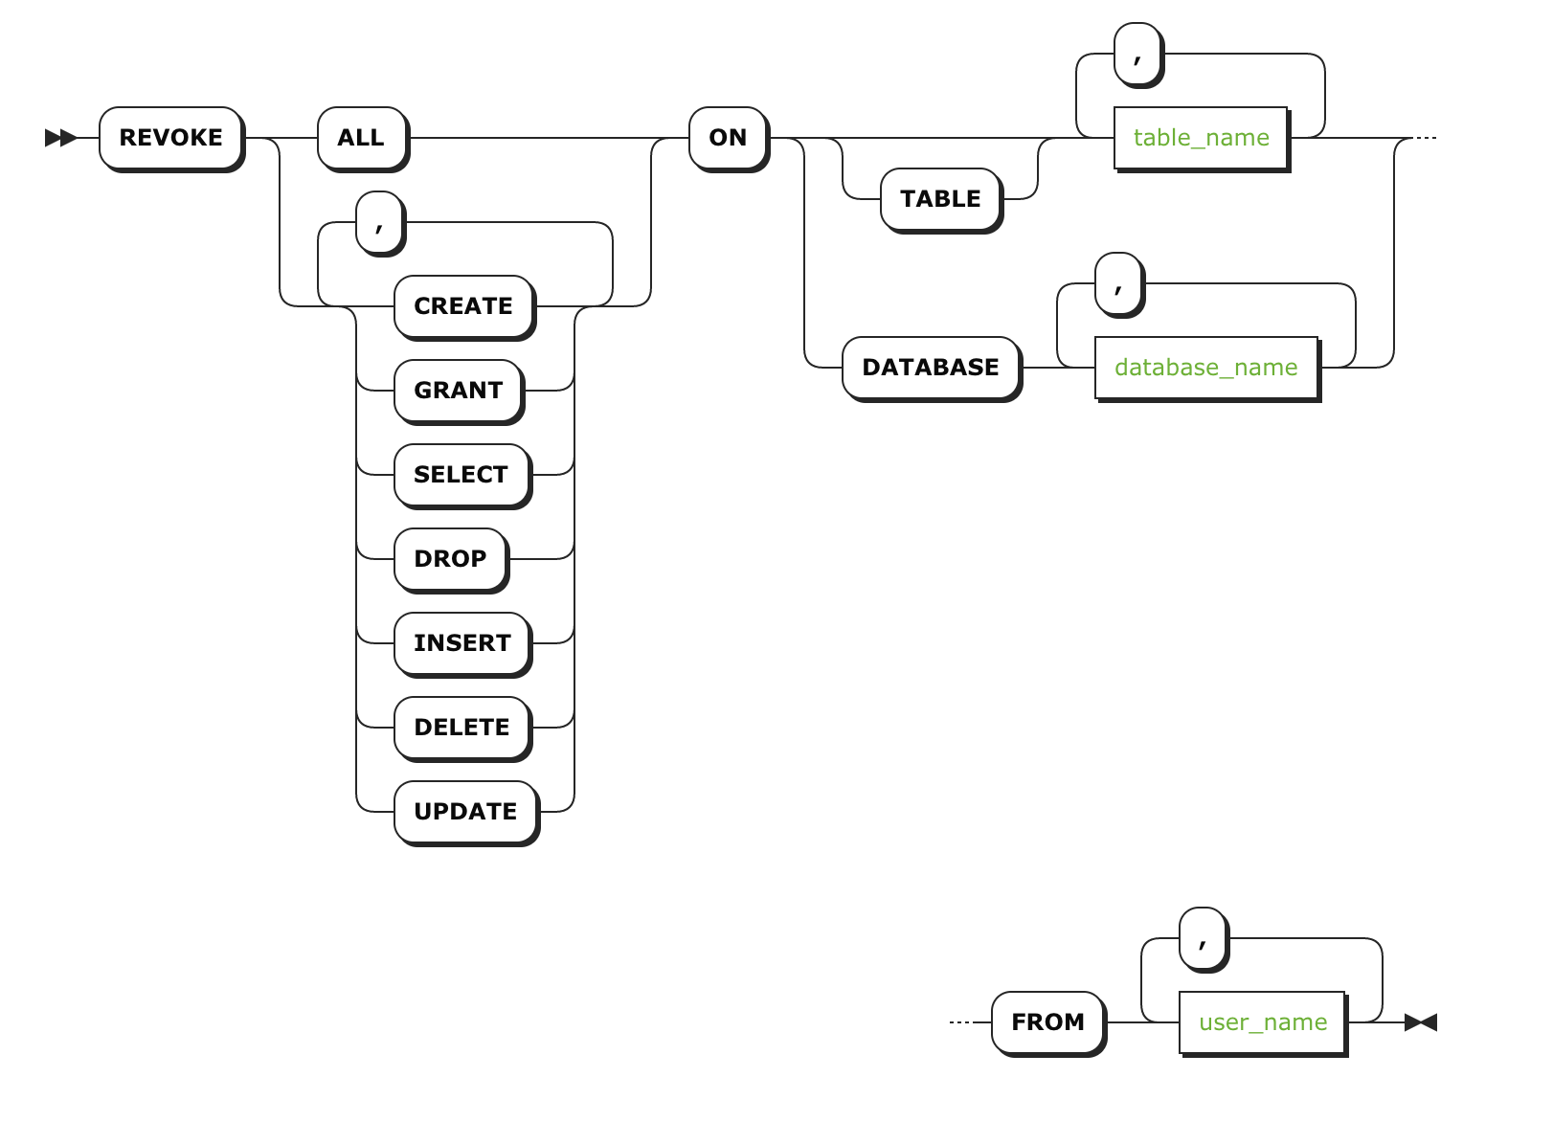

所需权限

撤销权限需要对指定的数据库或表 [GRANT](http://doc.cockroachchina.baidu.com/#develop/sql-statements/GRANT-%3Cprivileges%3E/) 权限。

Parameters

| **参数** | **描述** |
| --- | --- |
| table_name | 撤销权限对应的表。若想要撤销对多个表的权限，用逗号分隔表名称，若要撤销所有表权限则使用符号 * |
| database_name | 撤销权限对应的数据库。若想要撤销多个库的权限，用逗号分隔库名称。 |
| user_name | 想要撤销权限的 [用户](http://doc.cockroachchina.baidu.com/#deploy/access-management/manage-users/) 和/或者 [角色](http://doc.cockroachchina.baidu.com/#deploy/access-management/manager-roles-(enterprise)/) |

示例

撤销数据库权限

SHOW GRANTS ON DATABASE db1, db2;

+----------+------------+------------+

| Database | User | Privileges |

+----------+------------+------------+

| db1 | betsyroach | CREATE |

| db1 | maxroach | CREATE |

| db1 | root | ALL |

| db2 | betsyroach | CREATE |

| db2 | maxroach | CREATE |

| db2 | root | ALL |

+----------+------------+------------+

(6 rows)

**REVOKE** **CREATE** **ON** **DATABASE** db1, db2 **FROM** maxroach, betsyroach;

SHOW GRANTS ON DATABASE db1, db2;

+----------+------+------------+

| Database | User | Privileges |

+----------+------+------------+

| db1 | root | ALL |

| db2 | root | ALL |

+----------+------+------------+

(2 rows)

注意：任何一个在这之前继承数据库权限的表 都保留其权限。

撤销数据库中指定表的权限

SHOW GRANTS ON TABLE db1.t1, db1.t2;

+-------+------------+------------+

| Table | User | Privileges |

+-------+------------+------------+

| t1 | betsyroach | CREATE |

| t1 | betsyroach | DELETE |

| t1 | maxroach | CREATE |

| t1 | root | ALL |

| t2 | betsyroach | CREATE |

| t2 | betsyroach | DELETE |

| t2 | maxroach | CREATE |

| t2 | root | ALL |

+-------+------------+------------+

(8 rows)

**REVOKE** **CREATE** **ON** **TABLE** db1.t1, db1,t2 **FROM** betsyroach;

SHOW GRANTS ON TABLE db1.t1, db1.t2;

+-------+------------+------------+

| Table | User | Privileges |

+-------+------------+------------+

| t1 | betsyroach | DELETE |

| t1 | maxroach | CREATE |

| t1 | root | ALL |

| t2 | betsyroach | DELETE |

| t2 | maxroach | CREATE |

| t2 | root | ALL |

+-------+------------+------------+

(6 rows)

撤销数据库中所有表的权限

SHOW GRANTS ON TABLE db2.t1, db2.t2;

+-------+------------+------------+

| Table | User | Privileges |

+-------+------------+------------+

| t1 | betsyroach | DELETE |

| t1 | root | ALL |

| t2 | betsyroach | DELETE |

| t2 | root | ALL |

+-------+------------+------------+

(4 rows)

**REVOKE** **DELETE** **ON** db2.* **FROM** betsyroach;

+-------+------+------------+

| Table | User | Privileges |

+-------+------+------------+

| t1 | root | ALL |

| t2 | root | ALL |

+-------+------+------------+

(2 rows)

其他

* [权限](http://doc.cockroachchina.baidu.com/#deploy/access-management/privileges/)
* [GRANT <privileges>](http://doc.cockroachchina.baidu.com/#develop/sql-statements/GRANT-%3Cprivileges%3E/)
* [GRANT <roles> (企业版)](http://doc.cockroachchina.baidu.com/#develop/sql-statements/GRANT-%3Croles%3E/)
* [REVOKE <roles> (企业版)](http://doc.cockroachchina.baidu.com/#develop/sql-statements/REVOKE-%3Croles%3E/)
* [SHOW GRANTS](http://doc.cockroachchina.baidu.com/#develop/sql-statements/SHOW-GRANTS/)
* [SHOW ROLES](http://doc.cockroachchina.baidu.com/#develop/sql-statements/SHOW-ROLES/)
* [CREATE USER](http://doc.cockroachchina.baidu.com/#develop/sql-statements/CREATE-USER/)
* [DROP USER](http://doc.cockroachchina.baidu.com/#develop/sql-statements/DROP-USER/)
* [角色](http://doc.cockroachchina.baidu.com/#deploy/access-management/manager-roles-(enterprise)/)
* [其他SQL语句](http://doc.cockroachchina.baidu.com/#develop/sql-statements/overview/)