v2.0版本的新特性: 存在 REVOKE <roles> [语句](http://doc.cockroachchina.baidu.com/#develop/sql-statements/overview/) 去撤销一个[角色](http://doc.cockroachchina.baidu.com/" \l "deploy/access-management/manager-roles-(enterprise)/) 或者 一个[用户](http://doc.cockroachchina.baidu.com/" \l "deploy/access-management/manage-users/) 作为某个角色成员的身份。

REVOKE roles 是企业版特性。

概要

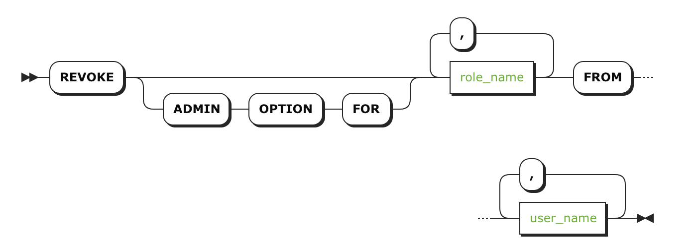

所需权限

发起操作的用户需要为 角色管理员 的身份 或者是 superuser（admin ).

注意事项

* root 用户不能撤销 admin 角色成员的身份.

参数

| **参数** | **描述** |
| --- | --- |
| ADMIN OPTION | 撤销用户的角色管理状态 |
| role_name | 删除成员角色的名称。若要从多个角色中撤销成员，请使用逗号分隔的角色名称。 |
| user_name | 想要撤销成员身份的[用户](http://doc.cockroachchina.baidu.com/" \l "deploy/access-management/manage-users/) 或 [角色](http://doc.cockroachchina.baidu.com/#deploy/access-management/manager-roles-(enterprise)/) 的名称 。 需要撤销多个成员身份，则用逗号分隔用户名或角色名。 |

示例

撤销角色内成员

SHOW GRANTS ON ROLE design;

+--------+---------+---------+

| role | member | isAdmin |

+--------+---------+---------+

| design | barkley | false |

| design | ernie | true |

| design | lola | false |

| design | lucky | false |

+--------+---------+---------+

**REVOKE** design **FROM** lola;

SHOW GRANTS ON ROLE design;

+--------+---------+---------+

| role | member | isAdmin |

+--------+---------+---------+

| design | barkley | false |

| design | ernie | true |

| design | lucky | false |

+--------+---------+---------+

Revoke the Admin Option

撤销一个 角色内 用户或角色的管理员身份 (不去除其成员身份):

REVOKE ADMIN OPTION FOR design FROM ernie;

+--------+---------+---------+

| role | member | isAdmin |

+--------+---------+---------+

| design | barkley | false |

| design | ernie | false |

| design | lucky | false |

+--------+---------+---------+

其他

* [权限](http://doc.cockroachchina.baidu.com/#deploy/access-management/privileges/)
* [GRANT <roles> (企业版)](http://doc.cockroachchina.baidu.com/#develop/sql-statements/GRANT-%3Croles%3E/)
* [GRANT <privileges>](http://doc.cockroachchina.baidu.com/#develop/sql-statements/GRANT-%3Cprivileges%3E/)
* [REVOKE <privileges>](http://doc.cockroachchina.baidu.com/#develop/sql-statements/REVOKE-%3Cprivileges%3E/)
* [SHOW GRANTS](http://doc.cockroachchina.baidu.com/#develop/sql-statements/SHOW-GRANTS/)
* [SHOW ROLES](http://doc.cockroachchina.baidu.com/#develop/sql-statements/SHOW-ROLES/)
* [CREATE USER](http://doc.cockroachchina.baidu.com/#develop/sql-statements/CREATE-USER/)
* [DROP USER](http://doc.cockroachchina.baidu.com/#develop/sql-statements/DROP-USER/)
* [Roles](http://doc.cockroachchina.baidu.com/#deploy/access-management/manager-roles-(enterprise)/)
* [其他SQL语句](http://doc.cockroachchina.baidu.com/#develop/sql-statements/overview/)