SAVEPOINT cockroach_restart 语句目的是使用 CockroachDB-provided函数重试[transactions](http://doc.cockroachchina.baidu.com/" \l "develop/transactions/) 。更多的信息请看[Transaction Retries](http://doc.cockroachchina.baidu.com/" \l "develop/transactions/#transaction-retries).

Warning: CockroachDB的SAVEPOINT 仅支持cockroach_restartsavepoint，不支持其他savepoint功能，例如嵌套事务。

概要

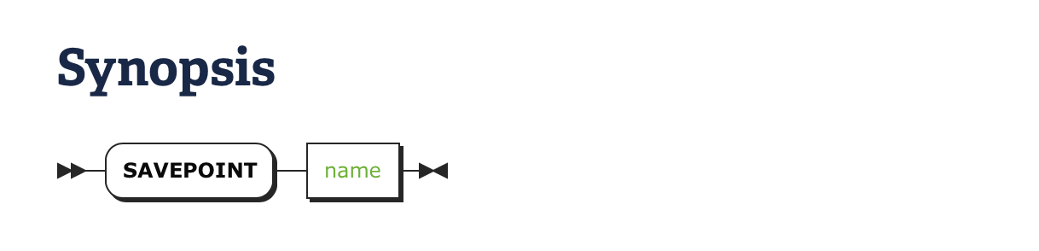

所需权限

创建一个savepoint不需要[权限](http://doc.cockroachchina.baidu.com/" \l "deploy/access-management/privileges/) 。但是，事务中每条语句的操作权限是需要的。

例子

创建Savepoint

在 BEGIN 事务后，必须创建savepoint，表明在与其他事务发生资源争用并且获取资源失败后，需要使用 [the function for client-side transaction retries](http://doc.cockroachchina.baidu.com/#develop/transactions/#transaction-retries).

> **BEGIN**;

> **SAVEPOINT** cockroach_restart;

> **UPDATE** products **SET** inventory = 0 **WHERE** sku = '8675309';

> **INSERT** **INTO** orders (customer, sku, **status**) **VALUES** (1001, '8675309', 'new');

> **RELEASE** **SAVEPOINT** cockroach_restart;

> **COMMIT**;

当使用SAVEPOINT时，你的应用必须有包含[ROLLBACK TO SAVEPOINT cockroach_restart](http://doc.cockroachchina.baidu.com/#develop/sql-statements/ROLLBACK/#retry-a-transaction)执行重试的函数。

See Also

* [Transactions](http://doc.cockroachchina.baidu.com/#develop/transactions/)
* [RELEASE SAVEPOINT](http://doc.cockroachchina.baidu.com/#develop/sql-statements/RELEASE-SAVEPOINT/)
* [ROLLBACK](http://doc.cockroachchina.baidu.com/#develop/sql-statements/ROLLBACK/)
* [BEGIN](http://doc.cockroachchina.baidu.com/#develop/sql-statements/BEGIN/)
* [COMMIT](http://doc.cockroachchina.baidu.com/#develop/sql-statements/COMMIT/)