SHOW CREATE TABLE [语句](http://doc.cockroachchina.baidu.com/#develop/sql-statements/overview/) 用于显示创建表的 CREATE TABLE 语句

所需权限

用户需拥有这个表的任一[权限](http://doc.cockroachchina.baidu.com/#deploy/access-management/privileges/)

概要

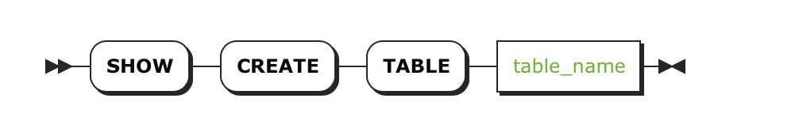

参数

| **Parameter** | **Description** |
| --- | --- |
| table_name | 要显示CREATE TABLE 语句的表名 |

返回

| **Field** | **Description** |
| --- | --- |
| Table | 表名 |
| CreateTable | 创建一个表的[CREATE TABLE](http://doc.cockroachchina.baidu.com/#develop/sql-statements/CREATE-TABLE/) 语句 |

例子

> **CREATE** **TABLE** customers (id INT **PRIMARY** **KEY**, email **STRING** **UNIQUE**);

> **CREATE** **TABLE** products (sku **STRING** **PRIMARY** **KEY**, price DECIMAL(9,2));

> **CREATE** **TABLE** orders (

id INT **PRIMARY** **KEY**,

product **STRING** **NOT** NULL **REFERENCES** products,

quantity INT,

customer INT **NOT** NULL **CONSTRAINT** valid_customer **REFERENCES** customers (id),

**CONSTRAINT** id_customer_unique **UNIQUE** (id, customer),

**INDEX** (product),

**INDEX** (customer)

);

> **SHOW** **CREATE** **TABLE** customer;

+*-----------+----------------------------------------------------+*

| Table | CreateTable |

+*-----------+----------------------------------------------------+*

| customers | **CREATE** **TABLE** customers (␤ |

| | id INT **NOT** NULL,␤ |

| | email **STRING** NULL,␤ |

| | **CONSTRAINT** "primary" **PRIMARY** **KEY** (id **ASC**),␤ |

| | **UNIQUE** **INDEX** customers_email_key (email **ASC**),␤ |

| | FAMILY "primary" (id, email)␤ |

| | ) |

+*-----------+----------------------------------------------------+*

(1 **row**)

> **SHOW** **CREATE** **TABLE** products;

+----------+--------------------------------------------------+

| Table | CreateTable |

+----------+--------------------------------------------------+

| products | CREATE TABLE products (␤ |

| | sku STRING NOT NULL,␤ |

| | price DECIMAL(9,2) NULL,␤ |

| | CONSTRAINT "primary" PRIMARY KEY (sku ASC),␤ |

| | FAMILY "primary" (sku, price)␤ |

| | ) |

+----------+--------------------------------------------------+

(1 row)

> **SHOW** **CREATE** **TABLE** orders;

+*--------+------------------------------------------------------------------------------------------+*

| Table | CreateTable |

+*--------+------------------------------------------------------------------------------------------+*

| orders | **CREATE** **TABLE** orders (␤ |

| | id INT **NOT** NULL,␤ |

| | product **STRING** **NOT** NULL,␤ |

| | quantity INT NULL,␤ |

| | customer INT **NOT** NULL,␤ |

| | **CONSTRAINT** "primary" **PRIMARY** **KEY** (id **ASC**),␤ |

| | **UNIQUE** **INDEX** id_customer_unique (id **ASC**, customer **ASC**),␤ |

| | **CONSTRAINT** fk_product_ref_products **FOREIGN** **KEY** (product) **REFERENCES** products (sku),␤ |

| | **INDEX** orders_product_idx (product **ASC**),␤ |

| | **CONSTRAINT** valid_customer **FOREIGN** **KEY** (customer) **REFERENCES** customers (id),␤ |

| | **INDEX** orders_customer_idx (customer **ASC**),␤ |

| | FAMILY "primary" (id, product, quantity, customer)␤ |

| | ) |

+*--------+------------------------------------------------------------------------------------------+*

(1 **row**)

See Also

* [CREATE TABLE](http://doc.cockroachchina.baidu.com/#develop/sql-statements/CREATE-TABLE/)
* [Information Schema](http://doc.cockroachchina.baidu.com/#develop/information-schema/)
* [Other SQL Statements](http://doc.cockroachchina.baidu.com/#develop/sql-statements/overview/)