SHOW CREATE VIEW [语句](http://doc.cockroachchina.baidu.com/#develop/sql-statements/overview/) 用于显示创建 [view](http://doc.cockroachchina.baidu.com/#develop/views/)的CREATE VIEW 语句。

所需权限

用户必需具有视图的任一[权限](http://doc.cockroachchina.baidu.com/" \l "deploy/access-management/privileges/)。

概要

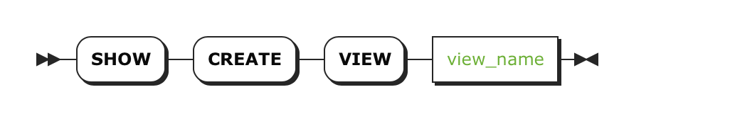

参数

| **Parameter** | **Description** |
| --- | --- |
| view_name | 要查看CREATE VIEW语句的视图名。 |

返回

| **Field** | **Description** |
| --- | --- |
| View | 视图名字 |
| CreateView | 创建视图的[CREATE VIEW](http://doc.cockroachchina.baidu.com/" \l "develop/sql-statements/CREATE-VIEW/) 语句 |

例子

查看一个视图的 CREATE VIEW 语句

> **SHOW** **CREATE** **VIEW** bank.user_accounts;

+--------------------+---------------------------------------------------------------------------+

| View | CreateView |

+--------------------+---------------------------------------------------------------------------+

| bank.user_accounts | CREATE VIEW "bank.user_accounts" AS SELECT type, email FROM bank.accounts |

+--------------------+---------------------------------------------------------------------------+

(1 row)

查看 视图的SELECT 定义语句

通过information_schema数据库的views表，使用视图名进行过滤后，就可以找出视图的SELECT定义语句。

> **SELECT** view_definition

**FROM** information_schema.views

**WHERE** table_name = 'user_accounts';

+---------------------------------------+

| view_definition |

+---------------------------------------+

| SELECT type, email FROM bank.accounts |

+---------------------------------------+

(1 row)

See Also

* [Views](http://doc.cockroachchina.baidu.com/#develop/views/)
* [CREATE VIEW](http://doc.cockroachchina.baidu.com/#develop/sql-statements/CREATE-VIEW/)
* [ALTER VIEW](http://doc.cockroachchina.baidu.com/#develop/sql-statements/alert-view/)
* [DROP VIEW](http://doc.cockroachchina.baidu.com/#develop/sql-statements/DROP-VIEW/)
* [Information Schema](http://doc.cockroachchina.baidu.com/#develop/information-schema/)
* [Other SQL Statements](http://doc.cockroachchina.baidu.com/#develop/sql-statements/overview/)