V2.0版本新特性: SHOW SCHEMAS [语句](http://doc.cockroachchina.baidu.com/#develop/sql-statements/overview/) 用于显示一个数据库中所有的 [schemas](http://doc.cockroachchina.baidu.com/#develop/sql-syntax/name-resolution/#logical-schemas-and-namespaces) 信息。

所需权限

无 [权限](http://doc.cockroachchina.baidu.com/#deploy/access-management/privileges/) 要求。

概要

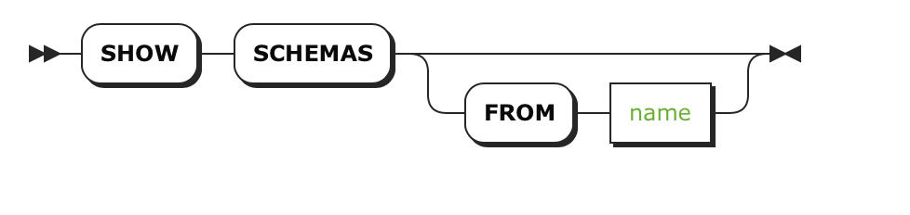

参数

| **Parameter** | **Description** |
| --- | --- |
| name | [schemas](http://doc.cockroachchina.baidu.com/#develop/sql-syntax/name-resolution/#logical-schemas-and-namespaces)对应的数据库名缺省时, 默认显示 [当前数据库](http://doc.cockroachchina.baidu.com/#develop/sql-syntax/name-resolution/#current-database)的schemas信息。 |

例子

> **SET** **DATABASE** = bank;

> **SHOW** SCHEMAS;

+--------------------+

| Schema |

+--------------------+

| crdb_internal |

| information_schema |

| pg_catalog |

| public |

+--------------------+

(4 rows)

See Also

* [Logical Schemas and Namespaces](http://doc.cockroachchina.baidu.com/#develop/sql-syntax/name-resolution/)
* [SHOW DATABASES](http://doc.cockroachchina.baidu.com/#develop/sql-statements/SHOW-DATABASES/)
* [Information Schema](http://doc.cockroachchina.baidu.com/#develop/information-schema/)
* [Other SQL Statements](http://doc.cockroachchina.baidu.com/#develop/sql-statements/overview/)