SHOW USERS [语句](http://doc.cockroachchina.baidu.com/#develop/sql-statements/overview/) 用于列出所有数据库的用户

概要

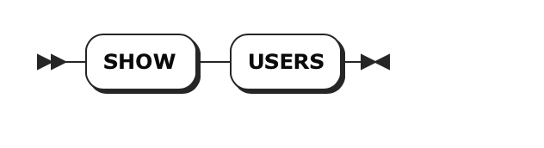

所需权限

用户必须具有系统表的 [SELECT](http://doc.cockroachchina.baidu.com/#develop/sql-statements/SELECT/) [权限](http://doc.cockroachchina.baidu.com/#deploy/access-management/privileges/)。

例子

> **SHOW** USERS;

+------------+

| username |

+------------+

| jpointsman |

| maxroach |

| root |

+------------+

See Also

* [CREATE USER](http://doc.cockroachchina.baidu.com/#develop/sql-statements/CREATE-USER/)
* [Manage Users](http://doc.cockroachchina.baidu.com/#deploy/access-management/manage-users/)