DROP INDEX [语句](http://doc.cockroachchina.baidu.com/#develop/sql-statements/overview/) 会删除表中的索引。

概要

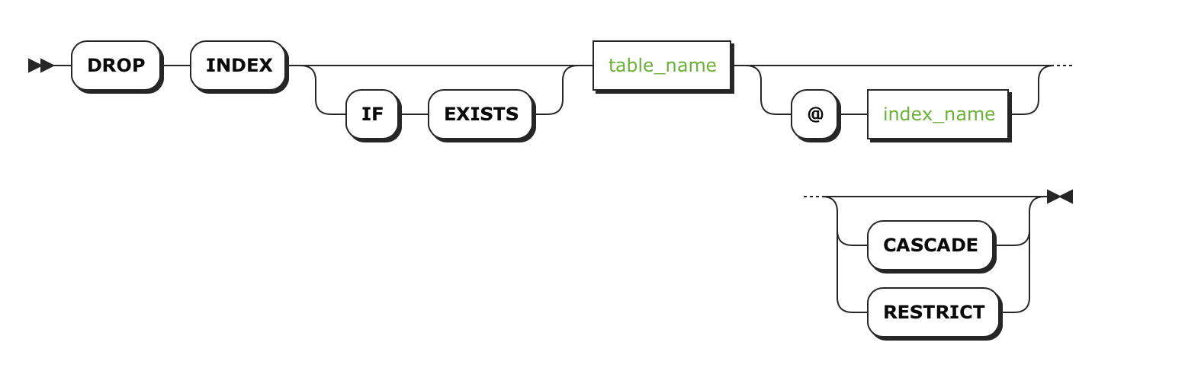

所需权限

用户必须拥有表的CREATE [权限](http://doc.cockroachchina.baidu.com/#deploy/access-management/privileges/)。

参数

| **Parameter** | **Description** |
| --- | --- |
| IF EXISTS | 如果要删除的索引存在，则删除该索引，如果没有，不会返回错误 |
| table_name | 要删除索引所在表的名字. 通过 [SHOW TABLES](http://doc.cockroachchina.baidu.com/#develop/sql-statements/SHOW-TABLES/)可以查看表名 |
| index_name | 要删除索引的名字。通过 [SHOW INDEX](http://doc.cockroachchina.baidu.com/#develop/sql-statements/SHOW-INDEX/)可以查看索引的名字。  不能删除表的 primary 索引。 |
| CASCADE | 删除所有依赖这个索引的对象 (例如 [constraints](http://doc.cockroachchina.baidu.com/#develop/constraints/overview/))。 当要删除一个 UNIQUE INDEX, 必须使用 CASCADE.  CASCADE不会列出要删除的对象，请谨慎使用 |
| RESTRICT | *(Default)* 当有对象依赖这个索引时(例如 [constraints](http://doc.cockroachchina.baidu.com/#develop/constraints/overview/))，不会删除这个索引。 |

例子

删除一个索引 (无依赖对象)

> **SHOW** **INDEX** **FROM** tbl;

+-------+--------------+--------+-----+--------+-----------+---------+----------+

| Table | Name | Unique | Seq | Column | Direction | Storing | Implicit |

+-------+--------------+--------+-----+--------+-----------+---------+----------+

| tbl | primary | true | 1 | id | ASC | false | false |

| tbl | tbl_name_idx | false | 1 | name | ASC | false | false |

| tbl | tbl_name_idx | false | 2 | id | ASC | false | true |

+-------+--------------+--------+-----+--------+-----------+---------+----------+

(3 rows)

> **DROP** **INDEX** tbl@tbl_name_idx;

> **SHOW** **INDEX** **FROM** tbl;

+-------+---------+--------+-----+--------+-----------+---------+----------+

| Table | Name | Unique | Seq | Column | Direction | Storing | Implicit |

+-------+---------+--------+-----+--------+-----------+---------+----------+

| tbl | primary | true | 1 | id | ASC | false | false |

+-------+---------+--------+-----+--------+-----------+---------+----------+

(1 row)

使用 CASCADE删除有依赖对象的索引

Warning: CASCADE 删除 *所有* 依赖这个索引的对象，并且不会列出锁删除的对象， 这样就可能会出现一个不可预料的损失。所以，为了避免这种情况出现， 我们推荐单独删除对象。

> **SHOW** **INDEX** **FROM** orders;

+--------+---------------------+--------+-----+----------+-----------+---------+----------+

| Table | Name | Unique | Seq | Column | Direction | Storing | Implicit |

+--------+---------------------+--------+-----+----------+-----------+---------+----------+

| orders | primary | true | 1 | id | ASC | false | false |

| orders | orders_customer_idx | false | 1 | customer | ASC | false | false |

| orders | orders_customer_idx | false | 2 | id | ASC | false | true |

+--------+---------------------+--------+-----+----------+-----------+---------+----------+

(3 rows)

> **DROP** **INDEX** orders@orders_customer_idx;

pq: index "orders_customer_idx" is in **use** **as** a **foreign** **key** **constraint**

> **SHOW** **CONSTRAINTS** **FROM** orders;

+--------+---------------------------+-------------+------------+----------------+

| Table | Name | Type | Column(s) | Details |

+--------+---------------------------+-------------+------------+----------------+

| orders | fk_customer_ref_customers | FOREIGN KEY | [customer] | customers.[id] |

| orders | primary | PRIMARY KEY | [id] | NULL |

+--------+---------------------------+-------------+------------+----------------+

> **DROP** **INDEX** orders@orders_customer_idx **CASCADE**;

> **SHOW** **CONSTRAINTS** **FROM** orders;

+--------+---------+-------------+-----------+---------+

| Table | Name | Type | Column(s) | Details |

+--------+---------+-------------+-----------+---------+

| orders | primary | PRIMARY KEY | [id] | NULL |

+--------+---------+-------------+-----------+---------+