RESET [语句](http://doc.cockroachchina.baidu.com/#develop/sql-statements/overview/) 通过客户端重置 [集群设置](http://doc.cockroachchina.baidu.com/#develop/sql-statements/SET-CLUSTER-SETTING/) 为默认值。

所需权限

仅有 root 用户可以更改集群设置。

概要

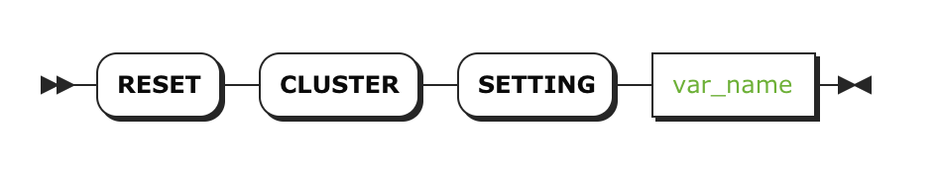

参数

| **参数** | **描述** |
| --- | --- |
| var_name | [集群设置](http://doc.cockroachchina.baidu.com/#develop/sql-statements/cluster-settings/)名称 |

示例

注意：同样可以使用 SET CLUSTER SETTING .. TO DEFAULT 去重置集群设置。

SET CLUSTER SETTING sql.metrics.statement_details.enabled = false;

SHOW CLUSTER SETTING sql.metrics.statement_details.enabled;

+---------------------------------------+

| sql.metrics.statement_details.enabled |

+---------------------------------------+

| false |

+---------------------------------------+

(1 row)

RESET CLUSTER SETTING sql.metrics.statement_details.enabled;

SHOW CLUSTER SETTING sql.metrics.statement_details.enabled;

+---------------------------------------+

| sql.metrics.statement_details.enabled |

+---------------------------------------+

| true |

+---------------------------------------+

(1 row)

其他

* [SET CLUSTER SETTING](http://doc.cockroachchina.baidu.com/#develop/sql-statements/SET-CLUSTER-SETTING/)
* [SHOW CLUSTER SETTING](http://doc.cockroachchina.baidu.com/#develop/sql-statements/SHOW-CLUSTER-SETTING/)
* [集群设置](http://doc.cockroachchina.baidu.com/#develop/sql-statements/cluster-settings/)