SET CLUSTER SETTING [语句](http://doc.cockroachchina.baidu.com/#develop/sql-statements/overview/) 用于修改 [集群范围的设置](http://doc.cockroachchina.baidu.com/#develop/sql-statements/cluster-settings/).

Warning: 许多的集群设置会影响CockroackDB内部运行机制。因此，修改这些设置前，强烈建议需要明确使用CockraochDB的目的，否则修改设置会带来一定的风险。

所需权限

仅root 用户可以更改集群参数设置

概要

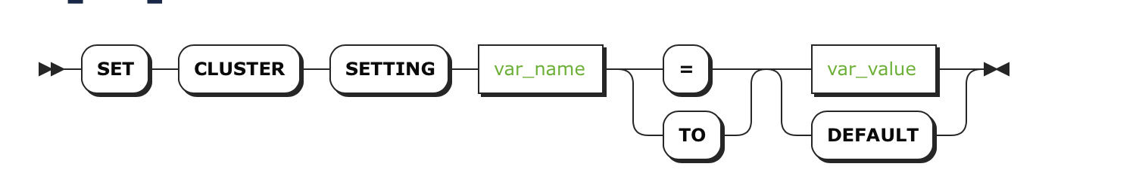

Note: SET CLUSTER SETTING 语句与 [SET TRANSACTION](http://doc.cockroachchina.baidu.com/#develop/sql-statements/SET-CLUSTER-SETTING/set-transaction.html) 和 [SET (session variable)](http://doc.cockroachchina.baidu.com/#develop/sql-statements/SET-CLUSTER-SETTING/set-vars.html) 语句没有关系。

参数

| **Parameter** | **Description** |
| --- | --- |
| var_name | [cluster setting](http://doc.cockroachchina.baidu.com/#develop/sql-statements/cluster-settings/) (case-insensitive)的名字 |
| var_value | [cluster setting](http://doc.cockroachchina.baidu.com/#develop/sql-statements/cluster-settings/)设置的值 |
| DEFAULT | 将[cluster setting](http://doc.cockroachchina.baidu.com/" \l "develop/sql-statements/cluster-settings/) 设置成初始默认值.  [RESET CLUSTER SETTING](http://doc.cockroachchina.baidu.com/#develop/sql-statements/reset-cluster-setting/) 会重置所有参数的值 |

例子

改变默认分布式执行参数

通过配置参数，可以让新的sessions自动执行分布式查询 [in a distributed fashion](https://www.cockroachlabs.com/blog/local-and-distributed-processing-in-cockroachdb/)。

> **SET** CLUSTER SETTING **sql**.defaults.distsql = 1;

也可以使集群的分布式执行失效。

> **SET** CLUSTER SETTING **sql**.defaults.distsql = 0;

禁用自动诊断报告

可以不使用Cockroach Labs的数据自动诊断报告[automatic diagnostic reporting](http://doc.cockroachchina.baidu.com/" \l "maintian/diagnostics-reporting/)。

> **SET** CLUSTER SETTING **diagnostics**.reporting.enabled = false;

> **SHOW** CLUSTER SETTING **diagnostics**.reporting.enabled;

+-------------------------------+

| diagnostics.reporting.enabled |

+-------------------------------+

| false |

+-------------------------------+

(1 row)

重置参数到默认值

Tips: 可以使用 [RESET CLUSTER SETTING](http://doc.cockroachchina.baidu.com/#develop/sql-statements/SET-CLUSTER-SETTING/reset-cluster-setting.html) 重置集群的所有参数

> **SET** CLUSTER SETTING **sql**.metrics.statement_details.enabled = false;

> **SHOW** CLUSTER SETTING **sql**.metrics.statement_details.enabled;

+---------------------------------------+

| sql.metrics.statement_details.enabled |

+---------------------------------------+

| false |

+---------------------------------------+

(1 row)

> **SET** CLUSTER SETTING **sql**.metrics.statement_details.enabled = **DEFAULT**;

> **SHOW** CLUSTER SETTING **sql**.metrics.statement_details.enabled;

+---------------------------------------+

| sql.metrics.statement_details.enabled |

+---------------------------------------+

| true |

+---------------------------------------+

(1 row)

See Also

* [SET (session variable)](http://doc.cockroachchina.baidu.com/#develop/sql-statements/SET(session-variable)/)
* [SHOW CLUSTER SETTING](http://doc.cockroachchina.baidu.com/#develop/sql-statements/SHOW-CLUSTER-SETTING/)
* [Cluster settings](http://doc.cockroachchina.baidu.com/#develop/sql-statements/cluster-settings/)