SHOW CLUSTER SETTING [语句](http://doc.cockroachchina.baidu.com/#develop/sql-statements/overview/) 用于可以查看一个或多个 [cluster settings](http://doc.cockroachchina.baidu.com/#develop/sql-statements/cluster-settings/)的值，也可以通过 [SET CLUSTER SETTING](http://doc.cockroachchina.baidu.com/#develop/sql-statements/SET-CLUSTER-SETTING/)进行配置

所需权限 Changed in v2.0

仅 root 权限可以使用

概要

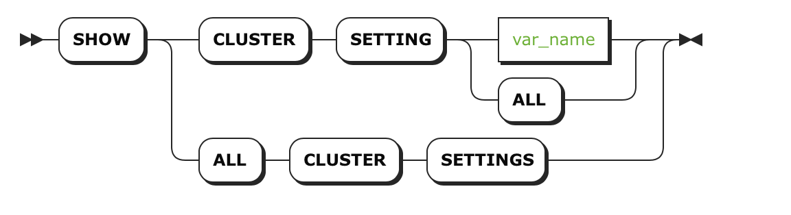

Note: 集群设置的SHOW 语句与下面SHOW 语句无关，具体语句如下: [SHOW (session variable)](http://doc.cockroachchina.baidu.com/#develop/sql-statements/SHOW-CLUSTER-SETTING/show-vars.html), [SHOW CREATE TABLE](http://doc.cockroachchina.baidu.com/#develop/sql-statements/SHOW-CLUSTER-SETTING/show-create-table.html), [SHOW CREATE VIEW](http://doc.cockroachchina.baidu.com/#develop/sql-statements/SHOW-CLUSTER-SETTING/show-create-view.html), [SHOW USERS](http://doc.cockroachchina.baidu.com/#develop/sql-statements/SHOW-CLUSTER-SETTING/show-users.html), [SHOW DATABASES](http://doc.cockroachchina.baidu.com/#develop/sql-statements/SHOW-CLUSTER-SETTING/show-databases.html), [SHOW COLUMNS](http://doc.cockroachchina.baidu.com/#develop/sql-statements/SHOW-CLUSTER-SETTING/show-columns.html), [SHOW GRANTS](http://doc.cockroachchina.baidu.com/#develop/sql-statements/SHOW-CLUSTER-SETTING/show-grants.html), and [SHOW CONSTRAINTS](http://doc.cockroachchina.baidu.com/#develop/sql-statements/SHOW-CLUSTER-SETTING/show-constraints.html)

参数

| **Parameter** | **Description** |
| --- | --- |
| any_name | [cluster setting](http://doc.cockroachchina.baidu.com/#develop/sql-statements/cluster-settings/) (case-insensitive)的名字 |

例子

查看一个Cluster Setting的值

> **SHOW** CLUSTER SETTING **diagnostics**.reporting.enabled;

+-------------------------------+

| diagnostics.reporting.enabled |

+-------------------------------+

| true |

+-------------------------------+

(1 row)

> **SHOW** CLUSTER SETTING **sql**.**default**.distsql;

+----------------------+

| sql.defaults.distsql |

+----------------------+

| 1 |

+----------------------+

(1 row)

查看所有Cluster Settings的值

> **SHOW** **ALL** CLUSTER SETTINGS;

+-------------------------------+---------------+------+--------------------------------------------------------+

| name | current_value | type | description |

+-------------------------------+---------------+------+--------------------------------------------------------+

| diagnostics.reporting.enabled | true | b | enable reporting diagnostic metrics to cockroach labs |

| ... | ... | ... | ... |

+-------------------------------+---------------+------+--------------------------------------------------------+

(24 rows)

See Also

* [SET CLUSTER SETTING](http://doc.cockroachchina.baidu.com/#develop/sql-statements/SET-CLUSTER-SETTING/)
* [RESET CLUSTER SETTING](http://doc.cockroachchina.baidu.com/#develop/sql-statements/reset-cluster-setting/)
* [Cluster settings](http://doc.cockroachchina.baidu.com/#develop/sql-statements/cluster-settings/)
* [SHOW (session variable)](http://doc.cockroachchina.baidu.com/#develop/sql-statements/SHOW(session-variables)/)
* [SHOW COLUMNS](http://doc.cockroachchina.baidu.com/#develop/sql-statements/SHOW-COLUMNS/)
* [SHOW CONSTRAINTS](http://doc.cockroachchina.baidu.com/#develop/sql-statements/SHOW-CONSTRAINTS/)
* [SHOW CREATE TABLE](http://doc.cockroachchina.baidu.com/#develop/sql-statements/show-create-table/)
* [SHOW CREATE VIEW](http://doc.cockroachchina.baidu.com/#develop/sql-statements/SHOW-CREATE-VIEW/)
* [SHOW DATABASES](http://doc.cockroachchina.baidu.com/#develop/sql-statements/SHOW-DATABASES/)
* [SHOW GRANTS](http://doc.cockroachchina.baidu.com/#develop/sql-statements/SHOW-GRANTS/)
* [SHOW INDEX](http://doc.cockroachchina.baidu.com/#develop/sql-statements/SHOW-INDEX/)
* [SHOW USERS](http://doc.cockroachchina.baidu.com/#develop/sql-statements/SHOW-USERS/)