New in v2.0: SHOW CREATE SEQUENCE [语句](http://doc.cockroachchina.baidu.com/#develop/sql-statements/overview/) 用于显示创建特定序列的 CREATE SEQUENCE 语句。

所需权限

用户需拥有目标序列的任一 [权限](http://doc.cockroachchina.baidu.com/#deploy/access-management/privileges/) 。

概要

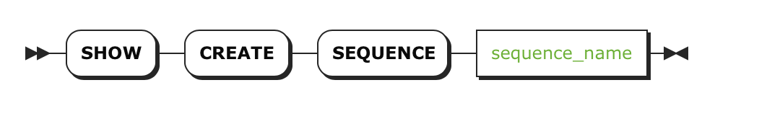

参数

| **Parameter** | **Description** |
| --- | --- |
| sequence_name | 序列名 |

返回

| **Field** | **Description** |
| --- | --- |
| Sequence | 序列名 |
| CreateSequence | 创建一个特定序列[CREATE SEQUENCE](http://doc.cockroachchina.baidu.com/" \l "develop/sql-statements/CREATE-SEQUENCE/) 语句。 |

例子

> **CREATE** SEQUENCE desc_customer_list **START** -1 INCREMENT -2;

> **SHOW** **CREATE** SEQUENCE desc_customer_list;

+--------------------+----------------------------------------------------------------------------------------------------+

| Sequence | CreateSequence |

+--------------------+----------------------------------------------------------------------------------------------------+

| desc_customer_list | CREATE SEQUENCE desc_customer_list MINVALUE -9223372036854775808 MAXVALUE -1 INCREMENT -2 START -1 |

+--------------------+----------------------------------------------------------------------------------------------------+

See Also

* [CREATE SEQUENCE](http://doc.cockroachchina.baidu.com/#develop/sql-statements/CREATE-SEQUENCE/)
* [ALTER SEQUENCE](http://doc.cockroachchina.baidu.com/#develop/sql-statements/ALTER-SEQUENCE/)
* [DROP SEQUENCE](http://doc.cockroachchina.baidu.com/#develop/sql-statements/DROP-SEQUENCE/)
* [Information Schema](http://doc.cockroachchina.baidu.com/#develop/information-schema/)
* [Other SQL Statements](http://doc.cockroachchina.baidu.com/#develop/sql-statements/overview/)