SHOW GRANTS [语句](http://doc.cockroachchina.baidu.com/#develop/sql-statements/overview/) 用于列出授予用户的 [权限](http://doc.cockroachchina.baidu.com/#deploy/access-management/privileges/)

概要

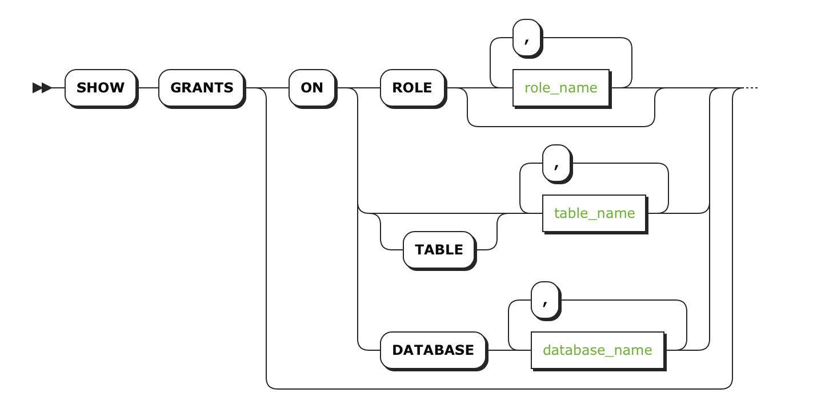 

所需权限

无[权限](http://doc.cockroachchina.baidu.com/#deploy/access-management/privileges/) 要求。 但是，对于 SHOW GRANTS ON ROLES， 用户需要系统表的 [SELECT](http://doc.cockroachchina.baidu.com/#develop/sql-statements/SELECT/) [权限](http://doc.cockroachchina.baidu.com/#deploy/access-management/privileges/)。

参数

| **Parameter** | **Description** |
| --- | --- |
| role_name | 多个由逗号隔开的role名字 |
| table_name | 多个由逗号隔开的表名。如果想显示所有表的权限，使用 *。 |
| database_name | 多个由逗号隔开的数据库名字 |
| user_name | 可选项，多个由逗号隔开的授权用户名 |

例子

显示所有权限 New in v2.0

显示所有用户和角色在所有数据库与表上的权限：

> **SHOW** **GRANTS**;

+------------+--------------------+------------------+------------+------------+

| Database | Schema | Table | User | Privileges |

+------------+--------------------+------------------+------------+------------+

| system | crdb_internal | NULL | admin | GRANT |

| system | crdb_internal | NULL | admin | SELECT |

| system | crdb_internal | NULL | root | GRANT |

...

| test_roles | public | employees | system_ops | CREATE |

+------------+--------------------+------------------+------------+------------+

(167 rows)

显示特定的一个用户或角色的权限New in v2.0

> **SHOW** **GRANTS** **FOR** maxroach;

+------------+--------------------+-------+----------+------------+

| Database | Schema | Table | User | Privileges |

+------------+--------------------+-------+----------+------------+

| test_roles | crdb_internal | NULL | maxroach | DELETE |

| test_roles | information_schema | NULL | maxroach | DELETE |

| test_roles | pg_catalog | NULL | maxroach | DELETE |

| test_roles | public | NULL | maxroach | DELETE |

+------------+--------------------+-------+----------+------------+

显示一个数据库上的权限

**所有用户与角色在特定的数据库的权限：**

> **SHOW** **GRANTS** **ON** **DATABASE** db2:

+----------+--------------------+------------+------------+

| Database | Schema | User | Privileges |

+----------+--------------------+------------+------------+

| db2 | crdb_internal | admin | ALL |

| db2 | crdb_internal | betsyroach | CREATE |

| db2 | crdb_internal | root | ALL |

| db2 | information_schema | admin | ALL |

| db2 | information_schema | betsyroach | CREATE |

| db2 | information_schema | root | ALL |

| db2 | pg_catalog | admin | ALL |

| db2 | pg_catalog | betsyroach | CREATE |

| db2 | pg_catalog | root | ALL |

| db2 | public | admin | ALL |

| db2 | public | betsyroach | CREATE |

| db2 | public | root | ALL |

+----------+--------------------+------------+------------+

**特定的用户与角色在具体数据库上的权限：**

> **SHOW** **GRANTS** **ON** **DATABASE** db2 **FOR** betsyroach;

+----------+--------------------+------------+------------+

| Database | Schema | User | Privileges |

+----------+--------------------+------------+------------+

| db2 | crdb_internal | betsyroach | CREATE |

| db2 | information_schema | betsyroach | CREATE |

| db2 | pg_catalog | betsyroach | CREATE |

| db2 | public | betsyroach | CREATE |

+----------+--------------------+------------+------------+

显示表上的权限

**所有用户与角色在特定表上的权限：**

> **SHOW** **GRANTS** **ON** **TABLE** test_roles.employees;

+------------+--------+-----------+------------+------------+

| Database | Schema | Table | User | Privileges |

+------------+--------+-----------+------------+------------+

| test_roles | public | employees | admin | ALL |

| test_roles | public | employees | root | ALL |

| test_roles | public | employees | system_ops | CREATE |

+------------+--------+-----------+------------+------------+

**特定的用户或角色在具体表上的权限：**

> **SHOW** **GRANTS** **ON** **TABLE** test_roles.employees **FOR** system_ops;

+------------+--------+-----------+------------+------------+

| Database | Schema | Table | User | Privileges |

+------------+--------+-----------+------------+------------+

| test_roles | public | employees | system_ops | CREATE |

+------------+--------+-----------+------------+------------+

**所有用户与角色在所有表上的权限：**

> **SHOW** **GRANTS** **ON** **TABLE** test_roles.*;

+------------+--------+-----------+------------+------------+

| Database | Schema | Table | User | Privileges |

+------------+--------+-----------+------------+------------+

| test_roles | public | employees | admin | ALL |

| test_roles | public | employees | root | ALL |

| test_roles | public | employees | system_ops | CREATE |

+------------+--------+-----------+------------+------------+

**特定用户在所有表上是权限：**

> **SHOW** **GRANTS** **ON** **TABLE** test_roles.* **FOR** system_ops;

+------------+--------+-----------+------------+------------+

| Database | Schema | Table | User | Privileges |

+------------+--------+-----------+------------+------------+

| test_roles | public | employees | system_ops | CREATE |

+------------+--------+-----------+------------+------------+

查看角色中用户 New in v2.0

**查看所有角色里的所有用户：**

**SHOW** **GRANTS** **ON** ROLE;

+--------+---------+---------+

| role | member | isAdmin |

+--------+---------+---------+

| admin | root | true |

| design | ernie | false |

| design | lola | false |

| dev | barkley | false |

| dev | carl | false |

| docs | carl | false |

| hr | finance | false |

| hr | lucky | false |

+--------+---------+---------+

**查看一个角色里的用户：**

**SHOW** **GRANTS** **ON** ROLE design;

+--------+--------+---------+

| role | member | isAdmin |

+--------+--------+---------+

| design | ernie | false |

| design | lola | false |

+--------+--------+---------+

**查看用户所在的所有角色**

**SHOW** **GRANTS** **ON** ROLE **FOR** carl;

+------+--------+---------+

| role | member | isAdmin |

+------+--------+---------+

| dev | carl | false |

| docs | carl | false |

+------+--------+---------+

See Also

* [CREATE ROLE](http://doc.cockroachchina.baidu.com/#develop/sql-statements/CREATE-ROLE-(Enterprise)/)
* [DROP ROLE](http://doc.cockroachchina.baidu.com/#develop/sql-statements/DROP-ROLE/)
* [SHOW ROLES](http://doc.cockroachchina.baidu.com/#develop/sql-statements/SHOW-ROLES/)
* [GRANT <privileges>](http://doc.cockroachchina.baidu.com/#develop/sql-statements/GRANT-%3Cprivileges%3E/)
* [GRANT <roles> (Enterprise)](http://doc.cockroachchina.baidu.com/#develop/sql-statements/GRANT-%3Croles%3E/)
* [REVOKE <privileges>](http://doc.cockroachchina.baidu.com/#develop/sql-statements/REVOKE-%3Cprivileges%3E/)
* [REVOKE <roles> (Enterprise)](http://doc.cockroachchina.baidu.com/#develop/sql-statements/REVOKE-%3Croles%3E/)
* [SHOW GRANTS](http://doc.cockroachchina.baidu.com/#develop/sql-statements/SHOW-GRANTS/)
* [Manage Users](http://doc.cockroachchina.baidu.com/#deploy/access-management/manage-users/)
* [Manage Roles](http://doc.cockroachchina.baidu.com/#deploy/access-management/manager-roles-(enterprise)/)
* [Privileges](http://doc.cockroachchina.baidu.com/#deploy/access-management/privileges/)
* [Other Cockroach Commands](http://doc.cockroachchina.baidu.com/#deploy/cockroach-commands/)
* [Information Schema](http://doc.cockroachchina.baidu.com/#develop/information-schema/)