**Vant-app_e洁家政服务**

1. 拿到项目，启动项目
2. 首页-轮播图区域



<header>

     <van-swipe class="my-swipe" :height="260" :autoplay="3000" indicator-color="white">

        <van-swipe-item >

          e洁家政1

        </van-swipe-item>

        <van-swipe-item>

          e洁家政2

        </van-swipe-item>

      </van-swipe>

    </header>

1. 栏目区域-查询所有栏目信息

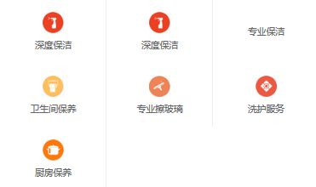

<van-grid :column-num="3">

      <van-grid-item

        @click="toProductHandler(c.id,index)"

        v-for="(c,index) in categories"

        :key="c.id"

        :icon="c.icon"

        :text="c.name"/>

    </van-grid>

async findAllCategories({commit}) {

            let response = await get('/category/findAll')

            commit('refreshCategories',response.data)

}

1. 产品区域-固定行列

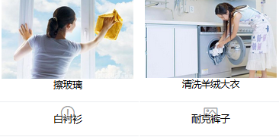

<van-grid :column-num="2">

      <van-grid-item

        @click="toProductListHandler(p.id)"

        v-for="p in products"

        :key="p.id">

        <van-image :src="p.photo" />

        <div>{{p.name}}</div>

      </van-grid-item>

    </van-grid>

调用后台接口分页查询，需要传递参数

async QueryProducts({commit},params) {

            let response = await post('/product/query',params)

            // 为产品添加number属性，为购物车做准备

            response.data.list.forEach(item=>{

                item.number = 0;

            })

            commit('refreshProducts',response.data.list)

        },

{page:0,pageSize:4}即为状态机中params

this.QueryProducts({page:0,pageSize:4});

5.