FCAF: An Evidence-Driven Crypto-Agility Assessment Framework for Post-Quantum Migration Readiness in Financial Systems
Saleh Ahmed Alrasheed
Infosys InStep Internship
Bangalore, India

Abstract— Post-quantum cryptography (PQC) migration planning in financial systems requires more than vulnerability detection: it requires a way to measure how readily a given cryptographic asset can be migrated. This paper presents the Financial Crypto Agility Assessment Framework (FCAF), an evidence-driven assessment framework implemented as a Python and Streamlit prototype that converts Cryptography Bill of Materials (CBOM) and runtime protocol evidence into a deterministic, per-asset crypto-agility maturity score. FCAF scores four evidence-grounded dimensions—migration coordination complexity, implementation pervasiveness, protocol agility, and persistent crypto-material exposure—combines them through a minimum-bound maturity rule, and derives a business-context-weighted migration priority and a Mosca-based harvest-now-decrypt-later (HNDL) planning deadline. The assessment methodology itself consumes no domain-specific input: Financial Systems define the framework's scope, and Payment Systems serve as its implemented and evaluated case study. We describe the architecture, the scoring rubric, and results from a controlled five-asset payment-system evidence set, together with a 184-test automated validation suite verifying the implementation's internal consistency. We report the framework's current state candidly and outline the evidence still required before any production or cross-domain readiness claim can be made.
Keywords— crypto-agility, post-quantum cryptography, CBOM, migration readiness, Mosca inequality, financial systems, maturity assessment
I. Introduction
Financial systems rely heavily on RSA, ECDSA, and Diffie-Hellman-family algorithms that a cryptographically relevant quantum computer (CRQC) would break. Regulatory attention to this risk is no longer theoretical: in May 2026 the Reserve Bank of India constituted a Quantum Secure and Adaptive Financial Ecosystem (Q-SAFE) Expert Committee, whose terms of reference explicitly call for evaluating the financial sector's cryptographic inventory through a Cryptography Bill of Materials (CBOM) and assessing crypto agility of critical systems [2]. Tools such as the CBOMKit Sonar Cryptography Plugin [1] can already generate a CycloneDX CBOM identifying quantum-vulnerable algorithms in a codebase. What they do not answer is the operational question a migration program needs: given a vulnerable algorithm, how quickly and safely can it actually be replaced, and which instances should be fixed first?
Crypto agility—the technical capacity of a system to change its cryptographic algorithms without disruptive redesign—is not implied by the mere presence of a vulnerable algorithm. Two systems using the same algorithm can differ sharply in how embedded it is, how many parties must coordinate a change, and how exposed any long-lived key material is. Existing crypto-agility guidance, including the CAMM maturity model [3] and the CARAF risk framework [4], addresses this gap through manual, questionnaire-based assessment rather than automated scoring from tool output.
This paper presents the Financial Crypto Agility Assessment Framework (FCAF), which scores per-asset crypto-agility maturity directly from CBOM and runtime protocol evidence, without questionnaires. FCAF's assessment methodology is domain-independent: the four scoring dimensions and the maturity/confidence calculations consume no business-context input. Payment Systems constitute the framework's implemented and evaluated case study, used here to demonstrate the full evidence-to-decision pipeline on a controlled, synthetic evidence set. This paper positions FCAF as follows: Framework Scope — Financial Systems; Technical Assessment Methodology — Domain-Independent; Implemented and Evaluated Case Study — Payment Systems. The remainder of this paper describes FCAF's architecture (Section III), scoring methodology (Section IV), maturity and prioritization logic (Section V), implementation and case study (Section VI), results and automated validation (Section VII), and discusses limitations and future directions (Section VIII).
II. Background and Related Work
A. Crypto Agility and PQC Migration
Crypto agility is the property that lets a system replace a cryptographic primitive without re-architecting it. NIST CSWP 39upd1 frames algorithm replacement and adaptation as strategic capabilities that organizations must build, but stops short of a mathematical scoring model [5]. RFC 7696 defines algorithm agility for IETF protocols specifically as the ability to negotiate among multiple cipher suites [6], a definition FCAF's Protocol Agility dimension draws on directly. The Mosca inequality—if the time to migrate (X) plus the required data-secrecy lifetime (Y) exceeds the time until a CRQC exists (Z), act now—gives crypto-agility urgency a concrete deadline condition [7], and is the basis for FCAF's HNDL planning logic (Section V-D).
B. CBOM and Runtime Evidence
The CycloneDX Cryptography Bill of Materials (CBOM) format standardizes how a codebase's cryptographic assets are reported: algorithm primitives, OIDs, key/material types, and source-code occurrence locations [8]. The CBOMKit Sonar Cryptography Plugin [1] produces CBOM output directly from static analysis, and is the evidence source FCAF's parser consumes. Runtime protocol evidence complements this static view: CryptoLyzer [9] reports the TLS versions and negotiated key-exchange groups an endpoint actually supports. CryptoLyzer is the runtime evidence source used by the current implementation of FCAF's Protocol Agility dimension. FCAF's scoring functions read only fields both tools are confirmed to emit; properties such as certificate validity, business-criticality tags, or architecture topology are explicitly outside the evidence model, since neither tool reports them.
C. Existing Assessment Approaches
CAMM [3] defines crypto-agility requirements—updateability (R11), cryptographic modularity (R20), algorithm intersection (R22), and effectiveness via the Mosca deadline (R38)—but is designed for manual, expert-led assessment rather than automated scoring against tool output. CARAF [4] evaluates crypto-agility risk through structured questionnaires and produces a broad risk score rather than a per-component, evidence-derived maturity level. Both frameworks supply the conceptual vocabulary FCAF's dimensions map to (Section IV), but neither automates the link between raw CBOM/CryptoLyzer fields and a numeric maturity score, nor connects that score to the Mosca deadline in a computable way. FCAF's contribution is specifically that automated link.
III. FCAF Architecture
FCAF is implemented as a Python scoring engine with two front ends: a Streamlit dashboard for interactive, evidence-upload-driven assessment, and a fixed-file batch runner for regenerating a report from a checked-in evidence set. Both front ends call the same report-generation function, so the scoring logic itself is not duplicated between the interactive and batch paths.
Fig. 1 shows the implemented evidence-to-decision pipeline. A CycloneDX CBOM and, optionally, CryptoLyzer runtime evidence are parsed into per-asset records: algorithm primitive, OID, source-code occurrence locations, and any linked persistent crypto material. A business-context mapping configuration resolves each occurrence location to a named system component; if a location does not match a configured marker, the asset is marked Unmapped rather than assigned a default component. The four assessment dimensions (D1–D4, Section IV) are then scored independently from evidence fields only, combined into a maturity level and a confidence metric, and used to compute a business-context-weighted migration priority and a maturity-adjusted Mosca deadline. Recommendations are generated per binding dimension and simulated forward through an impact chain to project a post-remediation maturity. The final per-asset report is exported to JSON/CSV and rendered on the dashboard.

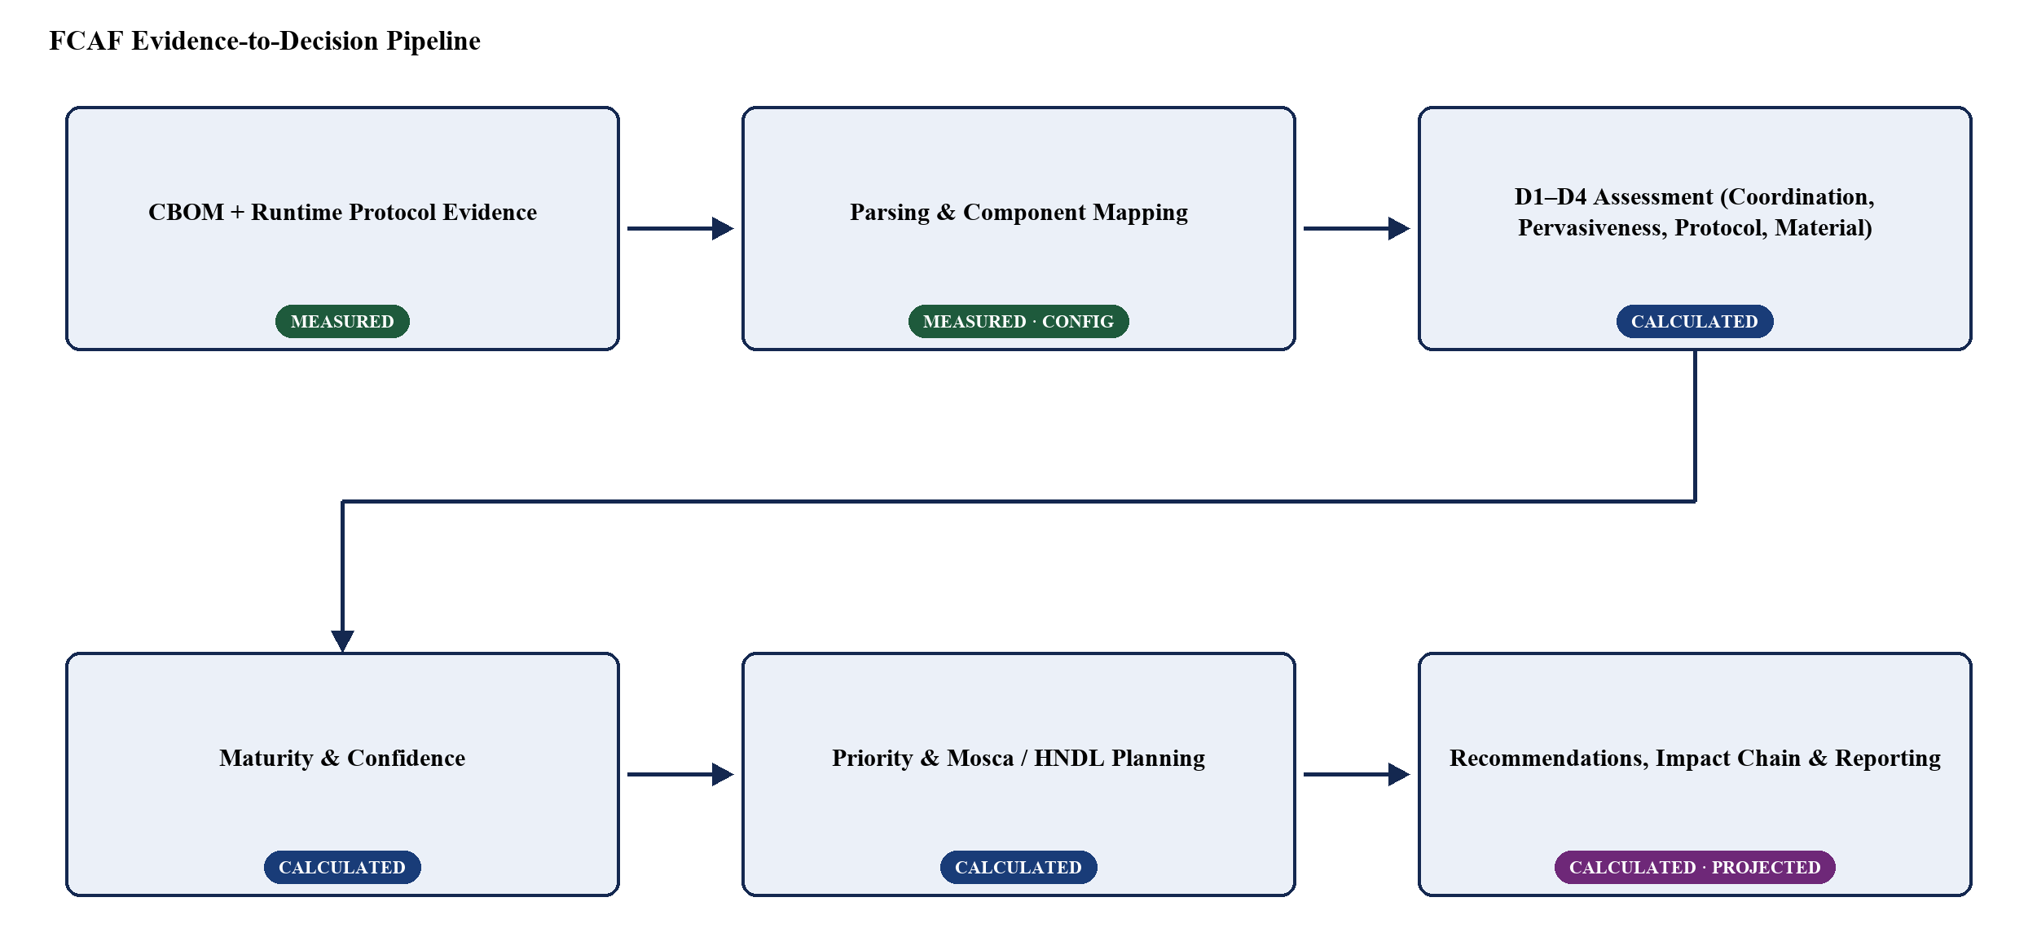
Fig. 1. Implemented FCAF architecture and evidence-to-decision flow. Stage labels indicate whether output is measured, calculated, or projected.

The pipeline enforces one architectural separation throughout: business-context configuration (component mapping, criticality weights, Mosca planning parameters) affects only component resolution, priority, and migration-deadline calculations. It never reaches the D1–D4 scoring functions, the maturity combination, or the confidence metric, which take CBOM/CryptoLyzer evidence as their only input. This separation is what allows the assessment methodology to be described as domain-independent even though the currently configured business-context profile is payment-system-specific (Section VI).
IV. Assessment Methodology
FCAF scores four dimensions, each computed from a specific, confirmed CBOM or CryptoLyzer evidence field and combined only at the maturity stage (Section V). Table I summarizes the evidence fields and thresholds; this section explains the rationale.
A. Coordination Complexity
D1 measures how many parties must coordinate a migration, using the CBOM algorithmProperties.primitive field. A signature algorithm scores Level 1 because it requires coordinated change between a signer and every verifier that trusts it; public-key encryption (pke) scores Level 2, requiring only pairwise sender/receiver coordination; key-encapsulation and key-agreement primitives score Level 3, since protocol-level negotiation already standardizes the exchange; hash, MAC, and KDF primitives score Level 4, since their replacement is internal to the service. An unrecognized or missing primitive is Not Assessed rather than defaulted to any level.
B. Implementation Pervasiveness
D2 measures how scattered a given algorithm OID is across the observed source locations reported in CBOM occurrence evidence, as a proxy for cryptographic modularity. Locations are grouped by OID and deduplicated after path normalization, so repeated occurrences of the same file do not inflate the count. Level 4 (best) is one location; Level 3 is two; Level 2 is three to four; Level 1 (worst) is five or more. CycloneDX dependency edges are deliberately not used for this calculation, since occurrence locations are the directly observed evidence and dependency graphs are reserved for linking persistent material to an algorithm (D4). In the current case study, RSA-2048 occurs at three distinct source locations, giving D2 = 2.
C. Protocol Agility
D3 measures whether an endpoint can negotiate algorithms dynamically at the protocol layer, using CryptoLyzer-reported TLS version and hybrid/PQC key-exchange evidence. TLS 1.0/1.1 scores Level 1; TLS 1.2 scores Level 2; TLS 1.3 without hybrid or PQC capability scores Level 3; a detected hybrid or PQC-capable key exchange scores Level 4 regardless of TLS version. D3 is Not Assessed whenever no CryptoLyzer evidence is available for the asset's resolved component, or when the evidence's declared component does not match the asset—evidence is never borrowed from a mismatched component.
D. Persistent Crypto Material Evidence
D4 measures whether an asset carries long-lived key material that binds it to a legacy lifecycle, using the CBOM relatedCryptoMaterialProperties.type field linked to the algorithm via CycloneDX dependency edges. A certificate scores Level 1; a private key paired with a signature primitive scores Level 2; a private key paired with a key-agreement or KEM primitive scores Level 3. The absence of any linked material scores Level 4, but this is explicitly an evidentiary absence, not proof that no persistent material exists—the framework does not claim ephemerality it cannot observe.

TABLE I. D1–D4 ASSESSMENT MODEL
Dim. | Evidence Field | Level 1 | Level 2 | Level 3 | Level 4 | Not Assessed When
D1 | algorithmProperties.primitive | signature | pke | kem / keyagreement | hash / mac / kdf | primitive unrecognized or missing
D2 | evidence.occurrences.location, grouped by OID | ≥5 distinct locations | 3–4 distinct locations | 2 distinct locations | 1 location (most localized) | 0 locations recorded for the OID
D3 | CryptoLyzer TLS version + hybrid/PQC key-exchange flag | TLS 1.0 / 1.1 | TLS 1.2 | TLS 1.3, no hybrid/PQC | hybrid or PQC-capable key exchange detected | no CryptoLyzer evidence matches the resolved component
D4 | relatedCryptoMaterialProperties.type + primitive (via CycloneDX dependency) | certificate | private-key + signature | private-key + kem/keyagreement | no linked material (absence, not proof of ephemerality) | other type/primitive combination

V. Maturity and Migration Prioritization
A. Maturity and Not Assessed Handling
Component maturity is the minimum of the assessed D1–D4 scores. A dimension is only excluded from this minimum when its evidence is genuinely absent or unrecognized (Not Assessed); it is never coerced to zero, so an asset scored on only one dimension is judged on that dimension alone rather than penalized for missing evidence. If all four dimensions are Not Assessed, the asset is preserved in the report as Not Assessed rather than dropped, so that evidence-coverage gaps remain visible rather than silently disappearing. Every dimension whose score equals the asset's maturity is a binding constraint. When maturity is Level 4—the maximum—every assessed dimension can be tied at that value and therefore listed as binding, even though there is no higher level to reach; this listing should be read as identifying the dimensions that determine the current ceiling, not as remediation targets.
B. Confidence
An independent confidence metric reports how many of the four dimensions were actually assessed: High for four, Medium for three, Low for two or fewer. Confidence does not feed into the numeric maturity or priority calculation; it exists solely to flag when a maturity score rests on thin evidence, so that a favorable score based on only two assessed dimensions is not read with the same certainty as one based on all four.
C. Business-Context Priority
Maturity measures technical readiness; priority ranks migration urgency, and the two are deliberately kept separate. Priority is computed as
Priority = Algorithm Risk × Business Criticality Weight × (5 − Maturity)
Algorithm risk is a coarse, name-pattern heuristic (4 for SHA-1/MD5, 3 for RSA/ECDH/ECDSA, 2 otherwise), not a structured cryptographic risk assessment. The business-criticality weight comes from a domain-specific component-mapping configuration (Section VI-B); an asset that cannot be resolved to a configured component receives weight 0 and priority 0, rather than inheriting a default weight. The term (5 − Maturity) is the readiness gap: it is 4 at Level 1 and 1 at Level 4, so a fully agile asset is deprioritized but never assigned a priority of zero. For example, an ECDSA-based asset with risk 3, a Payment Gateway weight of 1.0, and Maturity 1 yields Priority = 3 × 1.0 × 4 = 12.0; an RSA-2048 asset with risk 3, a PKI Infrastructure weight of 0.8, and Maturity 2 yields Priority = 3 × 0.8 × 3 = 7.2.
D. Mosca and HNDL Planning
FCAF applies a maturity-adjusted version of the Mosca inequality [7] to flag harvest-now-decrypt-later exposure. An adjusted migration time is computed as adjusted_X = base_X × (1 + (4 − L)/4), where L is the asset's maturity level, so a less agile asset carries a larger planning overhead. A migrate-by year is then CRQC_year − adjusted_X, and an asset is flagged Urgent whenever adjusted_X plus the assumed data-retention period exceeds the years remaining until the assumed CRQC year. All three planning inputs—CRQC year, base migration duration, and retention period—are user-configurable; the source code itself labels the adjustment multiplier a heuristic prototype, not an empirically validated timeline. The assumed CRQC year used in the current case study (2033) is consistent with credible lower-bound estimates in the literature [10], [11], [12]. Every Mosca/HNDL output should be read as an assumption-based planning projection, not a forecast.
VI. Implementation and Controlled Case Study
A. Implementation Components
FCAF's scoring engine is implemented in Python as a set of independent modules: CBOM/CryptoLyzer parsing and component-mapping resolution; the D1–D4 rule functions; a maturity/confidence combiner; a recommendation engine that maps binding constraints to remediation text; an impact-chain simulator that projects the effect of applying those recommendations; and JSON/CSV report exporters. A Streamlit dashboard consumes the same report structure for interactive display, using an explicit Measured/Calculated/Projected badge convention to distinguish raw evidence from derived scores and from simulated outcomes; this labeling is a maintained convention applied at each display call site, not an automatically enforced guarantee.
The assessment methodology's domain-independence is an architectural property, not a renaming exercise: the D1–D4 scoring functions, the maturity minimum-rule, and the confidence metric take no business-context input at all. The business-criticality weighting, by contrast, remains implemented as a payment-specific data model—internally named PAYMENT_WEIGHTS, get_payment_weight, and a payment_weight field—even though the dashboard presents it under the domain-neutral label “Business Criticality Weight.” This paper reports that distinction directly rather than describing the implementation as fully generalized.
B. Controlled Payment-System Environment
Validation uses a synthetic, hand-authored evidence set describing a simulated payment-system codebase, not evidence collected from a production estate. The business-context mapping configuration links source-path markers to five named components, weighted by an expert-assigned criticality scale informed by PCI-DSS v4.0.1 Requirement 4 scope classification [13] (Table II); of these, three—Payment Gateway, PKI Infrastructure, and VPN Infrastructure—are represented among the assets in the current evidence set. An unmatched or ambiguously matched source path is never silently assigned a default weight; it is explicitly marked Unmapped or Ambiguous and receives weight 0.
The CBOM evidence used for this case study places RSA-2048's key-management code at three distinct source locations (a key manager, a certificate manager, and a key-rotation service), which is the authoritative basis for its Implementation Pervasiveness score of 2 reported in Section VII. An earlier evidence file with a single RSA-2048 occurrence would compute a different D2 score; only the three-location evidence set is used for the results in this paper.
TABLE II. PAYMENT-SYSTEM BUSINESS-CRITICALITY PROFILE
Component | Weight | Rationale
Payment Gateway | 1.0 | Directly handles cardholder data in transit (PCI-DSS Req. 4 in-scope)
PKI Infrastructure | 0.8 | Trust anchor for cardholder-data protection
Open Banking API | 0.7 | Account-access tokens
VPN Infrastructure | 0.6 | Network transport connected to the cardholder-data environment
Internal Services | 0.3 | Does not directly handle cardholder data
VII. Results and Automated Validation
Table III reports the current case-study assessment, rebuilt directly from the framework's CSV output for five algorithm assets resolved to three of the five configured components. Average current maturity across the five assets is 2.2 of 4; average projected maturity after applying all generated recommendations is 3.0 of 4; all five assets are flagged Urgent under the current default Mosca assumptions (2026 assessment year, 2033 assumed CRQC year, 3-year base migration duration, 7-year retention period).

TABLE III. CONTROLLED CASE-STUDY RESULTS
Asset | Component | D1 | D2 | D3 | D4 | Maturity | Conf. | Priority | Proj. | Migrate By | HNDL
ECDSA-secp256r1-SHA-256 | Payment Gateway | 1 | 4 | N/A | 2 | 1 (Rigid) | Medium | 12.0 | 2 | 2027.75 | Urgent
RSA-2048 | PKI Infrastructure | 2 | 2 | 2 | N/A | 2 (Constrained) | Medium | 7.2 | 3 | 2028.5 | Urgent
EC-secp256r1 | PKI Infrastructure | 2 | 4 | 2 | N/A | 2 (Constrained) | Medium | 4.8 | 3 | 2028.5 | Urgent
FFDH | VPN Infrastructure | 2 | 4 | N/A | N/A | 2 (Constrained) | Low | 3.6 | 3 | 2028.5 | Urgent
SHA-256 | Payment Gateway | 4 | 4 | N/A | 4 | 4 (Agile) | Medium | 2.0 | 4 | 2030.0 | Urgent
N/A = Not Assessed.

ECDSA-secp256r1-SHA-256 (Payment Gateway) has the lowest maturity (Level 1) and highest priority (12.0) in the portfolio; its binding constraint is D1 (signature primitives require signer-and-all-verifiers coordination), not D2 or D4, both of which score well. RSA-2048 and EC-secp256r1 (PKI Infrastructure) both score Level 2, jointly bound by D1 and D3; RSA's higher priority (7.2 versus 4.8) comes entirely from the algorithm-risk heuristic matching “RSA” in its name, not from a maturity difference. FFDH (VPN Infrastructure) scores Level 2 with Low confidence, since only D1 and D2 were assessable. SHA-256 achieved Level 4 across all assessed dimensions and required no immediate recommendation under the current rubric.
TABLE IV. GROUPED AUTOMATED VALIDATION COVERAGE
Category | Test Files | Passed
Evidence Processing | parsers, CryptoLyzer parser, D2 multi-location integration | 42
Assessment Logic | rules, maturity | 42
Planning Logic | Mosca, recommendations, impact chain | 32
Behavioral Validation | mutations, sensitivity | 23
Reporting and Interface | report, UI helpers | 45
Total | 12 test files, 184 tests | 184 passed / 0 failed / 0 skipped
Table IV groups the framework's 184-test automated validation suite (184 passed, 0 failed, 0 skipped; validation run: August 2026) into five functional categories. The suite validates that the implemented scoring rules, maturity combination, priority and Mosca formulas, sensitivity to individual evidence changes, and report/export behavior behave as specified against fixture and synthetic evidence. It does not, and is not claimed to, constitute empirical evidence that the Mosca timeline assumptions are accurate or that any assessed system is production quantum-safe; it demonstrates internal consistency of the implemented engine.
Fig. 2 shows the corresponding executive metrics panel from the implemented FCAF dashboard, confirming these aggregate figures are the framework's own reported output rather than values recomputed only for this paper.

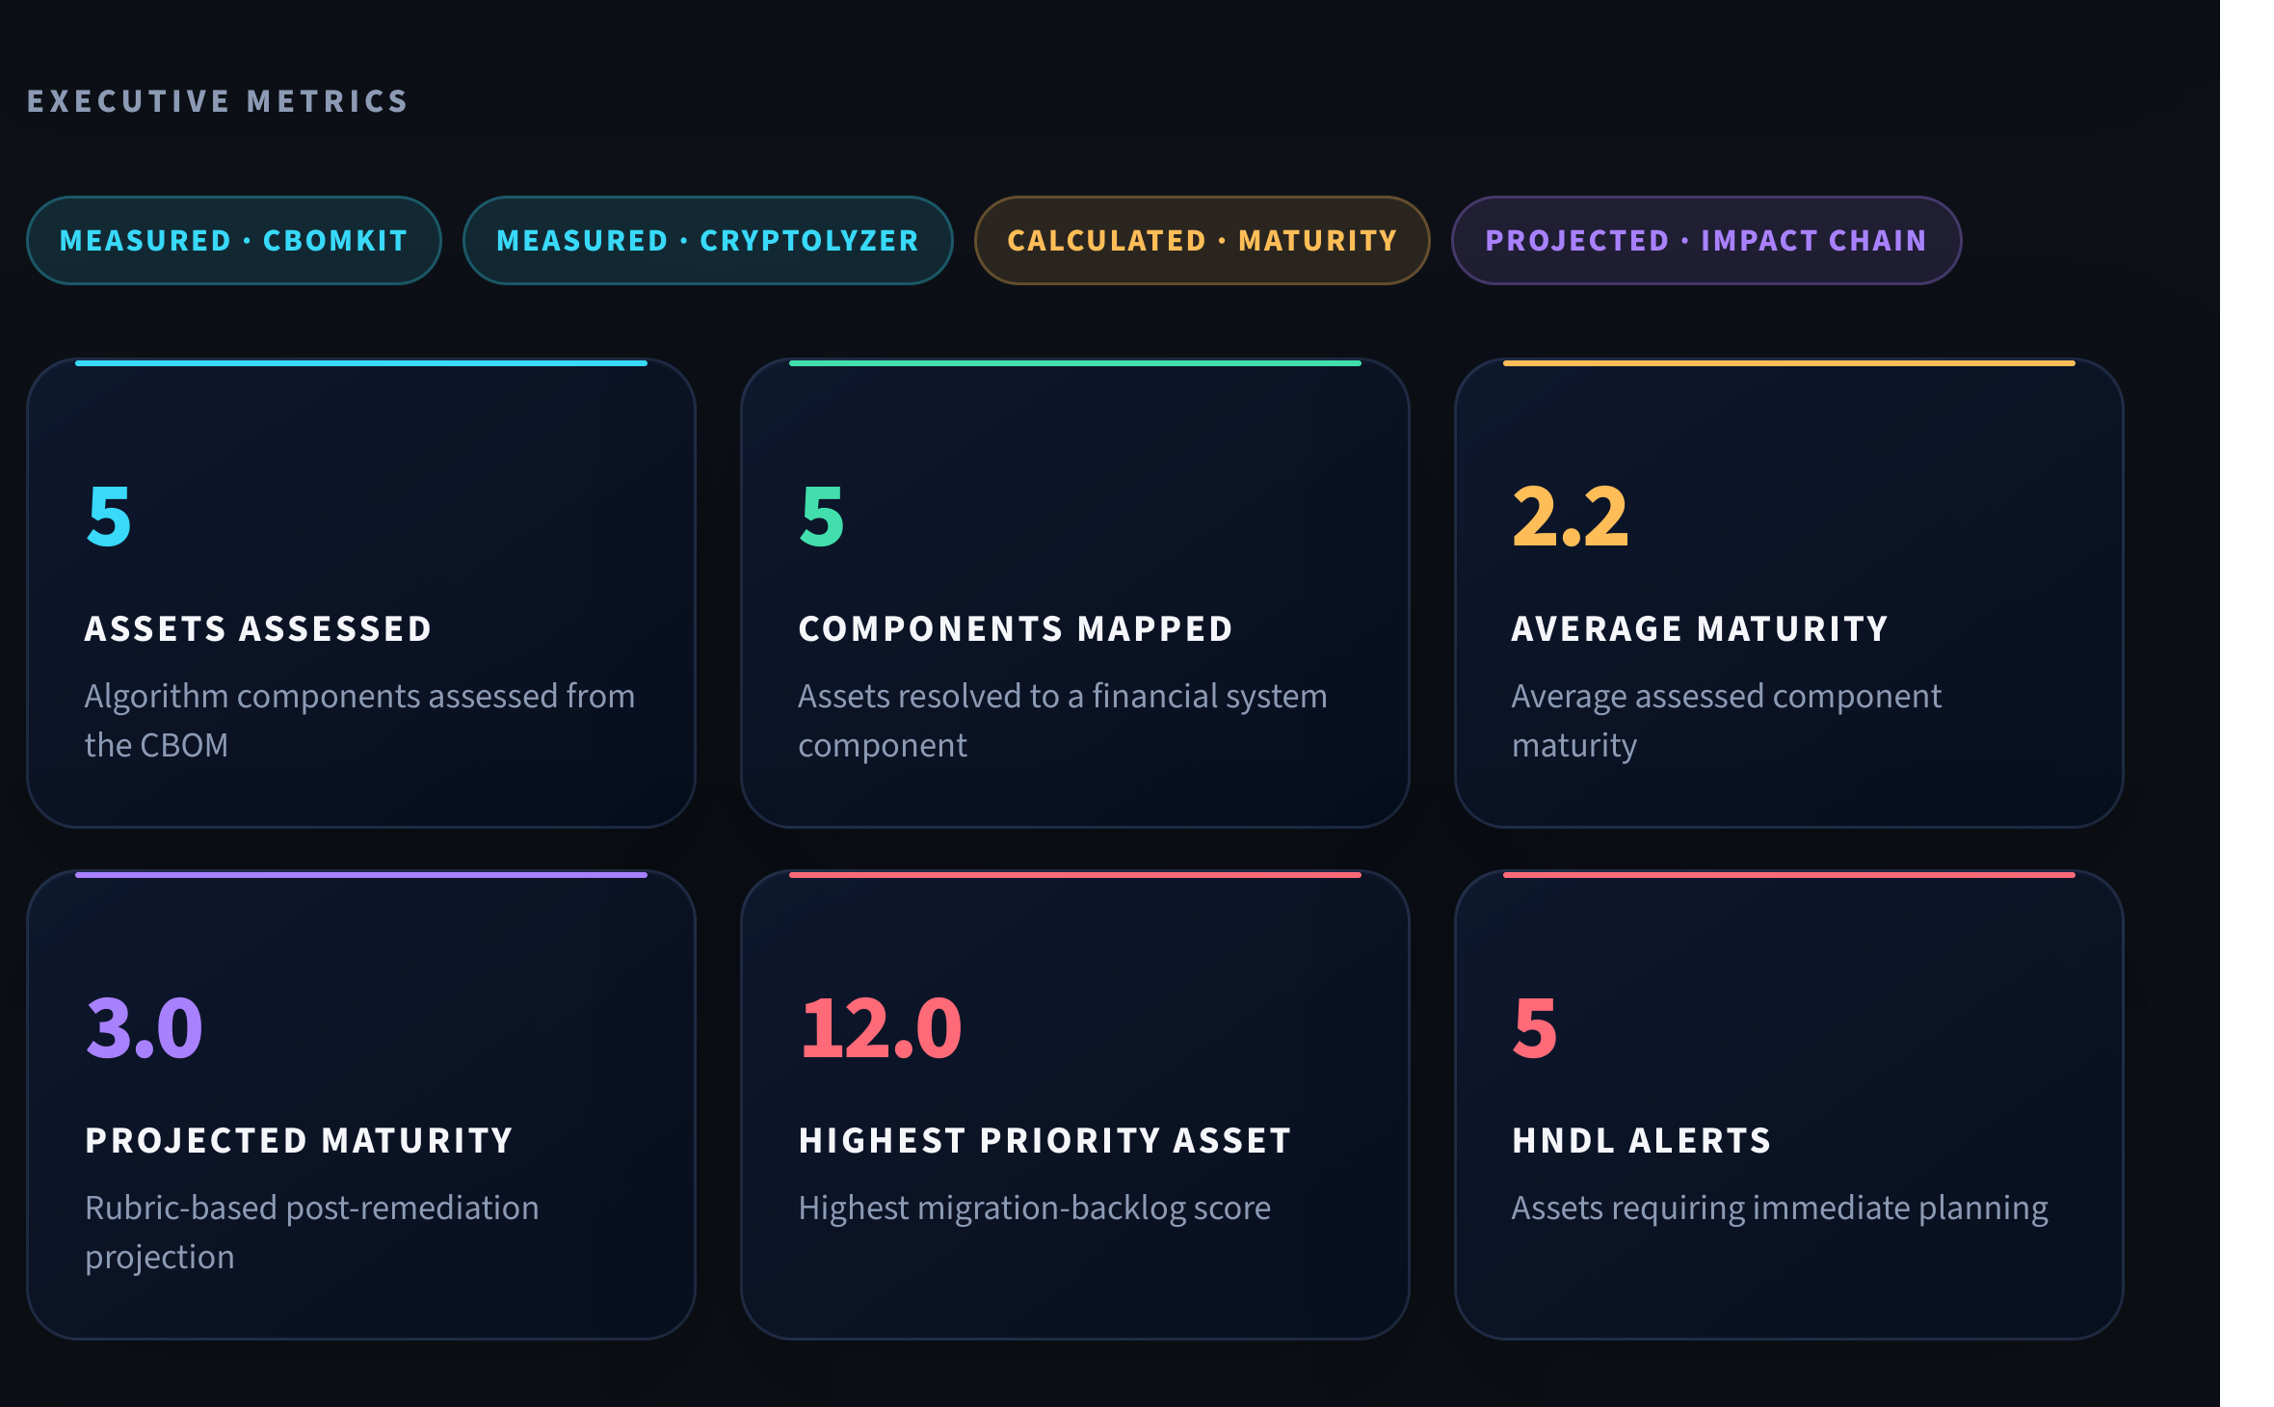
Fig. 2. Executive metrics panel from the implemented FCAF Command Center dashboard for the current case-study run.

VIII. Discussion, Limitations, and Path Forward
The results in Section VII demonstrate that FCAF's evidence-to-decision pipeline runs end to end and produces internally consistent, evidence-traceable scores; they do not by themselves demonstrate that the framework generalizes beyond the five-asset payment-system case study used to validate it. Several limitations follow directly from the current implementation and evidence, rather than from a hypothetical future concern. The case-study evidence is synthetic and hand-authored, and covers only five algorithm assets across three in-use component types—far narrower than a production financial estate. The business-context mapping is a small, manually maintained file; a source path with no configured marker is marked Unmapped rather than assigned a default weight, which is safe but means real coverage depends entirely on keeping the mapping current. D2's location-count metric is a structural proxy for modularity, not a direct measure of migration difficulty, and cannot distinguish a trivial thin wrapper from a deeply entangled implementation. D3 and D4 are only as complete as the runtime and dependency evidence supplied; in the current case study, D3 is Not Assessed for three of five assets because only one CryptoLyzer evidence record was available. The Mosca adjustment multiplier and the CRQC-year/retention-period assumptions are heuristic planning inputs, explicitly not empirically validated timelines, and should not be presented as forecasts. Finally, the framework's “domain-independent” positioning describes the D1–D4 scoring functions' architecture—they take no business-context input—rather than an empirically demonstrated result; no second financial-system domain has yet been run through the engine, and the underlying business-criticality data model itself still uses payment-specific identifiers rather than domain-neutral ones.
A related, structural observation is that two CSV export code paths currently coexist in the implementation with different column sets; the results reported here use the framework's dashboard-generated export, and this duplication is worth resolving before any wider deployment.
A potential future direction is to evaluate whether FCAF could complement Finacle-related modernization and PQC-readiness initiatives by providing an assessment layer between cryptographic evidence and migration planning. This would require evaluation of the available evidence pipeline and development of an appropriate business-context profile. More generally, extending FCAF beyond the payment-system case study—to a second financial-system domain, to a real (not synthetic) evidence set, and eventually to an empirical post-remediation rescan that checks whether a recommendation's projected maturity improvement actually materialized—represents the natural next phase of this work, consistent with the direction the RBI Q-SAFE committee's terms of reference point toward for the sector as a whole [2].
IX. Conclusion
This paper presented FCAF, a framework that scores per-asset crypto-agility maturity directly from CBOM and runtime protocol evidence, without questionnaires, and links that score to a business-context-weighted migration priority and a Mosca-based HNDL planning deadline. The scoring methodology is domain-independent by construction; Payment Systems serve as the framework's implemented and evaluated case study, exercised here on a controlled five-asset evidence set and verified against a 184-test automated suite. The framework's current state is reported candidly: the case study is synthetic and narrow, several evidence-coverage gaps remain visible in the results themselves, and the underlying business-criticality data model has not been fully generalized away from its payment-system origin. Extending the evidence base, the domain coverage, and the empirical validation of its planning assumptions is the identified path toward a broader financial-sector readiness tool.
Acknowledgment
The author thanks Vijayaraghavan Varadharajan for mentoring this work throughout the Infosys InStep internship, including guidance on the assessment methodology, scoring rubric, and validation approach presented in this paper.
References
[1] CBOMKit Sonar Cryptography Plugin. [Online]. Available: https://github.com/cbomkit/sonar-cryptography
[2] Reserve Bank of India, “Quantum Secure and Adaptive Financial Ecosystem (Q-SAFE) – Setting up of an Expert Committee,” Press Release, May 25, 2026. [Online]. Available: https://www.rbi.org.in
[3] J. Hohm, A. Heinemann, and A. Wiesmaier, “Towards a maturity model for crypto-agility assessment,” arXiv:2202.07645, 2022.
[4] C. Ma, L. Colon, J. Dera, B. Rashidi, and V. Garg, “CARAF: Crypto Agility Risk Assessment Framework,” J. Cybersecurity, vol. 7, no. 1, 2021, doi: 10.1093/cybsec/tyab013.
[5] National Institute of Standards and Technology, “Considerations for Achieving Cryptographic Agility: Strategies and Practices,” NIST CSWP 39upd1, 2026.
[6] R. Housley, “Guidelines for Cryptographic Algorithm Agility,” IETF RFC 7696, 2015, doi: 10.17487/RFC7696.
[7] M. Mosca, “Cybersecurity in an Era with Quantum Computers: Will We Be Ready?,” IEEE Security & Privacy, vol. 16, no. 5, pp. 38-41, 2018, doi: 10.1109/MSP.2018.3761723.
[8] OWASP CycloneDX, “Authoritative Guide to CBOM,” 2024. [Online]. Available: https://cyclonedx.org/guides/OWASP_CycloneDX-Authoritative-Guide-to-CBOM-en.pdf
[9] CryptoLyzer. [Online]. Available: https://github.com/c0r0n3r/cryptolyzer
[10] M. Webber et al., “The impact of hardware specifications on reaching quantum advantage in the fault tolerant regime,” AVS Quantum Science, vol. 4, no. 1, 2022, doi: 10.1116/5.0073075.
[11] National Security Agency, “Commercial National Security Algorithm Suite 2.0 (CNSA 2.0),” 2022.
[12] National Institute of Standards and Technology, “Transition to Post-Quantum Cryptography Standards,” NIST IR 8547 (Initial Public Draft), 2024.
[13] PCI Security Standards Council, “Payment Card Industry Data Security Standard, Requirement 4,” PCI DSS v4.0.1, 2024.

