From Cryptographic Inventory to Migration Decisions:
An Explainable Crypto-Agility Framework for Digital Financial Ecosystems
Anonymous Author(s)

Abstract. Digital financial platforms increasingly operate as interconnected ecosystems spanning web APIs, payment gateways, identity and trust services, and partner interfaces, so that cryptographic dependencies bear on security, trust, interoperability, and operational resilience. A cryptographic inventory alone does not indicate whether an asset is ready to migrate or how urgently it should be prioritised. This paper presents FCAF, a method for deriving evidence-derived readiness and confidence from CBOM evidence and component-matched runtime observations, keeping readiness separate from domain-configurable priority. Confidence reflects evidence completeness rather than being folded into a numeric score, and incomplete evidence is retained as “Not Assessed” rather than defaulting to a penalised value. In a controlled, synthetic payment-system case study spanning five cryptographic assets across three component types, the method produced differentiated priorities even where technical maturity coincided. An implementation test suite confirms internal consistency with the defined rules; external validity remains limited to this synthetic setting.
Keywords: Crypto agility, post-quantum migration, digital financial infrastructure, Cryptography Bill of Materials, migration readiness, evidence confidence.
1 Introduction
Modern financial platforms function as interconnected digital ecosystems: web-facing APIs, payment gateways, identity and trust services, middleware, and external financial-service integrations share protocols and cryptographic dependencies. When a cryptographic primitive is deprecated, the transition affects security, trust, interoperability, and operational resilience — a concern receiving increasing regulatory attention: the Reserve Bank of India established the Q-SAFE Expert Committee to consider cryptographic inventory, crypto agility, critical systems, and quantum-safe transition planning [2]. Yet inventory alone does not indicate whether an asset is technically ready to migrate, how confidently readiness can be asserted, or how urgently it should be prioritised. Existing crypto-agility guidelines and maturity models offer conceptual scaffolding [3–6], but operate through qualitative review rather than deriving indicators deterministically from observable, component-matched evidence.
This motivates our central research question: how can cryptographic inventory and runtime evidence be transformed into explainable, confidence-aware migration decisions for interconnected digital financial systems? We present FCAF (the Financial Crypto-Agility Assessment Framework), contributing a deterministic method for deriving crypto-agility indicators from CBOM and component-matched runtime evidence, a confidence-aware treatment of incomplete evidence in which “Not Assessed” is preserved rather than converted to zero, a separation between evidence-derived readiness and domain-configurable priority, and a controlled synthetic evaluation demonstrating differentiated migration decisions across five assets spanning three component types.
2 Related Work
Cryptographic agility has been formalised through IETF guidance [6], maturity models such as CAMM [3], and risk-oriented frameworks such as CARAF [4], with NIST guidance surveying strategies for achieving agility at scale [5]; these establish concepts — coordination cost, protocol negotiation, inventory completeness — that motivate evidence-derived assessment, but generally operate through qualitative review rather than deterministic rules. CBOM formats, standardised within OWASP CycloneDX, represent cryptographic assets and dependencies in machine-readable form [8]; static CBOM-extraction tools [1] and runtime protocol analysers [9] offer complementary evidence, and migration-planning guidance addresses harvest-now, decrypt-later exposure [7]. FCAF explores a specific implementation approach that derives per-asset readiness and priority indicators from CBOM and component-matched runtime evidence.
3 FCAF: Evidence-to-Decision Method
FCAF is a decision-support method, evaluated through a research prototype, transforming cryptographic evidence into explainable per-asset indicators to support, not replace, expert review. It consumes static CBOM evidence [8], component-matched runtime protocol evidence [9], and a domain-configurable mapping from source-location markers to business components with criticality weights.
Each asset is assessed along four evidence-derived dimensions, summarised in Table 1, scored 1 (most constrained) to 4 (most agile) when evidence exists, or Not Assessed otherwise. Maturity is the minimum across assessed dimensions; a Not-Assessed dimension is excluded rather than treated as zero, so missing evidence lowers confidence without penalising maturity. Confidence is derived from the count of assessed dimensions (High for four, Medium for three, Low for two or fewer) and does not feed back into maturity or priority. Dimensions tied at the minimum are binding constraints, identifying what determines an asset's level rather than remediation needs.
Migration priority is computed independently of confidence as
priority = algorithm_risk × business_criticality_weight × (5 − maturity) (1)
where algorithm_risk is a prototype heuristic pattern-matching the asset's name against known-weak identifiers — a limitation discussed below — and business_criticality_weight reflects component sensitivity. The term (5 − maturity) is the readiness gap, largest for the least mature assets. FCAF also produces recommendation text and a simulated maturity projection, reported only as a planning indicator.
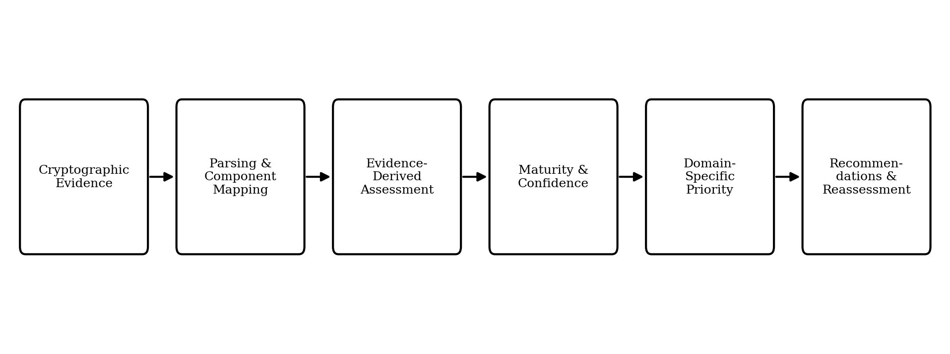
Fig. 1. FCAF evidence-to-decision workflow.
Table 1. D1–D4 dimensions. Higher levels indicate greater observed agility; unavailable evidence is recorded as Not Assessed rather than scored as zero.
Dimension | Measures | Evidence
D1 | Coordination complexity | Primitive
D2 | Implementation pervasiveness | Distinct OID locations
D3 | Protocol agility | Component-matched runtime TLS evidence
D4 | Persistent-material dependency | Linked keys/certificates
4 Controlled Evaluation
We evaluate FCAF through a controlled, synthetic payment-system case study of five cryptographic algorithm assets (ECDSA-secp256r1-SHA-256, RSA-2048, EC-secp256r1, FFDH, SHA-256) across three component types (Payment Gateway, PKI Infrastructure, VPN Infrastructure), distinguishing measured evidence, calculated results (maturity, confidence, priority), and projected guidance (simulated movement, not observed). The implementation passed 184 automated tests with zero failures and zero skipped tests.
5 Results and Discussion
Table 2 summarises the five assessed assets, whose current maturity averaged 2.2 out of 4, with priorities from 2.0 to 12.0. The RSA–EC priority difference (7.2 vs. 4.8) reflects the prototype risk heuristic, not independently measured cryptanalytic risk, demonstrating separation between maturity and priority without validating the risk calibration. For SHA-256, the Level-4 result indicates the assessed ceiling, not a remediation constraint. ECDSA-secp256r1-SHA-256's localised evidence (D2 = 4) still coexisted with dominant coordination complexity.
Three findings follow: priorities differed substantially across assets; equal maturity did not imply equal priority, as for RSA-2048 and EC-secp256r1; and missing evidence — as for FFDH, where D3 and D4 were Not Assessed — changed confidence without becoming a failing score. These reflect Web Science concerns about digital infrastructure: migration is a question of trust and evidence governance, not only algorithm replacement. We make no claim that findings generalise beyond the present setting, or that the weights or heuristic are empirically validated.
Table 2. Controlled case-study results for the five assessed cryptographic assets.
Asset | Component | Maturity | Confidence | Priority
ECDSA-secp256r1-SHA-256 | Payment Gateway | 1 | Medium | 12.0
RSA-2048 | PKI Infrastructure | 2 | Medium | 7.2
EC-secp256r1 | PKI Infrastructure | 2 | Medium | 4.8
FFDH | VPN Infrastructure | 2 | Low | 3.6
SHA-256 | Payment Gateway | 4 | Medium | 2.0
6 Limitations
The evaluation relies on synthetic, five-asset evidence across three component types, insufficient for general applicability. Component mapping was manual; D2 uses source-location count as a proxy for spread, not direct coupling; and runtime/material coverage was limited to the evaluated tools’ fields, so absent material does not prove ephemerality. Criticality weights and the risk heuristic require expert review, not empirical derivation. No second domain, production system, post-remediation rescan, or human-assessor comparison was conducted. A next step is evaluation against a broader evidence set with expert-reviewed mappings and weights.
7 Conclusion
Transforming cryptographic inventory into migration decisions requires evidence-derived readiness, an explicit account of confidence under incomplete observation, and a priority signal that remains separate from technical maturity. FCAF derives four dimensions of readiness from CBOM and component-matched runtime evidence, preserves incomplete evidence as Not Assessed rather than converting it to a penalised score, and computes priority from readiness, risk, and business context independently of confidence. In a controlled, synthetic case study, this separation produced differentiated priorities even where maturity coincided across assets. The findings are limited to this synthetic setting; broader evaluation, expert-reviewed mappings, and empirical post-remediation reassessment remain future work.
References
1. CBOMKit Sonar Cryptography Plugin. [Online]. https://github.com/cbomkit/sonar-cryptography
2. Reserve Bank of India: Q-SAFE — Setting up of an Expert Committee. Press Release 2026-2027/325, 25 May 2026. https://rbidocs.rbi.org.in/rdocs/PressRelease/PDFs/PR325298C71A0A576448B994AF2D9F3F97A59.PDF
3. Hohm, J., Heinemann, A., Wiesmaier, A.: Towards a maturity model for crypto-agility assessment. arXiv:2202.07645 (2022)
4. Ma, C., Colon, L., Dera, J., Rashidi, B., Garg, V.: CARAF: Crypto Agility Risk Assessment Framework. J. Cybersecurity 7(1), tyab013 (2021)
5. Barker, E., et al.: Considerations for Achieving Crypto Agility. NIST CSWP 39 (2025)
6. Housley, R.: Guidelines for Cryptographic Algorithm Agility. IETF RFC 7696 (2015)
7. Mosca, M.: Cybersecurity in an Era with Quantum Computers. IEEE Security & Privacy 16(5), 38–41 (2018)
8. OWASP CycloneDX: Authoritative Guide to CBOM (2024). https://cyclonedx.org/guides/OWASP_CycloneDX-Authoritative-Guide-to-CBOM-en.pdf
9. CryptoLyzer. [Online]. https://github.com/c0r0n3r/cryptolyzer

Please note that the LNCS Editorial assumes that all authors have used the western naming convention, with given names preceding surnames. This determines the structure of the names in the running heads and the author index.
The footnote numeral is set flush left and the text follows with the usual word spacing.

