Comparative Analysis of Fuzzy PID and Conventional PID Controllers for Quadrotor UAVs via Simulink
Weijian Zhang
School of Mechanical and Energy Engineering, Tongji University

Abstract
Quadrotor UAVs are widely used but face control challenges due to inherent nonlinear and under-actuated characteristics. Conventional PID controllers, though prevalent, rely on manual parameter tuning and lack robustness in dynamic environments, prompting research on fuzzy PID as an adaptive solution. By introducing fuzzy logic to adjust controller gains, fuzzy PID aims to overcome the main limitations of traditional PID methods.
In this study, a quadrotor dynamic model is established using the Newton–Euler method, and comparative simulations of fuzzy PID and conventional PID controllers are conducted in MATLAB/Simulink for time-varying trajectory tracking.
The results indicate that fuzzy PID performs better than conventional PID in several aspects. Specifically, the settling time is reduced by 76.24% to 88.13%, the RMSE is decreased by 55.71% to 85.00%, and the steady-state attitude error is improved by 14.70% to 71.50%. But there are larger overshoots appear on some axes. With overshoot properly considered, fuzzy PID shows potential for high-precision and complex flight applications.

Keywords
quadrotor UAV; PID control; fuzzy PID control; trajectory tracking; Simulink

Introduction
Quadrotors, a type of unmanned aerial vehicle (UAV), have become increasingly popular due to their four-rotor configuration, which provides good stability and maneuverability. They are widely applied in areas such as pesticide spraying, package delivery, and aerial photography. With the expansion of UAV applications, higher requirements are placed on control systems, especially in terms of stability and adaptability under complex environmental conditions. Classical Proportional–Integral–Derivative (PID) control is commonly used in UAVs because of its simple structure and effectiveness in basic flight stabilization; however, its fixed parameters limit performance in dynamic or disturbed environments. Tassanbi et al. [1] experimentally demonstrated that PID control performance deteriorates when external disturbances, such as wind gusts, are present.
To improve control performance under such conditions, fuzzy logic has been introduced into UAV control systems. The combination of fuzzy logic with classical PID, known as fuzzy PID control, aims to enhance adaptability by adjusting controller’s parameters online. Singh et al. [2] reported that fuzzy PID incorporates heuristic rules into the PID framework to improve control performance for complex systems. Although fuzzy PID has shown promising results in previous studies, its superiority over classical PID is not always guaranteed and depends on specific operating conditions.
In this study, I developed a Simulink-based simulation model for a quadrotor UAV to compare the performance of fuzzy PID and conventional PID controllers. The main objective is to evaluate the ability of both controllers to stabilize the UAV under different conditions. Performance is assessed using metrics such as tracking accuracy, stability, and response time. The simulation results indicate that fuzzy PID achieves faster response and higher tracking accuracy in certain cases, but does not perform better in all aspects, such as overshoots along some axes, suggesting that its advantages are dependent on the application scenario.

Materials and Methods

Quadrotor Dynamic Modeling

Kinematic Model
When describing the motion of a quadrotor UAV, two coordinate frames are commonly defined: the inertial frame (E-xyz) and the Body-fixed frame (B-xyz). The first one is a fixed reference frame aligned with the Earth’s coordinate system, where the quadrotor’s position and translational motion are evaluated. The last one is a frame rigidly attached to the quadrotor’s fuselage, where rotational motion and aerodynamic forces are analyzed. The control system requires to convert vectors between these frames. To finish this task, a rotation matrix R is proposed, which is derived by sequentially rotating the inertial frame around the z-, y-, and x-axes, and it corresponds with three Euler angles.
- $ψ$(yaw angle): Rotation around the z-axis (controls the quadrotor’s heading direction).
- $θ$(pitch angle): Rotation around the y-axis (controls the quadrotor’s nose-up/nose-down attitude).
- $φ$ (roll angle): Rotation around the x-axis (controls the quadrotor’s lateral tilt attitude).
This rotation matrix R that change vectors from body frame to inertial frame is calculated as the product of single-axis rotation matrices:
$R=\left[\begin{matrix}cosθcosψ & -cosφsinψ+sinφsinθcosψ & sinφsinψ+cosφsinθcosψ \\ cosθsinψ & cosφcosψ+sinφsinθsinψ & -sinφcosψ+cosφsinθsinψ \\ -sinθ & sinφcosθ & cosφcosθ\end{matrix}\right]$ (1)
Madebo et al. [3] used this standard kinematic approach matrix to model quadrotor orientation.

$​​$Dynamic Model
The quadrotor’s translational motion follows Newton’s second law ($F=m\ddot{x}$), where $F$ is the resultant force, $m$ is the quadrotor’s mass, and $\ddot{x}={\left[\ddot{x} , \ddot{y} , \ddot{z}\right]}^{T}$ is the acceleration in the inertial frame.
Two dominant forces act on the quadrotor:
Lift force ($F_{B}$): Generated by the four rotors, expressed in the body frame as $F_{B}={\left[0 , 0 , -U_{1}\right]}^{T}$ (where $U_{1}$ is the total lift magnitude).
Gravitational force ($G_{E}$): Expressed in the inertial frame as $G_{E}={\left[0 , 0 , mg\right]}^{T}$ (where $g$ is gravitational acceleration).

Converting the lift force to the inertial frame via $R$, the resultant force in the inertial frame is:
$F_{E}= RF_{B} + G_{E}$ (2)
Substituting$F_{E}=m\ddot{x}$, expanding the matrix product and simplify these equations, then the final translational dynamic model was derived:
$\left\{\begin{aligned}\ddot{x}=\frac{U_{1}}{m}\left(cosθ sinψ sinφ-cosφ sinψ\right) \\ \ddot{y}=\frac{U_{1}}{m}\left(cosφ cosψ+sinφ sinθ sinψ\right) \\ \ddot{z}=g-\frac{U_{1}}{m}cosφ cosθ\end{aligned}\right.$ (3)
Certainly, a quadrotor can’t only be described by translational movement, but also rotational motion. Singh et al. [2] pointed out that its rotational motion is described by Euler’s equation in the body frame:
$I{\dot{ω}}_{B}=-ω_{B}×\left(Iω_{B}\right)+τ_{B}$ (4)
where:
- $I=\left[I_{X},I_{Y},I_{Z}\right]$, is the diagonal moment of inertia matrix in the body frame.
- $ω_{B}={\left[ω_{X},ω_{Y},ω_{Z}\right]}^{T}$, is the angular velocity vector in the body frame.
- $τ_{B}={\left[U_{2},U_{3},U_{4}\right]}^{T}$, is the torque vector. It is generated by rotor thrust differences and respectively corresponds to roll, pitch, yaw motions.
For practical control design, a small-angle approximation is commonly adopted: the angular velocity $ω_{B}$ is approximated as the time derivative of the Euler angles, i.e.,$ω_{B}≈{\left[\dot{φ},\dot{θ},\dot{ψ}\right]}^{T}$.
Consistent with the above modeling logic, this angular approximation is substituted into Euler’s equation, and the small-angle approximation is utilized to simplify the equation for quadrotor attitude control, the attitudinal dynamic model is derived as:
$\left\{\begin{aligned}\ddot{φ}=\frac{1}{I_{x}}\left[\left(I_{y}-I_{z}\right)\dot{θ}\dot{ψ}+U_{2}\right] \\ \ddot{θ}=\frac{1}{I_{y}}\left[\left(I_{z}-I_{x}\right)\dot{φ}\dot{ψ}+U_{3}\right] \\ \ddot{ψ}=\frac{1}{I_{z}}\left[\left(I_{x}-I_{y}\right)\dot{φ}\dot{θ}+U_{4}\right]\end{aligned}\right.$ (5)
These translational and attitudinal dynamic equations are consistent with the modeling logic of Madebo et al. [4] form the core mathematical model of the quadrotor, which is implemented in Simulink for subsequent control system simulation.

Controller Design
To address the trajectory tracking control of quadrotors, a cascade control architecture that contains outer position loop and inner attitude loop is adopted for both controllers in this study, ensuring effective decoupling of translational and rotational motions and laying a foundation for stable control. The outer loop takes the position error between reference and actual position as input to output desired attitude angles and total lift; the inner loop adjusts the control torque based on attitude error, forming a closed-loop control chain.

Conventional PID Controller
The conventional PID controller is selected as the benchmark, leveraging the advantages of Simulink’s built-in PID Controller module (a ready-to-use finished module) for rapid implementation and reliable performance. Figure 1 shows the altitude using conventional PID controller module, this module can be replaced by fuzzy PID controller shown in Figure 2
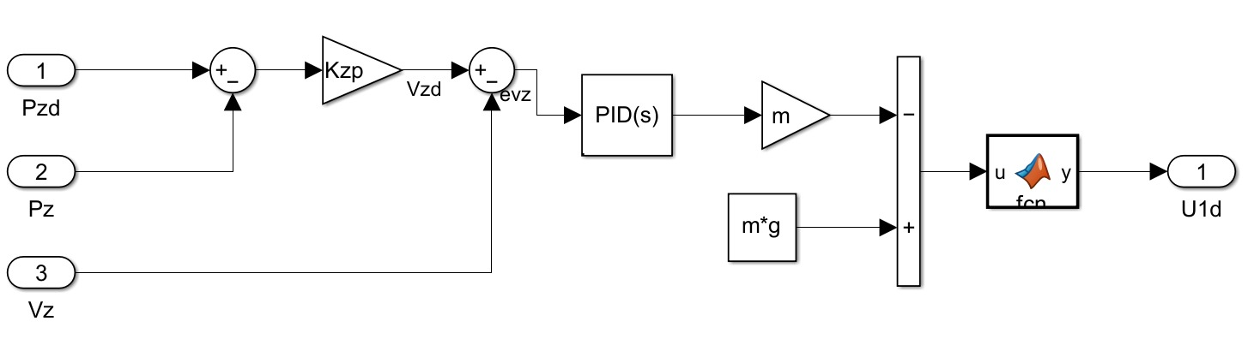
Figure 1. altitude control module using conventional PID

Fuzzy PID Controller
To address the limitations of the conventional PID controller, I propose a fuzzy PID controller for adaptive trajectory tracking control. The controller integrates a fuzzy logic inference module into the conventional PID framework and is implemented in Simulink with a modular design as Figure 2, maintaining consistency with the conventional PID in terms of overall control architecture for fair comparison.
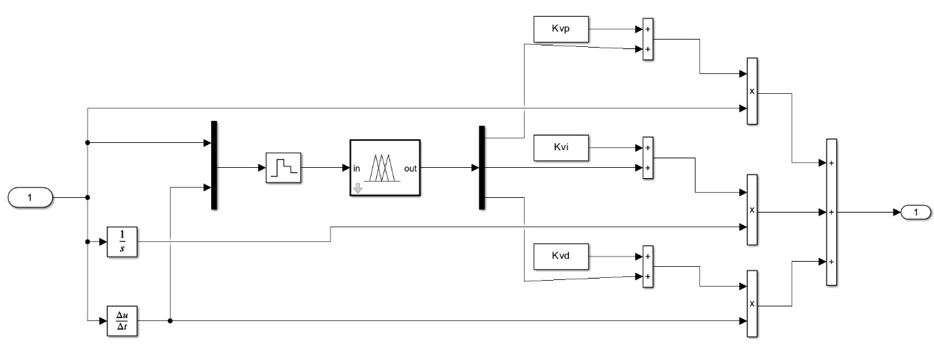
Figure 2. fuzzy PID controller module
The fuzzy logic system adopts a Mamdani-type inference structure with two inputs and three outputs. In my case, they are respectively error E, error change-rate EC and PID gain correction amounts $K_{p} K_{i} K_{d}$. The input variables as well as output variables are all divided into 7 fuzzy subsets: Negative Big (NB), Negative Medium (NM), Negative Small (NS), Zero (ZE), Positive Small (PS), Positive Medium (PM), Positive Big (PB). Triangular membership functions and Gaussian membership functions are adopted for fuzzy subset mapping. The centroid method is used for defuzzification.
The complete fuzzy rules for $K_{p}, K_{i} and K_{d}$ adjustment are shown in Table 1, 2 and 3,which follows the fuzzy PID logic proposed by Bai et al. [5]. They are slightly different from each other, so all fuzzy rules are retained to ensure the completeness of the inference logic.

Table 1. Fuzzy Rules for $K_{p}$ Adjustment
Error | Error Change-rate
 | NB | NM | NS | ZE | PS | PM | PB
NB | PB | PB | PM | PM | PS | ZE | ZE
NM | PB | PM | PM | PS | PS | ZE | NS
NS | PM | PM | PS | PS | ZE | NS | NS
ZE | PM | PS | PS | ZE | NS | NM | NM
PS | PS | PS | ZE | NS | NS | NM | NM
PM | ZE | ZE | NS | NM | NM | NB | NB
PB | ZE | NS | NS | NM | NM | NB | NB

Table 2. Fuzzy Rules for $K_{i}$Adjustment
E |  | Error Change-rate
 |  | NB |  | NM |  | NS |  | ZE |  | PS |  | PM |  | PB
NB | NB |  | NB |  | NM |  | NM |  | NS |  | ZE |  | ZE
NM | NB |  | NB |  | NM |  | NS |  | NS |  | ZE |  | ZE
NS | NB |  | NM |  | NS |  | NS |  | ZE |  | PS |  | PS
ZE | NM |  | NM |  | NS |  | ZE |  | PS |  | PM |  | PM
PS | NM |  | NS |  | ZE |  | PS |  | PS |  | PM |  | PB
PM | ZE |  | ZE |  | PS |  | PS |  | PM |  | PB |  | PB
PB | ZE |  | ZE |  | PS |  | PM |  | PM |  | PB |  | PB

Table 3. Fuzzy Rules for $K_{d}$Adjustment
E |  | Error Change-rate
 |  | NB |  | NM |  | NS |  | ZE |  | PS |  | PM |  | PB
NB | PB |  | PM |  | PM |  | PS |  | ZE |  | NS |  | NS
NM | PM |  | PM |  | PS |  | ZE |  | NS |  | NS |  | NM
NS | PM |  | PS |  | ZE |  | NS |  | NS |  | NM |  | NB
ZE | PS |  | ZE |  | NS |  | ZE |  | NS |  | PS |  | PS
PS | ZE |  | NS |  | NS |  | NS |  | PS |  | PS |  | PM
PM | NS |  | NS |  | NM |  | PS |  | PS |  | PM |  | PM
PB | NS |  | NM |  | NB |  | PS |  | PM |  | PM |  | PB
The fuzzy logic surfaces in MATLAB intuitively reflect the adaptive adjustment law of PID gain correction amounts with respect to E and EC. As an illustrative example, Figure 3 presents the fuzzy logic response surface of$K_{p}$; the surfaces for $K_{i}$ and $K_{d}$ are not fully displayed herein due to space constraints, while their adjustment trends are consistent with the fuzzy rules in Table 2 and Table 3.
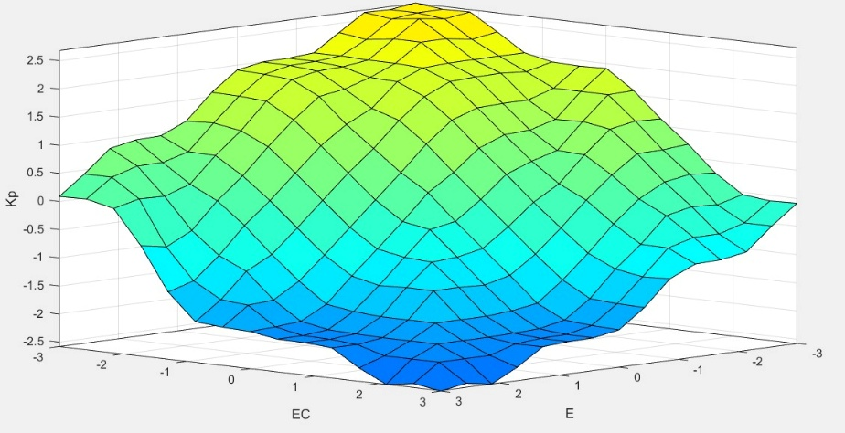
Figure 3. Fuzzy Logic Response Surface of $K_{p}$

Simulation Platform and Parameter Setup

Simulation Environment
The simulation is implemented in MATLAB R2024b using Simulink, where a modular quadrotor control system is constructed. The ode45 solver is adopted to numerically solve the dynamic model, and the maximum step size is set to 0.001 s to ensure simulation accuracy and stability. The Simulink model mainly consists of the quadrotor dynamic model, a reference trajectory generation module, and two controllers, namely conventional PID and fuzzy PID, which allows direct switching and comparative analysis between different control strategies.

Quadrotor Parameters
The physical parameters of the quadrotor and the tuned PID control gains are determined via engineering calibration and iterative simulation adjustment, as summarized in Table 4 and Table 5. These PID control gains are used as base gains for both conventional PID and fuzzy PID.
For these parameters in table 5: Kp means Proportional gain of position loop; Kvp means Proportional gain of velocity loop; Kvi means Integral gain of velocity loop; Kvd means Derivative gain of velocity loop. All gains are tuned via iterative simulation to ensure baseline stability for both controllers.
Table 4. Quadrotor Dynamic Parameters
Parameter | Value | Unit | Description
M | 1.3 | kg | Mass of the quadrotor
$$Ix$$ | 0.065 | kg·m² | Moment of inertia around the X-axis
$$Iy$$ | 0.065 | kg·m² | Moment of inertia around the Y-axis
$$Iz$$ | 0.092 | kg·m² | Moment of inertia around the Z-axis
g | 9.81 | m/s² | Acceleration due to gravity
$$C_{T}$$ | $$1.12×{10}^{-7}$$ | N/(rad/s)² | Thrust constant for the rotors
$$C_{M}$$ | $$2.15×{10}^{-9}$$ | N·m/(rad/s)² | Torque constant for the rotors
$$T_{m}$$ | 0.045 | s | Motor time constant
$$C_{R}$$ | 78.2 | - | Rotor drag coefficient
$$ω_{b}$$ | 890 | rad/s | Baseline rotor angular velocity
d | 0.225 | m | Distance from each rotor to the center of gravity

Table 5. PID Control Gains for Each Control Channel
Control Channel | Kp | Kvp | Kvi | Kvd
x | 30 | 100 | 0 | 80
y | 10 | 78 | 0 | 50
z | 16 | 60 | 0 | 16
Roll | 6 | 70 | 0 | 0
pitch | 8 | 70 | 0 | 0
Yaw | 12 | 75 | 0 | 0

Simulation Scenarios
To evaluate the trajectory tracking performance of conventional PID and fuzzy PID controllers, a time-varying reference trajectory is designed with a total simulation duration of 10 s:
- 0s: At the beginning, the quadrotor is stopped at the initial position (0, 0, 0).
- 0–5 s: The quadrotor is required to track the reference position (1, 1, -1).
- 5–10 s: The reference position is switched to (4, 4, -4) to test the controller’s dynamic response to sudden trajectory changes.
The simulation focuses on comparing the tracking accuracy, response speed and stability of the two controllers under this time-varying trajectory scenario, with key performance indicators including position tracking error, overshoot and settling time.
Note: The Z-axis of the inertial frame is defined downward as positive in this study, consistent with the lift force direction in the dynamic model.

Performance Evaluation Metrics
To comprehensively assess the control performance of the conventional PID and fuzzy PID controllers for quadrotor trajectory tracking, I choose three key evaluation metrics, covering stability, response speed, tracking accuracy and anti-disturbance capability. The calculation methods of each metric are defined as follows.

Overshoot (σ%)
Overshoot quantifies the maximum deviation of the actual position from the steady-state reference position during the transient response, reflecting the stability of the control system. It is calculated as the percentage of the peak deviation relative to the steady-state value, with the formula:
$σ\%=\frac{x_{peak}-x_{steady}}{x_{steady}}×100\%$ (6)
Where $x_{peak}$ denotes the maximum value of the actual position during the transient response, and $x_{steady}$ denotes the steady-state reference position. In my model, I use both (1, 1, -1) m for 0–5 s and (4, 4, -4) m for 5–10 s to calculate σ.

Settling Time (ts)
Settling time refers to the time required for the actual position of the quadrotor to enter and remain within a specified tolerance band after a trajectory change or disturbance, reflecting the dynamic response speed of the controller. Here I set this specified tolerance band as ±5% of the steady-state reference value. The calculation is based on the time series of position data: the settling time is determined as the first time point when the position error remains within the ±5% tolerance band for all subsequent sampling moments.

Root Mean Square Error (RMSE)
RMSE measures the overall trajectory tracking accuracy of the controller by quantifying the average magnitude of the position error over the entire simulation duration. For the 3D position tracking of the quadrotor, the RMSE for each axis (x/y/z) is calculated separately as:
$RMSE=\sqrt{\frac{1}{N}\sum_{i=1}^{N}{{\left(x_{d,i}-x_{i}\right)}^{2}}}$ (7)
where N is the total number of sampling points in the simulation, $x_{d,i}$ is the reference position of the$i-th$ sampling point, and $x_{i}$ is the actual position of the $i-th$ sampling point. The overall 3D RMSE can be derived by aggregating the RMSE values of the x, y, and z axes.

Results and Discussion

Simulation Results
Figure 4 presents the X/Y/Z-axis position tracking performance of the conventional PID controller for the quadrotor. In this figure, the dashed lines represent the desired position trajectory of each axis, while the solid lines denote the actual position trajectory tracked by the conventional PID controller. Figure 5 illustrates the corresponding X/Y/Z-axis position tracking errors of the conventional PID controller over the simulation time, where the curves reflect the deviation between the actual position and the desired position of each axis. These figures are all come from “scope” module in Simulink. Since the position tracking curve of the fuzzy PID controller nearly overlaps with that of the conventional PID controller, I only present the curves of the conventional PID controller here for a better visual clarity.
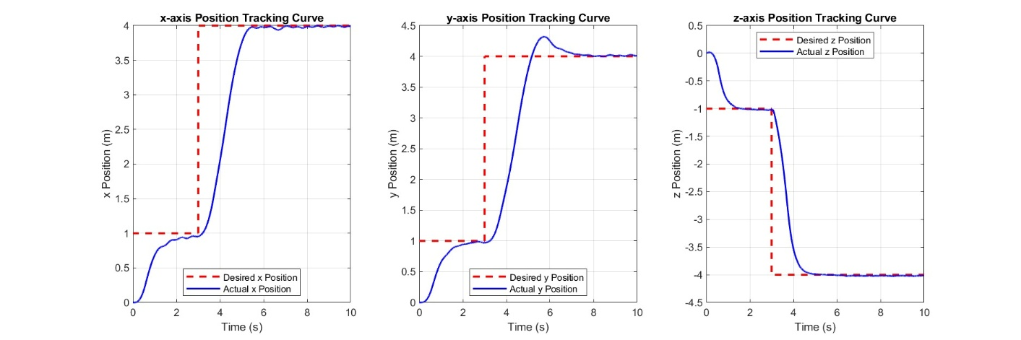
Figure 4. X/Y/Z-axis Position Tracking Curves of the Quadrotor
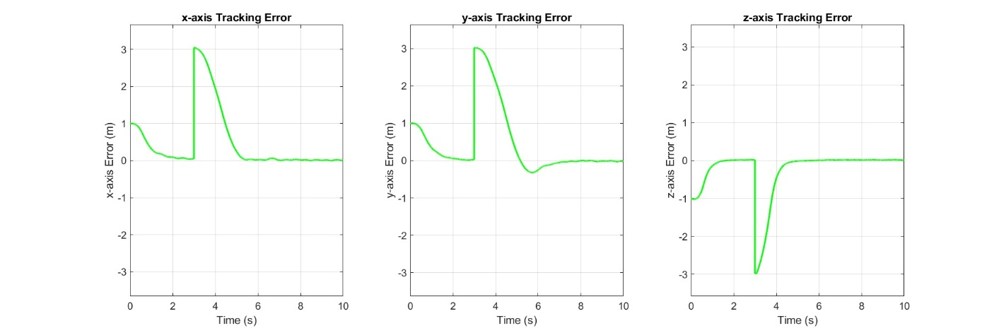
Figure 5. X/Y/Z-axis Position Tracking Error Curves of the Quadrotor

Nominal Flight Performance
The simulation results of position and attitude control under time-varying trajectory tracking are shown in Table 6 and Table 7. The performance differences between the two controllers are clearly reflected in key metrics such as overshoot, settling time, RMSE and steady-state error.
Table 6. Position Control Performance Metrics Comparison
Control Axis | Performance Metric | Conventional PID | Fuzzy PID | Improvement (%)
X-axis | Overshoot (%) | 0.30 | 13.96 | -4553.33
 | Settling Time (s) | 5.04 | 0.79 | 84.33
 | RMSE (m) | 0.96 | 0.33 | 65.63
Y-axis | Overshoot (%) | 7.61 | 15.62 | -105.39
 | Settling Time (s) | 5.02 | 0.59 | 88.13
 | RMSE (m) | 1.00 | 0.15 | 85.00
Z-axis | Overshoot (%) | 10.05 | 14.28 | -42.09
 | Settling Time (s) | 4.25 | 1.00 | 76.24
 | RMSE (m) | 0.70 | 0.31 | 55.71

Table 7. Attitude Control Performance Metrics Comparison
Attitude Axis | Performance Metric | Conventional PID | Fuzzy PID | Improvement (%)
Roll | Steady State (rad) | 0.0200 | 0.0118 | 41.20
 | Fluctuation Range (rad) | 0.0800 | 0.0621 | 22.38
 | Steady State Error (rad) | 0.0150 | 0.0098 | 34.45
Pitch | Steady State (rad) | 0.0180 | 0.0051 | 71.50
 | Fluctuation Range (rad) | 0.0750 | 0.0669 | 10.76
 | Steady State Error (rad) | 0.0200 | 0.0195 | 2.42
Yaw | Steady State (rad) | 0.0250 | 0.0213 | 14.70
 | Fluctuation Range (rad) | 0.0900 | 0.0687 | 23.68
 | Steady State Error (rad) | 0.0180 | 0.0140 | 22.25

Position Control Performance
Overshoot: Conventional PID exhibits smaller overshoots in all position axes, with the X-axis at 0.30%, the Y-axis at 7.61% and the Z-axis at 10.05%. In contrast, the overshoot of fuzzy PID increases significantly across all axes. The X-axis overshoot rises to 13.96% with a negative improvement rate of 4553.33%, while the Y-axis and Z-axis overshoot increases by 105.39% and 42.09% respectively compared with conventional PID.
Settling Time: Fuzzy PID achieves a significant reduction in settling time across all position axes. The Y-axis performs the best, shortening from 5.02 seconds to 0.59 second with an improvement rate of 88.13%. Followed by the X-axis, which shortens from 5.04 seconds to 0.79 second with an improvement rate of 84.33%. The Z-axis shortens from 4.25 seconds to 1.00 second with an improvement rate of 76.24%.
RMSE: Fuzzy PID significantly reduces position tracking errors. The Y-axis has the highest improvement rate, decreasing from 1.00 meter to 0.15 meter with a reduction of 85.00%. The X-axis decreases from 0.96 meter to 0.33 meter with a reduction of 65.63%, and the Z-axis decreases from 0.70 meter to 0.31 meter with a reduction of 55.71%, demonstrating superior tracking precision of fuzzy PID.

Attitude Control Performance
Steady State: Fuzzy PID achieves lower steady-state values in all attitude axes. The Pitch axis shows the most remarkable improvement, decreasing from 0.0180 radians to 0.0051 radians with a reduction of 71.50%. The Roll axis decreases from 0.0200 radians to 0.0118 radians with an improvement rate of 41.20%, and the Yaw axis decreases from 0.0250 radians to 0.0213 radians with an improvement rate of 14.70%.
Fluctuation Range: Fuzzy PID narrows the attitude fluctuation range effectively. The Roll axis has an improvement rate of 22.38%, decreasing from 0.0800 radians to 0.0621 radians. The Yaw axis has an improvement rate of 23.68%, decreasing from 0.0900 radians to 0.0687 radians. The Pitch axis has an improvement rate of 10.76%, decreasing from 0.0750 radians to 0.0669 radians, reflecting better attitude stability.
Steady State Error: Except for the Pitch axis which only achieves a slight improvement of 2.42%, both the Roll axis and Yaw axis of fuzzy PID show significant error reduction. The Roll axis decreases from 0.0150 radians to 0.0098 radians with an improvement rate of 34.45%. The Yaw axis decreases from 0.0180 radians to 0.0140 radians with an improvement rate of 22.25%.

Key Observations
Comprehensive analysis of position and attitude control data shows that fuzzy PID has obvious advantages over conventional PID in dynamic response speed and tracking precision. It shortens the settling time by 76.24%-88.13% and reduces position RMSE by 55.71%-85.00% for time-varying trajectory tracking. Meanwhile, it optimizes attitude control performance with lower steady-state values and narrower fluctuation ranges, especially the 71.50% improvement of Pitch axis steady-state value.

Discussion

Performance Difference Analysis and Causes
The superior performance of fuzzy PID in settling time, RMSE and attitude steady-state value mainly comes from its core dynamic gain adjustment mechanism, which adapts to the time-varying trajectory’s demand for real-time parameter tuning according to Bhuvaneswary et al. [6]. Unlike conventional PID with fixed parameters, fuzzy PID adjusts $K_{p}, K_{i} and K_{d}$ in real time based on error E and error change rate EC, which effectively reduces the response lag and improves adaptability. However, the significantly larger overshoot in partial position axes is due to insufficient optimization of the fuzzy control strategy. On the one hand, the fuzzy rule base was designed based on general experience rather than fully matching the quadrotor’s inherent nonlinear and coupled dynamic characteristics, leading to mismatched control output. On the other hand, the range division of membership functions failed to balance response speed and overshoot suppression, and the pursuit of fast dynamic response resulted in excessive gain adjustment in the initial transient phase, thus causing overshoot. In addition, the limited improvement of Pitch axis steady-state error is because the current fuzzy rules cannot fully fit the dynamic response characteristics of the Pitch axis, which needs further targeted optimization.

Limitations of the Proposed Fuzzy PID
From an undergraduate research perspective, this study has obvious limitations: first, the simulation scenario is relatively simple, only verifying the time-varying trajectory tracking without considering practical factors such as wind disturbance and sensor noise; second, the fuzzy rules and initial parameters were tuned manually, lacking systematic algorithm support, leading to incomplete optimization; third, the research only focuses on basic control indicators and does not involve complex flight tasks.

Future Improvements
Subsequent research will focus on addressing existing defects: optimizing the fuzzy rule base and membership function ranges combined with the quadrotor’s dynamic characteristics; introducing simple meta-heuristic algorithms to replace manual parameter tuning for higher optimization efficiency; adding practical disturbance factors in simulations and expanding test scenarios to enhance the controller’s adaptability and practicality.

Conclusions
The quadrotor dynamic model established based on the Newton–Euler method is able to describe the nonlinear and coupled characteristics of the system, providing a basis for the comparative simulation of conventional PID and fuzzy PID controllers. For time-varying trajectory tracking, the fuzzy PID controller shows better performance than the conventional PID in several metrics. Specifically, the settling time is reduced by 76.24%–88.13%, the position RMSE is decreased by 55.71%–85.00%, and the steady-state attitude error is improved by 14.70%–71.50%. This improvement is mainly attributed to the adaptive gain adjustment introduced by fuzzy logic. However, noticeable overshoot appears on some axes, which may be caused by mismatches between the initial fuzzy rule design and the quadrotor dynamic response, leading to temporary over-adjustment.
The simulation results demonstrate the feasibility of combining fuzzy logic with classical PID control for quadrotor applications. Conventional PID control is suitable for tasks with low complexity and modest precision requirements, while fuzzy PID shows advantages in terms of response speed, tracking accuracy, and attitude stability under more demanding conditions. Nevertheless, the presence of overshoot indicates that fuzzy PID does not perform optimally in all aspects. With further improvement, it has the potential to be applied in high-precision quadrotor control scenarios.
Future work will focus on reducing the overshoot observed in the current fuzzy PID controller. This includes optimizing the fuzzy rule base and gain adjustment strategy according to the quadrotor’s dynamic characteristics. In addition, meta-heuristic optimization methods will be considered to further tune controller parameters. More extensive simulations and experimental flight tests will be conducted to evaluate the effectiveness of the improved controller and support its practical application.

References
[1] A. Tassanbi, A. Khan, A. Kashkynbayev, E. Shehab, T. Do, and M. Ali, "Performance evaluation of developed controllers for unmanned aerial vehicles with reference camera," (in English), Meas. Control, vol. 58, no. 9, pp. 1217–1244, Oct 2025, doi: 10.1177/00202940241270863.
[2] B. Singh, A. Kumar, and V. Giri, "Comprehensive Review of Various Control Strategies for Quadrotor Unmanned Aerial Vehicles," (in English), FME Trans., Review vol. 51, no. 3, pp. 298–317, 2023, doi: 10.5937/fme2303298S.
[3] L. M. Gonzalez, "Adaptive Sliding Mode Control for UAVs: Mitigating Wind Disturbances via Reinforcement Learning Tuning," (in English), IEEE Access, vol. 12, pp. 45902–45917, 2024, doi: 10.1109/access.2024.3487621.
[4] N. Madebo, C. Abdissa, and L. Lemma, "Enhanced Trajectory Control of Quadrotor UAV Using Fuzzy PID Based Recurrent Neural Network Controller," (in English), IEEE Access, vol. 12, pp. 190454–190469, 2024, doi: 10.1109/access.2024.3516494.
[5] Y. Bai, K. Li, and G. Wang, "A Hybrid Quadrotor Unmanned Aerial Vehicle Control Strategy Using Self-Adaptive Bald Eagle Search and Fuzzy Logic," (in English), Electronics, vol. 14, no. 11, pp. 2112, 2025, doi: 10.3390/electronics14112112.
[6] N. Bhuvaneswary, B. Gowtham Reddy, K. Praveen Kumar Reddy, M. Vishnu Vardhan, K. Jagadeesh Kumar, and M. Anudeep Venkat Reddy, "Quadcopter with Fuzzy Logic based Self-Tuning PID Controller," in 5th International Conference on Trends in Material Science and Inventive Materials-ICTMIM, Kanyakumari, INDIA, Apr 07–09 2025, NEW YORK: IEEE, pp. 559–563, 2025, doi: 10.1109/ictmim65579.2025.10988349.

