Gather and Grow
  - MarketLink Project Documentation
TechWiz 7 | End to End Web Solutions | eGreen Basket
This document explains the website, its main pages and the steps used by customers, farmers and administrators. It also covers local setup, support, AI assistants and testing.
Document date: 28 September 2026

About this document
This is an AI-assisted draft for the project owner to review. It uses the current code and screenshots from the local website. It is not a claim of independent student authorship. Follow the official competition rules before using it in a final submission.
Public page screenshots show the local development website. Some dashboard screenshots use isolated test accounts or test responses. These are marked in their captions. They explain the interface and do not prove that a real order, payment or email was completed.

Sections
- Project purpose and homepage
- Markets and produce
- Growers and contact
- Registration and login
- Customer workspace
- Farmer workspace
- Administrator workspace
- Support and mobile navigation
- AI assistants
- Technical structure and setup
- Testing and known limits

Main idea
A customer reserves local produce online and collects it from a farmer at a market. The farmer plans stock and pickup times. The administrator manages the platform. Payment happens in person at pickup.

Project purpose and homepage
Gather & Grow is the website name used for the MarketLink project. The website brings market discovery, produce reservations and farmer operations into one application.
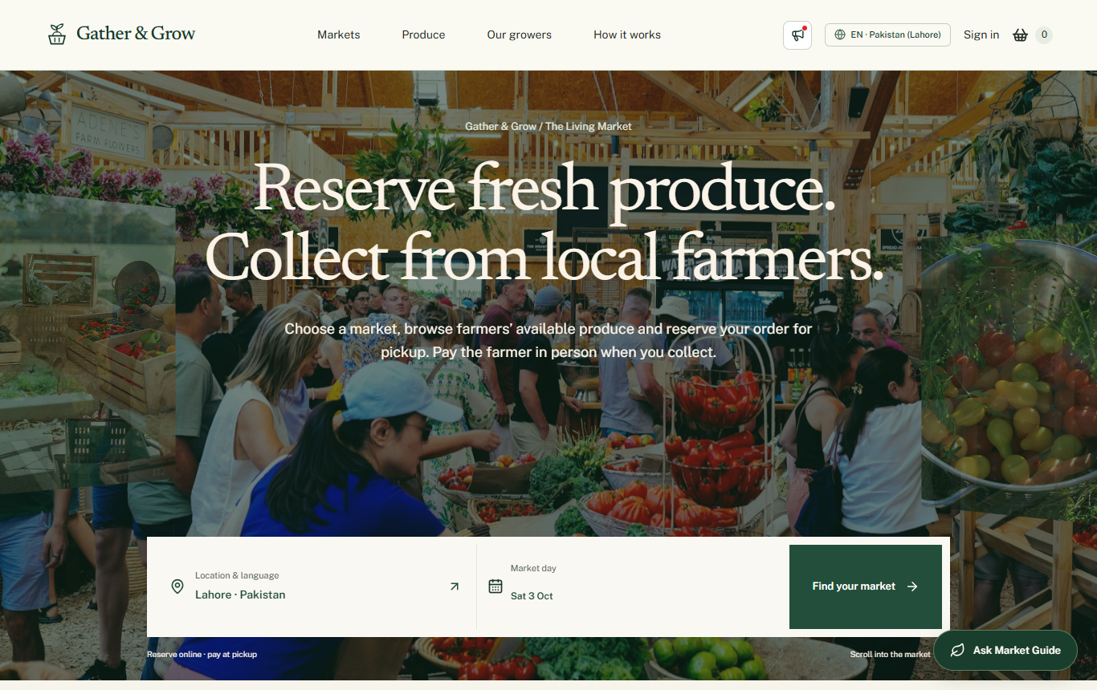
Figure 1 Homepage from the local development website

What the homepage helps a visitor do
- Choose a location and look for participating markets.
- Browse produce and learn about growers.
- Understand reservation and pickup before creating an account.
- Open the public Market Guide for help.

Project scope
The system supports customers, farmers and administrators. It includes market information, produce listings, a basket, pickup planning, order records, messages, support and announcements. There is no online payment gateway. Booked order value is the value of reservations, not proof of money received.

Markets and produce
The Markets page helps visitors find a collection venue. Market information includes its location and schedule. The Produce page helps customers search and filter available listings.
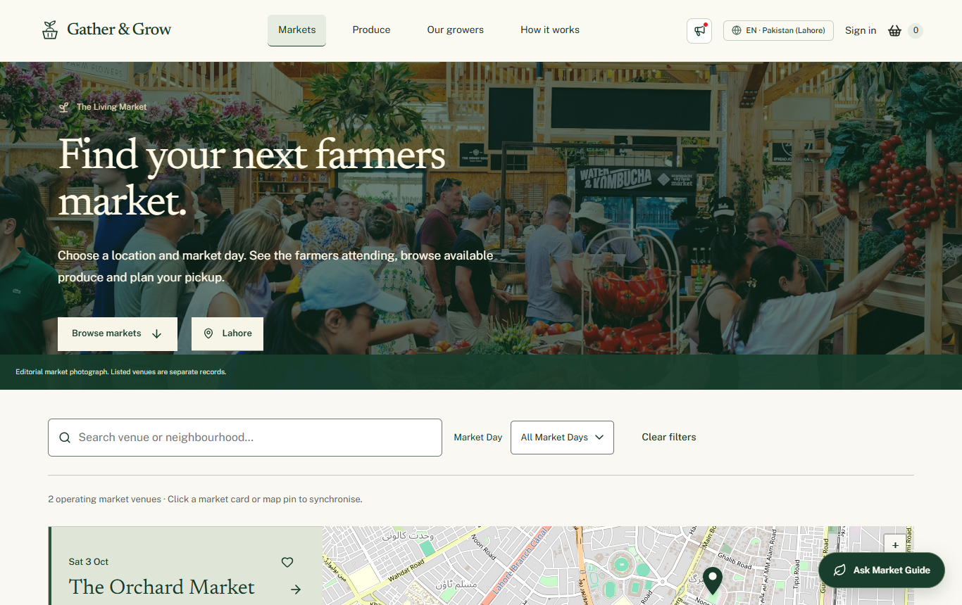
Figure 2 Market discovery page
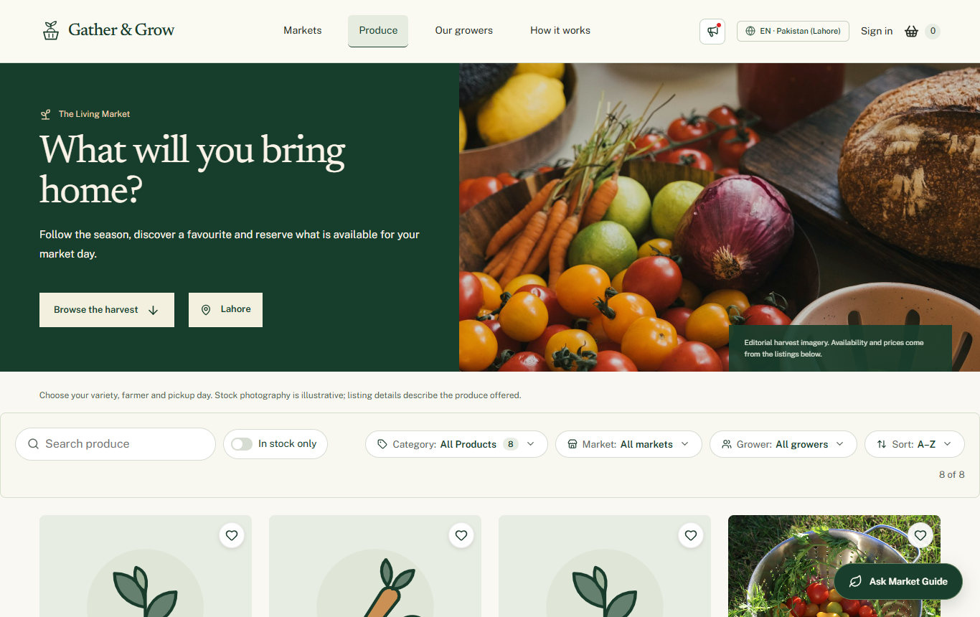
Figure 3 Produce discovery page

Reservation steps
Open a product and check its farmer, unit, price and availability. Add a suitable quantity to the basket. The basket groups items by farmer. Choose a pickup window for each farmer, review the details and confirm. The server must check stock and slot capacity again before accepting the reservation.
A market schedule and a farmer pickup window are different records. An open market does not automatically mean that every farmer has an available pickup slot.

Growers and contact
Grower pages help customers understand who sells the produce. A stall profile can show the grower, produce, market participation and reviews. Reviews belong to the grower experience and are not repeated below each product.
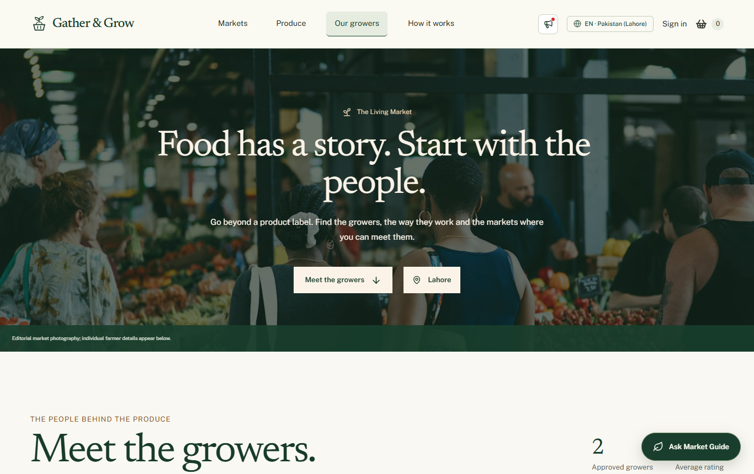
Figure 4 Grower directory
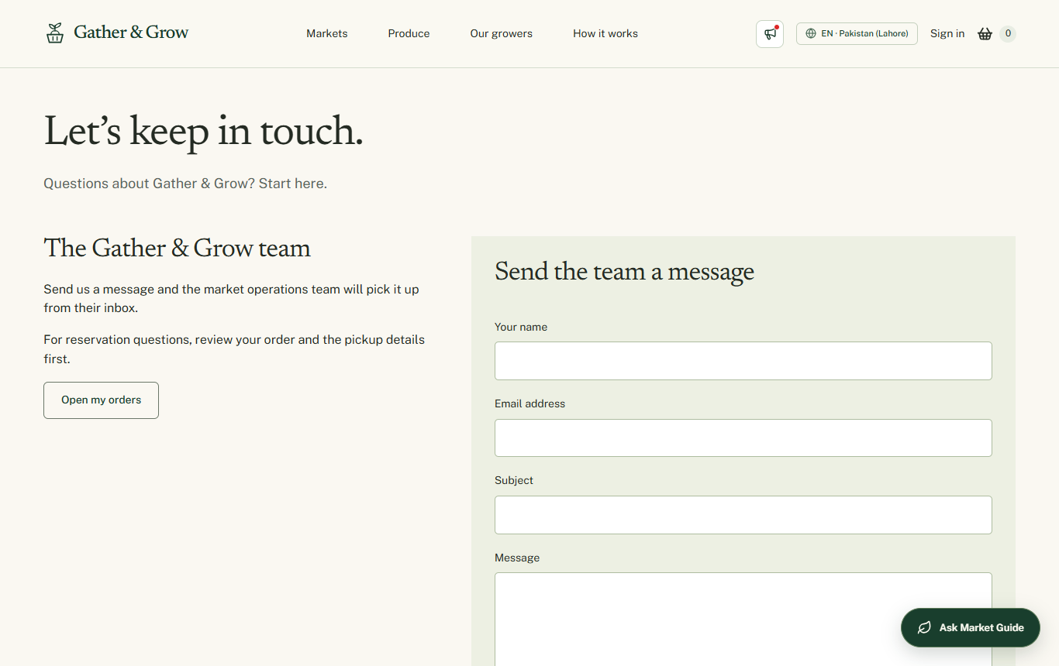
Figure 5 Contact page
The contact form is used for general enquiries. Signed-in customers and farmers can use support tickets for a conversation that remains available in their dashboard. Email delivery and automatic replies depend on working server email settings.

Registration and login
Customers and farmers use separate registration choices. A new account must complete email verification. Farmer selling access also depends on the application review process.
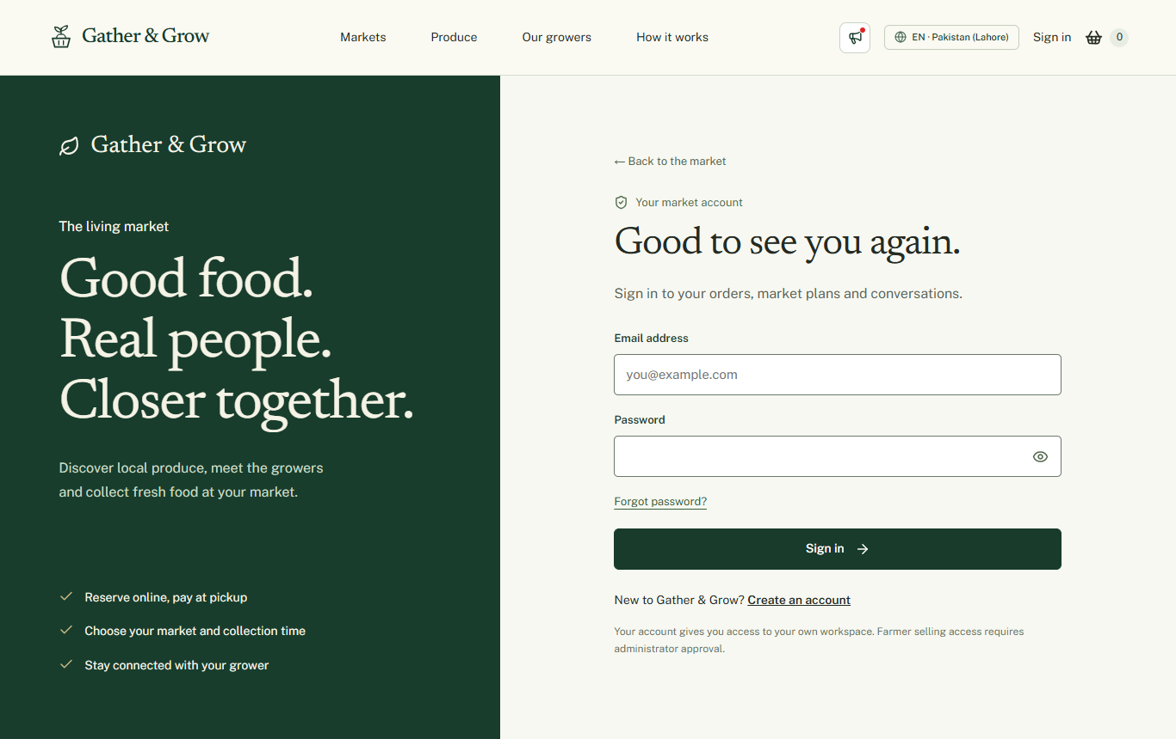
Figure 6 Login page
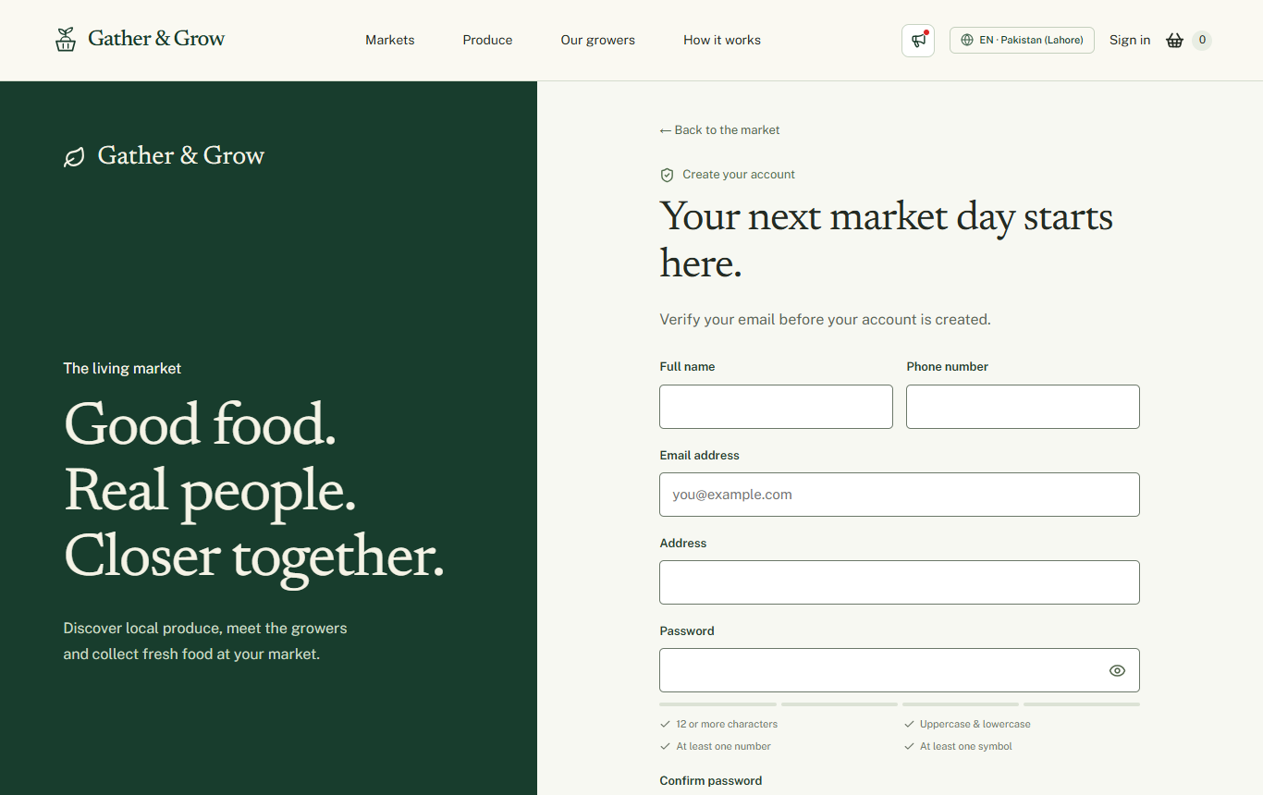
Figure 7 Customer registration form

Account steps
Enter your details and a strong password. Request the email code, enter the six-digit code and continue. The code expires after ten minutes. New passwords require at least twelve characters, uppercase and lowercase letters, a number and a symbol. The server also checks its password length limit.
The forgot-password option sends a reset code to a registered email address. Unknown addresses receive a not-registered message. Real email delivery needs to be checked with a working sender account before demonstration.

Customer workspace
The customer workspace keeps shopping and pickup information together. The left navigation gives access to planning, orders, messages, support, favourites, notifications and the profile.
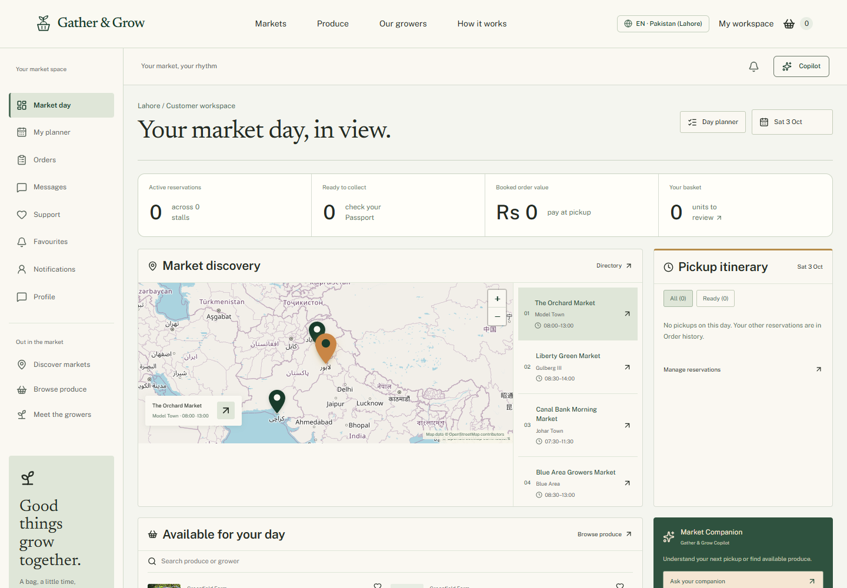
Figure 8 Customer dashboard layout using an isolated test session

Main tasks
- Plan a market visit and select produce.
- Review active reservations and previous orders.
- Check the farmer and pickup details for an order.
- Use the available modify or cancel controls when the order rules allow it.
- Contact a farmer through messages or ask the platform team through support.

Pickup flow
The customer selects a pickup window at checkout. The farmer then follows the supported preparation and pickup workflow. The customer should follow the latest recorded order information. The frontend must not display a simulated change as a saved database update.
On desktop, the customer navigation is kept within the available screen height. On mobile, the hamburger menu opens workspace links from the left.

Farmer workspace
The farmer workspace is used to manage a stall and prepare for market days. It includes products, dated stock, weekly templates, pickup windows, orders, markets, reviews and reports.
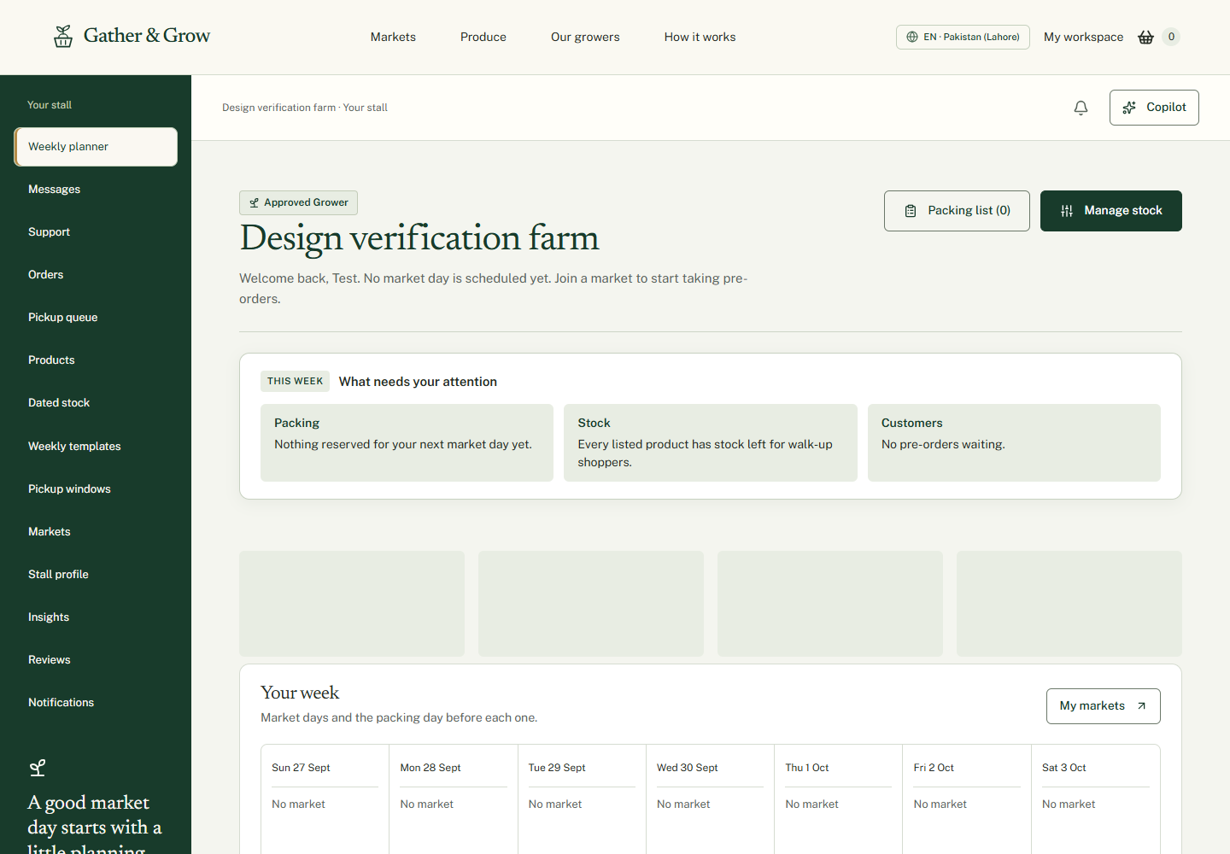
Figure 9 Farmer workspace using an isolated test session

Getting ready to sell
- Complete and submit the farmer application.
- Wait for review and correct any rejected details.
- Request participation in a suitable market through the Markets page.
- Create products and publish stock for the correct market date.
- Create pickup windows with suitable capacity and cutoff settings.

Farm location and market participation
The farm address shows where the grower is based. A market venue is the place where collection takes place. Saving the farm address does not automatically join a market. The participation request must follow the administrator review flow.

Handling orders
Review incoming reservations, accept or decline as allowed, prepare the items and update pickup readiness. A decline should include the farmer’s actual reason. Stock and reservation records must remain consistent when an order changes.

Administrator workspace
The administrator uses the Command Centre to review platform activity and handle work that needs a decision. The dashboard separates application review, market management and operational information.
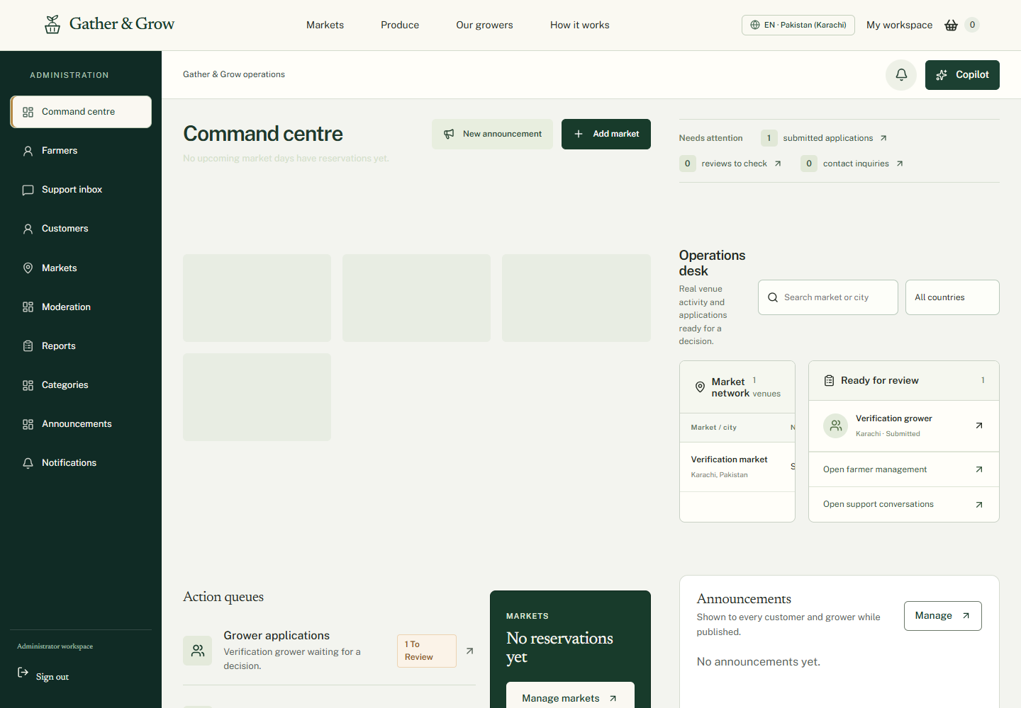
Figure 10 Administrator layout with test records and metric loading placeholders

Main tasks
- Review submitted farmer applications and market participation requests.
- Manage market venues, schedules and categories.
- Review customers, produce listings and flagged reviews.
- Reply to support tickets and close resolved conversations.
- Publish announcements and open platform reports.

Where announcements appear
Published notices are available from the Market announcements button in the header. The public homepage also displays an announcement notice. The administrator can manage notices from the Announcements page. Unpublished or archived notices should not appear as current public notices.
Metrics must come from recorded platform data. Do not describe booked value as verified revenue or present unconnected system-health numbers as live measurements.

Support and mobile navigation
Support tickets give customers and farmers a way to contact the administrator. Each ticket has a reference, subject, status and message history. The inbox has filters for open and closed conversations.
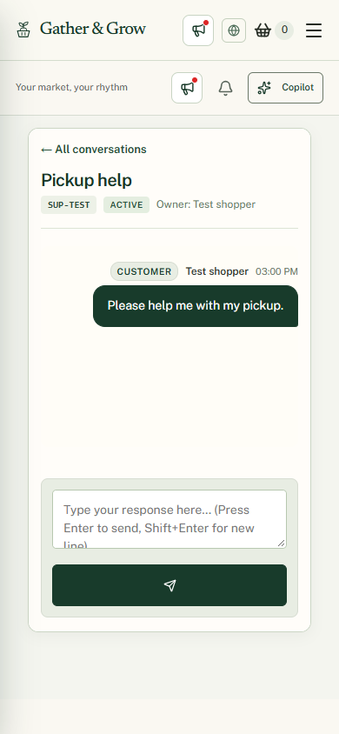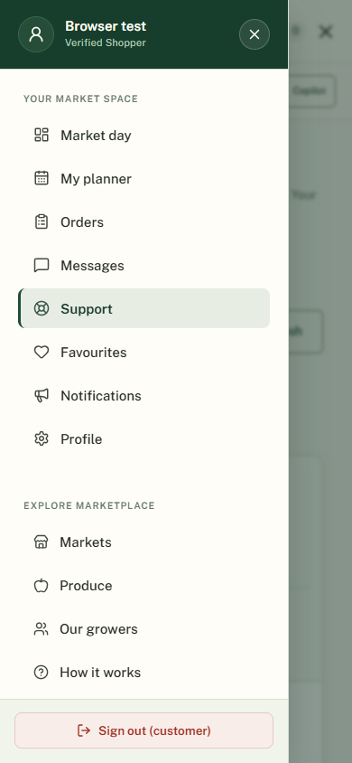
Figure 11 Mobile support conversation and navigation using an isolated test account

Using support
Open Support from the dashboard. Create a ticket and describe the problem. Include an order or conversation reference if needed. Select the ticket later to read replies. On mobile, use All conversations to return to the ticket list. The administrator can close the ticket after the issue is resolved.
The administrator has a separate conversation-ID inspection tool for authorised review of customer and farmer messages. A support ticket reference and a conversation ID are not the same thing. Never include passwords or secret keys in either conversation.

AI assistants
The website has a public Market Guide and role-based dashboard Copilot experiences. The public guide helps with discovery and shopping. Dashboard assistants use the tools permitted for the signed-in role.
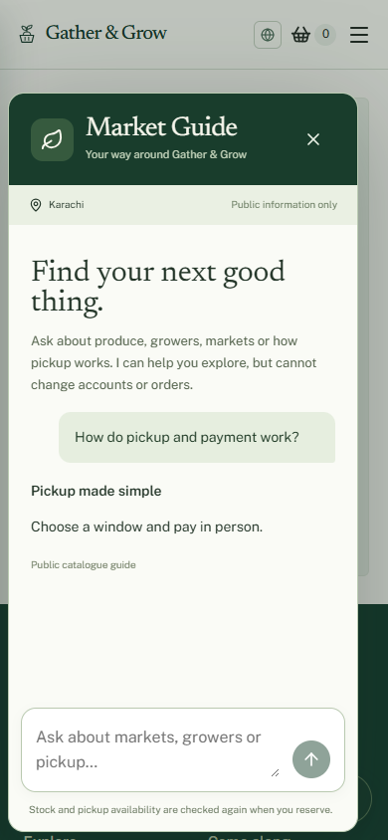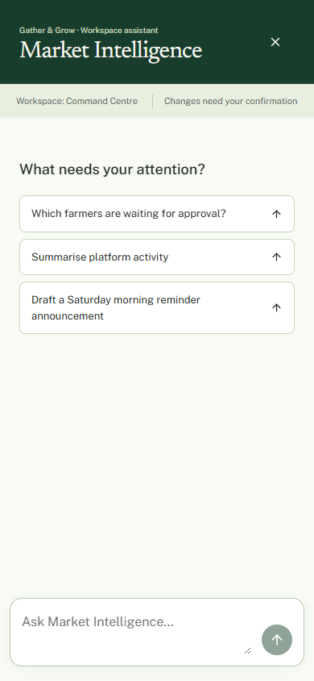
Figure 12 Public guide and dashboard Copilot from isolated browser verification

Public Market Guide
Ask about markets, growers, produce or pickup. Catalogue results should be relevant to the question. General guidance should not include an unrelated product list. The public guide cannot approve farmers, change orders or open private account records.

Dashboard Copilot
Customers use Market Companion, farmers use Farm Copilot and administrators use Market Intelligence. The assistant can explain permitted records and prepare supported actions. A consequential change should show a preview and require confirmation. A proposed action is not a completed action. The ordinary website remains usable when AI is unavailable.

Technical structure and setup

Application structure
The frontend uses React, TypeScript and Vite. Reusable components provide forms, navigation and common interface elements. A central API layer sends requests to the backend. The server uses Express and MongoDB. Server code handles permissions, orders, stock and AI requests.
The main connection is Browser → Frontend API client → Express API → MongoDB. The browser does not connect directly to MongoDB. AI and email credentials stay in server configuration.

Folders
- Client contains the React application and frontend tests.
- Server contains the API, validation and backend services.
- Documentation contains project and engineering notes.

Local setup
- Install dependencies in Client and Server using their package lock files.
- Configure the required server environment values using the existing setup notes.
- Start the backend from Server with npm run dev.
- Start the frontend from Client with npm run dev.
- Open the address shown by Vite and check that API requests reach the backend.

External services
Email verification needs a valid server sender configuration. The local maps use OpenStreetMap-based controls. Optional AI answers need server-side provider configuration. Never put a database password, email app password or AI key in React code or screenshots.

Access and data
The backend checks the user’s role and ownership of records. Authentication uses cookies and CSRF protection. Forms need validation on both the client and server. An error message must not claim that a failed operation succeeded.

Testing and known limits

Checks completed during this work
The production frontend build passed. The existing frontend unit suite passed 27 tests. Focused backend suites passed 37 tests during the preceding authentication and public-guide work. These results cover selected areas and do not mean that every production workflow has been tested.
Targeted browser checks covered mobile support for all three roles, opening and closing the menu, returning from a support conversation, horizontal overflow and customer sidebar stability. These checks used isolated API responses and did not create real orders or send real email.

Checks still needed before final delivery
- Complete a real registration and check delivery of the email code.
- Submit a farmer application, approve it and verify the farmer view updates.
- Approve market participation, publish dated stock and create pickup windows.
- Place a real test reservation and verify the customer and farmer records agree.
- Test allowed order changes, stock release, pickup completion and review eligibility.
- Publish and archive an announcement and check its public visibility.
- Open a support ticket, reply as administrator and close it.
- Verify each required role on desktop and mobile.

Known limits
The full Playwright command could not start its managed server because port 5173 was already in use. A separate preview was used for targeted checks. Real SMTP delivery was not verified in this documentation task. Existing dashboard screenshots include test sessions and some loading states. They are interface examples, not evidence of completed backend transactions.
One reviewed backend behaviour supplies a stock or capacity reason when a decline reason is missing. The final workflow should require or preserve the farmer’s actual reason rather than inventing one.

Final review
Check this document against the official SRS. Add the required student details, your own observations and final test evidence. Recheck screenshots after any further design change. Follow the competition rules for AI use and attribution. This draft does not certify full SRS compliance.

Source of this draft
Current project code, the local website and frontend engineering notes were used. No claim is made that the official SRS was re-audited in full during this document task.

Additional features and project enhancements
This appendix compares the current implementation with MarketLink SRS version 1.0, mainly section 1.6. It separates added features from improvements to features that the SRS already asks for. These are implementation notes for the project owner to review. They are not a claim that every live workflow has passed final testing.

Support tickets for customers and farmers
Customers and farmers can open a private support ticket from their dashboard. They enter a subject and message and receive a ticket reference. They can return to the same conversation, read replies and send more information. The SRS asks for static contact information but does not specifically require a support ticket system.

Administrator support inbox
The administrator can list tickets, search an exact ticket reference, reply and close a resolved ticket. Open and closed filters help separate active work from completed conversations. Closed tickets remain readable. The mobile interface opens one conversation at a time and provides a back control.

Customer and farmer messaging
Customers and farmers have a separate messaging workspace for their own conversations. It includes conversation history, sending messages, read tracking, unread badges and archiving. This is different from a support ticket because it connects the customer directly with the farmer. The SRS describes communication in general but does not specify this conversation system.

Conversation lookup for administrators
An authorised administrator can enter a conversation ID in the support area to inspect a customer and farmer thread. This is a read-only review tool. A conversation ID is separate from a support ticket reference. Access remains subject to backend permission checks. This feature is not specifically requested in the SRS.

AI reply suggestions for farmers
The messaging backend includes a suggested-reply action for farmer conversations. It helps prepare a response; it should not be described as an automatically sent message. Live AI availability and the full suggested-reply workflow still need final verification.

Planning and operational additions

Customer Market Day Planner
The planner brings the customer’s upcoming pickups into one view. It helps the customer see when and where to collect orders from different farmers. The SRS requires pickup details but does not require a separate market-day planning screen. This is not a claim of automatic route optimisation.

Pickup Passport
An order has a pickup-focused view called the Pickup Passport. It brings the order reference, farmer and collection details together so the customer can use them at the market. This does not add online payment, identity verification or guaranteed QR scanning.

Market Day Workbench
The farmer workspace links incoming orders, preparation tasks, dated stock and pickup work. A preparation checklist helps farmers organise packing. The underlying inventory and order features are required by the SRS; this connected workbench and checklist are additional workflow improvements.

Market participation requests
Farmers can request to join a market instead of assuming that saving a farm address adds them to a venue. Administrators review participation requests and give approval or rejection. The SRS requires farmers to manage their markets, but does not define this separate request and decision process.

Application correction and resubmission
The farmer application separates an incomplete draft from a submitted application. Rejection feedback allows the farmer to edit details and submit again. Pending access is limited. Farmer approval itself is required by the SRS; the draft, correction and resubmission flow is an extension.

Produce price comparison
The farmer stock view compares a product price with other listed products in the same category and unit. This is a planning aid. It is not an external market-price feed and does not prove that the products have the same quality or growing method.

Location and regional preferences
The website has a location and language selector and supports country and city context. Market records can include local time zones and currencies. These extend the basic nearby-market requirement. The application must show an honest empty result where no participating market exists; it does not cover every market in the world.

AI and account improvements

Farm Copilot
The farmer assistant goes beyond the optional customer chatbot in the SRS. It can explain permitted farm records and prepare supported management actions through registered backend tools. Examples include reviewing stock and preparing order or product actions. Its capability list must match the tools actually available.

Market Intelligence for administrators
The administrator assistant can summarise permitted platform records and prepare supported administrative changes. It is separate from the public assistant. A proposed announcement or management action must not be reported as completed until the backend confirms it.

Action previews and confirmation
Dashboard Copilot supports draft actions, previews and confirmation before consequential changes. It includes error feedback and handling for unavailable, conflicting or expired actions. These controls extend a basic question-and-answer chatbot. They do not replace backend authorisation.

Public Market Guide
Visitors can ask about public markets, growers, produce and pickup without opening a dashboard. The guide provides public source links when relevant and can fall back to catalogue guidance when AI is unavailable. A basic customer assistant is already optional in the SRS; public access, source links and the read-only boundary are refinements rather than an entirely new requirement.

Email verification and password recovery
The project adds registration email codes, login verification for ordinary accounts, password reset codes, a password-strength checklist and show or hide controls. The SRS requires secure registration and login but does not specify these exact mechanisms. Actual email delivery depends on server email configuration. The owner-requested administrator exception is a special case, not a security enhancement.

Contact email and automatic acknowledgement
The contact form supports a server-side email workflow for the administrator and an acknowledgement for the sender. The SRS only asks for static contact information and a location map. This form and email workflow are additions. Successful inbox delivery still needs a real test with valid email settings.

Further refinements and scope notes

Operational reporting refinements
Reports include period-based views, currency-aware information where supported and CSV export controls. The SRS already requires reports and analytics. These refinements make the existing requirement easier to use. Booked order value is kept distinct from verified payment revenue.

Navigation and mobile inbox improvements
The desktop workspace keeps navigation separate from the scrolling content. The mobile drawer groups workspace and public links, supports keyboard closing and keeps sign-out accessible. The support inbox switches between a ticket list and a conversation on small screens. Responsive design is already required; these are usability refinements.

Editorial design and motion
The website adds its own Gather & Grow identity, produce imagery, a preloader, transitions and scroll-based visual effects. Reduced-motion handling supports users who prefer less movement. These are presentation enhancements and do not replace required functionality.

Existing requirements that should not be counted as extras
The official SRS already includes market maps and directions, favourite farmers and products, restock alerts, quick reorder, recurring weekly stock templates, pickup windows and cutoffs, reviews, farmer review replies, administrator approval, moderation, reports, announcements, notifications, About and Contact pages. Their presence should be credited as requirement coverage, not as additional scope.

Features not claimed in this appendix
The application does not claim an online payment gateway, delivery service, organic certification verification, complete worldwide market coverage, automatic travel-route optimisation or verified live infrastructure monitoring. A visible AI option does not prove that every external provider is connected.

Final scope review needed
The SRS asks for reviews of both farmers and individual products. The owner requested that reviews appear under the stall rather than below products. This presentation choice should not hide a missing product-review capability. Check the stored review targets and final workflow against the SRS before claiming full compliance.

Evidence and final checks
This feature list was checked against the SRS text and relevant frontend and backend implementation. It is not a replacement for live end-to-end testing. Demonstrate support creation, customer and farmer messaging, administrator inspection, market participation, planner and passport views, AI confirmations and email delivery before marking those workflows fully verified.
Source: MarketLink Software Requirements Specification version 1.0, sections 1.5, 1.6, 1.7 and 1.9; current application routes, pages and services. AI assistance must be acknowledged. The SRS prohibits fully AI-produced ready-made documentation, so this appendix remains a reference draft for meaningful owner review and rewriting.

Submission database and installation
The submission dataset contains 10 countries and 40 cities. Each city has two sample markets. Each market has four sample growers, and each grower has four products. This gives 80 markets, 320 growers and 1280 products. The existing administrator account is preserved. Old customer accounts, orders, reviews and other related records have been removed after a private backup.
The markets, growers, prices and available quantities are illustrative evaluation data. They are not verified real businesses. Market pins identify approximate city centres. The country and city information supports browsing, but does not prove actual market coverage. There are no fabricated customer reviews or sales records in the new export.
The dataset includes 5120 dated stock offers and 2560 pickup windows for four upcoming weekend dates. Stock offers and pickup windows reference the same farmer, market and date. There are 40 available units per stock offer and no reserved units initially. Reservations must still pass the application stock and cutoff checks.

Running the project
Install dependencies with npm ci separately in Client and Server. Configure the server environment using Server/.env.example and your own database and provider settings. Do not put server secrets in browser variables. Start the server and client with npm run dev in their respective directories. Build the frontend with npm run build from Client.
The Database File folder contains MarketLink.ejson and a count and checksum manifest. It uses canonical MongoDB Extended JSON to preserve object identifiers and dates. To restore it, configure an empty evaluation database and run node scripts/restore-submission.mjs followed by the absolute export path from Server. The restore script refuses a nonempty target. Do not run the older npm run seed command on the submission database.
The export preserves the existing administrator password hash. Keep it and the submission archive private. The source repository does not include the database export or environment credentials. Sample grower accounts use example.test addresses and an unavailable random password. Use real registration with an email you control to test OTP and farmer onboarding. No common sample-account password is published.

Verification and remaining work
Local and live catalogue responses were checked on 28 September 2026 and both returned 80 markets, 320 growers, 1280 products and 2560 pickup windows. Automated dataset checks confirmed the requested hierarchy, stock and window relationships, and timezone cutoff conversion. These checks do not prove every reservation, email or AI operation works on the live server. Source deployment remains separate from updating the shared database.
Screenshots earlier in this document show the interface captured before the final sample-data reset. Their displayed names and counts may differ from the exported dataset. The project video is intentionally left for the owner. This document remains an AI-assisted reference draft for meaningful owner review and rewriting under the official competition rules. Its final pagination has not been visually verified because the local Word renderer is unavailable.

