Gather and Grow
  - Complete website documentation
MarketLink • eGreen Basket • TechWiz 7 • End to End Web Solutions
28 September 2026
This document explains the complete website for visitors, customers, farmers and administrators. It covers each main page, the order and market workflows, support conversations, AI tools, technical design, database structure, installation and testing. The last chapter identifies additions beyond the official requirements.

Document status
This is an AI-assisted reference draft based on the application code and available screenshots. The owner must review, understand and meaningfully revise it before submission. The official SRS forbids fully AI-produced ready-made documentation and requires acknowledgement of AI tools. This document does not claim independent student authorship or complete live acceptance testing.
Current public screenshots use the local website after the sample-data reset. Existing dashboard screenshots use isolated test sessions and are labelled. They show interface design, not proof of saved production transactions. Final Word pagination still needs visual review because the local renderer is unavailable.

Project links
Repository: https://github.com/zoaibahmed/techwiz-project
Live website: http://84.247.164.10:5050/
Code reference: main branch, dbc06c8286fc5c5e198724cd59dac1c24b8e1169

Owner details to complete
Participant name: ____________________ Student ID: ____________________
Centre: ____________________ Reviewed on: ____________________

Contents
1. Project background and scope
2. Roles and navigation
3. Homepage and discovery
4. Markets and maps
5. Grower directory and stall pages
6. Produce catalogue and product details
7. Registration and account access
8. Customer dashboard and market planning
9. Basket and reservation checkout
10. Orders and pickup lifecycle
11. Favourites notifications and reviews
12. Farmer application and market joining
13. Farmer products and inventory
14. Pickup windows and weekly planning
15. Farmer orders insights and reviews
16. Administrator Command Centre
17. Administration and moderation
18. Announcements and contact
19. Messages and support tickets
20. Public guide and dashboard Copilot
21. Design accessibility and mobile use
22. Architecture and data flow
23. Database design
24. Installation and configuration
25. Test data and verification
26. Page and capability inventory
27. Submission and owner review
28. Additional features beyond the SRS
Use the Word navigation pane to move between headings. The document contains no application source code. Installation commands are operational instructions.

Project background and scope

Problem definition
A customer may visit a market without knowing which farmers will attend or whether the produce is still available. Farmers also need a clear record of the stock they plan to bring and the orders they must prepare. Separate messages and informal lists make this harder to manage.

Proposed solution
Gather and Grow connects market discovery, farmer stock and pickup reservations. A customer chooses a market day, finds produce, reserves an available quantity and collects it at a farmer stall. Farmers manage listings, dated stock, pickup slots and orders. Administrators review participation and manage platform records.

Objectives
- Show where and when produce can be collected.
- Keep reservations within published stock and pickup capacity.
- Give each role a clear workspace with its own permissions.
- Keep order history, favourites, reviews and messages together.
- Provide optional AI help without making AI necessary for ordinary tasks.

Scope boundaries
Payment takes place physically at pickup. There is no online payment gateway or delivery service. The website does not verify farmer identity, licensing or organic certification. Booked order value describes reservations, not verified revenue. The exported markets and growers are labelled sample records, not genuine business partnerships.

Requirement source
The official MarketLink SRS version 1.0 defines the minimum scope. The Agent Blueprint adds a planning experience, connected dashboards and role-based Copilot tools. A page or tool found in the code is described as implemented; that alone is not a claim that its complete live workflow has passed acceptance testing.

Roles and navigation
Role | Main purpose | Access boundary
Visitor | Browse markets, growers, products, information pages and the public guide | No private orders or management actions
Customer | Reserve produce, plan pickups, manage own orders and communicate | Own profile, orders, favourites and conversations
Farmer | Manage own stall, stock, windows and reservations | Selling functions require approval; records belong to the farmer
Administrator | Review users, venues, content, support and reports | Elevated actions require an authenticated administrator

The public header connects Markets, Produce, Our growers and How it works. The location selector stores the browsing country, city and supported language preference. The basket shows selected items. A signed-in user can open the correct workspace. Public pages and dashboard pages share the site identity but use different layouts.
Each dashboard has a left navigation area, content area, notifications and Copilot access. The desktop rail separates navigation from page content. Mobile layouts use a hamburger drawer with close and sign-out controls. The server still checks permissions when a request is made; hiding a link is not access control.

Three important differences
- A farm address describes where a grower is based. A market is a collection venue.
- A market opening schedule does not automatically create a farmer pickup window.
- A product describes an item. A dated stock offer publishes quantity and price for a particular market day.

Homepage and discovery
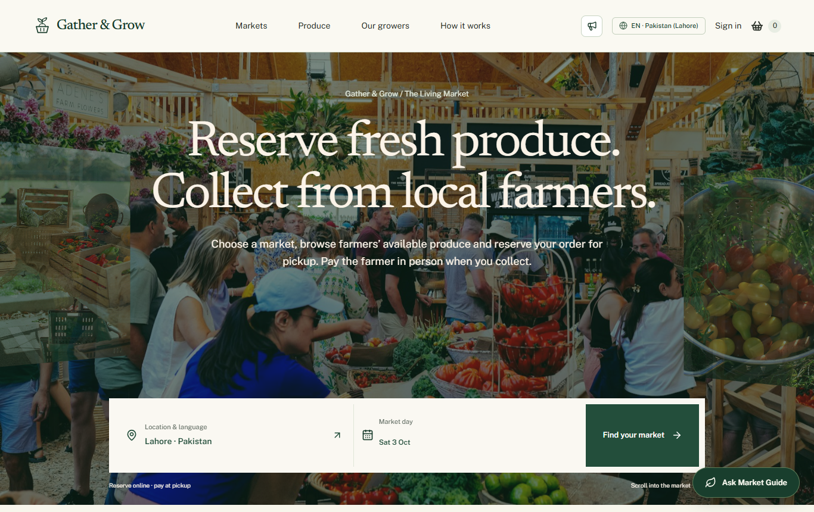
Figure 1 Homepage captured from the local website after the data reset
The homepage introduces the reservation and pickup idea. The hero includes location selection, market-day selection and a discovery action. Changing the location should change the available markets and produce. An unsupported location shows a coverage message instead of unrelated markets.
Section | Purpose
Hero and location controls | Choose where and when to shop
Start Here | Explain the first steps in plain language
Market Explorer | Connect venue discovery with the selected day
Market announcement | Show the latest published notice when available
Harvest Index | Browse relevant produce for the selected market context
Market Journey | Explain discovery, reservation and collection
Market Pulse | Present platform activity from the available data
Copilot showcase and trust section | Introduce optional assistance and the pickup model

The preloader and scroll transitions are presentation features. They must not hide essential controls. Reduced-motion preferences change motion behaviour. Activity statistics must not be treated as verified sales or uptime measurements.

Markets and maps
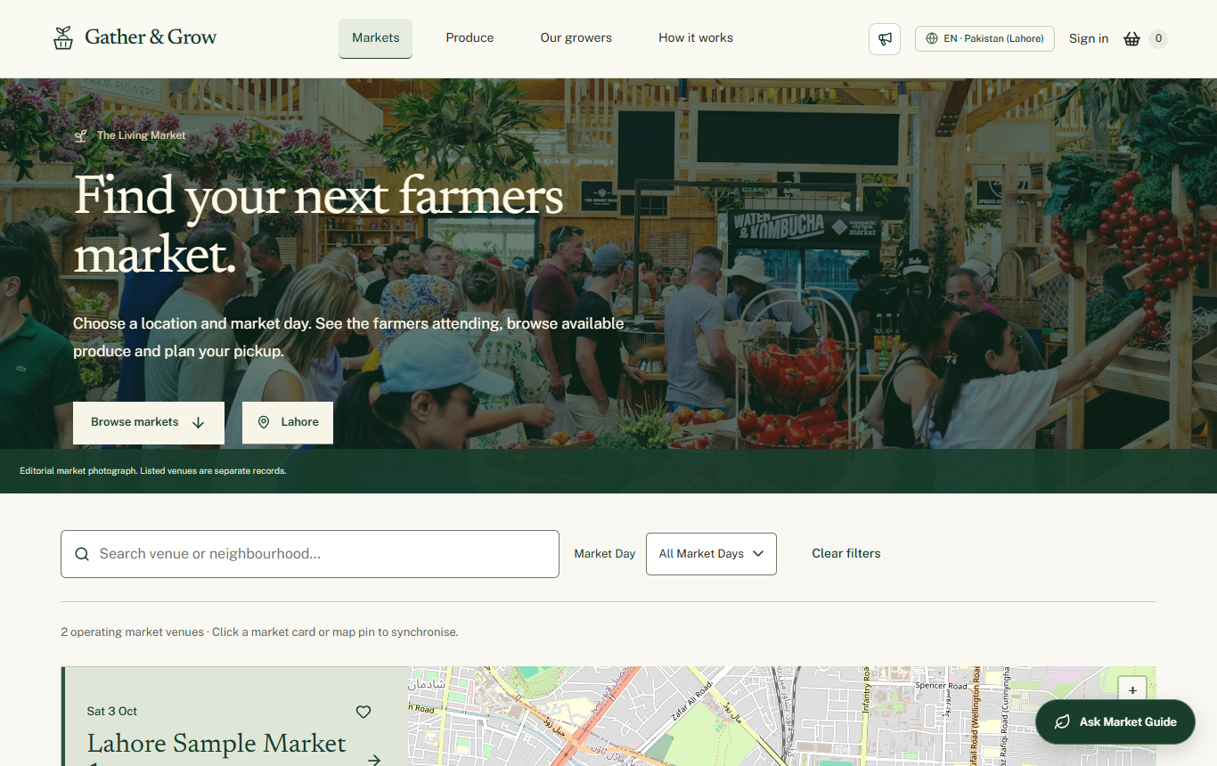
Figure 2 Market discovery with the current sample catalogue

Market directory
A visitor browses venues by location and market day. Search and available filters narrow the results. The directory connects a map selection with market information, so the user can understand where collection takes place. No matching venue should produce an empty state and a way to change the filters.

Market detail
Opening a market shows its address, operating schedule, map position, participating growers and related produce. The user can continue to a grower or product and open directions. A map pin is stored with the venue; the sample-data pins are approximate city centres and must not be used as verified physical pickup addresses.

Map tools
The application uses Leaflet and OpenStreetMap-based maps. Farmer profile and administrator venue forms support searching and placing a pin. The map picker separates the readable address from latitude and longitude. This does not require the owner to purchase a Google Maps key. Internet access and map-provider availability are still required.

Venue setup responsibility
The administrator creates the market and its local timezone, currency, opening days and hours. An approved farmer requests participation in a matching city. After approval, that farmer publishes dated stock and creates pickup windows. Customers can then choose a compatible window at checkout.

Grower directory and stall pages
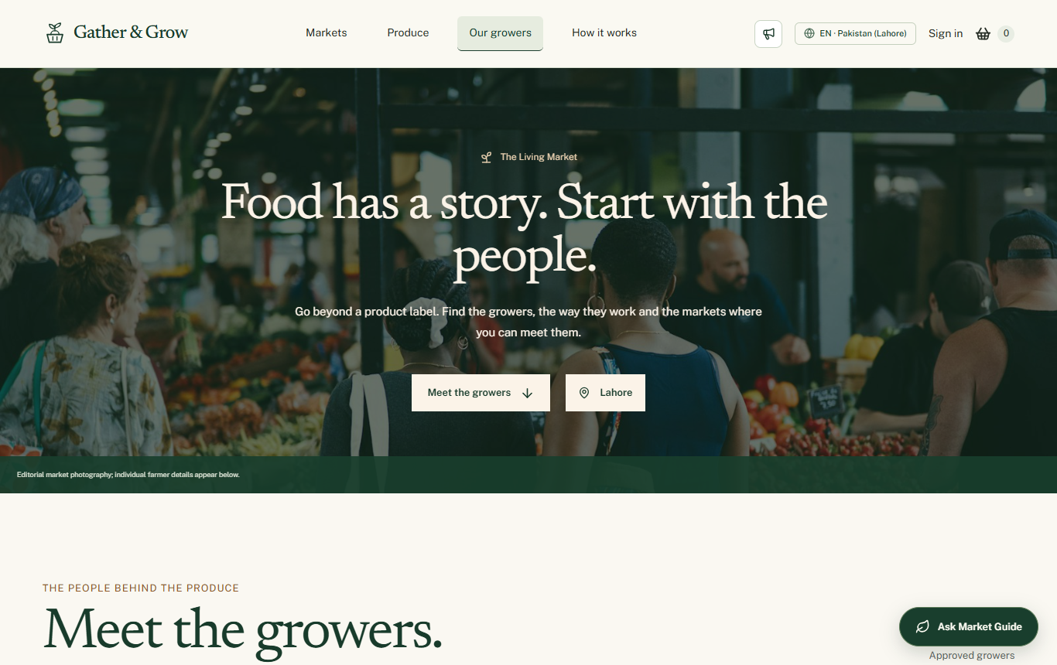
Figure 3 Grower directory captured after the data reset
Our growers introduces the businesses behind the catalogue. Selecting a grower opens the stall page with the business name, story, location, market participation and produce. Customers can save the grower and use the available messaging entry point when signed in.

Stall reviews
The stall page is the main public location for grower ratings, written reviews and farmer replies. The requested design keeps reviews at the stall rather than repeating them under product details. Empty ratings must not appear as fabricated feedback. Reviews need to remain readable when the surrounding section uses sticky positioning.

Customer actions
1. Open a grower and check the market and available day.
2. Browse that grower’s produce and inspect a product.
3. Save the grower if useful, or start an authorised conversation.
4. After a completed order, use the review action from the order record.
The SRS also requires individual product reviews. That target must be tested separately; a visible stall review section does not by itself prove full product-review coverage.

Produce catalogue and product details
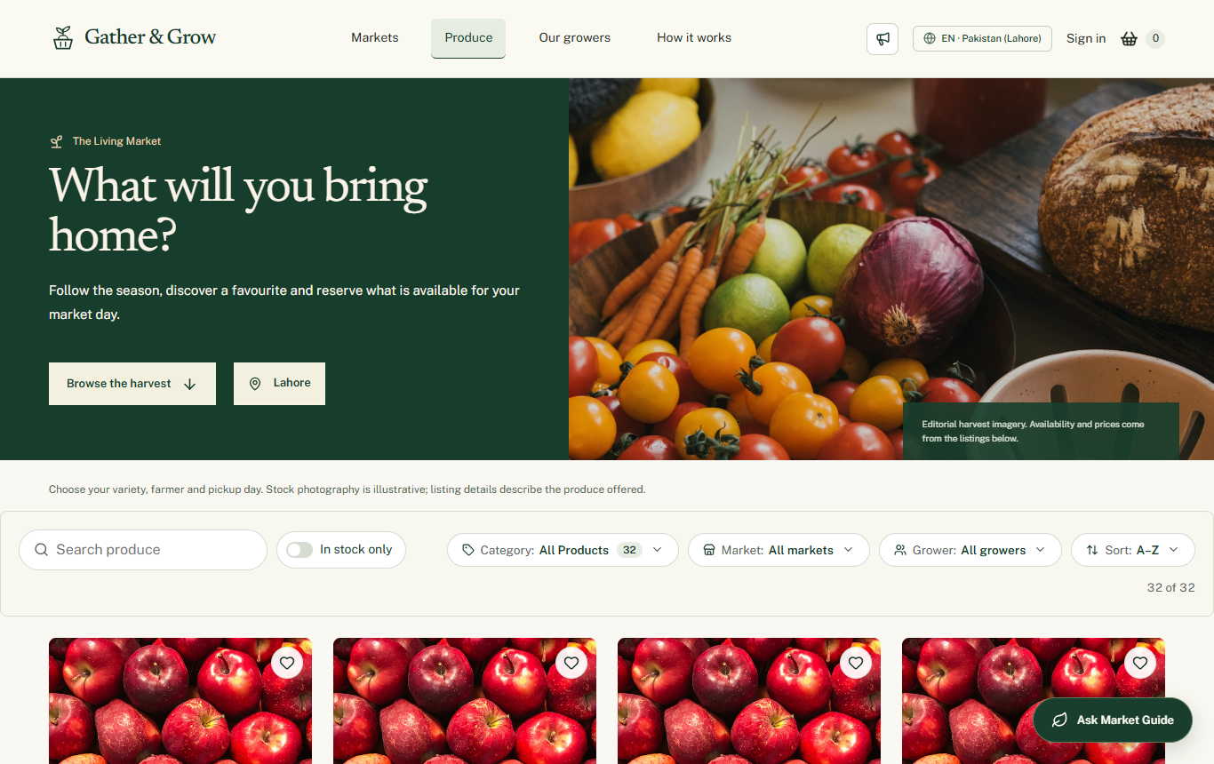
Figure 4 Produce directory with current sample products

Discovery
The Produce page combines search, a category selector near the results count, and available market, day and sorting controls. The displayed count should describe the filtered records. A category selection changes results rather than opening an unrelated page. The selected browsing location limits relevant supply.

Product details
The product page explains the item, grower, selling unit, price and available quantity. The customer must understand the market date and pickup context before adding the item to the basket. Quantity controls must respect the selected offer. Unavailable stock should not remain purchasable simply because a product record exists.

Stock and alerts
The product catalogue and dated stock serve different purposes. The listing can remain visible while a particular dated offer is unavailable. Restock subscriptions let a signed-in customer ask for an alert. Reopening a product later does not guarantee the earlier price or quantity is still available; checkout validates it again.

Sample content
The final dataset has four products for each sample grower: tomatoes, carrots, apples and bread. Descriptions identify sample prices and quantities as evaluation data. These examples are not a claim of certified organic produce or real commercial stock.

Registration and account access
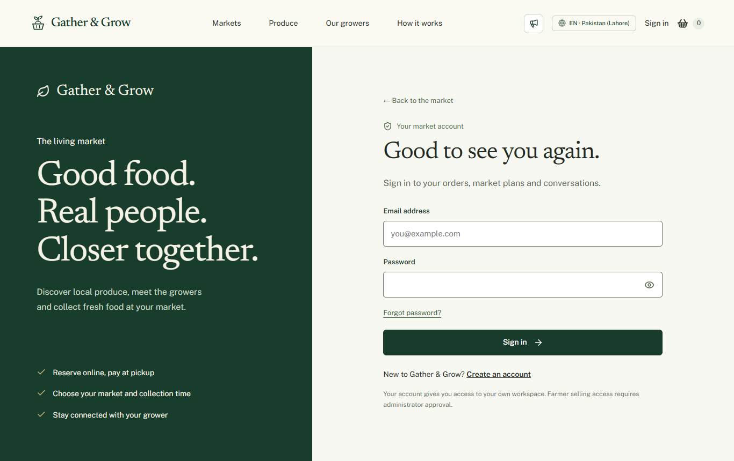
Figure 5 Current login interface
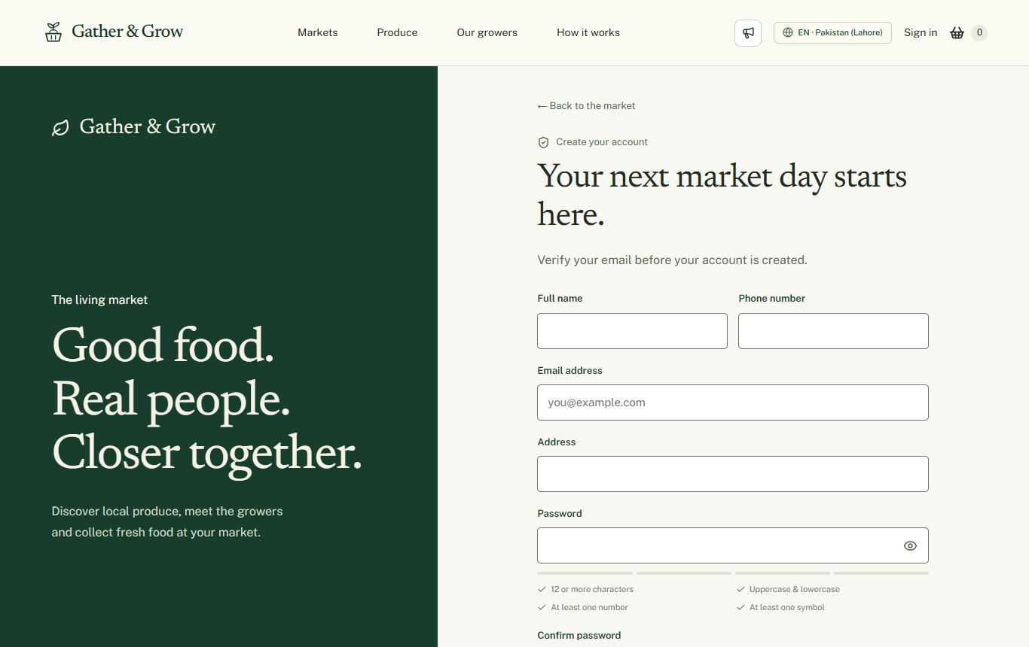
Figure 6 Customer registration interface
Visitors choose customer or farmer registration. Customer information includes name, email, contact details and address. Farmer registration leads to the business application. New registration uses an email verification code before access is completed. Login also uses the configured verification flow, with the owner-requested exception for the designated administrator.
The password interface shows requirement feedback and supports showing or hiding the value. New passwords require at least 12 characters, upper and lower case letters, a number and a symbol, within the 72-byte limit. The forgot-password flow uses an email code and validates the new password. Unknown accounts receive a not-registered message in the implemented flow.
OTP delivery depends on server email configuration. An accepted form is not proof that an email reached the inbox. Rate limits, expired codes, wrong codes and unavailable email service need final live verification. No passwords or email app passwords belong in this document or public screenshots.

Customer dashboard and market planning
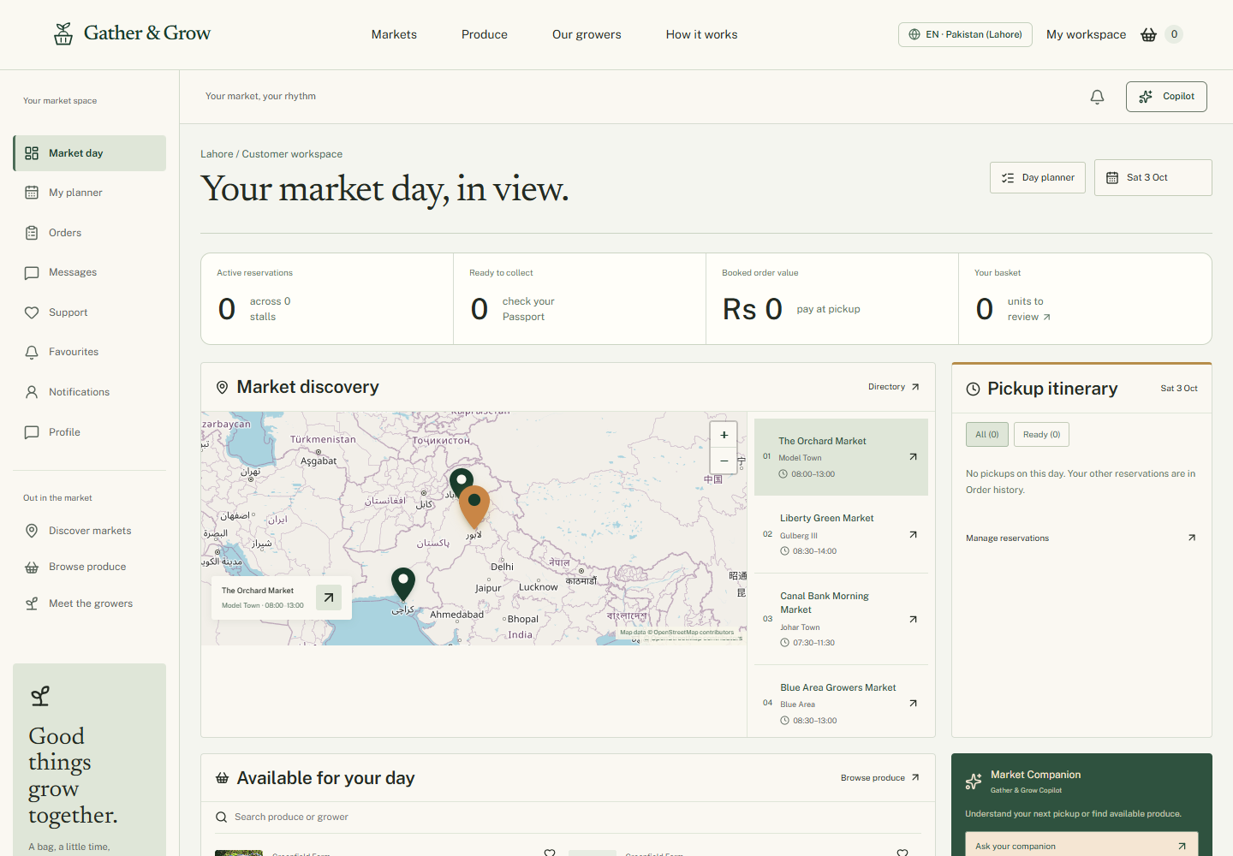
Figure 7 Customer workspace using an isolated test session
The customer dashboard is the personal market-day workspace. It brings together upcoming reservations, pickups, useful market links and saved interests. The user can open orders, planning, messages, support, favourites, notifications and profile from the navigation.

Market Day Planner
The planner arranges the customer’s market visit around upcoming orders and pickup details. It connects the selected date with collection windows and venues. It is a planning view, not a guaranteed travel-time or automatic route-optimisation service.

Pickup Passport
Order details include a pickup-focused presentation of the reference, farmer and collection information. The customer can use this as a reminder at the venue. This must not be described as online payment, identity verification or a guaranteed QR scanning system.

Profile
The profile page lets the customer maintain supported contact and preference information. Updates belong to the signed-in account. The customer’s saved address and the public browsing location serve different purposes; changing one does not automatically create a new market.

Basket and reservation checkout
1. Add a product with an available dated offer to the basket.
2. Review the farmer groups, quantities and selling units.
3. Choose the matching pickup date and available window for every farmer group.
4. Review each reservation and the total booked value.
5. Confirm the reservation while signed in.
6. Open the resulting order record and follow its status. Pay physically at pickup.

Validation and consistency
The server checks available stock, farmer and market relationships, pickup capacity and cutoff time. A browser total is only a preview. The backend reserves the accepted quantities and records the order. A stock conflict should produce an error that helps the user update the basket, not a false confirmation.

Why a pickup list may be empty
- The farmer has not created a window for the exact market and date.
- The window cutoff has passed or capacity is full.
- The basket refers to a different market day.
- The farmer or market is not eligible to take reservations.
- The API could not load the current windows.
To fix setup, the farmer opens Markets, checks approved participation, publishes dated stock, then opens Pickup windows to create a valid window. The administrator’s venue opening hours alone are not enough.

Several farmers
The basket is grouped by farmer because each stall prepares its own reservation and has its own collection window. Mixed currencies must not be interpreted as one converted payment total. Follow any server restriction when combining different markets or currencies.

Orders and pickup lifecycle
Recorded state | Meaning | Next ordinary action
placed | Customer reservation recorded | Farmer accepts or declines
accepted | Farmer has accepted the reservation | Farmer prepares and marks ready
ready_for_pickup | Items are ready to collect | Farmer records completion
completed | Collection recorded | Customer can use eligible review controls
declined | Farmer declined the reservation | Read the recorded reason and released-stock result
cancelled | Reservation cancelled under the rules | Read the confirmation and stock update

The current service treats older confirmed records as accepted. The public interface may show human-readable labels. Preparation checklists are work aids, not an invented extra order status.

Modification cancellation and reorder
The current order service allows item editing only while an order is placed and subject to cutoff rules. Cancellation supports the permitted early states and cutoff checks. Ready or completed orders should not offer an unrestricted cancellation. Reorder checks current products, stock and a new pickup date; it does not guarantee the old items or price.

Farmer sequence
1. Open the incoming order and check its items and pickup time.
2. Accept it or decline with the real reason.
3. Prepare the accepted items and mark the reservation ready.
4. At collection, confirm the correct order and record completion.
Stock quantities and pickup capacity must remain consistent after changes. Tests should also cover repeated requests and concurrent reservations. Do not claim that changing a card locally has changed the database.

Favourites notifications and reviews

Saved records
Favourites groups saved products, farmers and markets. A customer can return to a record and remove it from the saved list. Empty groups have an empty state. Favourite growers and products are required by the SRS; market preferences support the pickup journey.

Notifications and restock
Notifications show relevant account and order information with read and unread controls. Restock alerts relate to a selected product or market context. Email and in-app notification delivery are distinct: a stored notice does not prove SMTP inbox delivery. The ordinary website remains usable if email delivery is delayed.

Review flow
1. Open a completed order from order history.
2. Select the available review action.
3. Enter a rating and an honest comment for the supported review target.
4. Submit and follow any moderation state.
5. Read eligible public reviews and a farmer reply from the stall experience.
The backend owns review eligibility, ownership and moderation. Administrators can moderate inappropriate content. The owner must confirm product-specific review coverage against the SRS. Seeded example ratings were removed in the final dataset, so empty reviews are expected until real evaluation orders are completed.

Farmer application and market joining
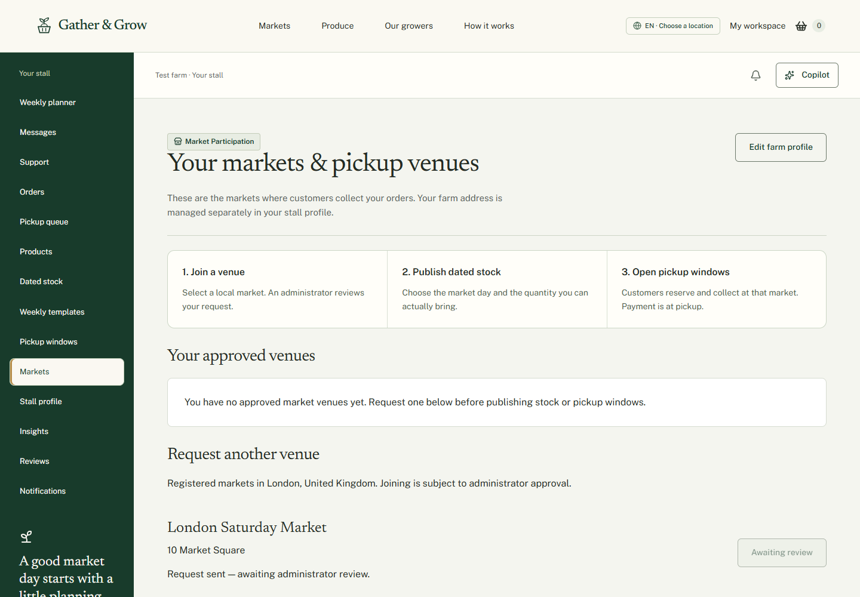
Figure 8 Market participation interface from earlier isolated verification

Application
A farmer supplies business details, contact information, location and the required application fields, then submits for review. Draft details must not be treated as a submitted application. Pending, returned and suspended access is restricted. The application view explains the decision or next step. Support remains available for questions.

Return and resubmission
The administrator reviews the full submitted details. If correction is needed, the decision should include a reason. The farmer edits and resubmits rather than creating a second identity. Approval in the administrator panel and the farmer workspace must agree after refresh.

Joining a market
1. Open Markets in the farmer workspace.
2. Check Your approved venues.
3. Under Request another venue, choose a registered market matching the profile city and country.
4. Send the request and wait for the administrator decision.
5. After approval, plan dated stock and pickup windows for that venue.
If no matching venue exists, contact support about the city or venue. The farm map pin belongs in the stall profile and does not itself join a market. A rejected venue request shows feedback and can be requested again.

Farmer products and inventory

Products
The Products page lists the farmer’s own catalogue. Add Produce opens the product form. The farmer enters a name, category, unit, description, price and supported image information. Editing changes the relevant listing. Archiving removes a product from normal sale while preserving relationships needed by existing records.

Dated stock
Dated stock connects a product to a market and day. It contains price, currency, published quantity, reserved quantity, available quantity and availability status. The farmer can change supported quantities and mark a line unavailable or sold out. A positive quantity alone does not override an unavailable status.
Published stock must never be lowered below active reservations. The display should distinguish total stock from stock already reserved. Reopening availability and increasing quantity are different operations. The final seed uses 40 available units per offer with zero reservations.

Weekly templates
A recurring stock template describes the farmer’s usual weekly produce. It can be adjusted and used to prepare dated offers. A template is not a customer order or an automatic promise that every future market day has stock. The actual dated offers remain the records used during reservation.

Price comparison
The stock interface includes a comparison with other listings in the same category and selling unit. It is a planning aid based on application records, not an external price feed. It does not prove identical variety, quality or certification.

Pickup windows and weekly planning
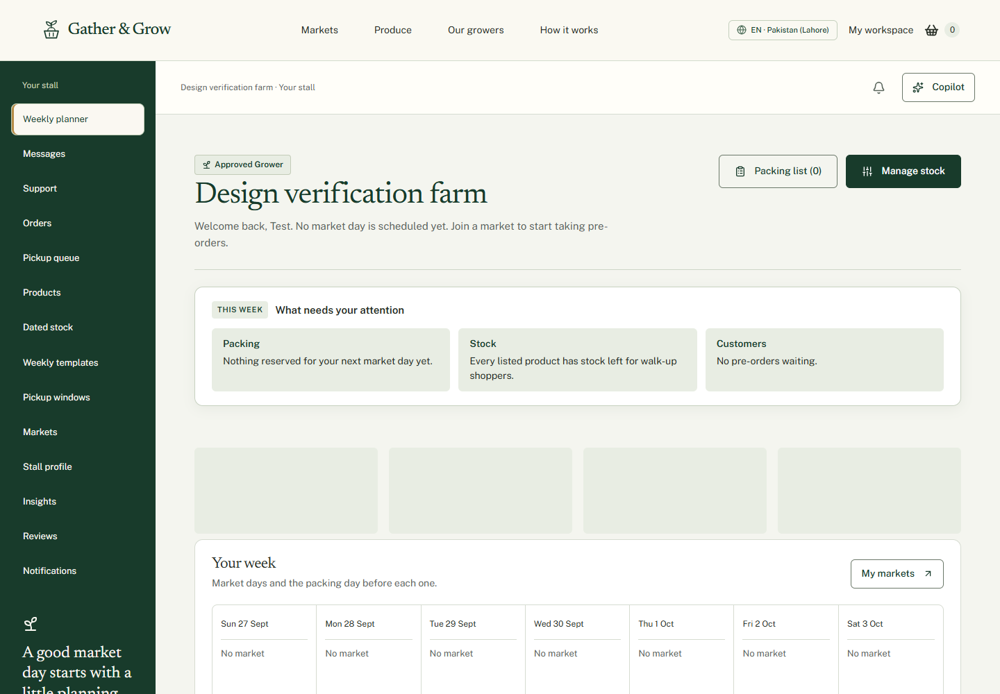
Figure 9 Farmer workbench using an isolated test session
The farmer overview brings the next market session, pending decisions, preparation, stock health and upcoming pickups together. The weekly view helps the grower move between preparation and market days. Each item should use the same underlying reservation across Orders and Pickups.

Creating a pickup window
1. Choose an approved market and an upcoming operating date.
2. Enter a start and end time within the venue schedule.
3. Set the permitted capacity and order cutoff.
4. Save the window and confirm it appears for that date.
5. Publish matching dated stock, then check the customer basket for the same farmer, market and date.
Window capacity limits reservations rather than product units. A customer may buy several units in one order. Cutoff time controls when a reservation can be changed or placed according to the server rules. The venue timezone is important, particularly when browsing the international sample dataset.
The dataset generator converts local cutoffs using the venue timezone. Some existing overview date calculations use Asia/Karachi. Full cross-timezone planning and display still need live acceptance testing; the sample-data checks do not certify the entire UI as timezone independent.

Farmer orders insights and reviews

Order queue and detail
The farmer can search and inspect incoming reservations, open individual orders and use the allowed accept, decline and readiness controls. The detail view connects the customer order, item quantities and collection time. A decline reason should describe the actual decision.

Preparation and pickup queue
Accepted orders feed preparation work. The pickup queue focuses on collection readiness and completion. The grower should verify the order reference before marking it collected. Completion affects later review eligibility and reporting; it is not proof of electronic payment.

Insights and reports
The reports view provides supported period-based metrics, order activity, stock information and product performance. It can help the farmer understand demand and prepare the next market day. Booked amounts should be read with the order state and currency. An empty dataset should show empty or zero results instead of invented trends.

Reviews and profile
Farmers can read eligible feedback and add supported replies. The Stall profile page updates the business name, contact person, phone, story, address and map pin. The profile explains the grower, while market participation controls where customer pickups happen.

Messages notifications and support
Messages are direct customer conversations. Notifications highlight relevant updates. Support opens a separate ticket with the administrator. Farm Copilot is available as an optional assistant for permitted records and proposed actions.

Administrator Command Centre
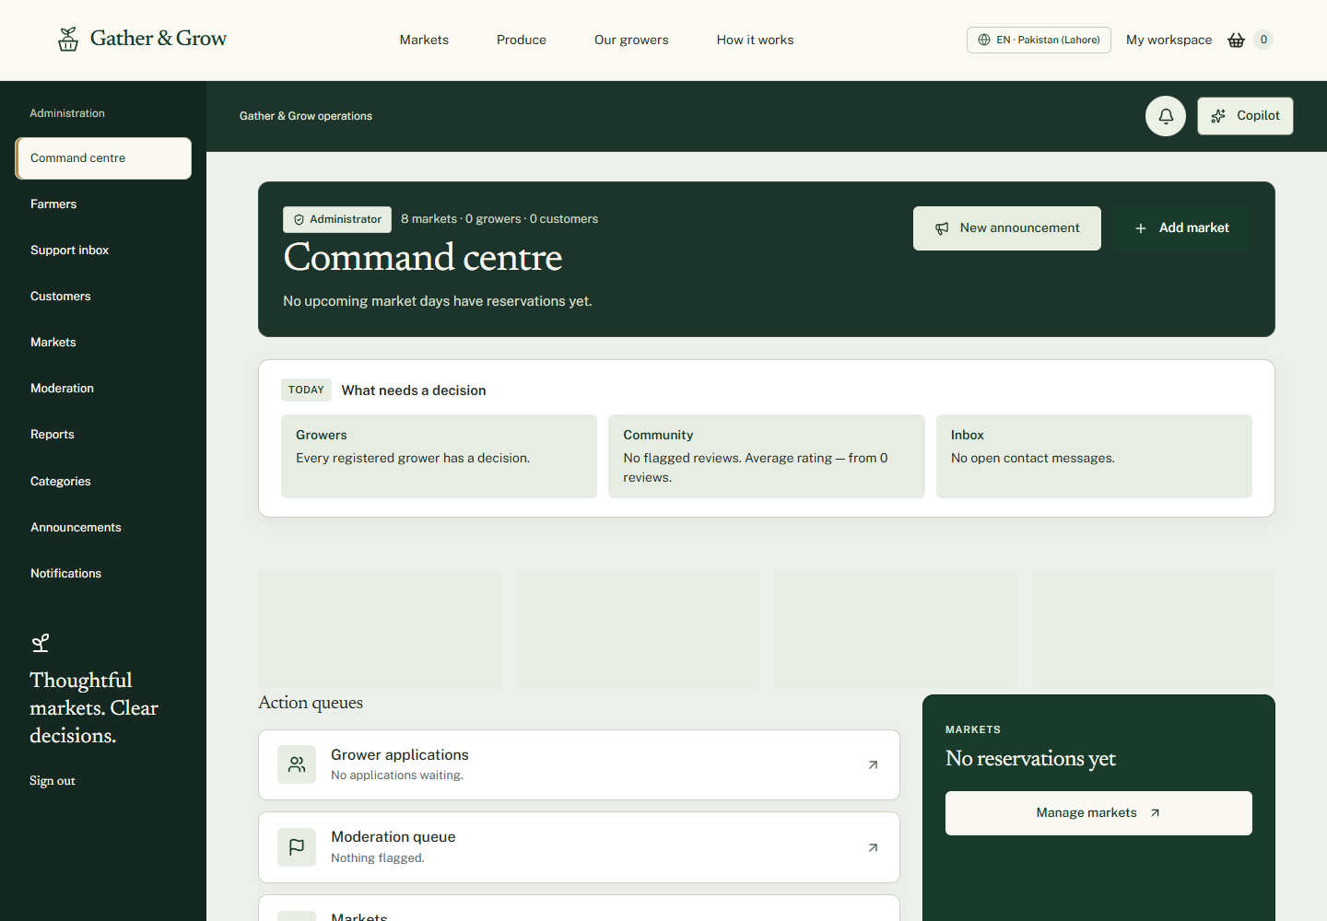
Figure 10 Administrator dashboard captured during earlier interface verification
The Command Centre is the administrator’s operational overview. It surfaces submitted grower applications, moderation work, markets, open inquiries and platform metrics. Quick actions lead to market creation and announcements. Reported values come from the available records; no payment revenue or uptime is invented.

Decision priorities
- Review completed farmer applications rather than drafts.
- Inspect venue participation requests and their requested location.
- Review flagged or pending reviews and hidden listings.
- Reply to unresolved inquiries or support tickets.
- Check market schedules and platform reports.

Reports
Reports and analytics provide supported period and location views of orders, booked value and farmer activity. Currency-separated values should remain distinct. With the cleared submission dataset, a lack of orders is expected. Empty metrics do not mean the dashboard should invent transaction history.

Access
Administrative pages require the admin role. Customers and farmers cannot gain administrative permission by navigating to an admin URL or by asking an assistant. The owner-requested login exception for the designated admin must not be described as a general security improvement.

Administration and moderation
Area | Available work | Important rule
Farmers | List profiles, inspect full applications, approve, return or suspend; review venue requests | Give reasons where needed and verify the farmer view updates
Customers | Inspect registered customers and supported activation controls | A disabled account must not retain unrestricted API access
Markets | Create or edit venue name, address, country, city, map pin, schedule, timezone and currency | Existing reservation relationships must remain safe
Categories | Manage the master catalogue categories | Do not confuse categories with individual stock offers
Moderation | Review listing visibility and customer reviews | Preserve the reason and permitted audit information
Reports | Read platform activity and supported exports | Booked value is not verified payment revenue
Support inbox | Reply to tickets, inspect authorised conversations and close issues | Private records require server permission checks

Market editor
The venue form includes address details and a map picker. Operating days, local opening and closing times, IANA timezone and currency are entered separately. Editing a venue does not automatically publish a farmer’s stock or create a pickup window. Removal or deactivation must follow the restrictions protecting active orders.

Application review
Open the farmer’s detail page before deciding. Check the submitted business, contact and location information. Approve or return with a meaningful message. Review market requests in the same farmer context so that the approved venue matches the intended collection location.

Announcements and contact

Announcements
The administrator creates and manages notices from Announcements. Published notices are accessible through the public Market announcements header control. The homepage also displays the latest published notice when the selected area has market coverage. Archiving or unpublishing should remove a notice from current public notices.
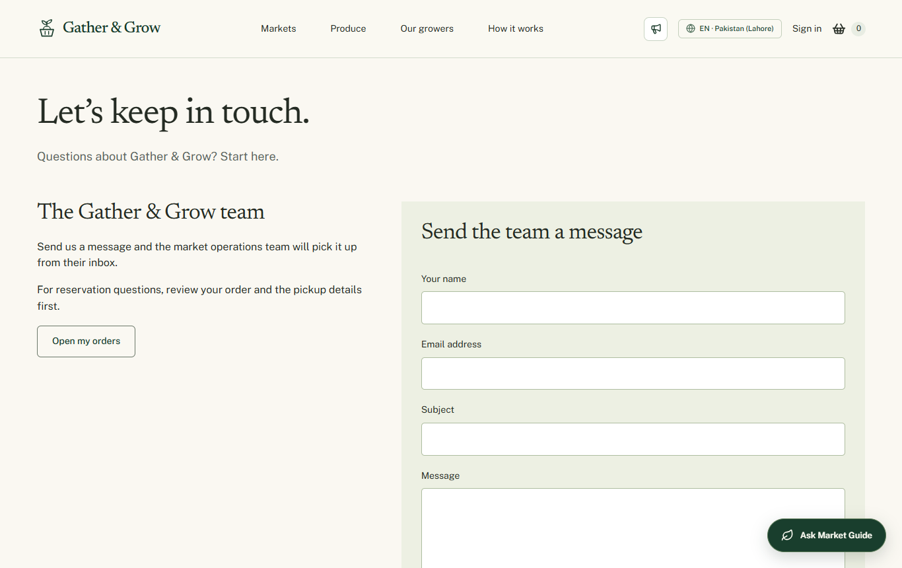
Figure 11 Current public contact form

Contact form
A visitor enters name, email, subject and message. The backend validates the input and stores or handles the inquiry through its configured flow. Email forwarding to the administrator and a fixed acknowledgement depend on server SMTP settings. An app password alone is not enough: the sender account address must also be configured.
The administrator receives the visitor message with a reply address. The visitor acknowledgement confirms receipt, not resolution. SMTP acceptance does not prove inbox delivery. General contact inquiries and signed-in support tickets are separate records.

About and Help
About explains the platform and its purpose. Help explains how discovery, reservation and pickup work. These pages should make the payment-at-pickup model and the difference between a venue and a farmer clear. The public guide offers optional help without replacing these ordinary pages.

Messages and support tickets
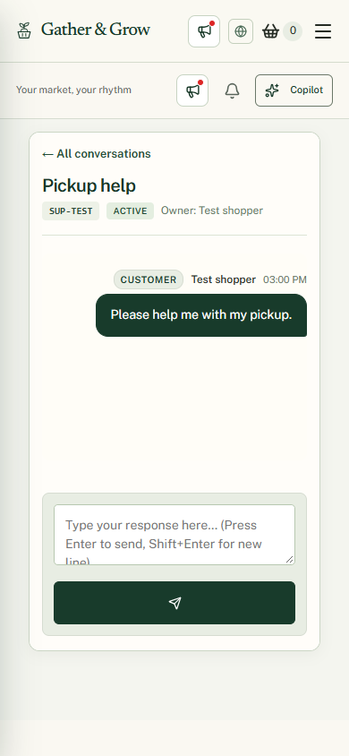
Figure 12 Mobile support conversation using an isolated test account

Customer and farmer messages
A signed-in customer can open the supported conversation with a farmer. Both participants can read their thread and send messages. The messaging interface includes conversation history, read tracking, unread indicators and archiving. Farm reply suggestions are drafts; sending is a separate authorised action.

Support workflow
1. The customer or farmer opens Support and creates a ticket with a subject and problem description.
2. The ticket receives a reference and appears in the participant’s inbox.
3. The administrator searches or opens the ticket and replies.
4. The participant reads the response and sends any further information.
5. The administrator closes the ticket when the issue is resolved. The history remains readable.

Conversation inspection
An authorised administrator can use a conversation ID to inspect a customer and farmer thread. A support ticket reference is different from a chat conversation ID. Knowing an ID must not grant another customer access. Passwords, app passwords and keys should never be posted in messages.

Mobile inbox
On a small screen the interface opens one conversation at a time and provides a return-to-list control. Open and closed filters help separate active support work. Loading and failure states should not be confused with an empty inbox.

Public guide and dashboard Copilot
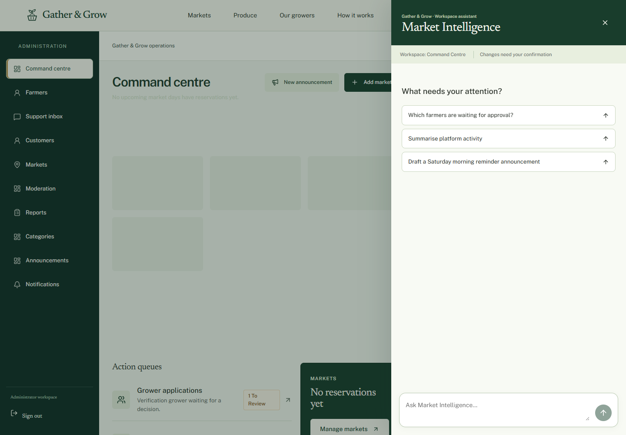
Figure 13 Dashboard Copilot from isolated browser verification

Public Market Guide
The public guide answers questions about catalogue products, farmers, markets and how pickup works. Relevant result cards and navigation links help the visitor continue. A general question should not always produce an unrelated product list. The implementation also supports a guided contact inquiry; it must not be described as wholly read-only. It has no authority to manage dashboards or private orders.

Role assistants
Customers use Market Companion, farmers use Farm Copilot and administrators use Market Intelligence. They share a conversation interface but receive different permitted tools and context. The registry later in this document lists the implemented tool declarations. Registry presence is not proof that every provider-backed tool has passed live testing.

Safe action flow
1. Ask a question or request a supported change.
2. Inspect the answer, references and proposed action.
3. For a consequential action, review the before-and-after preview.
4. Confirm the draft through the supported control.
5. Read the backend success or error result. An expired or conflicting draft must be refreshed rather than treated as completed.
The backend owns OpenAI access, data retrieval, permissions and action execution. No provider key belongs in the frontend. Normal forms remain available when AI is unavailable. The assistant must not invent farmers, stock, prices, sales or successful changes.

Design accessibility and mobile use
The visual system uses forest green, ivory, ink, sage and restrained harvest accents without gradients. Newsreader supports editorial headings and Public Sans supports operational text and controls. Public pages tell the market story; customer pages focus on the visit; farmer and admin workspaces use denser operational layouts.
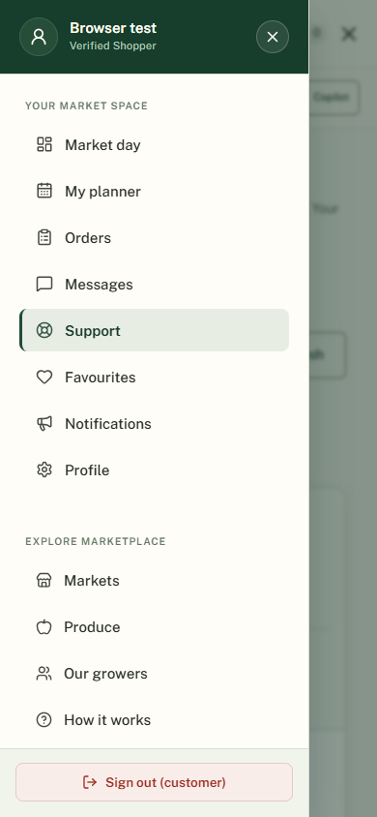
Figure 14 Mobile workspace navigation using a test session

Interaction approach
- Use readable labels, visible focus, meaningful validation and clear button states.
- Make forms and dialogs usable with a keyboard.
- Keep operational tables readable on smaller screens.
- Provide reduced-motion behaviour for decorative and scroll-driven effects.
- Use navigation drawers and conversation detail views suited to mobile screens.
- Show loading, empty, denied and failed states separately.
The site uses GSAP, Motion and CSS for entrances, section movement, overlays and feedback. Animation is presentation, not proof of progress on the server. Targeted mobile checks have been completed, but no formal WCAG certification or full cross-browser certification is claimed.

Architecture and data flow
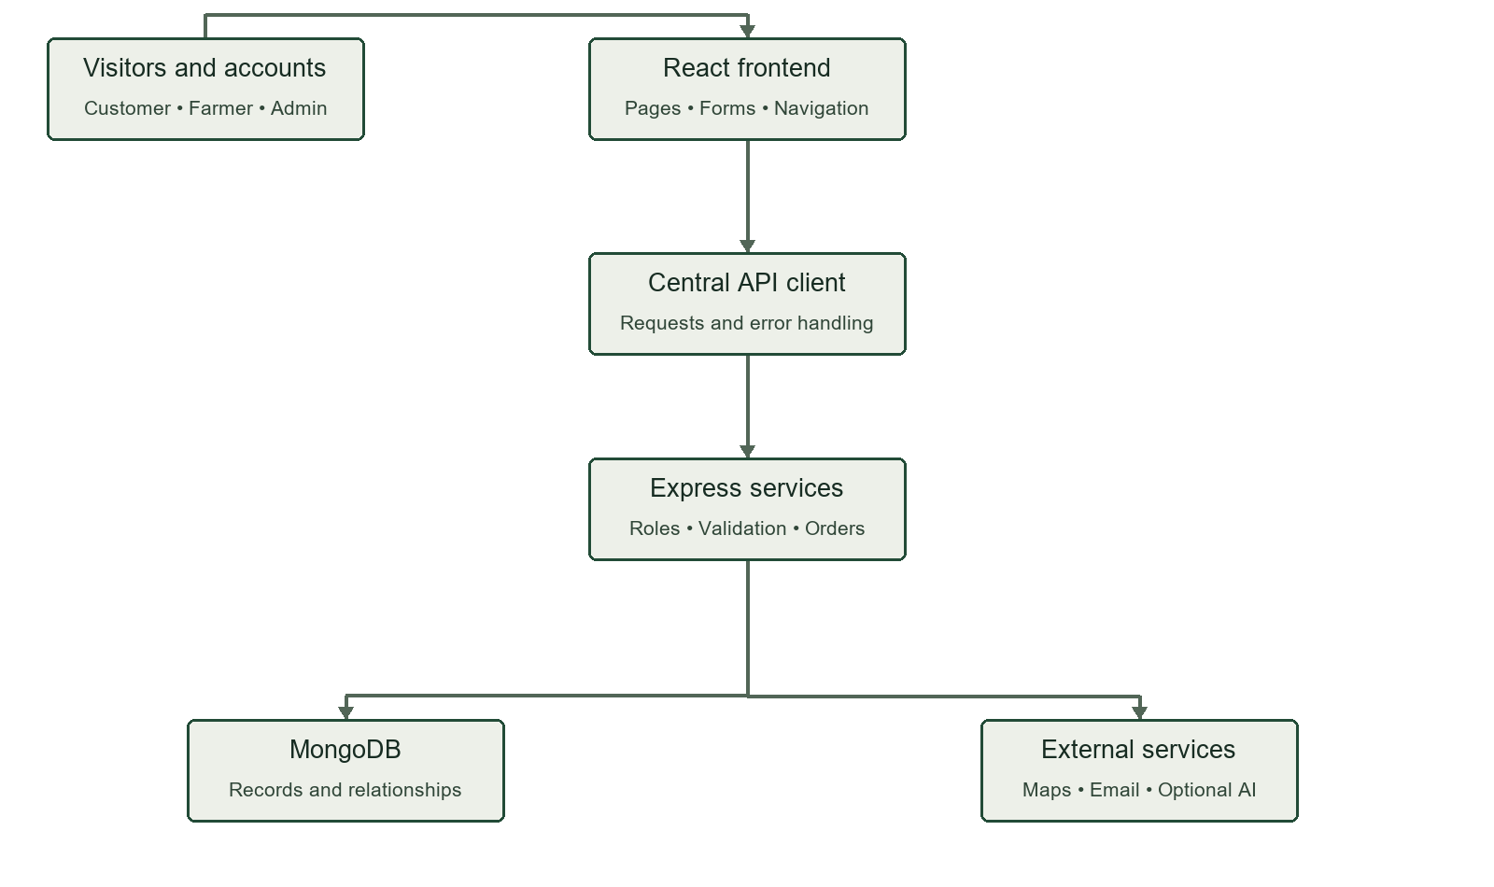
Figure 15 Application architecture and the main request path
Layer | Responsibilities
React TypeScript and Vite | Pages, components, routing, form interaction, API state and responsive design
Central client API layer | Request transport, authentication context, errors and domain calls
Express API | Validation, authentication, role checks and business services
MongoDB native driver | Users, markets, stock, orders, messages and related records
External providers | Map tiles and location search, configured email delivery and optional AI

Discovery data flow
Visitor selects a location → frontend requests catalogue data → server reads active markets, approved farmers, listings and offers → frontend displays matching results. The browser does not connect directly to MongoDB.

Reservation data flow
Customer confirms basket → API checks ownership, offer quantity, window and cutoff → order service records the reservation and stock allocation → customer and farmer views reload authoritative records. Errors return to the current form for correction.

Administrative data flow
Administrator opens a decision → API checks the admin role → service validates the proposed change → database record and supported audit information are updated → dependent views refresh.

AI data flow
Conversation request → authenticated role context → registered tool selection → permitted record retrieval or action draft → user confirmation where required → normal business service validation. An AI response must not bypass stock checks or permissions.

Source organisation
Client/src/features holds role and public views. Client/src/components contains shared interface elements. Client/src/data and Client/src/lib provide state and API access. Server/src/routes, controllers, services, schemas and middleware separate request handling. Server/src/seed and Server/scripts contain data preparation and export tools.

Database design
The application uses MongoDB collections with ObjectId references. Monetary values are stored in minor units with a currency. Timestamps use dates; market dates are stored separately from local pickup times. GeoJSON points use longitude before latitude.
Collection | Main data and relationships
users | Email, password hash, role, name and activation; parent identity for account records
farmerProfiles | User reference, business and contact details, approval, location and market references
markets | Name, address, country, city, GeoJSON point, local schedule, timezone and currency
categories | Unique category name and slug with active state
products | Farmer and category references, name, unit, base price, image and visibility
stockOffers | Farmer, market, product and date; published, reserved and available quantities
pickupWindows | Farmer, market and date; local times, cutoff and capacity
orders | Customer and farmer references, item snapshots, market date, pickup and status history
reviews | Customer, order and target references; rating, comment, reply and moderation
favourites and restockAlerts | Customer links to saved targets or subscribed availability
weeklyStockTemplates | Farmer recurring inventory planning records

Database relationships and supporting records
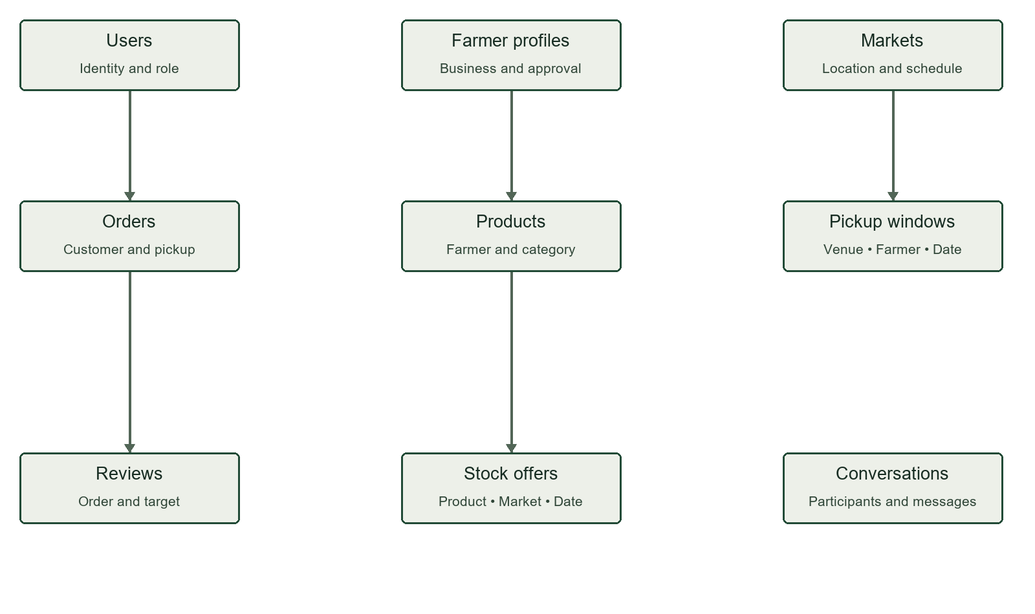
Figure 16 Selected database relationships; the table explains additional links
Relationship | Meaning
User → Farmer profile | A farmer account owns its business profile
Farmer profile → Markets | A grower may participate in approved venues
Farmer profile → Products | Each product belongs to a farmer
Product + Market + Farmer + Date → Stock offer | Quantity is specific to a trading occasion
Farmer + Market + Date → Pickup windows | Time capacity is shared by reservations for that occasion
Customer → Orders → Item snapshots | Orders preserve what was reserved at the time
Completed order → Eligible review | Review permission depends on recorded customer activity
Participants → Conversations → Messages | Direct chats belong to authorised participants

Supporting collection | Purpose
notifications | Account and order notices
announcements | Published platform notices
contactInquiries | Public contact submissions
supportTickets | Owner, reference, status and support conversation
conversations and messages | Customer and farmer chat records
aiActionDrafts | Proposed AI actions and confirmation lifecycle
auditLogs | Supported changes for review
pendingRegistrations | Registration verification before account creation

Indexes include unique account email, unique farmer user linkage, category uniqueness and a compound dated-stock key. Geographic indexes support stored map locations. The export includes index definitions. Do not share password hashes, registration codes or private conversations in public screenshots.

Installation and configuration
1. Install a Node.js version meeting Client/package.json, currently 22.12 or newer, and npm.
2. Extract Project Folder to a writable local directory.
3. Run npm ci inside Server and then inside Client.
4. Configure private server environment values using the supplied examples. Use your own database connection and strong production signing secrets.
5. For the exported dataset, select a dedicated empty evaluation database and run node scripts/restore-submission.mjs followed by the absolute MarketLink.ejson path from Server. The script refuses a nonempty target.
6. Run npm run dev in Server. Run npm run dev in Client. Open the Vite address and confirm API connectivity.
7. Run npm run build in Client for production assets. Configure hosting and API routing for the deployed environment.

Configuration groups
Group | Values and purpose
Database | MONGODB_URI and MONGODB_DB_NAME select the database
HTTP and auth | PORT, CLIENT_ORIGIN, JWT_SECRET, JWT_EXPIRES_IN and COOKIE_SECRET
Registration email | EMAIL_USER, EMAIL_APP_PASSWORD and EMAIL_FROM
Contact email | Use Server/contact-email.example.env and the contact setup notes; set sender address as well as its app password
AI | OPENAI_API_KEY and OPENAI_MODEL remain server-only
Regional defaults | DEFAULT_CURRENCY and DEFAULT_TIMEZONE do not replace individual venue settings

Do not expose private environment files in the source archive. Do not use the legacy npm run seed command on the prepared submission database because it replaces its data. The restore helper has not been tested against a separate fresh deployment during this documentation task.

Test data and verification
Dataset item | Count
Countries | 10
Cities | 40, four per country
Markets | 80, two per city
Growers | 320, four per market
Products | 1280, four per grower
Dated stock offers | 5120
Pickup windows | 2560
Users | 321, including the preserved administrator
Old orders and reviews | Removed after private backup

Countries are Pakistan, United Kingdom, United States, Canada, Australia, Germany, France, United Arab Emirates, India and South Africa. Sample venues use approximate city-centre pins. Each grower has four produce examples and four future weekend stock dates. The data is illustrative and labelled accordingly.

Verification evidence
Check | Recorded result
Frontend production build | Passed in the preceding implementation checkpoint
Frontend unit tests | 27 passed at the preceding checkpoint
Focused backend tests | 38 passed after submission preparation
Dataset consistency tests | 2 passed for counts, relationships, availability and timezone conversion
Export checksum | Verified against the manifest
Local and live catalogue | Both returned 80 markets, 320 growers, 1280 products and 2560 windows
Targeted mobile UI checks | Support, navigation and customer rail checked with isolated responses
Complete live acceptance run | Still required

A passed unit test does not prove email delivery or a complete real order. Screenshots with isolated test records are layout evidence. The final export contains no invented order history or reviews.

Acceptance scenarios and known limits
Scenario | Expected result | Evidence status
Register customer and verify email | One account after a valid code; reject wrong or expired codes | Live email test needed
Submit farmer application | Admin reviews submitted details; returned details can be corrected | Full role-to-role run needed
Request a venue | Correct city venues; decision visible to farmer | Full live run needed
Publish offer and window | Same farmer, market and date visible at checkout | Seed relationships checked
Reserve available stock | Order created once and quantity allocated correctly | Live checkout run needed
Exceed available quantity | Reservation rejected without overselling | Final concurrency test needed
Cancel before cutoff | Eligible order cancelled and reservation released | Live run needed
Complete and review | Only eligible completed-order customer can review | Product target needs review
Open and close support | Owner and admin see the thread; closed state retained | UI verified; live run needed
Publish announcement | Current notice appears publicly; archived notice disappears | Live run needed
Confirm Copilot action | Role, expiry and current record checked before write | Provider-backed acceptance needed

Known limits include unverified real SMTP delivery, unverified final Word pagination, incomplete full-browser acceptance coverage and outstanding product-review target verification. Existing date display assumptions need cross-timezone testing. The server’s decline fallback must be checked so that an omitted reason is not presented as a farmer’s own explanation.
HTTPS configuration should be reviewed before wider production use because the supplied live URL uses HTTP. No 24-hour availability, penetration-test result or verified performance benchmark is claimed.

Page and capability inventory
Routes below come from the current React application. Dynamic identifiers refer to existing records; they are not literal example IDs. Shared pages such as notifications and support are reused across roles.
Area | Route | Purpose
Public | / | Homepage
Public | /markets and /markets/:marketId | Market list and detail
Public | /farmers and /farmers/:farmerId | Grower list and stall
Public | /products and /products/:productId | Produce list and detail
Public | /about /contact /help | Information and contact
Account | /login and /admin/login | Login forms
Account | /register /register/customer /register/farmer | Role choice and registration
Shopping | /basket and /checkout | Basket and pickup review
Customer | /customer | Dashboard
Customer | /customer/market-day | Planner
Customer | /customer/orders | Order history
Customer | /customer/orders/:orderId | Order detail and passport
Customer | /customer/orders/:orderId/edit | Eligible modifications
Customer | /customer/orders/:orderId/review | Eligible review
Customer | /customer/favourites | Saved records
Customer | /customer/messages | Farmer conversations
Customer | /customer/support | Support tickets
Customer | /customer/notifications | Account notices
Customer | /customer/profile | Profile settings

Farmer and administrator page inventory
Area | Route | Purpose
Farmer | /farmer | Weekly overview and workbench
Farmer | /farmer/access and /farmer/onboarding | Application and access state
Farmer | /farmer/products | Own catalogue
Farmer | /farmer/products/new | Create product
Farmer | /farmer/products/:productId/edit | Edit product
Farmer | /farmer/stock | Dated stock
Farmer | /farmer/stock-templates | Weekly templates
Farmer | /farmer/pickup-windows | Capacity and cutoff settings
Farmer | /farmer/orders and /farmer/orders/:orderId | Queue and order detail
Farmer | /farmer/pickups | Pickup station
Farmer | /farmer/markets | Venue requests and approved venues
Farmer | /farmer/profile | Stall details and farm pin
Farmer | /farmer/insights and /farmer/reports | Analytics
Farmer | /farmer/reviews | Feedback and replies
Farmer | /farmer/messages and /farmer/inbox | Customer chat
Farmer | /farmer/support and /farmer/notifications | Support and notices
Admin | /admin | Command Centre
Admin | /admin/farmers and /admin/farmers/:farmerId | Farmer review
Admin | /admin/customers and /admin/customers/:customerId | Customer management
Admin | /admin/markets | Venue directory
Admin | /admin/markets/new and /admin/markets/:marketId/edit | Venue editor
Admin | /admin/moderation | Listings and reviews
Admin | /admin/categories | Category management
Admin | /admin/announcements | Notices
Admin | /admin/reports and /admin/analytics | Platform analytics
Admin | /admin/support and /admin/inquiries | Support tickets and public inquiries
Admin | /admin/notifications | Administrator notices

Customer Copilot capability reference
This inventory records declared backend tools, not a claim that every live AI action has passed testing. Read tools retrieve permitted data. Write tools are subject to normal service validation and the recorded confirmation requirement.
Capability | Type | Confirm | Declared purpose
get profile | read | No | Retrieve the authenticated customer profile, contact details, address, and dietary preferences.
update profile | write | Yes | Propose updating customer profile details such as name, phone, address, or dietary preferences.
get markets | read | No | Find active farmers markets, schedules, operating days, and locations.
get farmers | read | No | View registered farmers, their farm names, bios, and assigned stalls.
get products | read | No | Search the harvest catalogue for available fresh produce, categories, and prices.
search dated stock | read | No | Check available dated inventory, remaining quantities, and pricing for a specific market day.
get pickup windows | read | No | View scheduled market pickup time windows for stalls.
get orders | read | No | Retrieve current customer reservations, orders, items, and status.
get order details | read | No | Get complete itemized details and pickup instructions for a specific pre-order.
cancel order | write | Yes | Propose cancelling a customer reservation order and releasing reserved produce back to the grower.
reorder | write | Yes | Propose repeating a past order for an upcoming market pickup date.
get favourites | read | No | View saved favourite farmers and produce.
toggle favourite | write | No | Add or remove a farmer or product from customer favourites.
get restock alerts | read | No | View active out-of-stock restock notification subscriptions.
subscribe restock alert | write | No | Subscribe for notification when an out-of-stock produce item is restocked.
get notifications | read | No | View order status notifications and platform alerts.
mark notifications read | write | No | Mark notification(s) as read.
submit review | write | Yes | Propose submitting a review and rating for an order or farmer.

Farmer Copilot capability reference
This inventory records declared backend tools, not a claim that every live AI action has passed testing. Read tools retrieve permitted data. Write tools are subject to normal service validation and the recorded confirmation requirement.
Capability | Type | Confirm | Declared purpose
get profile | read | No | View authenticated farmer farmstead details, approval status, and stall designation.
update profile | write | Yes | Propose updating farm stall location, bio, or contact information.
get products | read | No | List all products in the farmer produce catalogue with base prices and units.
create products | write | Yes | Propose adding one or more new produce items to the farmer catalogue with name, selling unit, price in PKR, category, and appetizing description.
update product | write | Yes | Propose updating an existing catalogue produce price, unit, name, or description.
archive product | write | Yes | Propose archiving/discontinuing a produce item from the catalogue.
get inventory | read | No | View active dated stock offers, published vs reserved quantities.
publish dated stock | write | Yes | Propose allocating harvest inventory for an upcoming market date (e.g. 50 kg tomatoes for Saturday).
mark sold out | write | Yes | Propose marking a product or stock allocation as sold out to halt new reservations.
get orders | read | No | View customer pre-orders placed for the farm, filterable by status or date.
update order status | write | Yes | Propose updating an order status: accept, decline (releases reserved stock), mark ready for pickup, or complete pickup.
get reviews | read | No | View customer reviews, ratings, and existing responses for the farm.
reply to review | write | Yes | Propose publishing an official farm reply to a customer review.
get reports | read | No | Retrieve executive operational analytics: orders placed, accepted, completed, booked order value, stock health, top products, pickup workloads, and customer review metrics.
get analytics | read | No | Alias for deep farmer executive analytics and performance breakdown.
get messages | read | No | Retrieve shopper inquiries and customer chat messages, including unread message counts.
draft chat reply | read | No | Draft a polite response to a customer grounded in real inventory and order status.
send chat message | write | Yes | Propose sending an official message or reply to a customer conversation.

Admin Copilot capability reference
This inventory records declared backend tools, not a claim that every live AI action has passed testing. Read tools retrieve permitted data. Write tools are subject to normal service validation and the recorded confirmation requirement.
Capability | Type | Confirm | Declared purpose
get farmers | read | No | List registered farmers and filter by status: pending, approved, suspended.
change farmer status | write | Yes | Propose changing farmer approval state: approve pending applicant, suspend, or reactivate.
get customers | read | No | List registered customer accounts, activity, and pre-order metrics.
get markets | read | No | List platform farmers markets, operating schedules, and stall capacities.
create market | write | Yes | Propose creating a new farmers market location with schedule and operating hours.
update market | write | Yes | Propose updating an existing market schedule, operating days, or active status.
get products | read | No | Audit listed produce across all farmers on the platform.
moderate product | write | Yes | Propose moderating or hiding an inappropriate or non-compliant product listing.
get categories | read | No | List produce categories.
create category | write | Yes | Propose creating a new produce category.
get reviews | read | No | Inspect reviews queue for moderation.
moderate review | write | Yes | Propose moderating or deleting a flagged customer review.
get announcements | read | No | List platform announcements.
publish announcement | write | Yes | Propose broadcasting a platform notice to customers and farmers.
get inquiries | read | No | List public support and contact inquiries.
update inquiry status | write | Yes | Propose updating a support inquiry resolution status.
get analytics | read | No | Retrieve platform analytics, multi-country matrix, market performances, category analytics, booked order value separated by currency, and operational attention queue.

Submission and owner review
Folder or file | Contents
Project Folder | Frontend and backend source plus installation guidance
Documentation | This Word reference draft with screenshots
Project Video | Left empty for the owner’s required recording
Database File | Canonical MongoDB EJSON export, checksum manifest and import notes
Live Links.txt | Repository and website URLs

The SRS allows MongoDB as a database choice. This application therefore uses a native Extended JSON export and index definitions rather than inventing a relational SQL schema. Confirm the accepted database-file format with the centre if it insists on a specific extension.

Evaluation account handover
Role | Current position | Owner action before evaluation
Administrator | Existing admin@marketlink.com account preserved | Supply its password privately to the evaluator
Customer | Old accounts removed during requested reset | Register a controlled email and provide the evaluation credentials privately
Farmer | 320 illustrative profiles use example.test addresses and unavailable random credentials | Register a controlled farmer email, complete approval and prepare a real test stall

The SRS requests credentials for every role. They are intentionally not fabricated or printed in this public-source document. The owner must complete the private handover and make email verification available for evaluation. Do not publish the database export or submission ZIP because it contains the preserved admin password hash.

Required owner completion
- Review and meaningfully revise this AI-assisted draft under the SRS rules.
- Add participant information, actual decisions and final test observations.
- Replace test-session dashboard screenshots if final real-account evidence is required.
- Check Word page layout and screenshot readability.
- Provide private evaluation access for all roles.
- Record the required demonstration video.
- Confirm final deployment, workflow testing and submission packaging.

Additional features beyond the SRS
This final chapter separates added functionality from the minimum requirements. Features already present in the SRS are not counted as new simply because they have a custom layout. Descriptions identify implementation scope and do not claim unverified live success.

Support tickets for customers and farmers
Users create a ticket with a subject and message, keep the history and return for administrator replies. Tickets have references and open or closed states. The SRS asks for contact information but does not specify this ticket system.

Administrator support inbox
The administrator searches and manages tickets, replies and closes resolved issues. Mobile conversation navigation supports the same workflow in a smaller layout.

Direct customer and farmer chat
Separate private threads support message history, unread indicators, read tracking and archiving. This is more specific than the general communication described in the SRS.

Conversation reference inspection
An authorised administrator can look up a customer–farmer thread using its conversation ID. This is separate from the ticket reference and must remain permission-controlled.

Farmer reply suggestions
A backend AI tool can propose a reply using an authorised conversation context. Drafting and sending are separate actions.

Market Day Planner
The customer gets a dedicated view of planned market visits and pickups. The SRS requires pickup details but not this separate planning workspace.

Pickup Passport
A collection-focused order view brings the reference, venue and pickup information together. It does not add an online payment or verified identity mechanism.

Market Day Workbench
The farmer overview links decisions, preparation, stock and pickups. Stock and orders are required; the connected operating workspace is an interface enhancement.

Market participation review
Farmers request specific venues and administrators review those requests. A farm address alone does not create venue membership. This separate request and decision workflow is an extension.

Application return and resubmission
Draft and submitted states, administrator reasons and correction support improve the required farmer approval process.

Produce price comparison
The farmer stock view compares category and unit prices within the application catalogue. It is not an external market-price or quality comparison service.

Role-based dashboard Copilots
Market Companion, Farm Copilot and Market Intelligence extend the optional basic customer chatbot into role-specific record tools and proposed actions.

AI action previews and confirmations
Supported write actions use reviewable drafts, confirmation and conflict or expiry feedback. The backend continues to enforce permissions and business rules.

Guided public inquiry
The public guide can collect a contact inquiry through the supported conversation flow. It does not gain access to private dashboards.

Contact form email and acknowledgement
A submitted contact inquiry can be forwarded to the configured administrator address with an acknowledgement to the sender. This extends the static Contact requirement and depends on working email settings.

Email verification and password guidance
Registration and login code flows, reset codes and visible strength feedback extend the baseline account forms. The special admin exception is an owner-requested behaviour, not an enhancement to security.

Regional discovery preferences
Country, city and supported language preferences help browse the catalogue. Multiple currencies and venue timezones are modelled; worldwide completeness and perfect localisation are not claimed.

Reporting and export refinements
Period selection, supported CSV outputs and currency-aware presentation refine the required report functions. Booked value remains separate from verified revenue.

Editorial identity and motion
Gather and Grow adds an original visual identity, preloader, transitions and scroll-based presentation with reduced-motion handling. These support the experience but do not replace required business functions.

Required features that are not extras
Market maps, directions, favourites, restock alerts, quick reorder, recurring stock templates, pickup windows, cutoffs, customer reviews, optional farmer replies, administrator approval, moderation, reporting, announcements, notifications, About, Contact, search, role access and responsive design are already in the SRS.

Features not claimed
No online payment gateway, delivery logistics, identity or certification verification, automatic route optimisation, verified uptime monitoring, guaranteed AI availability or complete worldwide market coverage is claimed. The private export is sample evaluation data. Final review should focus on understanding and demonstrating the real workflows.

