1. Put installpackages.R under the current directory,  run installpackages.R.



2. Copy model.rda("/home/visionexpts") from server to the product server.

3.enter R studio



load model.rda



4.Test if all the packages are installed correctly, run these four in r studio.

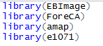

E.g: >library(EBImage)

>library(ForeCA)

5. Test images one by one. testpath1 is the image's directory, imagename is the image name, pred is either 1(poster) or -1(original).

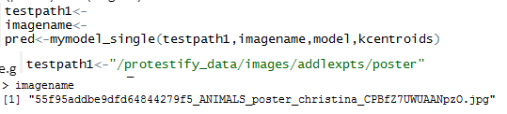

step1&2 only run once.

step3&4 run each time when you begin  the program.

Step5 should be called multiple times for different images.(step 4&5 is written in stream.R)

For batch processing, run batch.R to classify several images in a directory together.

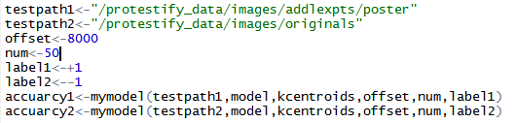

testpath1 and 2 are directories, offset means it starts from the 8000th image, num means it tests the 8000~8049th images.

In testpath1, they're all posters, label1 is +1, mymodel calculates the prediction and compares it to the labels, returns the accuarcy.

In testpath2, they're all originals, label2 is -1.