TECHNICAL RESEARCH MANUAL
LLM Fine-Tuning, Parameter-Efficient Adaptation, Quantization,
and Retrieval-Augmented Generation
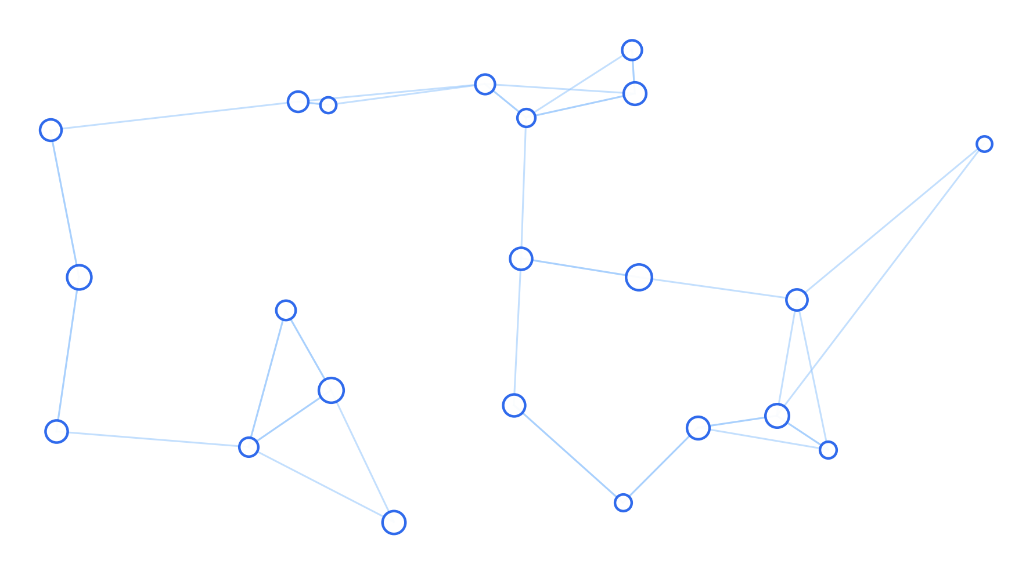

Name: | Zobia Rafiq
Internship Level: | Intermediate
Companion Project: | Enterprise Knowledge Assistant — RAG Chatbot
Prepared for: | AI Engineering Internship — Mandatory Research Manual (Task 3 & 4)

Table of Contents
Introduction 3
1. Transfer Learning 4
2. Large Language Model (LLM) Fine-Tuning 6
3. Dataset Preparation for Fine-Tuning 8
4. LoRA (Low-Rank Adaptation) 9
5. QLoRA 11
6. Model Quantization 13
7. GPU Requirements for Training and Inference 15
8. GPU Memory Utilization and Optimization 16
9. Fine-Tuning vs. RAG with Vector Databases 18
10. Naive RAG vs. Graph RAG 20
Conclusion 22
References 23

Introduction
Large Language Models (LLMs) can be adapted to specific domains and tasks in two broad ways: by changing the model itself (fine-tuning, using techniques such as Transfer Learning, LoRA, and QLoRA), or by changing what the model sees at inference time without altering its weights (Retrieval-Augmented Generation). Both approaches have distinct costs, benefits, and appropriate use cases.
This manual explains each underlying concept, shows how they relate to one another, and compares the two overall strategies — fine-tuning versus RAG — as well as two flavors of RAG itself: Naive RAG and Graph RAG. It is written to support the RAG chatbot project built alongside this manual, and to demonstrate applied understanding of the trade-offs involved in building production LLM systems.

1. Transfer Learning
Transfer learning is the practice of taking a model trained on one large, general-purpose dataset (the source task) and reusing part or all of its learned representations for a new, typically smaller, related task (the target task), instead of training a new model from scratch.

1.1 Why It Works
Deep neural networks trained on large datasets learn a hierarchy of features. Early layers tend to capture general, reusable patterns (e.g. edges and textures in vision models, or syntax and basic semantics in language models), while later layers capture task-specific patterns. Because the early, general representations transfer well across tasks, only the later layers usually need to be retrained or fine-tuned for a new task.
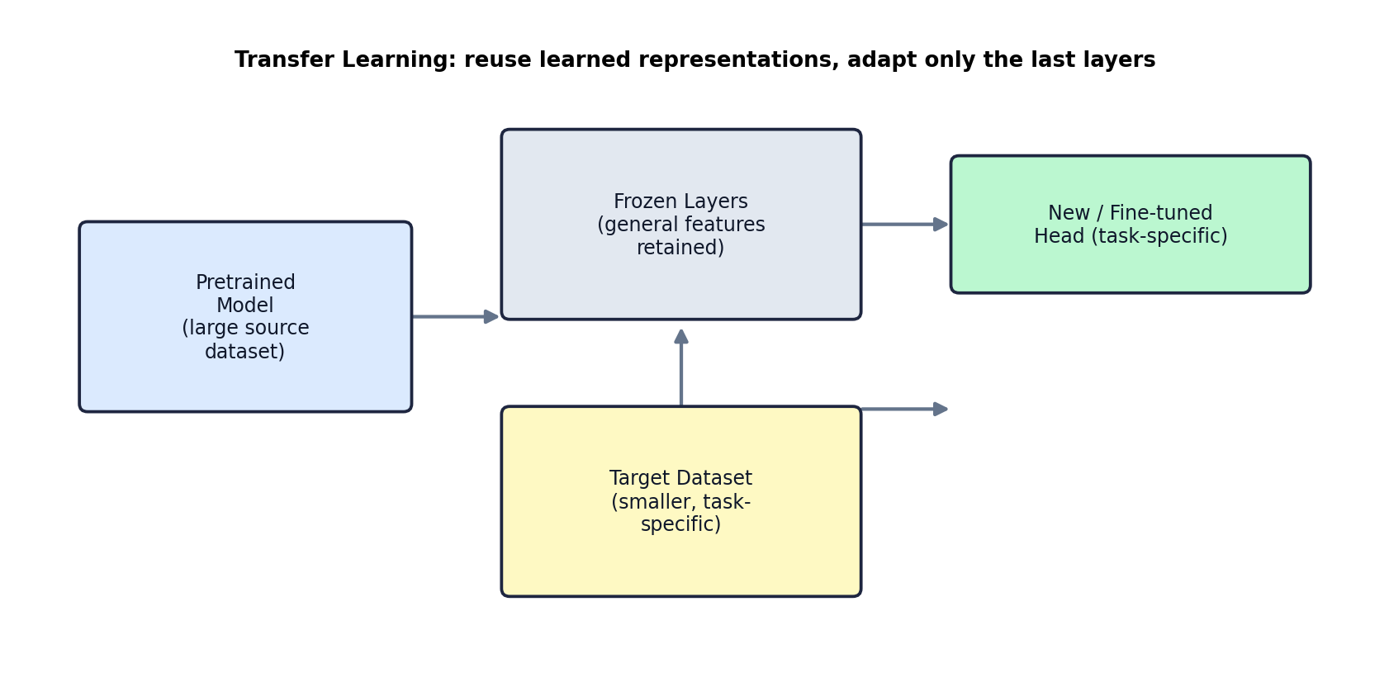

1.2 Approaches to Transfer Learning
- Feature extraction: freeze the entire pretrained model and train only a new classification/task head on top of its outputs.
- Fine-tuning (full or partial): unfreeze some or all layers and continue training on the target dataset at a low learning rate.
- Domain adaptation: adjust a model trained on one data distribution (e.g. news text) to perform well on a related but different distribution (e.g. legal text).

1.3 Practical Example
A team wants a sentiment classifier for product reviews but only has 2,000 labeled examples — not enough to train a transformer from scratch. They start from a pretrained language model (trained on billions of tokens of general text), freeze most of its layers, and train a small classification head on their 2,000 examples. The model reaches strong accuracy in a fraction of the time and data that training from scratch would require.

1.4 Advantages, Limitations, and Use Cases
Aspect | Details
Advantages | Drastically reduces data and compute requirements; faster convergence; strong performance even on small target datasets.
Limitations | Source and target domains must be reasonably related; risk of 'negative transfer' if domains are too dissimilar; may still require significant compute for full fine-tuning of large models.
Typical Use Cases | NLP classification tasks, medical imaging with limited labeled data, sentiment analysis, domain-specific chatbots, code understanding tasks.

2. Large Language Model (LLM) Fine-Tuning
LLM fine-tuning is a specific application of transfer learning: continuing to train a pretrained LLM (such as Llama, Mistral, or GPT-family models) on a new dataset so that its outputs better match a desired task, domain, tone, or format.

2.1 Types of Fine-Tuning
- Full fine-tuning: every parameter in the model is updated. Most expressive, but very expensive in compute and memory for large models.
- Instruction fine-tuning: trains the model on (instruction, response) pairs so it follows natural-language instructions more reliably (this is how base models become 'chat' or 'instruct' models).
- Parameter-efficient fine-tuning (PEFT): only a small subset of parameters (or small added parameters) are trained, keeping the bulk of the model frozen. LoRA and QLoRA, covered in Sections 4 and 5, are the dominant PEFT techniques today.
- Reinforcement Learning from Human Feedback (RLHF) / Direct Preference Optimization (DPO): further aligns a model's outputs with human preferences after initial fine-tuning.

2.2 The Fine-Tuning Workflow
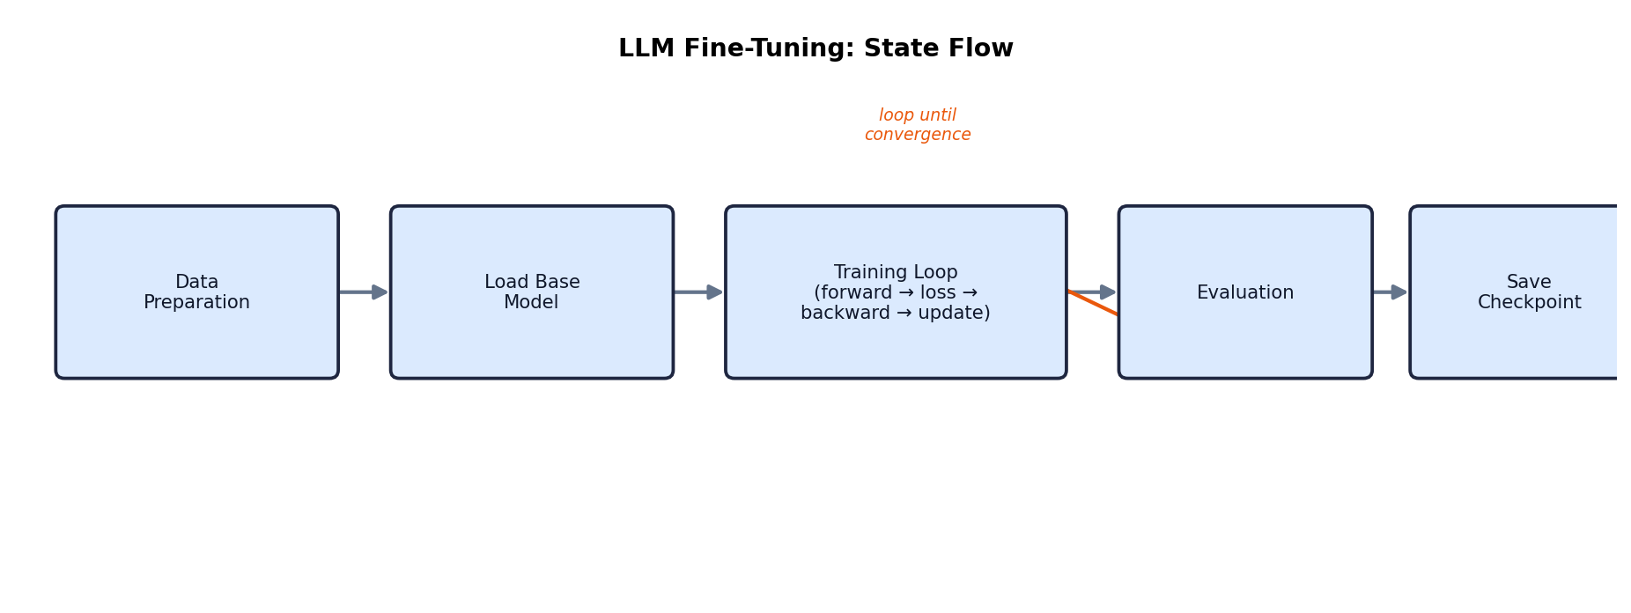
At a high level: (1) prepare and format a labeled dataset, (2) load a pretrained base model and tokenizer, (3) run a training loop of forward pass → loss computation → backward pass → parameter update, repeated over many batches and epochs, (4) periodically evaluate on a held-out validation set, and (5) save checkpoints of the best-performing model state.

2.3 Advantages, Limitations, and Use Cases
Aspect | Details
Advantages | Model internalizes domain knowledge and style directly; no retrieval step needed at inference; can improve reliability on narrow, well-defined tasks.
Limitations | Requires labeled/curated data; compute and GPU-memory intensive (especially full fine-tuning); knowledge becomes 'frozen' at training time and is expensive to update; risk of catastrophic forgetting of general capabilities.
Typical Use Cases | Customer support tone/style adaptation, code-generation specialization, structured output formatting, domain-specific classification or extraction tasks.

3. Dataset Preparation for Fine-Tuning
The quality of a fine-tuned model is bounded by the quality of its training data. Dataset preparation is often the most time-consuming and highest-leverage part of a fine-tuning project.

3.1 Key Steps
- Data collection: gather examples representative of the target task (support tickets, domain documents, Q&A pairs, code samples, etc.).
- Cleaning: remove duplicates, personally identifiable information (PII), corrupted records, and off-topic content.
- Formatting: convert raw data into a consistent instruction/response or prompt/completion structure matching the target model's expected chat template.
- Labeling / annotation: for supervised tasks, ensure labels are accurate and consistently applied (often via human review or LLM-assisted annotation with spot-checking).
- Splitting: divide into training, validation, and test sets (a common split is 80/10/10) to monitor for overfitting.
- Balancing: ensure the dataset does not overrepresent a narrow subset of cases, which can bias the fine-tuned model.

3.2 Example Instruction-Formatted Record
{"instruction": "Summarize the customer's complaint in one sentence.", "input": "<support ticket text>", "output": "<one-sentence summary>"}

3.3 Advantages, Limitations, and Considerations
Aspect | Details
Advantages | High-quality, well-curated data can outweigh model size — even a small, clean dataset often outperforms a large, noisy one.
Limitations | Manual labeling is slow and expensive; synthetic data generation (using another LLM) can introduce bias or hallucinated errors if not validated.
Implementation Considerations | Deduplicate aggressively; validate a sample of formatted records by hand before large-scale training runs; keep a fixed, untouched test set to measure real generalization.

4. LoRA (Low-Rank Adaptation)
LoRA is a parameter-efficient fine-tuning technique. Instead of updating a pretrained weight matrix W directly, LoRA freezes W and injects a pair of small, trainable low-rank matrices (A and B) whose product approximates the necessary weight update, ΔW.
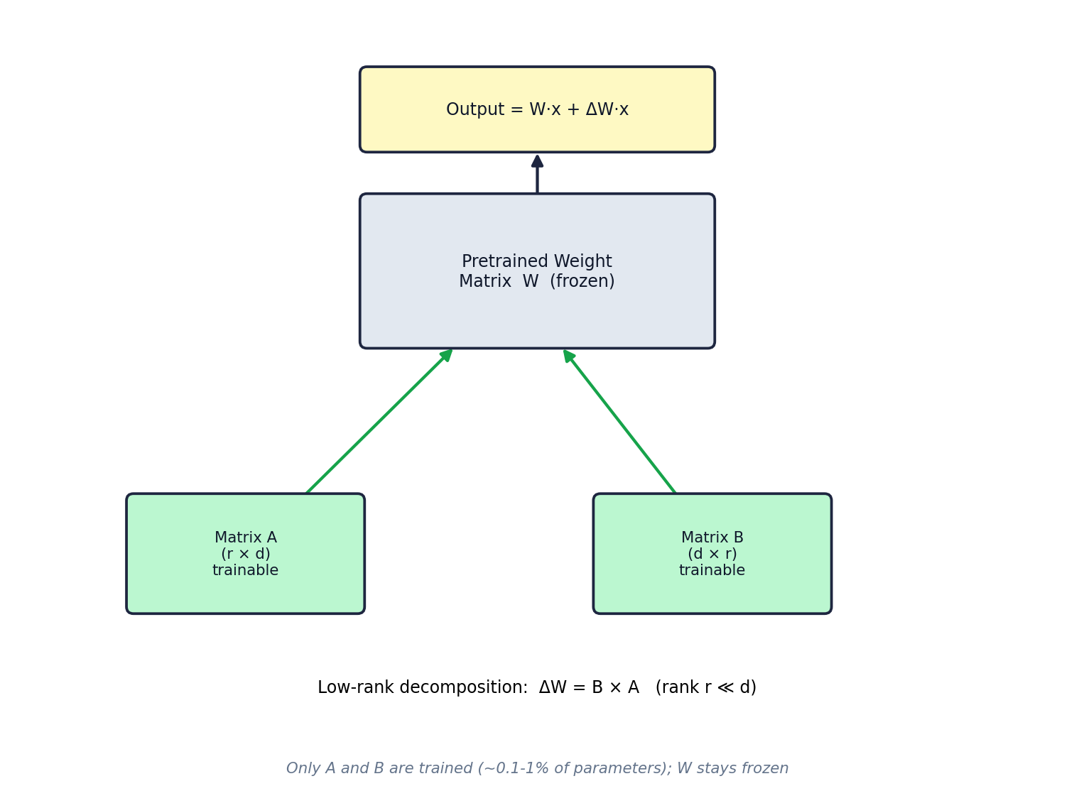

4.1 How It Works
For a weight matrix W of size d×d, LoRA represents the update as ΔW = B×A, where A is r×d and B is d×r, with rank r chosen to be much smaller than d (commonly 4–64). This means only 2×r×d parameters are trained per layer instead of d², often reducing trainable parameters by 99% or more, while the frozen base model still contributes its full capacity at inference time (output = Wx + ΔWx).

4.2 Why It Matters
- Drastically lower GPU memory requirement, since gradients and optimizer states are only needed for the small A/B matrices, not the full model.
- Multiple LoRA adapters (one per task/domain) can be trained and swapped in/out on top of the same frozen base model, saving storage compared to multiple full fine-tuned copies.
- Comparable performance to full fine-tuning on many tasks, at a fraction of the cost.

4.3 Advantages, Limitations, and Use Cases
Aspect | Details
Advantages | Massively reduced trainable parameters and memory footprint; fast training; multiple adapters can share one base model; easy to merge back into the base weights if desired.
Limitations | May slightly underperform full fine-tuning on tasks requiring very large representational shifts; choice of rank r and which layers to target requires some tuning.
Typical Use Cases | Multi-tenant fine-tuning services, rapid domain adaptation, personalization, resource-constrained fine-tuning (single consumer GPU).

5. QLoRA
QLoRA (Quantized LoRA) extends LoRA by additionally quantizing the frozen base model's weights to 4-bit precision, further reducing memory usage so that fine-tuning very large models becomes feasible on a single consumer or prosumer GPU.
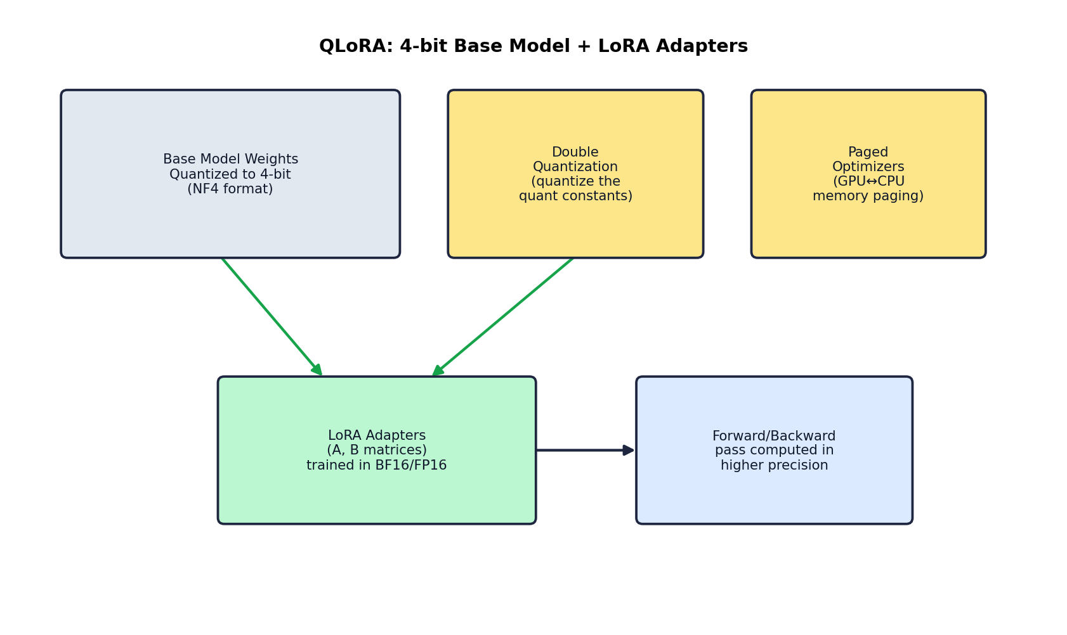

5.1 Core Components
- 4-bit NormalFloat (NF4) quantization: an information-theoretically optimal 4-bit data type for normally-distributed weights, used to store the frozen base model.
- Double quantization: quantizes the quantization constants themselves, saving further memory (roughly 0.4 bits per parameter on average).
- Paged optimizers: uses NVIDIA unified memory to page optimizer states between GPU and CPU memory automatically, preventing out-of-memory errors during gradient checkpointing spikes.
- LoRA adapters (as in Section 4) remain in higher precision (BF16/FP16) and are the only trained parameters; gradients flow through the quantized frozen weights but do not update them.

5.2 Practical Impact
QLoRA made it practical to fine-tune 30B–65B parameter models on a single 24–48 GB GPU — a task that previously required multiple high-end datacenter GPUs — while achieving performance close to full 16-bit fine-tuning on many benchmarks.

5.3 Advantages, Limitations, and Use Cases
Aspect | Details
Advantages | Enables fine-tuning of very large models on limited hardware; memory savings compound with LoRA's efficiency; minimal accuracy loss versus full-precision fine-tuning in most cases.
Limitations | Slightly slower training throughput than non-quantized LoRA due to dequantization overhead; quality depends on the quantization scheme's fit to the weight distribution.
Typical Use Cases | Fine-tuning large open-weight models (13B+) on a single GPU, academic/individual research, cost-constrained enterprise fine-tuning.

6. Model Quantization
Quantization reduces the numerical precision used to store and/or compute a model's weights and activations — for example, converting 32-bit floating-point (FP32) weights to 8-bit or 4-bit integers — to reduce memory footprint and often increase inference speed, at some cost to numerical precision.
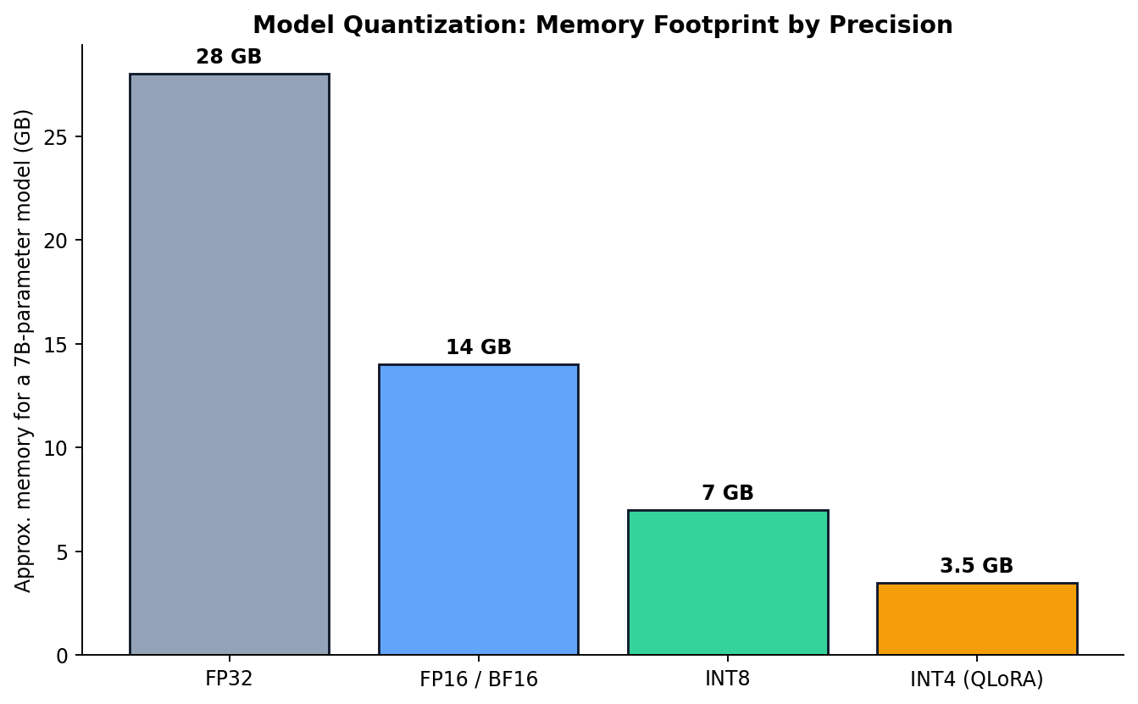

6.1 Common Precision Levels
Precision | Bits/Param | Typical Use
FP32 | 32 | Training (rarely used for inference of large models)
FP16 / BF16 | 16 | Standard training and inference precision for modern LLMs
INT8 | 8 | Post-training quantization for faster, lower-memory inference
INT4 / NF4 | 4 | Aggressive quantization for large-model inference or QLoRA fine-tuning

6.2 Quantization Approaches
- Post-Training Quantization (PTQ): quantize an already-trained model's weights, typically with a small calibration dataset to minimize accuracy loss.
- Quantization-Aware Training (QAT): simulate quantization effects during training so the model learns to be robust to reduced precision.
- Weight-only vs. weight-and-activation quantization: weight-only quantization (e.g. GPTQ, AWQ) is common for LLM inference since activations are more sensitive to precision loss.

6.3 Advantages, Limitations, and Use Cases
Aspect | Details
Advantages | Large reduction in memory and storage; faster inference on supporting hardware; enables running large models on consumer GPUs or edge devices.
Limitations | Potential accuracy degradation, especially at very low bit-widths or on outlier-heavy weight distributions; not all hardware accelerates low-precision arithmetic equally.
Typical Use Cases | Deploying LLMs on limited-VRAM GPUs, edge/on-device inference, cost-sensitive high-throughput serving.

7. GPU Requirements for Training and Inference
GPU memory (VRAM) is typically the binding constraint when working with LLMs, more so than raw compute throughput, because the entire working set — weights, gradients, optimizer states, and activations — must fit in GPU memory (or be paged, at a performance cost).

7.1 Estimating Memory for Training (Full Fine-Tuning, Adam Optimizer)
A common rule of thumb for full fine-tuning in mixed precision with the Adam optimizer is approximately 16–20 bytes per parameter: 2 bytes for FP16 weights, 2 bytes for FP16 gradients, and roughly 12–16 bytes for FP32 optimizer states (Adam keeps two moment estimates in FP32, plus an FP32 master copy of the weights). This means a 7B-parameter model can require well over 100 GB of GPU memory for full fine-tuning — far beyond a single consumer GPU.

7.2 Estimating Memory for Inference
Inference memory is dominated by the model weights plus the KV-cache (which grows with context length and batch size). As a rough guide, inference memory in GB ≈ (parameters in billions) × (bytes per parameter), plus additional memory for the KV-cache that scales with sequence length.

7.3 Illustrative GPU Requirement Table
Model Size | Full Fine-Tuning (FP16 + Adam) | LoRA Fine-Tuning | QLoRA Fine-Tuning | Inference (FP16)
7B | ~112 GB+ | ~16–24 GB | ~6–10 GB | ~14 GB
13B | ~208 GB+ | ~24–40 GB | ~10–16 GB | ~26 GB
70B | ~1.1 TB+ | ~80–160 GB (multi-GPU) | ~35–48 GB | ~140 GB (multi-GPU)

7.4 Practical Guidance
- A single 24 GB consumer GPU (e.g. RTX 3090/4090) can comfortably QLoRA fine-tune models up to ~13B parameters, and with careful settings, larger models.
- Full fine-tuning of models above ~3B parameters generally requires multi-GPU datacenter hardware (e.g. A100/H100) unless using memory-saving techniques such as ZeRO/FSDP sharding.
- For inference-only workloads, quantization (Section 6) is usually the most impactful way to fit a larger model onto smaller hardware.

8. GPU Memory Utilization and Optimization
Beyond choosing PEFT methods and quantization, several orthogonal techniques reduce peak GPU memory usage during training and inference.
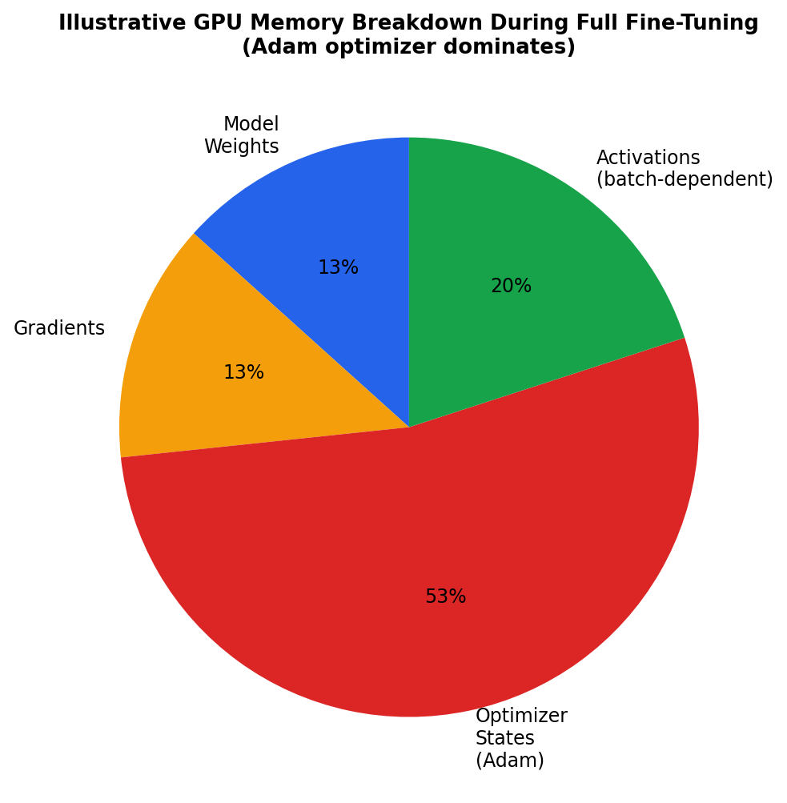

8.1 Key Optimization Techniques
- Gradient checkpointing: discards intermediate activations during the forward pass and recomputes them during the backward pass, trading extra compute for significantly reduced activation memory.
- Mixed-precision training: uses FP16/BF16 for most computation while keeping a small set of values in FP32 for numerical stability, roughly halving memory versus pure FP32.
- Gradient accumulation: simulates a larger effective batch size by accumulating gradients over several smaller micro-batches before an optimizer step, reducing the peak activation memory of any single step.
- ZeRO / Fully Sharded Data Parallel (FSDP): shards optimizer states, gradients, and/or parameters across multiple GPUs so no single GPU holds the full training state.
- Paged optimizers (as used in QLoRA): offload optimizer states to CPU memory when GPU memory is under pressure.
- Flash Attention: a fused, memory-efficient attention implementation that avoids materializing the full attention matrix, reducing memory and increasing speed.

8.2 Advantages, Limitations, and Considerations
Aspect | Details
Advantages | Enables training/serving larger models on the same hardware; techniques are largely complementary and can be combined.
Limitations | Gradient checkpointing and CPU offloading trade memory for speed (slower training); multi-GPU sharding adds engineering and communication overhead.
Implementation Considerations | Profile memory usage early (e.g. with PyTorch's memory profiler) to identify the actual bottleneck before applying optimizations; combine mixed precision + gradient checkpointing + LoRA/QLoRA as a strong default starting point.

9. Fine-Tuning vs. RAG with Vector Databases
Fine-tuning and RAG solve a similar problem — making an LLM's outputs reflect specific knowledge — via fundamentally different mechanisms. They are not mutually exclusive and are often combined in production systems.
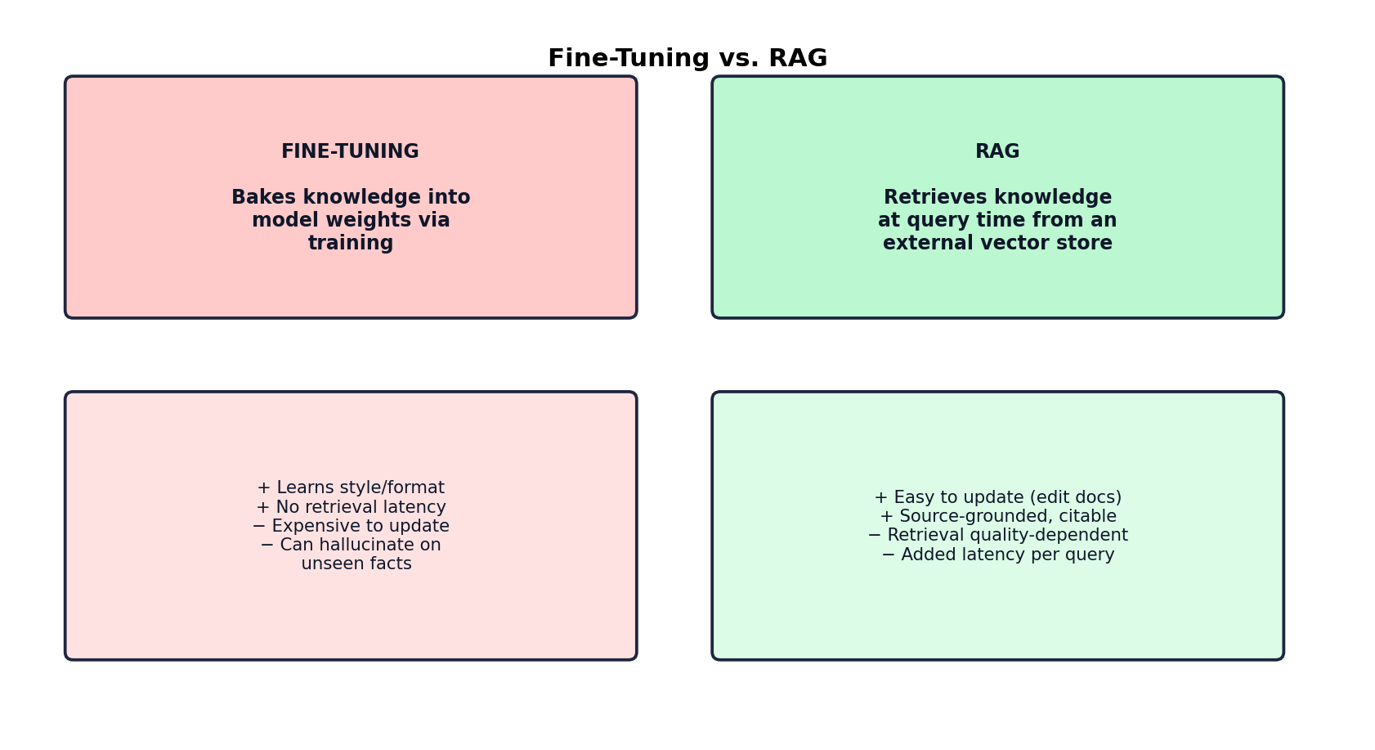

9.1 Comparison Table
Dimension | Fine-Tuning | RAG
Where knowledge lives | Inside model weights | External vector database, retrieved per query
Update cost | Requires retraining to add/change knowledge | Update by editing/re-indexing documents — no retraining
Latency | No retrieval step; single forward pass | Adds retrieval latency before generation
Source attribution | Not inherently traceable | Can cite retrieved source chunks directly
Best for | Style, tone, format, task-specific behavior | Fast-changing or large factual knowledge bases
Hallucination risk | Can hallucinate confidently on unseen facts | Reduced when retrieval succeeds; still possible if retrieval fails or context is misread
Setup complexity | Requires labeled data, training pipeline, GPUs | Requires embedding model, vector DB, retrieval pipeline

9.2 When to Combine Both
A common production pattern is to fine-tune a model for style, instruction-following, and domain vocabulary, while using RAG to supply up-to-date or proprietary factual content at query time. This project's chatbot uses this philosophy in spirit — it relies on RAG for factual grounding in uploaded documents, avoiding the cost and staleness risk of fine-tuning for document-specific knowledge.

10. Naive RAG vs. Graph RAG
Naive RAG — the architecture used in this project's chatbot — retrieves the top-k most semantically similar text chunks from a flat vector index for each query. Graph RAG instead builds a structured knowledge graph of entities and relationships extracted from the source documents, and retrieves using graph traversal and community summarization in addition to (or instead of) flat similarity search.

10.1 Naive RAG Architecture
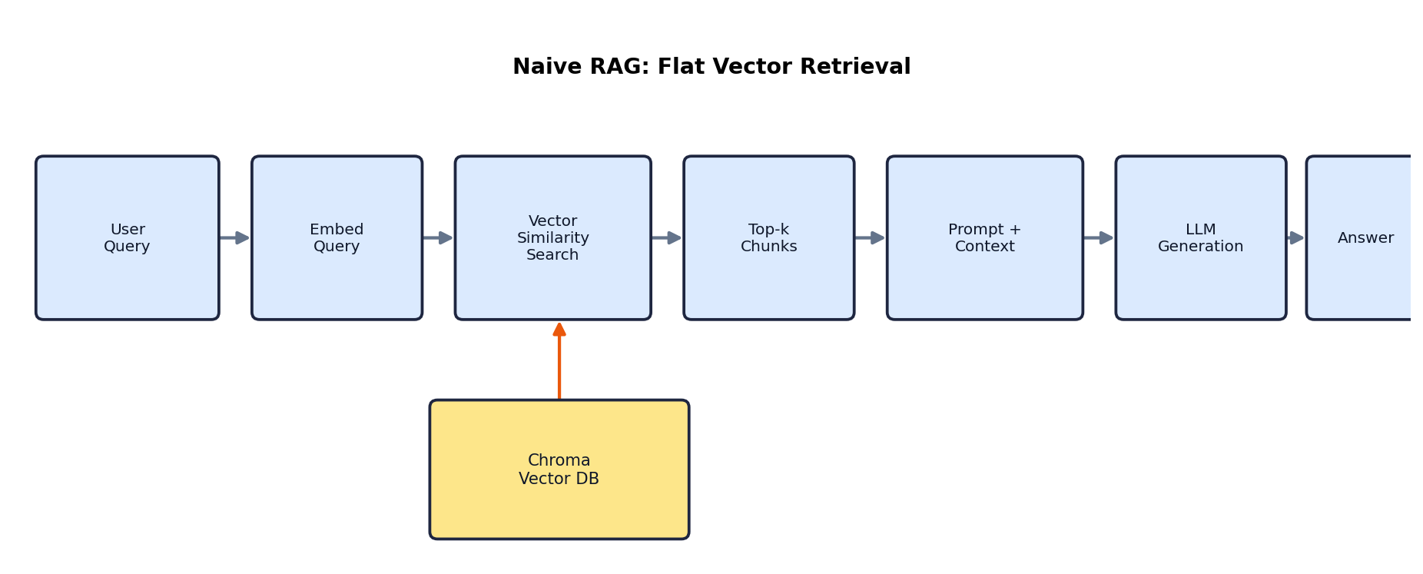

10.2 Graph RAG Architecture
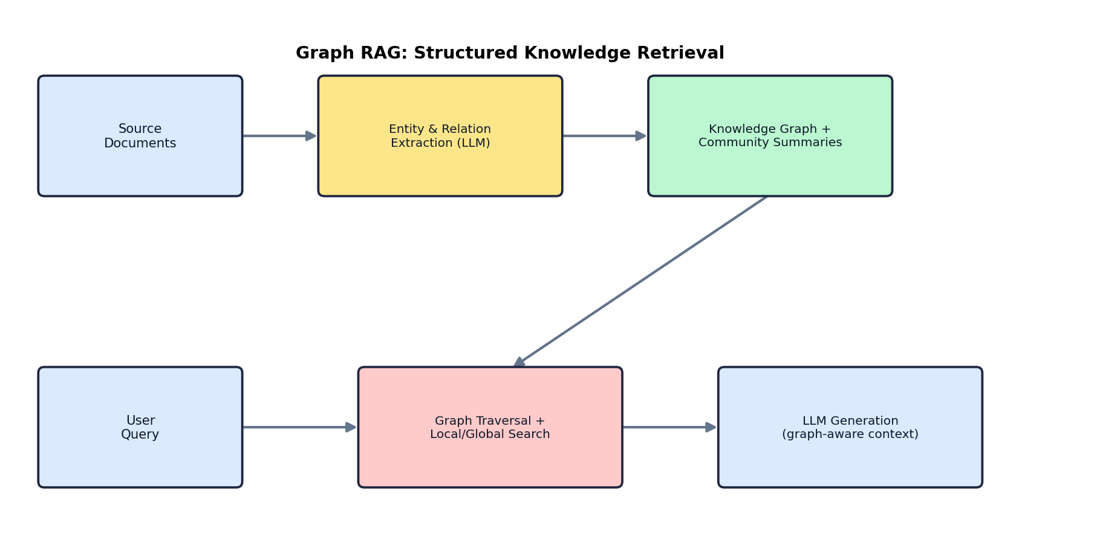

10.3 Comparison Table
Dimension | Naive RAG | Graph RAG
Index structure | Flat vector embeddings of text chunks | Knowledge graph of entities, relationships, and community summaries, often alongside vector embeddings
Strength | Simple, fast to build, effective for direct factual lookup | Strong at multi-hop reasoning and questions requiring connections across many documents
Weakness | Struggles with questions requiring reasoning across multiple, disconnected chunks (as observed in this project — see Section 'Challenges and Solutions' in the project README) | More expensive and complex to build; requires LLM-based extraction of the graph itself
Build cost | Low — embed and store chunks | High — extract entities/relations, build graph, generate community summaries
Query cost | Low — single similarity search | Higher — graph traversal and/or multi-step retrieval
Best for | FAQ-style lookup, document Q&A with locally-contained answers | Global/summarization questions, entity-relationship questions, multi-hop reasoning

10.4 Relevance to This Project
During testing of this project's chatbot, a question like 'name her?' (referring to the resume owner) failed because the specific chunk containing the person's name was not among the top-k retrieved chunks — a classic naive RAG limitation. A Graph RAG approach would represent 'Zobia Rafiq' as an entity directly connected to the 'resume' document node, making such identity questions resolvable regardless of which text chunk was semantically closest to the query. This is a concrete illustration of why Graph RAG is often preferred for knowledge-dense, entity-rich document collections, at the cost of added build-time complexity.

Conclusion
Transfer learning underlies nearly all modern LLM adaptation, from full fine-tuning down to highly parameter-efficient methods like LoRA and QLoRA. These techniques, combined with quantization and GPU-memory optimization strategies, have made it possible to adapt very large models on modest hardware. Meanwhile, RAG offers a complementary path to grounding model outputs in current, verifiable information without retraining — and Graph RAG extends this further for knowledge that spans multiple interconnected sources. Understanding when to reach for each tool, and how to combine them, is central to building effective, cost-efficient LLM systems.

References
- Hu, E. J., et al. (2021). LoRA: Low-Rank Adaptation of Large Language Models. arXiv:2106.09685.
- Dettmers, T., et al. (2023). QLoRA: Efficient Finetuning of Quantized LLMs. arXiv:2305.14314.
- Dettmers, T., et al. (2022). LLM.int8(): 8-bit Matrix Multiplication for Transformers at Scale. arXiv:2208.07339.
- Edge, D., et al. (2024). From Local to Global: A Graph RAG Approach to Query-Focused Summarization. Microsoft Research. arXiv:2404.16130.
- Lewis, P., et al. (2020). Retrieval-Augmented Generation for Knowledge-Intensive NLP Tasks. arXiv:2005.11401.
- Rajbhandari, S., et al. (2020). ZeRO: Memory Optimizations Toward Training Trillion Parameter Models. arXiv:1910.02054.
- Dao, T., et al. (2022). FlashAttention: Fast and Memory-Efficient Exact Attention with IO-Awareness. arXiv:2205.14135.
- Hugging Face PEFT Documentation — https://huggingface.co/docs/peft
- LangChain Documentation — https://python.langchain.com
- ChromaDB Documentation — https://docs.trychroma.com

