Scrabble

Nikka Marie De Jesus & Rodney O. Dublin

February 8, 2018

**Game description.** A classic crossword game that is played by two to four players. The players will have to use their seven drawn letter-tiles to form words on the gameboard. Each word that is laid out will earn points by adding the corresponding points of each tile used, with certain board spaces giving bonuses. Players must keep in mind that a word can only be played if it uses at least one tile that has already been laid out or played or adds to an already-played word. Additionally, only horizontal and vertical words are allowed, i.e., diagonal words are discouraged.

**Objects.**

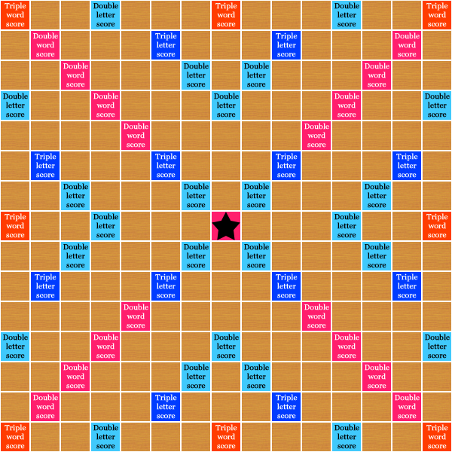**Gameboard.** The gameboard is divided into 15x15 squares where some of the square contains bonuses. The bonuses include double and triple letter score which double or triple the points of the tile placed on it and double and triple word score which double or triple the score of the word placed. The star square is the starting point of the game and the initial word’s score placed on it is doubled. Below is the layout of the gameboard.

*http://theologygaming.com/wp-content/uploads/2013/01/board.png*

**Tiles.** A tile is an object that contains a letter and its corresponding point(s). The tiles are used to form a word and the score is calculated by adding the corresponding points of each tiles in the word being formed. Below is the distribution of tiles and their corresponding point(s).

|  |  |  |
| --- | --- | --- |
| **TILE LETTER** | **POINT(S)** | **DISTRIBUTION(S)** |
| A | 1 | 9 |
| B | 3 | 2 |
| C | 3 | 2 |
| D | 2 | 4 |
| E | 1 | 12 |
| F | 4 | 2 |
| G | 2 | 3 |
| H | 4 | 2 |
| I | 1 | 9 |
| J | 8 | 1 |
| K | 5 | 1 |
| L | 1 | 4 |
| M | 3 | 2 |
| N | 1 | 6 |
| O | 1 | 8 |
| P | 3 | 2 |
| Q | 10 | 1 |
| R | 1 | 6 |
| S | 1 | 4 |
| T | 1 | 6 |
| U | 1 | 4 |
| V | 4 | 2 |
| W | 4 | 2 |
| X | 8 | 1 |
| Y | 4 | 2 |
| Z | 10 | 1 |
| * | 0 | 2 |

*Note: It is a blank character which can represent any letter but receives no point. Once its corresponding letter is established it is unchangeable all throughout the game.

**Racks.** Each player has his/her own rack where the tiles he/she owned are placed. There are seven tiles placed on each rack across the game until no more tiles are available in the pouch or rack. The player can reorder the arrangement of tiles in the rack according to his/her desire.

**Pouch.** Initially the pouch contains all 100 tiles and all throughout the game tiles are being drawn from the pouch. The mechanism for drawing a tile is by randomization.

**Dictionary.** All acceptable words are registered in the dictionary and it can be optionally used by a player to search if a word is acceptable. This also serves as a guide if a word can be placed on the board or not.

**Scoreboard and Information panel.** This is where the current score of the players are shown and their corresponding rankings. Together with it is a timer which is used to limit the time for a player in thinking and placing a word in the board. The user can also view the tally of all the words and scores in this panel.

**Game control.** The game will start by randomly drawing a tile for each player and the one that have the tile nearer to ‘A’ or blank will start first and the rest will follow by alphabetical order. The drawn tiles will be back to the pouch and each player will receive seven letter-tiles given to them at random. Players will only have to use their mouse/mouse pad and the “Enter” key to be able to play. The player will have to drag and drop or click and drop the letter to the squares of the board for them to form the word they desire and press the “Enter” key for it to be submitted.

If a player has a blank tile and decided to use it, he has to type the letter he wants to use before submitting. The number of letter-tiles used will automatically be replaced randomly by new ones after submission.

**Game networking.** This game consists of two to four players and each player will have his/her own gameboard. In order for each player to communicate, a connection must be established to facilitate the current status of the game. The data that will be sent over the network are the words and the score of each player as well as the position of each tiles on the board. However, current tiles of each player are not being sent over the network. The network will be established using Socket object in Java using TCP/IP protocol.