2.a. Truncated quantization
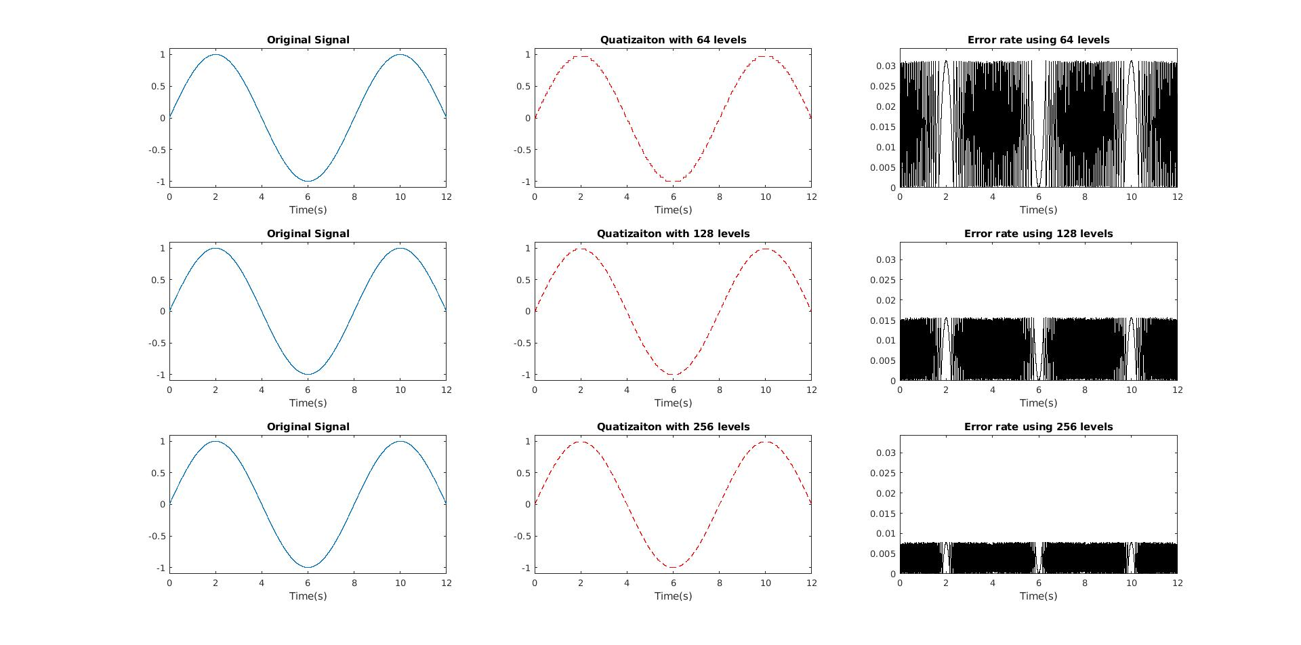
2.b. Rounded quantization
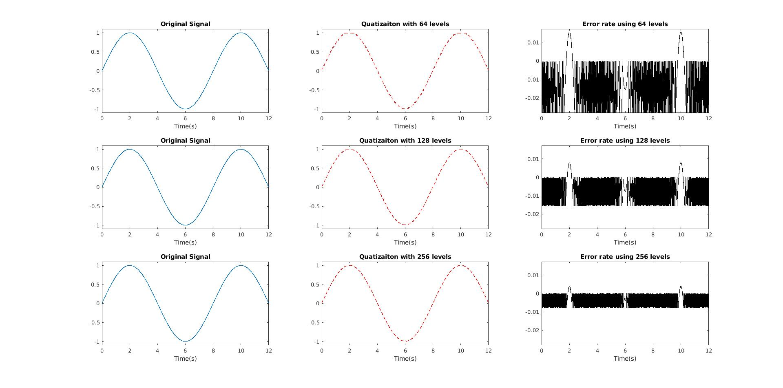

2.c. Whenever we use more bits to quantize a signal our error gets smaller; Also the difference between the floor and round quantization shows that all the errors are on truncated quantization are more on the positive side than the negative

2.d
Bits Used | SQNR Theory | SQNR Calculated
6 | 37.88 | 32.2076
7 | 43.90 | 38.1160
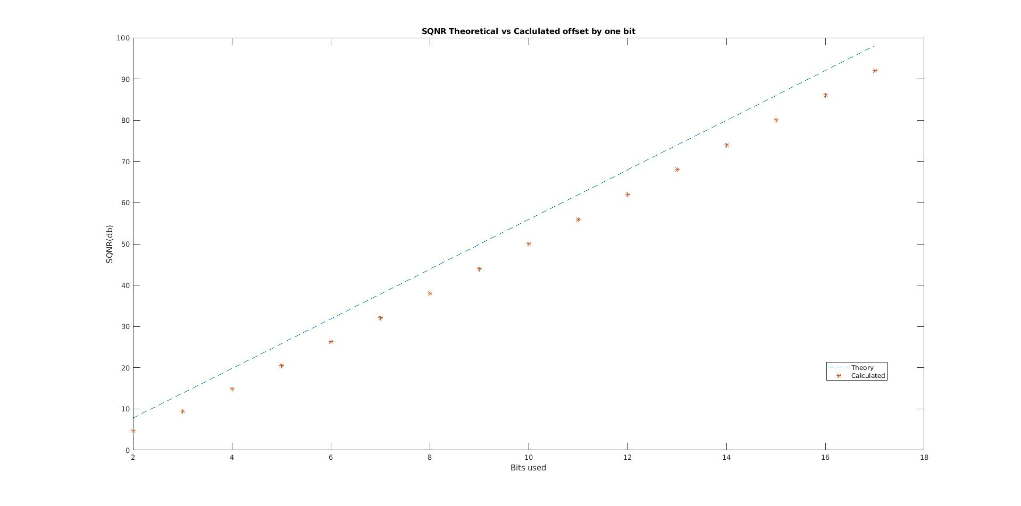  8 | 49.92 | 44.0617
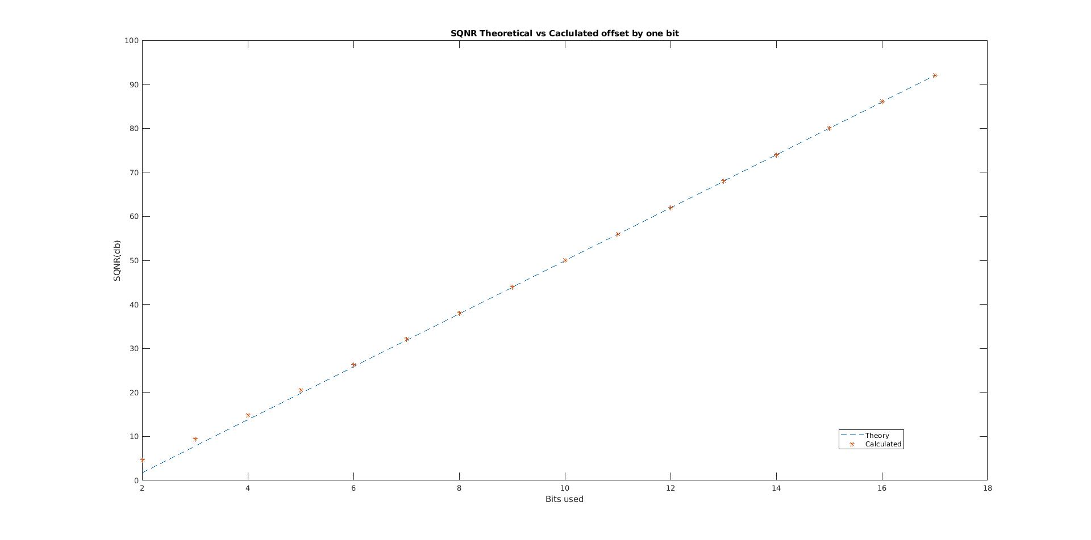

%% Signal set up

clc;clear;close all;

%Constants

DSP_HW_2
amp = 1 ; %amplitude
fm = 1/8; %message frequency
time_start = 0;
time_end = 12;
fs = 1000;% Sampling frequency Hz
time = time_start:1/fs:time_end;
bits_to_use= 1:16; %
bits = bits_to_use(1:1:length(bits_to_use));
type = 2; %Quantization method floor = 1, round =2, ceiling = 3;

%Create a signal
sig_cont = sin(2*pi*time*fm);

%Allocate memory for error and SQNR arrays;
error = zeros(length(bits),length(sig_cont));
SQNR = zeros(1,length(bits));

%% Plotting multiple levels of quantization
for index = 1:length(bits);
L= 2^(bits(index));

[sig_q,SQNR(index)] = quant(sig_cont,L,type);
error(index,:) = sig_cont-sig_q;
%if a value is within range of
min_err = min(error(1,:));
max_err = max(error(1,:));

%Original Signal
figure(1)
subplot (3,3,index +(index-1)*2)
plot (time,sig_cont);
title (['Original Signal']);
xlabel ('Time(s)')
ylim ([(-amp-amp/10) (amp+amp/10)]);

%Quantization Signal
subplot (3,3,index + 1+ (index-1)*2)
plot (time,sig_q,'--r')
title (['Quatizaiton with ', num2str(L), ' levels']);
xlabel ('Time(s)')
ylim ([(-amp-amp/10) (amp+amp/10)]);

%Error values
subplot (3,3,index+2+(index-1)*2)
plot (time,error(index,:),'black')
title (['Error rate using ', num2str(L), ' levels']);
xlabel ('Time(s)')
ylim ( [ (min_err - min_err/10) (max_err + max_err/10)])

end
%

%% SQNR Comparison
for index = 1:length(bits)
L=2^(bits(index));
[sig_q, SQNR(index)]= quant(sig_cont,L,type);
end;
SQNR_theory = 1.76+6.02*(bits)
SQNR
figure
plot (bits+1,SQNR_theory,'--',bits+1,SQNR,'*');
title ('SQNR Theoretical vs Caclulated ')
ylabel ('SQNR(db)');
xlabel ('Bits used');
legend ('Theory','Calculated');

%% SQNR
SQNR

%% END

quant.m
function [sig_out,SQNRdb] = quant(sig_in,L,type)
%Quant Quantize a signal based on the function
% sig_in signal to quantize
% L levels of quantization
% type 1 for floor, 2 for round, 3 for ceiling

sig_max = max(sig_in);
sig_min = min(sig_in);
range = max(sig_in)-min(sig_in);
del = range/L ; %Step size

%Creating Bins for the values to go in and the
if type == 1 %Floor
q_bins = sig_min : del :sig_max-del; %Creating Bins for the values to go in and the
bin_location = min(L,floor((sig_in-sig_min)/del+1));%Determine the bin what the signal will go into

elseif type == 2
q_bins = sig_min+del*1/2 : del :sig_max-del*1/2; %Creating Bins for the values to go in and the
bin_location = min(L,round((sig_in-sig_min)/del+1));%Determine the bin what the signal will go into

elseif 3
q_bins = sig_min+del : del :sig_max; %Creating Bins for the values to go in and the
bin_location = min(L,ceil((sig_in-sig_min)/del+.1));%Determine the bin what the signal will go into

end

sig_out = q_bins(bin_location); %Assign the signal a value from the q_bins based on the bin_location
S0 = norm(sig_in);
N0 = norm(sig_in-sig_out);
SQNR = S0/N0;
SQNRdb =20*log10(SQNR);
end

