|  |  |
| --- | --- |
| A | B |
| C | S |

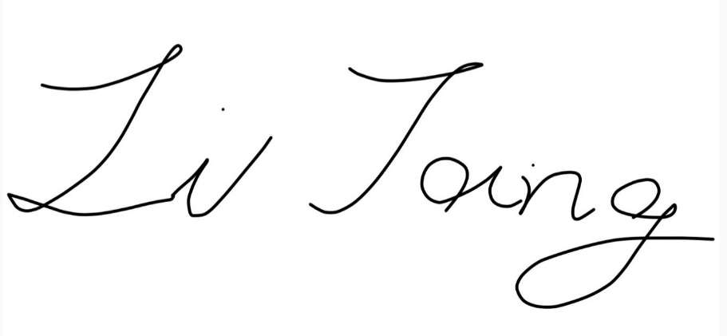

Word2结束语