## Tuesday

### 2-1 Generalised Logistic Growth

### 2-2 The Lotka-Volterra Interaction model

### 2-3 Equilibria and Stability

### 2-4 Apparent Competition

Lotka-Volterra interaction model (a system of 2 differential equations)

* Describes how the densities of two competing species change simultaneously

#### Limitation of the L-V model

* The model assumes constant competition coefficients. It might well be that the effects of competition depend in some complicated way on the densities.
* It is quite possible that the populations are structured so that this description is not correct (e.g. age structure, spatial structure, etc. ). (You would then need more than 2 equations to describe this)
* All effects of competition are assumed to be immediate. No delays are taken into account
* The model only considers competition and no effects of any other parts of the ecosystem are taken into account (e.g. depletion of resources, shared predators or pathogens)

#### Apparent Competition

* We have so far implicitly assumed that competition has a direct effect on the other species
* This need not always be the case. Indirect effects occur when the effect of species 1 on species 2 is transmitted through a third species
* A shared predator can mediate an indirect effect between two species, even if there is no direct contact between them





The predator density changes as:



We can bring this back to a 2 species model by assuming that the predator responds much faster, and is at quasi-equilibrium



So that the model reads



* We get the 2 species the L-V model back.
* It can be shown that for large carrying capacities one species of prey always outcompetes the other.
* The species that wins the competition is the one that can withstand the highest predator density.

## Wednesday

### 3-1 Phase Shifts and Catastrophic Transitions

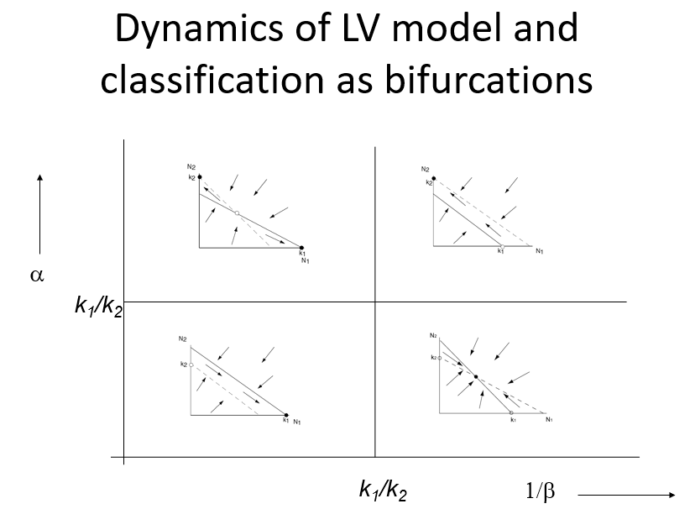

### 3-2 Alternative Stable States in Coral Reefs

### 3-3 Evidence for Alternative Stable States

### 3-4 Chaos and unpredictability