ACPE NLP Workshop Lab 2 Glossary
  - A continuation of the Lab 1 glossary
Use this reference alongside the LLM extraction notebook. The terms follow the models, prompts, extraction tasks and scoring used in Lab 2.
Start with: system prompt, user prompt, few-shot, schema, temperature and F1.
Run cells in order; later cells use earlier setup. An LLM is one type of NLP model.

Models and setup
Term | Meaning in this lab
Large language model (LLM) | A model trained on large amounts of text to predict and generate tokens. Here, it reads a note and produces an extraction.
Pretrained model | A model whose weights have already been learned. We load Qwen rather than train a model from scratch.
Parameters / weights | Numbers learned during training. Qwen3 1.7B and 4B have roughly 1.7 and 4 billion parameters; size alone does not guarantee accuracy.
Inference | Using a trained model to produce an answer. Each call to ask_qwen(...) runs inference.
Local model | A model running in our computing environment. In this Colab, that environment is Google's hosted runtime, not your laptop.
GPU / T4 | Hardware that speeds up model calculations. T4 is the GPU option used for this lab.
Ollama | Software that downloads and runs Qwen. The notebook talks to an Ollama server inside its runtime.
API / client | An interface that lets code request a service. client.chat(...) sends messages to Ollama and receives the model's response.

Continuing the NLP comparison
Term | Meaning in this lab
Baseline | A reference method for comparison. Here, the supplied rules-based extractor is the NLP baseline.
Regular expression / regex | A text pattern used to find matches. re.findall returns matches; re.search finds the first, if any.
Normalisation | Making permitted differences consistent, such as case or spacing. It does not mean inventing missing information or expanding a drug brand.
Deterministic rule | A fixed rule gives the same result for the same input and implementation. It can still be consistently wrong or miss new wording.

How an LLM extracts information
A Qwen-style LLM builds an answer one token at a time, using your messages and the text it has already generated.
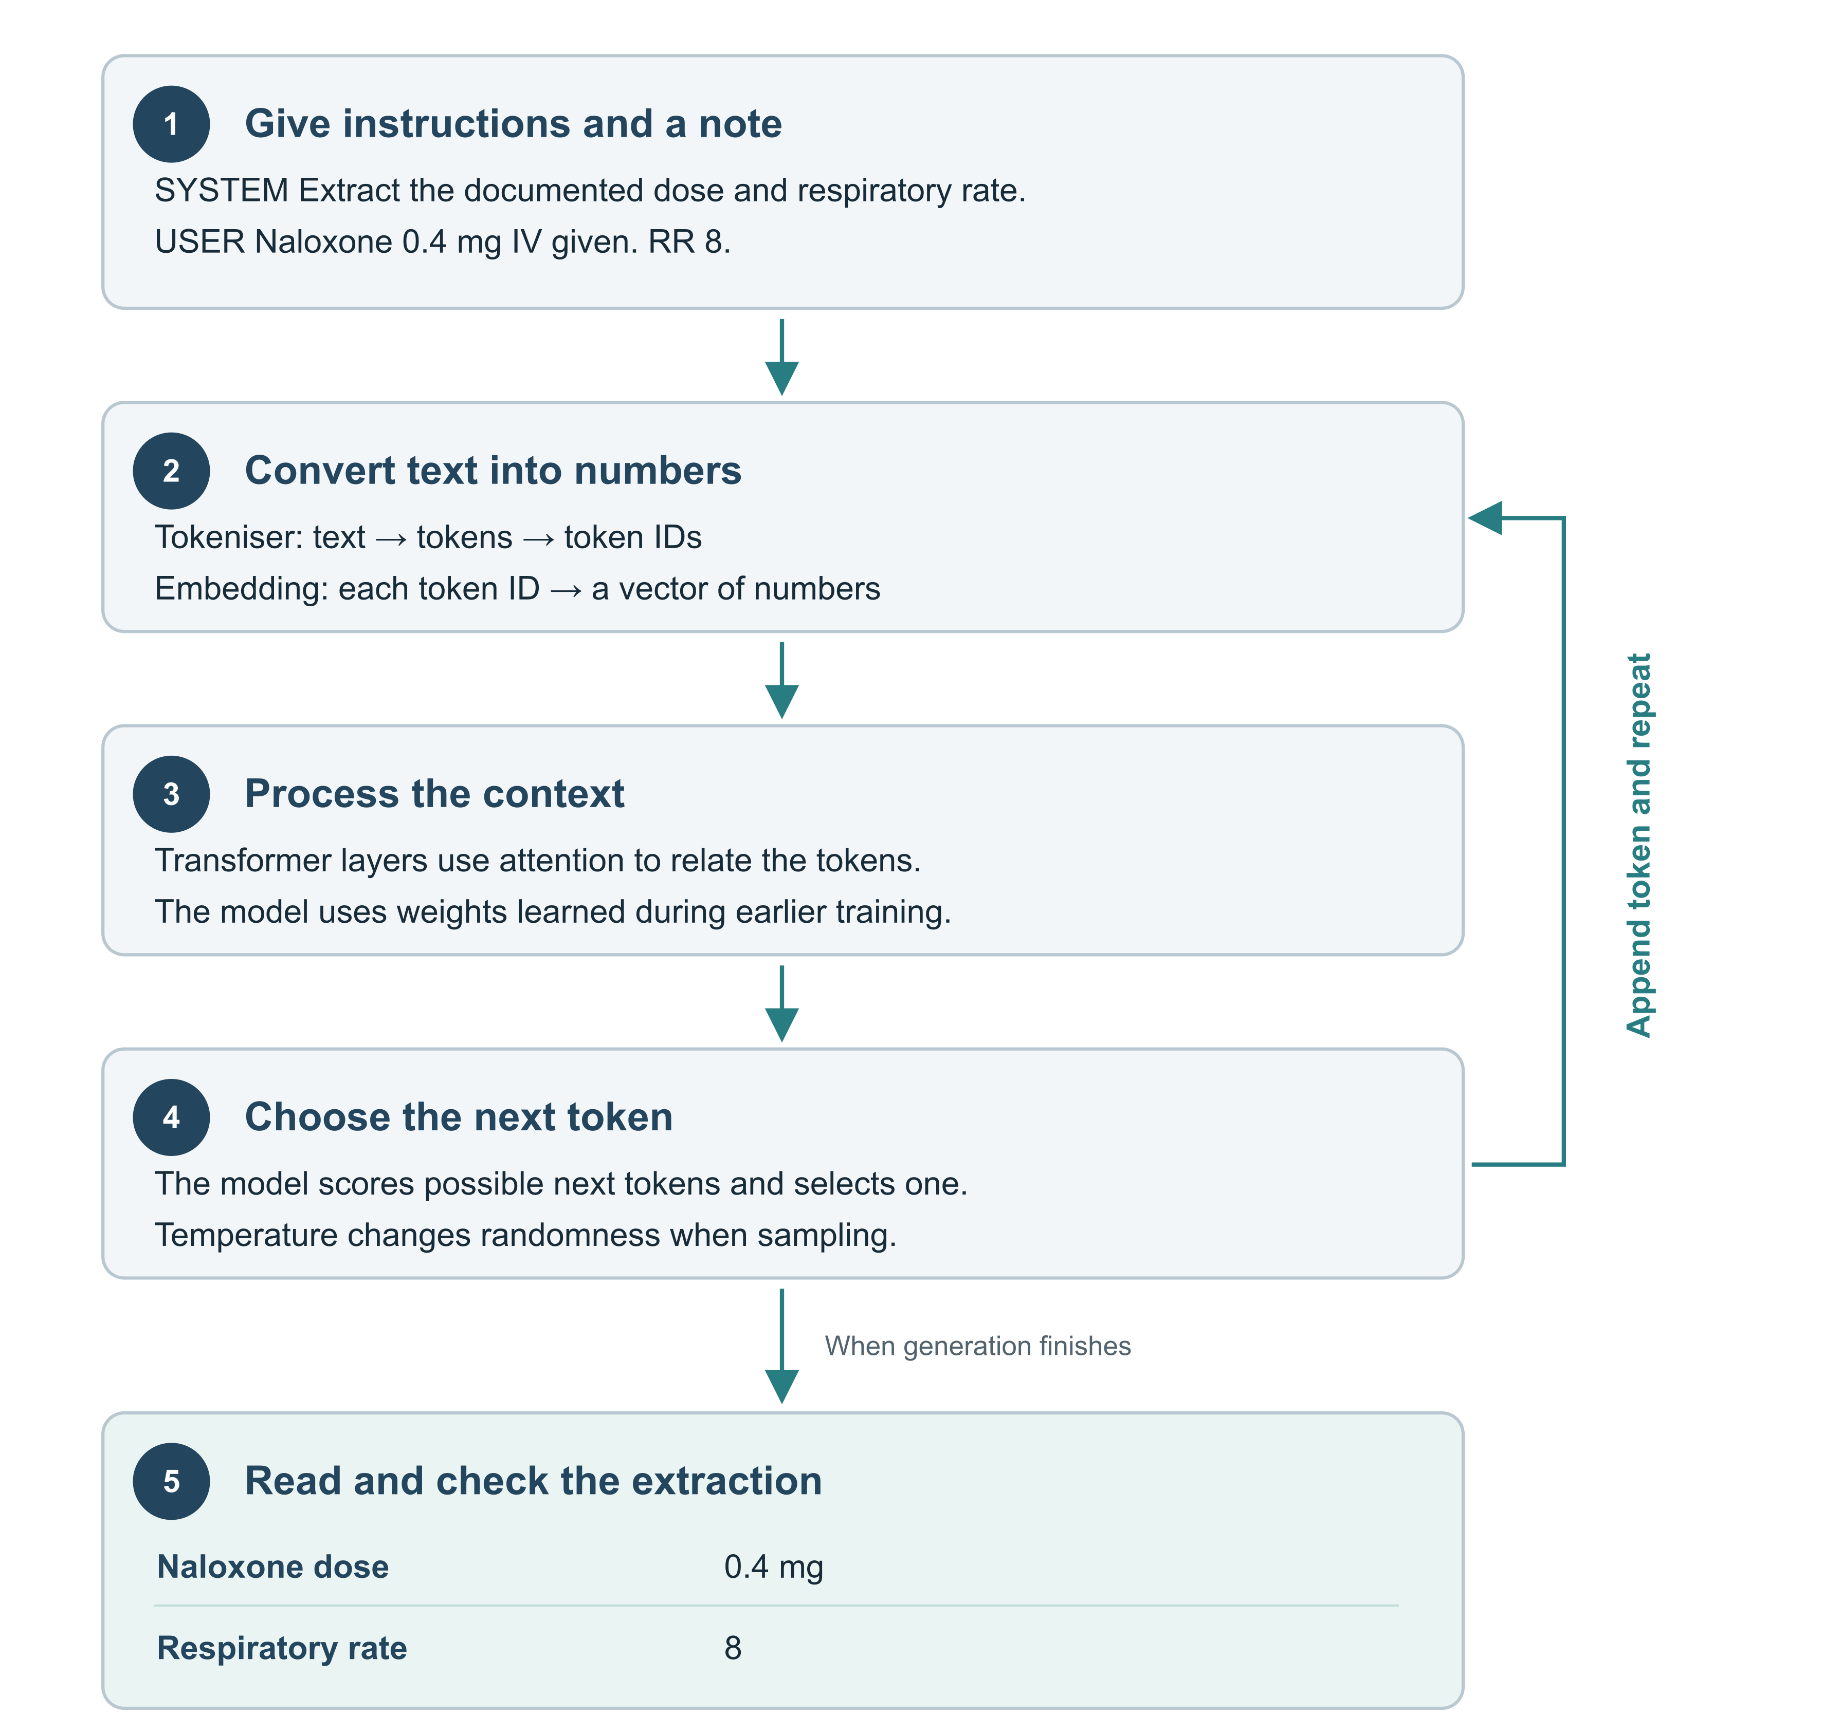
Illustrative example and expected fields. The diagram simplifies the model; it is not a recorded model run.
- Prompting: change the instructions, note or examples. Model weights stay fixed during this lab.
- Thinking mode: can generate additional reasoning tokens before the final answer. It still needs checking.
- Validation: a schema checks the answer format; compare the facts and quotes with the original note.
How token generation works | Attention Is All You Need

Traditional NLP and LLM extraction
The same note and target fields, with two different routes to an answer. Here, traditional NLP means a dictionary and pattern extractor.
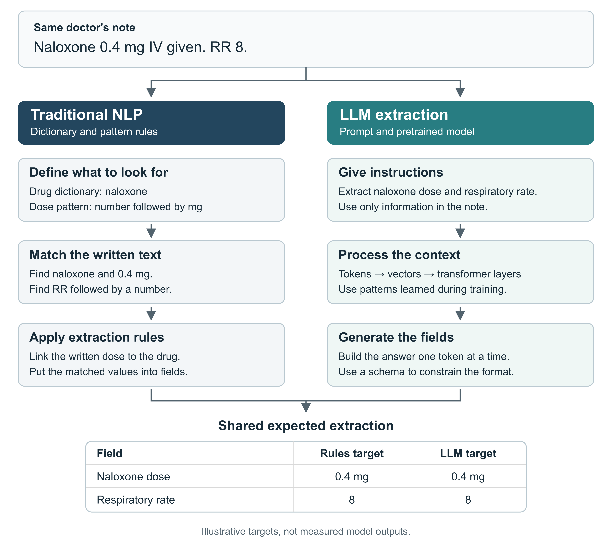
- Rules: repeatable and easy to inspect; new wording may need new patterns.
- LLM: prompts can guide extraction across varied wording; answers can still omit or invent facts.
- Both: compare predictions with the source note and an answer key. Traditional NLP can also include trained models and negation rules.
Try changing “RR 8” to “respiratory rate eight”. What would you change in the rules or prompt, and how would you check the answer?
spaCy rules and trained models

Prompts and messages
Term | Meaning in this lab
Prompt / prompt engineering | The instructions and context supplied to a model; prompt engineering means revising these and testing their effect.
System prompt | Reusable instructions, such as extraction rules and output requirements. Edit system_prompt in the marked prompt cell.
User prompt | The current request and note. Edit user_prompt; keep {note} where the note should appear.
Message role / assistant | The role field identifies a message as system, user or assistant. Assistant messages contain model answers or supplied example answers.
Prompt template / placeholder | Reusable text with a slot for changing data. user_prompt.replace("{note}", note_text) inserts the current note.
Zero-shot prompting | Asking for an answer without supplying worked examples. In the notebook, examples = [].
Role prompting | Giving a perspective, such as 'Assume you are a clinical data abstractor'. This wording does not change the message's API role.
Explicit rules | Stating exactly what to include, exclude and do when information is missing. The model must still be checked against the note.
Few-shot prompting | Supplying a few note–answer examples in examples. They guide the current response without changing the model's weights.

Reasoning and revision
Term | Meaning in this lab
Chain-of-thought (CoT) prompting | Asking for intermediate steps before answering. This lab uses short quoted evidence checks, then a second call for the extraction.
Thinking mode | Qwen's generation mode, controlled by thinking and passed as think. It differs from writing a CoT instruction in the prompt.
Self-check | Asking the model to check its answer against a checklist. Our exercise adds a prompt instruction; it is not an independent fact-checker.
Fine-tuning | Additional training that changes model weights. Editing prompts or adding few-shot examples in this lab is not fine-tuning.

Tokens and model settings
Term | Meaning in this lab
LLM token | A unit used by the model: often a word part, punctuation or a whole word. LLM tokens need not match spaCy tokens.
Context window | The token budget available for input and generated text. This notebook sets num_ctx = 8192; instructions and examples also use space.
Output token limit | The generation cap: max_tokens is passed to Ollama as num_predict. Too small a limit can leave an unfinished answer.
Temperature | Controls randomness when choosing tokens. Higher values allow more variation; lower values favour likely tokens. It is not an accuracy setting.
Seed / reproducibility | A starting value for random sampling. Fixing the seed, model, prompt and settings helps repeat comparisons; identical results across environments are not guaranteed.
Latency | The time taken to return an answer. Compare time as well as extraction quality when changing models or thinking mode.

Structured extraction and missing information
Term | Meaning in this lab
Information extraction | Turning free text into named facts, such as a drug, dose or respiratory rate. Classification instead assigns a category, such as opioid_case.
Field | One named part of an answer, such as opioids or respiratory_rate. The lab scores five fields and checks evidence separately.
Schema | The required fields and data types. Extraction defines the answer shape; schema passes that shape to the model.
JSON | A text format for structured data. The model returns JSON; the notebook turns it into readable tables.
Pydantic / validation | Pydantic checks whether an answer matches the required structure and types. Passing validation does not prove the extracted facts are correct.
Evidence quote | Text copied exactly from the note to support an answer. A matching quote can still be misinterpreted.
Hallucination | A generated claim unsupported by the source, such as adding a dose that the note never states.
Negation / mention | Negation says something is absent or denied. A drug can be mentioned in a denial without supporting an opioid case.
null / None | JSON null becomes Python None: a missing or unknown value. Use it only where allowed, such as an undocumented respiratory rate.
false / False | JSON false becomes Python False: a negative Boolean value under the field's rules. It is different from unknown.
Empty list [] | No items to report for a list field. For example, doses = [] means no qualifying explicit doses were extracted.

How parameters and settings change the output
Learned parameters are the model weights. The B in 1.7B or 4B means billions of parameters. They stay fixed during this lab; fine-tuning would change them.
Generation settings control how the loaded model produces an answer. Changing temperature or a token limit does not retrain it.
Same note: Naloxone 0.4 mg IV given. RR 8.
Expected facts: naloxone dose = 0.4 mg; respiratory rate = 8, whatever settings we test.
Control | Example change | What may change in the output
Model size | Qwen 1.7B  to Qwen 4B | Uses a different, larger set of learned weights. It may handle difficult wording better, but can still make errors. Usually needs more memory at the same precision.
Temperature | 0.2 to 0.8 | Higher values spread sampling across more possible tokens. Wording or extracted values may vary more. Lower values can still repeat the same wrong answer.
Top-p  (top_p) | 0.9 to 0.5 | Keeps the smallest set of likely tokens whose probabilities total at least 50%, instead of 90%. This narrows sampling choices without checking facts.
Top-k  (top_k) | 40 to 10 | Restricts sampling to the 10 highest-scoring next tokens instead of 40. Fewer choices may reduce variation. Test separately from top-p.
Seed | 42 to 43 | Changes the random sequence used for sampling, so an answer may change. A fixed seed helps repeat a run with the same setup; it does not guarantee accuracy.
Output limit  (num_predict) | 128 to 512 tokens | Allows more generated tokens before the cap. A low cap may cut off fields or JSON. A higher cap allows completion but does not force a longer answer.
Context window  (num_ctx) | 2048 to 8192 tokens | Allows more of a long note and examples to fit, with room for generation. If all text already fits, extra space alone need not change the answer.
Thinking mode  (think) | False to True | For these Qwen3 models, enables reasoning tokens before the final answer. This can use more time and output budget. Extraction may improve, worsen or stay the same.

Try one change at a time
- Keep the note, prompt and schema fixed. Start with temperature; compare several seeds at each value.
- Record correct fields, missing or invented facts, complete output and time taken. Identical answers can all be wrong.
- Use this short note to learn the controls, then check harder practice notes. These are suggested comparisons, not measured results or recommended defaults.
In the notebook, max_tokens is passed to Ollama as num_predict, and thinking is passed as think. Top-p and top-k are optional additional controls.
Ollama settings | Sampling definitions | Thinking mode

Practice scoring and the leaderboard
Term | Meaning in this lab
Practice / challenge set | Use the 20 practice notes to develop prompts. The 80 challenge notes are for scoring; do not put their answers into your prompt.
Reference answer / gold standard | The answer key used to score predictions. A teaching key needs review and can contain errors; 'gold' does not mean infallible.
Prediction | The answer produced by a model or rule. It is compared with the reference answer.
Precision | Of the facts extracted, the proportion that are correct. Extra or incorrect facts reduce precision.
Recall | Of the reference facts, the proportion successfully extracted. Missed facts reduce recall.
F1 score | Combines precision and recall: 2 × precision × recall / (precision + recall). The score runs from 0 to 1; higher is better.
Field-level micro F1 | Pool correct, extra and missed facts across notes for one field, then calculate F1. This gives one score for each field.
Leaderboard score | The mean of the five field-level F1 scores, with equal weight per field. Evidence-quote matches and time are reported separately.
Exact-note match | A note for which all five scored fields match the key under the scoring rules. The count breaks leaderboard ties.
Submission | Sending predictions for private scoring and public ranking. RUN_CHALLENGE runs the notes; SUBMIT controls sending the completed run.

References
Qwen3 model family
Ollama chat messages and thinking
Ollama generation parameters
Ollama structured outputs
scikit-learn F1 definition
Few-shot prompting — Brown et al. 2020
Chain-of-thought prompting — Wei et al. 2022

