# Lab 05.1 CURL

Question 1:

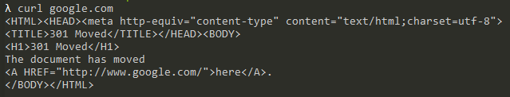

Question 2:

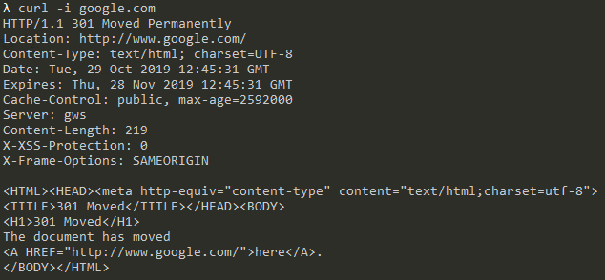

Question 3a:



Question 3b:

No employee 2202 existed so called employee 8301 instead just to show functionality 

Question 4:



Question 5 (Windows):

* Need to escape “ in json!





Question 6 (Windows):



