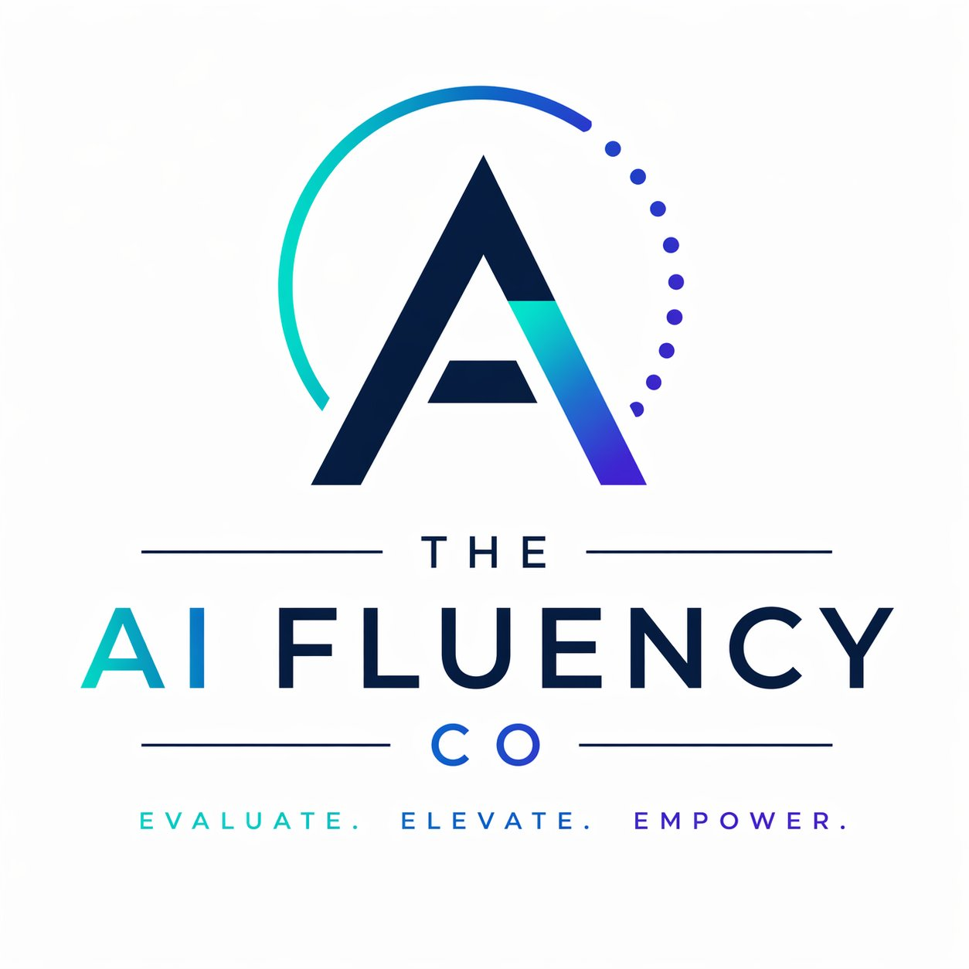
EXECUTIVE GUIDE
The Executive’s Guide to the AI Product Lifecycle
From concept to retirement — governing AI across its full life.

By Zoë François
Founder, The AI Fluency Company
First edition · 2026

CONTENTS
What’s in this guide.
Foreword | The companion volume. | 1
Chapter 1 | The lifecycle, in overview. | 2
Stage 1 | Concept & Use Case Definition. | 5
Stage 2 | Design & Development. | 8
Stage 3 | Validation & Testing. | 11
Stage 4 | Deployment. | 14
Stage 5 | Operation & Monitoring. | 17
Stage 6 | Maintenance & Improvement. | 20
Stage 7 | Decommissioning. | 23
Closing | Bringing it together. | 26
About | The AI Fluency Company.

FOREWORD
The companion volume.
This is the second volume in a series of PDF guides on elements of AI Fluency and governance. The first — The Executive’s Guide to AI Governance — gave you the framework. This one gives you the operating manual.
If you have read the first volume, you already know the ten pillars of ISO/IEC 42001 and how to think about AI governance at the executive level. That is the conceptual scaffolding. This guide takes one of those pillars — AI Lifecycle Management — and turns it into something you can actually do.
The reason for going deeper here is simple: the lifecycle is where governance either becomes real or stays theoretical. An organisation can publish an AI policy on a Monday and approve a use case the following Tuesday in a way that violates every principle in the policy. The lifecycle is the discipline that connects the two — a structured way to ensure that what is decided in the boardroom is what actually happens at the workstation.
This guide is structured as one short overview chapter followed by seven deep-dive chapters — one for each lifecycle stage. Each stage chapter has the same shape: the stage in depth, what ISO/IEC 42001 requires, what good looks like, where organisations go wrong, and the questions to ask your organisation. You can read it cover to cover, or pull out the chapter for the stage you are currently in.
A note on language. The standard refers to the “AI lifecycle”. I have called this “the AI product lifecycle” in the title because for a senior leader, that is the more useful framing. AI in your business is not a science project. It is a product, or a feature in a product, or a capability your team has built or bought. Treating it that way — with the same lifecycle discipline you would apply to any other product — is the bridge from theory to practice.
“AI policy without lifecycle discipline is a document. AI lifecycle discipline without policy is improvisation. You need both.”
The South African context, again, matters. The 2024 National AI Policy Framework and the 2026 draft policy explicitly reference lifecycle thinking. The standards being adopted internationally — ISO/IEC 42001, the EU AI Act, the OECD AI Principles — all centre on lifecycle controls. Building lifecycle discipline into your AI work now puts you ahead of regulation; ignoring it puts you behind.

Zoë François
Cape Town, 2026
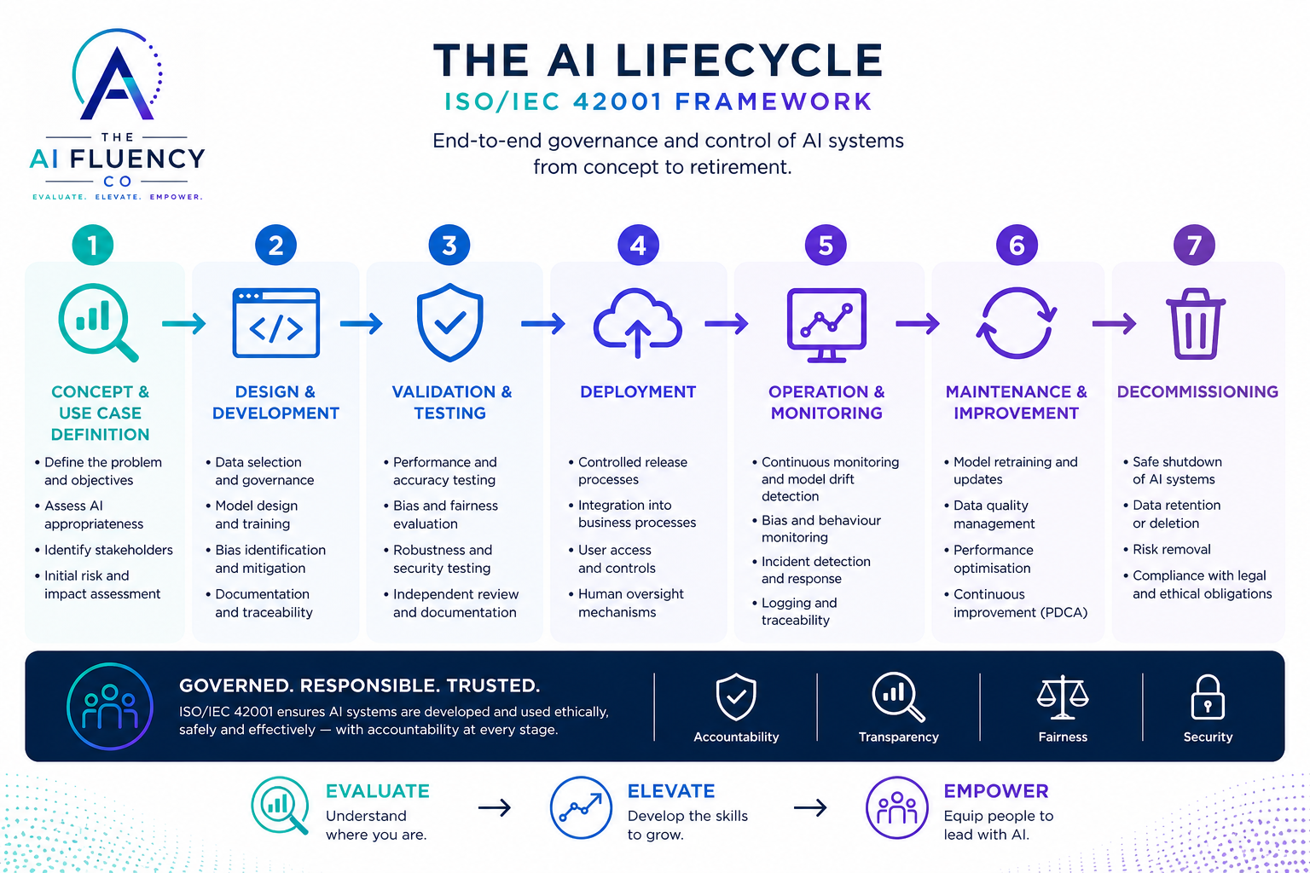
CHAPTER 1
The lifecycle, in overview.
Seven stages, one journey — from a question worth asking to a system safely retired.
Every AI system in your business is somewhere on a journey. Some are still being conceived. Some are being designed. Some are running in production, generating value or accumulating problems. Some are quietly degrading without anyone noticing. Some are well past their useful life and should have been retired months ago. The lifecycle gives you a way to know where each one is — and what governance applies at each point.
ISO/IEC 42001 organises the lifecycle into seven stages. The framework is summarised below, and each stage is explored in detail in the chapters that follow.

STAGE | WHAT IT COVERS
1. Concept & Use Case Definition | Deciding whether AI is the right answer to a real business problem — and defining what success looks like before any technology is chosen.
2. Design & Development | Translating a defined use case into an AI system: data selection, model design, bias controls, documentation, and the architectural choices that determine what is possible later.
3. Validation & Testing | Proving, with evidence, that the system performs as intended — across all the conditions and stakeholders it will affect. Not just “does it work” but “does it work safely, fairly, reliably?”
4. Deployment | Moving from controlled testing to real-world use, with the integrations, controls, oversight mechanisms, and user readiness needed to deploy responsibly.
5. Operation & Monitoring | Running the system day to day, watching for drift, anomalies, and emerging risks; ensuring it continues to perform within tolerance after launch.
6. Maintenance & Improvement | Updating, retraining, refining, and continuously improving the system as data, business needs, and the AI landscape evolve.
7. Decommissioning | Retiring the system safely — protecting data, removing access, capturing lessons, and closing risk responsibly.
Why the lifecycle matters.
Three things happen when an organisation thinks about AI without lifecycle discipline. First, AI initiatives concentrate at the front of the journey — lots of pilots, lots of use cases, lots of investment in development — and then quietly degrade once they are deployed because nobody owns what comes after. Second, governance becomes a checkpoint at one stage rather than a discipline across all of them — an approval at procurement, perhaps, or a sign-off at launch, but nothing in between. Third, decommissioning never happens at all. AI systems accumulate in the operational stack, like servers in a data centre nobody has decommissioned, until somebody discovers they have been generating wrong answers for a year.
Lifecycle discipline addresses all three. It distributes governance evenly across the journey. It ensures someone owns each stage. It builds the assumption of an ending into the beginning.
“Most AI systems do not fail at deployment. They fail because the wrong problem was chosen at conception, or because nobody owned what happened after.”

How the stages connect.
The stages are sequential but not strictly linear. A real AI system loops back constantly: a deployment problem might surface a design weakness; a monitoring finding might require revalidation; a maintenance update might require redeployment. The lifecycle is best understood as a journey with milestones, not a conveyor belt with one-way doors.
Each stage has its own controls and its own questions. But three principles run through all seven stages and are worth holding in mind as you read the chapters that follow.

THREE PRINCIPLES THAT RUN THROUGH EVERY STAGE
Accountability is named, not assumed. At every stage, someone is accountable. The same person is not accountable for every stage — but no stage is unowned.
Documentation is not paperwork. The records you keep at each stage are the evidence that, if something goes wrong, you can explain what was decided, why, and by whom. Without documentation, every stage becomes a story rather than a fact.
The earlier the stage, the cheaper the correction. A bad use case caught at concept costs nothing to fix. The same bad use case caught at deployment costs months of work. The same bad use case caught after deployment costs reputation and trust.
How to use this guide.
Each of the seven stage chapters that follows is self-contained. You can read them in order if you are building lifecycle discipline from scratch. You can pull out the chapter for the stage you are currently in if you need a working reference. You can read only the questions at the end of each chapter if all you have is fifteen minutes before a meeting.
If you read nothing else, read the closing chapter. It brings the stages back together and gives you a one-page view of what mature lifecycle governance looks like — and a starting point for your own journey toward it.

STAGE 1
Concept & Use Case Definition.
Where AI success is won — or lost.
Most AI initiatives don’t fail in deployment. They fail here — because the wrong problem was chosen.

THE STAGE IN DEPTH
The concept stage is the most consequential and the most overlooked. By the time an organisation is wrestling with whether its AI system performs reliably or whether its monitoring is adequate, the most important decision has already been made: the decision about what problem the AI is solving in the first place. Get that wrong, and no amount of downstream excellence rescues the project. Get it right, and almost every later stage becomes easier.
What this stage is about, fundamentally, is asking three questions before any technology gets chosen. What problem are we actually solving? What does success look like, in measurable terms? Is AI the right tool for this — or have we just decided we want to use AI?
These questions sound obvious. They are routinely skipped. The pattern is familiar: someone in the organisation hears about a capability, or a vendor pitches a solution, or a team becomes excited about a tool, and the project starts at the answer rather than the question. By the time anyone asks “what problem is this solving?”, several months and several budgets have been committed.
The concept stage is also where you do your first risk and impact assessment, identify the stakeholders who will be affected, and decide whether the use case is one your organisation should pursue at all. A well-defined concept is the foundation on which everything else rests — and it is the lowest-cost place in the entire lifecycle to discover that the foundation is unsound.

THE ISO/IEC 42001 LENS — WHAT THIS STAGE REQUIRES
- Alignment with business objectives — the use case connects to a stated organisational goal.
- Identification of affected stakeholders — customers, employees, third parties, communities.
- Initial risk and impact assessment — what could go wrong, who could be harmed.
- Consideration of ethical, legal, and societal implications relevant to the use case.
- Documented justification for choosing AI as the solution — and for the boundaries of its use.

WHAT GOOD LOOKS LIKE
- Clear business value — expressed in revenue, cost, risk reduction, or capability terms.
- Defined success metrics — measurable, with thresholds for what good and bad outcomes look like.
- Identified data sources — known, accessible, and fit for purpose.
- Known constraints and risks — surfaced and documented at concept, not at deployment.
- Executive sponsorship — a named senior leader who owns the use case and its outcomes.
- An explicit decision: “this is the right problem to solve, and AI is the right way to solve it.”

WHERE ORGANISATIONS GO WRONG
- Jumping straight to tools — “let’s use ChatGPT for X” before defining what X actually is.
- No clear problem definition — a fuzzy ambition rather than a specific, measurable outcome.
- No quantified value — “it will help productivity” without numbers behind it.
- Ignoring risk and governance early — treating the concept stage as exciting and the governance stage as boring.
- Skipping stakeholder identification — building for one user group while affecting many others.

THREE QUESTIONS TO ASK YOUR ORGANISATION
- What problem are we actually solving — and could we describe it without mentioning AI?
- What does success look like at day 90, expressed in numbers we will measure?
- Who are the stakeholders affected by this use case — and have we asked any of them?

“If these questions are uncomfortable to answer, the concept is not yet defined. Stop. Don’t proceed.”

STAGE 2
Design & Development.
Where ideas become intelligent systems — and where future risk is locked in.
Good design builds value. Poor design builds risk. Both are decisions you make here.

THE STAGE IN DEPTH
Design and development is where the use case defined at the concept stage becomes a working system. It is the most technical of the seven stages and, for a senior leader, the one where it is easiest to feel out of one’s depth and disengage. That is a mistake. Some of the most consequential governance decisions in the entire lifecycle are made here — and they are made in language that doesn’t look like governance language.
What data will the system be trained on, and where will that data come from? What architectural choices are being made about how the system works, and how will it be possible to explain its decisions later? What testing for bias is being built in, and across which groups? What documentation is being created, and will it survive long enough to be useful when someone wants to audit this system three years from now? What roles are being defined, and who has authority over what?
These are not technical questions. They are governance questions, asked at a moment when the technology team is moving fast and the rest of the organisation is not yet paying attention. By the time the system is built, every one of these decisions has consequences that are expensive to unwind.
The discipline of this stage is to ensure that design decisions are made with governance criteria as inputs, not afterthoughts — and that the people who will be accountable for the system over its life are involved before the system exists.

THE ISO/IEC 42001 LENS — WHAT THIS STAGE REQUIRES
- Controlled and repeatable development processes — not heroic individual work.
- Data governance — quality, provenance, consent, and security applied to the data feeding the system.
- Traceability of data, models, code, and versions — so that any output can be linked back to its inputs.
- Cross-functional collaboration and clearly defined accountabilities across the development team.
- Comprehensive records and documentation of decisions and design choices made along the way.

WHAT GOOD LOOKS LIKE
- High-quality, relevant, and unbiased data — the result of deliberate selection, not whatever was available.
- Well-architected and tested models — with the architecture chosen to support explainability and oversight.
- Bias and fairness controls built into the design — not bolted on later.
- Secure coding practices and infrastructure controls applied as a matter of course.
- Clear documentation and version control — with a documentation standard that survives team changes.
- Defined roles, responsibilities, and approvals — so that decision rights are explicit before the work begins.

WHERE ORGANISATIONS GO WRONG
- Using poor-quality or biased data — the most common failure, with the most far-reaching consequences.
- Rushing to build without proper design — prototyping in production is not an architectural choice.
- Ignoring bias and fairness early — deferring those questions until “we see how it performs”.
- Inadequate documentation — producing systems nobody can later explain, audit, or defend.
- Unclear accountability — a development team where everyone is responsible for everything, which means no-one is responsible for anything specific.

THREE QUESTIONS TO ASK YOUR ORGANISATION
- Where did our training data come from — and would we be comfortable showing that lineage to a regulator?
- If a stakeholder asked tomorrow “why did the AI make this decision?”, could the system answer?
- Who, by name, is accountable for the design choices we are making this month?

“What you build must be explainable, traceable, and justifiable — or you will pay for its absence later.”

STAGE 3
Validation & Testing.
Where confidence and trust are proven — not assumed.
This is not just about “does it work?” It’s about “does it work safely, fairly and reliably across everyone it will affect?”

THE STAGE IN DEPTH
Validation and testing is the stage where the system that was designed and developed gets exposed to scrutiny before it touches anything that matters. It is the difference between confidence based on hope and confidence based on evidence. The discipline here is to test enough things, well enough, that you can defend the decision to deploy.
Most organisations have no trouble testing whether an AI system is accurate. They test much less rigorously whether it is fair across different groups, whether it is robust against unexpected inputs, whether it is secure against adversarial attacks, whether it is explainable to a non-specialist, and whether the humans who will work with it understand what it does. Each of those dimensions has its own testing discipline. Each can be the source of failure that an accuracy-only test would have missed.
The validation stage is also where independent review matters. A team that has spent six months building a system is not the right team to declare it ready for deployment. ISO/IEC 42001 expects independent validation where appropriate — the system being assessed by people who did not build it. That is not bureaucracy; it is the most reliable way to surface the things the build team cannot see.
Most importantly, validation is where the go/no-go decision is made — with documentation. A defensible “yes” and a defensible “no” are both possible outcomes. A “well, let’s just try it in production” is not.

THE ISO/IEC 42001 LENS — WHAT THIS STAGE REQUIRES
- Defined validation and acceptance criteria — documented before testing begins, not negotiated in light of results.
- Testing across diverse and representative datasets — not just the data the system was trained on.
- Independent review where appropriate — by people who were not part of the build team.
- Documentation of methods, results, and limitations — the boundaries of where the system has been proven to work.
- Identification and management of residual risks — not eliminated but acknowledged and mitigated.
- Decision gates before release to deployment — with named approvers and documented evidence.

WHAT GOOD LOOKS LIKE
- Meets or exceeds the performance benchmarks set in the concept stage.
- Fair and unbiased across the groups identified during stakeholder analysis.
- Resilient to edge cases and unexpected inputs — tested deliberately, not only on clean data.
- Secure against known threats and misuse scenarios.
- Outcomes are explainable and understandable to the audience who will use them.
- Human-in-the-loop controls have been tested and shown to work in practice, not just in theory.
- A clear go/no-go decision based on evidence — with the evidence preserved.

WHERE ORGANISATIONS GO WRONG
- Testing only for accuracy — not for real-world impact, fairness, or robustness.
- Using narrow or unrepresentative data — testing on the easy cases and assuming the rest will be similar.
- Ignoring bias and fairness testing — because it is harder, less rigorous, or politically uncomfortable.
- Overlooking security and robustness testing — leaving the system exposed to misuse.
- Skipping independent review or peer validation — the team that built it signs off on it.
- Treating validation as a hurdle to clear rather than a source of evidence to preserve.

THREE QUESTIONS TO ASK YOUR ORGANISATION
- What did we test — and what did we deliberately decide not to test?
- Who, independent of the build team, has reviewed this system before deployment?
- If this system causes harm in production, what evidence will we have that we tested for it?

“Trust is earned through evidence. Evidence comes from rigorous testing — done before deployment, not after.”

STAGE 4
Deployment.
From ready to real — safely, securely, and responsibly.
This is where strategy becomes reality. Good deployment ensures control, oversight, and adoption. Poor deployment creates resistance, risk, and reputational damage.

THE STAGE IN DEPTH
Deployment is the moment the AI system stops being a project and becomes an operational reality. It is also the moment when the discipline established in the previous stages either holds up or falls apart. A system that was carefully validated can be undone by a careless deployment — unclear access controls, missing oversight mechanisms, untrained users, no monitoring in place from day one.
Deployment is much more than a technical release. It is the integration of the system into the business processes it will affect — with the people, controls, and oversight required to use it well. It is also where change management begins. The teams who will use the system need to understand what it does, what its limits are, and what their role in working with it actually is. Without that, even an excellent system will fail to deliver value — because the humans around it will not trust it, will work around it, or will trust it too much.
ISO/IEC 42001 expects deployment to be controlled, with explicit accountability and human oversight in place from the moment the system goes live. That means stop conditions — the circumstances under which the system would be paused or rolled back — are defined and tested. It means escalation paths are clear. It means user-facing communication is in place. It means data protection and privacy are not deployment afterthoughts but operational realities.
And deployment is when monitoring begins, not after. The monitoring you wish you had at month six is the monitoring you have to set up at week one. Deferring it is one of the most common and most consequential failures of AI deployment.

THE ISO/IEC 42001 LENS — WHAT THIS STAGE REQUIRES
- Controlled release and change management — not a flag flipped from ‘off’ to ‘on’.
- Defined accountability and ownership for the live system — named, not implied.
- Human oversight mechanisms in place from the moment of deployment.
- Clear operating procedures and user guidance — written for the people who will use the system.
- Transparency with end users about how the system works and where its limits lie.
- Monitoring setup and incident response procedures live from day one.
- Data protection and privacy by design carried through into the operational deployment.

WHAT GOOD LOOKS LIKE
- Seamlessly integrated into business workflows — not a separate tool requiring separate behaviour.
- Accessible to the right people, in the right way, with appropriate controls.
- Monitored from day one — with thresholds, alerts, and named recipients of those alerts.
- Supported by clear documentation and training for users, administrators, and oversight roles.
- Designed with human-in-the-loop controls operating in practice, not just in design.
- Compliant with applicable legal, ethical, and regulatory requirements — demonstrably.
- Trusted by the users and stakeholders affected by the deployment — because trust was built deliberately.

WHERE ORGANISATIONS GO WRONG
- Rushing to go live without operational readiness — deployment as an event, not a process.
- No clear ownership or accountability for the live system once it is in production.
- No human oversight mechanisms in place — oversight assumed but not designed.
- No monitoring active at launch — the assumption that monitoring can be added ‘soon’.
- Poor user communication and training — the people who will work with the system don’t understand it.
- Treating deployment as the end of the project rather than the start of operations.

THREE QUESTIONS TO ASK YOUR ORGANISATION
- On day one of deployment, who is accountable for this system, and would they answer the phone if it failed?
- What monitoring will be active from the moment the system goes live — and who will respond to its alerts?
- What are the conditions under which we would pause or roll back this deployment, and have we tested them?

“Adoption and trust start with a well-managed deployment. They are very difficult to recover if the deployment goes badly.”

STAGE 5
Operation & Monitoring.
Continuous visibility. Early detection. Confident action.
This is where your AI system delivers value — every day. Good operation and monitoring keep it performing, safe, and trusted.

THE STAGE IN DEPTH
Once an AI system is live, it operates in a dynamic environment. The world changes around it. The data feeding it changes. The people using it change. The behaviour of the model itself can change in subtle ways over time — a phenomenon known as drift. The job of operation and monitoring is to ensure the system continues to perform as expected, despite all of that, and to surface problems while they are still small.
Operation is not the absence of governance; it is the part of governance that runs every day. The system’s performance against the metrics defined in the concept stage is being measured continuously. Bias and fairness are being monitored, not just tested once. Anomalies in the system’s behaviour are being detected by mechanisms that are themselves being maintained. User feedback is being captured and channelled into review. Incidents are being logged, escalated, and resolved through documented processes. Audit trails are being generated and stored.
All of this requires resources — people, attention, tools, time. One of the most common failure modes in AI is treating operation as a low-effort steady state, when in fact it is the most demanding stage in the entire lifecycle. The work does not get easier after deployment. It changes shape — from “build it well” to “run it well” — and the latter requires its own discipline.
Reporting is part of operation. The board and executive team should be receiving meaningful information about the performance of material AI systems — not technical metrics, but the business questions: is the system delivering its expected value, are there incidents the leadership should know about, what is changing, what needs attention. This is the channel through which AI moves from being something operations is doing to something the organisation is doing.

THE ISO/IEC 42001 LENS — WHAT THIS STAGE REQUIRES
- Continuous monitoring of performance and behaviour — not periodic snapshots.
- Detection of deviations and emerging risks, with thresholds for action defined in advance.
- Logging and traceability of system activity, sufficient to support audit and investigation.
- Defined incident management process — detection, response, communication, resolution, review.
- Communication and escalation procedures clear to everyone in the operational chain.
- Regular review of outputs and impacts — not just system metrics but business and stakeholder outcomes.
- Transparency with users and stakeholders about ongoing operation, changes, and incidents.
- Protection of data, privacy, and security maintained as operating conditions evolve.
- Periodic reporting to governance and leadership in language they can engage with.

WHAT GOOD LOOKS LIKE
- Delivers consistent, reliable performance against the metrics defined at the concept stage.
- Detects issues early and responds quickly — measured by time to detection and time to response.
- Maintains data quality and relevance as input conditions change.
- Identifies and mitigates bias over time — not just at launch.
- Has clear accountability and escalation paths — known to the operations team, not just documented.
- Generates audit-ready logs and reports as a by-product of operation, not as a separate effort.
- Is continuously aligned with business and user needs — reviewed regularly against original objectives.
- Operates within ethical, legal, and regulatory boundaries — demonstrably.
- Builds and maintains trust with users and stakeholders through visible, ongoing diligence.

WHERE ORGANISATIONS GO WRONG
- No monitoring once deployed — “set it and forget it” applied to a system that doesn’t stay set.
- Ignoring model and data drift — assuming today’s performance equals next quarter’s performance.
- Not tracking bias over time — a system that was fair at launch may not be fair six months later.
- No alerts or incident response — problems detected by stakeholders rather than by the operations team.
- Poor logging and traceability — making investigation expensive and assurance impossible.
- No ownership or accountability for ongoing operation — the system is in production but no-one is in charge of it.

THREE QUESTIONS TO ASK YOUR ORGANISATION
- Can we name the performance indicators for our material AI systems — and tell the board what they are doing this month?
- How would we know if the system was drifting — and how long would it take us to know?
- What would happen at 02:00 if a critical AI system started behaving strangely — who would notice, and who would act?

“What you don’t monitor will drift. What drifts will fail. The cost of monitoring is small. The cost of its absence is not.”

STAGE 6
Maintenance & Improvement.
AI is not static. Continuous improvement creates lasting value.
This is where your AI system evolves and adapts. Good maintenance keeps it accurate, relevant, fair and aligned with changing needs.

THE STAGE IN DEPTH
AI systems must learn and improve over time to stay effective. The world they operate in is not static. Customer behaviour changes. Regulatory requirements change. The data environment changes. The people working with the system change. New and better techniques become available. A system that is not maintained will, over time, become less accurate, less fair, and less aligned with the business it was built to serve. The decline is rarely sudden. It is usually slow enough not to be noticed until something goes wrong.
Maintenance and improvement is the structured discipline of keeping the system fit for purpose. It includes performance review and optimisation, model retraining and fine-tuning, data and dataset updates, refinement of how the system is used, re-assessment of bias and fairness as conditions change, change impact assessment, integration of user feedback, and ongoing documentation. None of this is glamorous. All of it is what separates a good AI system from a great one over time.
The discipline most often missed at this stage is the link to the rest of the lifecycle. A maintenance change should trigger re-validation, sometimes re-deployment, and always documentation. Maintenance done in isolation — a quiet model update, a small data refresh, a quick fix to a parameter — is how systems silently leave the boundary of their original validation and become something different from what was approved.
And maintenance is the stage where lessons get applied. Incidents from operation, feedback from users, findings from audits, changes in regulation — all of these are inputs to the improvement loop. An organisation that captures lessons but never feeds them back into its AI systems has a learning function that doesn’t learn. Continuous improvement, in the ISO 42001 sense, is the discipline that closes that loop.

THE ISO/IEC 42001 LENS — WHAT THIS STAGE REQUIRES
- Use of a continual improvement approach — a documented, repeating cycle, not ad-hoc fixes.
- Regular evaluation of performance and impact against the original objectives.
- Updating data, models, and system components in a controlled and traceable way.
- Management of changes and configurations — with version control and rollback capability.
- Re-validation after significant changes — not after every change, but consistently after material ones.
- Documentation of changes and the rationale behind them.
- Monitoring of improvements and their outcomes — to confirm change actually improved things.
- Lessons-learned and knowledge capture — from incidents, from feedback, from external developments.

WHAT GOOD LOOKS LIKE
- Maintains high performance over time — measured against benchmarks, not impression.
- Adapts to new data, trends, and user needs — visibly, not just in principle.
- Remains fair, unbiased, and inclusive — with regular re-testing as conditions change.
- Has a clear improvement roadmap, owned at executive level, with named milestones.
- Uses strong data and model governance to support change without losing control.
- Has robust change control and re-validation processes — changes don’t bypass governance.
- Delivers measurable improvement in outcomes — with the measurement to prove it.
- Is future-ready and scalable — designed to evolve, not just designed once.

WHERE ORGANISATIONS GO WRONG
- Treating AI as “set and forget” — the most expensive assumption in the lifecycle.
- Ignoring model drift and performance decline — absence of monitoring leading to absence of action.
- Not updating data or training on new information — a model trained for last year still being used this year.
- Skipping re-validation after changes — quietly leaving the boundary of what was originally approved.
- Poor change management and documentation — producing systems that, after eighteen months, nobody can explain.
- No ownership for improvement — maintenance happens when something breaks, not as a discipline.

THREE QUESTIONS TO ASK YOUR ORGANISATION
- When was the last material change to our most important AI system — and was it re-validated?
- Where in our organisation is the improvement loop — and is anyone formally responsible for closing it?
- If our regulator asked how our AI systems have evolved over the past twelve months, could we tell them?

“Continuous improvement isn’t a task. It’s a commitment — and the system you improve today is the advantage you keep tomorrow.”

STAGE 7
Decommissioning.
End responsibly. Protect people, data and value.
This is where your AI system is retired — in a safe, controlled, and compliant way. Good decommissioning closes risk and protects what matters.

THE STAGE IN DEPTH
Decommissioning is the most overlooked stage in the AI lifecycle. Most organisations have a clear process for launching AI systems and almost no process for retiring them. The result is a slowly accumulating backlog of AI components that are still running, still consuming resources, still holding data, and still capable of producing outputs — long after anyone is paying attention to them. This is one of the largest invisible risks in any AI estate.
An AI system needs to be decommissioned when it is no longer needed, has been replaced, has reached the end of its useful life, or has been judged no longer fit for purpose. The decision to decommission is itself a governance decision — made by someone with authority, on the basis of documented evidence, with a documented retirement plan.
What that plan covers is more than just turning the system off. It covers safe shutdown of the AI system, decisions about data — retention, archival, secure deletion in line with legal obligations — and the removal of all access, accounts, and endpoints associated with the system. It covers third-party and vendor offboarding, the transfer or deletion of any model or code artefacts, the closing out of related contracts, and the documentation of the entire process. It covers communication with stakeholders affected by the retirement.
And it includes the most often-missed element: the post-decommissioning review and capture of lessons learned. A system being retired has eighteen months or more of operational experience to share with whatever replaces it. That experience is wasted if it is not captured and fed back into the broader AI Management System. Done well, decommissioning closes risk and creates capacity. Done badly, it leaves a residual liability — systems still partly running, data still partly accessible, accounts still partly active — that surfaces years later, often in ways that are expensive to resolve.

THE ISO/IEC 42001 LENS — WHAT THIS STAGE REQUIRES
- Defined decommissioning criteria and triggers — the circumstances under which retirement is warranted.
- Risk assessment prior to decommissioning — ensuring the retirement itself does not create new risks.
- Controlled and documented shutdown process, with a named owner and documented stage gates.
- Data management in line with legal requirements — retention, archival, deletion as obligated.
- Protection of privacy and intellectual property through the retirement.
- Revocation of access and credentials — systematically, not on best efforts.
- Secure removal or repurposing of assets — hardware, software, infrastructure.
- Update of records, inventory, and documentation — the AI estate stays accurate.
- Stakeholder notification and transparency about the retirement.
- Review of outcomes and continual improvement — closing the loop on what was learned.

WHAT GOOD LOOKS LIKE
- Is retired only when the right criteria are met — not because someone forgot it existed.
- Has no residual risk to people or the organisation — demonstrated, not assumed.
- Protects personal, sensitive, and proprietary data through the retirement process.
- Complies with all legal and regulatory obligations on data retention and deletion.
- Has no active access, accounts, or endpoints associated with the retired system.
- Has documented evidence of decommissioning — sufficient to satisfy an auditor years later.
- Ensures third-party and contract obligations are closed — not silently breached.
- Captures lessons learned for future systems — systematically, not anecdotally.
- Maintains trust with users and stakeholders through the way the retirement is communicated.
- Frees resources for innovation and higher-value work — the genuine purpose of decommissioning.

WHERE ORGANISATIONS GO WRONG
- No clear exit strategy — systems that nobody knows how to retire.
- Leaving data exposed — retention rules ignored, deletion not actually performed.
- Not revoking access or permissions — accounts still active long after the system is supposedly retired.
- Poor documentation or record-keeping — making the audit trail of decommissioning unrecoverable.
- Ignoring third-party obligations — vendor contracts, data sharing agreements, certification scopes left dangling.
- No post-decommissioning review or learning — the experience of the retired system lost to the organisation.

THREE QUESTIONS TO ASK YOUR ORGANISATION
- Do we know which AI systems we have retired in the past two years — and could we evidence the decommissioning?
- For our active AI systems, do we have a documented retirement plan — or only a launch plan?
- Where is the lessons-learned record from our most recently retired system — and who, by name, is using it to inform what comes next?

“The end of an AI system is not the end of accountability. Decommission responsibly today — and you build trust for tomorrow.”

CLOSING
Bringing it together.
Seven stages, three patterns, one discipline.
If you have read this far, you have seen the seven stages described in detail and worked through the questions at the end of each chapter. Three patterns recur across all of them. They are worth restating as the foundations of mature AI lifecycle governance.
Pattern one: every stage has an owner.
In organisations where AI lifecycle governance works, the answer to “who is accountable for this stage of this AI system?” is always a person’s name. Not a department. Not a committee. Not “we”. The same person is not accountable for every stage — lifecycle ownership rotates as the system moves through its journey — but every stage has a name attached to it. In organisations where AI lifecycle governance fails, the same answer is some version of “well, IT, or the business, or actually I’m not sure”. That ambiguity is the most reliable predictor of failure across the entire lifecycle.
Pattern two: documentation is the test of governance.
The questions at the end of each chapter all share a hidden assumption: that you can show evidence of how each stage was conducted. That assumption is the test of whether your governance is real. You can describe a beautiful concept stage; the question is whether you have a documented record of the use case definition, the stakeholder analysis, the risk assessment, the executive sign-off. You can claim a robust validation; the question is whether you have a documented test plan, results, residual risks, and approval to proceed. Documentation is not paperwork. It is the evidence that converts intention into governance.
Pattern three: the lifecycle is a system, not a checklist.
The seven stages are not separate boxes to be ticked. They form a system in which decisions made at each stage flow into the next. A weak concept makes design harder. A weak design makes validation harder. A weak validation makes deployment riskier. A weak deployment makes operation more demanding. A weak operation makes maintenance reactive rather than improving. A weak maintenance discipline makes decommissioning chaotic. The discipline is to treat every stage as an investment in the next.
“AI systems do not fail in any one stage. They fail across them — because nobody connected the stages into a single discipline of governance over time.”

Where to start.
If you have just finished reading this guide and are wondering where to start in your own organisation, the answer is almost always the same: with an inventory. Most organisations underestimate how many AI systems they already have. The first act of lifecycle governance is to know what is in scope. From there, three priorities tend to be most valuable for most organisations — in the order shown.

THREE PLACES TO START — IN THIS ORDER
1. Build an AI inventory. List every AI system, AI feature, and AI-powered tool currently in use. For each, capture the lifecycle stage it is in, who owns it, and what its key risks are. The inventory itself is often a revelation.
2. Strengthen your concept stage. The cheapest place to fix things is at conception. Ensure that no new AI use case enters the lifecycle without a defined problem, a measurable outcome, and a named executive sponsor.
3. Establish your monitoring discipline. Operations is where most organisations are weakest. Decide what is being monitored for which systems, who owns the monitoring, and how findings flow back into improvement and governance.

These are not transformation programmes. They are first steps. Done in order, they create the foundation on which the broader lifecycle discipline can be built. A useful sequence is: inventory in month one, concept-stage controls by month three, operational monitoring discipline by month six. Maturity follows from there.

“The lifecycle is a system. Govern it as one — stage by stage — and the rest gets easier.”

ABOUT
The AI Fluency Company.
The AI Fluency Company helps executive teams adopt AI responsibly — building the language, the judgement, and the governance to make AI work in their business. We work with mid-market organisations, family businesses, and compliance-minded leaders who want to do AI properly the first time.
How we work with executive teams.
ENGAGEMENT | WHAT IT IS
AI Fluency Training | Half-day workshop for leadership teams. Builds shared understanding of working with AI effectively, efficiently, ethically, and safely.
AI Strategy Workshop | Two days. Prioritise use cases, map ownership, build a 90-day roadmap.
AI Opportunity & Risk Diagnostic | Five days. Board-ready review of where AI belongs in your business and where you are exposed. ISO/IEC 42001 aligned.
AI Governance & ISO 42001 Readiness | A structured pathway to certification, delivered with an accredited specialist partner.

About the author.
Zoë François is the founder of The AI Fluency Company. She trained as a chemical engineer and built one of South Africa’s earliest applied industrial AI systems in the 1990s — an expert system on the Gensym G2 platform that modelled Anglo American Platinum’s refinery operations. She then spent a further two decades in commercial leadership, ultimately as General Manager of Sales at Sappi and Senior Sales Executive at Consol Glass. She holds the Oxford Saïd Business School AI Programme certificate.
Engineering rigour. Commercial judgement. The combination most AI engagements are missing.

TAKE THE NEXT STEP
Take the AI Fluency Assessment for a maturity benchmark : https://zoefrancois123-netizen.github.io/AI-Fluency-Company/
Book a 30-minute conversation to walk through where your AI lifecycle discipline is today.
Read the companion volume — The Executive’s Guide to AI Governance — for the full ten-pillar framework.

First edition · 2026 · Cape Town
© The AI Fluency Company. All rights reserved.

