1. **Purpose**

Implement two types of algorithms for multiplying two n × n matrices. Assume n is a power of 2:

*1.* The straight-forward O(𝑛!) matrix multiplication algorithm.

*2.* Strassen’s matrix multiplication algorithm.

Evaluate your different algorithms, and write a short report. Create test matrices for different values of n (4, 16, 512 and 1024).

1. **Algorithm**
2. Algorithm for straight-forward O(𝑛!) matrix multiplication.

Here is the pseudocode of the straight-forward matrix multiplication.

for i = 1 to n

for j = 1 to n

for k = 1 to n

C(i,j) = C(i,j) + A(i,k) * B(k,j)

Therefore, the running time is O(n^3).

1. Strassen’s matrix multiplication algorithm.

Frist, divide A, B, and C into same size matrix.

技术分享；

So, we can find matrix C can be solved by the below method.

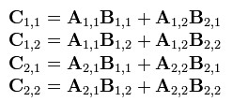

Second, from Strassen’s method, we can decrease the calculate times from 8 to 7.

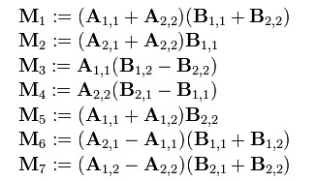

Third, we use these 7 new sub-matrix to get the sub-matrix of C.

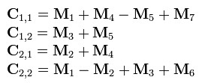

In the end, we use these four sub-array of C to get the complete answer of C.

Therefore, we get the conclusion that the running time of Strassen’s matrix multiplication is技术分享.

1. **Conclusion**

When I use the test file from the professor, I get the correct answer which show on the below.

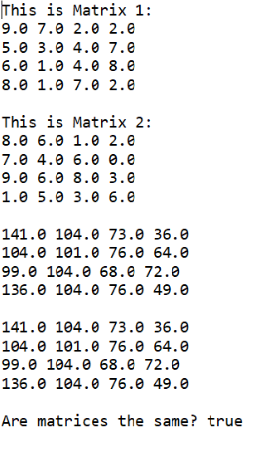

When I run the JUnit file, I got the result on the below.

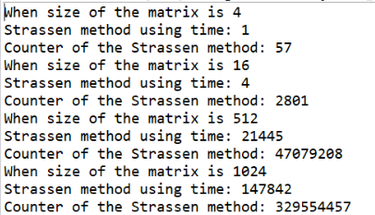 

From the final answer of comparing these two method, we can see that the counter of the Strassen method is always smaller than straight forward method. That means the running time of Strassen method is always smaller than straight forward method. Therefore, Strassen’s matrix multiplication algorithm is more efficiency than straight-forward matrix multiplication algorithm.