ACADEMIC EXPLORATORY DATA ANALYSIS REPORT
AUDIO FEATURE EXTRACTION & ACOUSTIC PROFILING
Cross-Market Analysis: Vietnam (VN), United States (US), and South Korea (KR) [2021–2026]
Module: ADY201m – Applied Data Analytics | Project: What Makes a Hit Song?
Author / Primary Responsibility: | Member 2 – Audio Feature Engineering & Acoustic Analytics
Data Source of Truth: | Supabase Database (public.modeling_dataset WHERE is_sampled = True)
Sample Size & Scope: | 2,860 Chart Entries | 1,912 Unique Spotify Tracks | 100% Extraction Completeness
Date of Publication: | October 2026 (Academic Submission)

1. Theoretical Rationale: Feature Selection & Acoustic Meanings
Commercial music analysis requires moving beyond raw waveforms into psychoacoustically grounded descriptors. Sound signals cannot be fed directly into predictive modeling due to extreme dimensionality and temporal variance. Therefore, we engineered 18 discrete, standardized acoustic features across four foundational signal processing domains: (1) Rhythm & Temporal Structure, (2) Signal Energy & Dynamics, (3) Spectral Timbre, and (4) Harmony & Structural Recurrence. All features were derived from full audio tracks (mean duration ~207.1 seconds / 3.45 minutes) at 44.1 kHz mono, capturing complete structural trajectories from intro to outro and enabling holistic recurrence pattern discovery across entire songs.

Comprehensive Acoustic Feature Dictionary & Selection Rationale
Feature Name & Domain | Signal Formula & Method | Physical Unit & Range | Psychoacoustic Meaning & Research Rationale
tempo_bpm  (Rhythm) | Dynamic Programming Tempogram Peak Tracking | BPM  [58 - 235] | WHY CHOSEN: Fundamental pace of rhythmic entrainment. Governs physiological motor response (dancing, heart rate matching). Bimodal pop standard.
beat_interval_variability  (Rhythm) | Coefficient of Variation of Inter-Beat Intervals: CV = σ_Δt / μ_Δt | Dimensionless Ratio  [0.007 - 0.06] | WHY CHOSEN: Quantifies mechanical timing stability vs organic human drift. Critical for detecting modern DAW quantized grid production vs acoustic live recordings.
onset_rate  (Rhythm / Density) | Spectral Flux Peak Picking over STFT frames | Events / Second  [25 - 345] | WHY CHOSEN: Note attack density. Distinguishes sparse ballad vocal delivery from kinetic, hyper-active synth and percussion arrangements (e.g., K-Pop 16th-note patterns).
rms_energy  (Energy) | Root-Mean-Square Amplitude: √(1/N ∑ x[n]²) | Linear Amplitude  [0.02 - 0.57] | WHY CHOSEN: Primary measure of physical acoustic power. Reflects mastering compression, perceived 'loudness punch', and commercial mixing fullness.
dynamic_range  (Dynamics) | Percentile Difference: P95(RMS_dB) - P05(RMS_dB) | Decibels (dB)  [2.2 - 193.5] | WHY CHOSEN: Measures dynamic contrast between verse lull and chorus explosion. Essential for auditing the 'loudness war' vs dynamic breathing space.
spectral_centroid  (Timbre) | Center of Spectral Mass: (∑ f·|X(f)|) / (∑ |X(f)|) | Hertz (Hz)  [544 - 3,628] | WHY CHOSEN: Corresponds directly to perceived sound 'brightness' and sharp presence. High centroids reflect crisp treble excitation, metallic hi-hats, and synth leads.
spectral_bandwidth  (Timbre) | Standard Deviation around Centroid: √(∑ (f - C)²·|X(f)| / ∑ |X(f)|) | Hertz (Hz)  [908 - 3,291] | WHY CHOSEN: Measures timbral spread across the auditory frequency spectrum. Differentiates monochromatic acoustic sounds from multi-layered, wide commercial mixes.
audio_key & audio_mode  (Harmony) | Krumhansl-Schmuckler (K-S) Key-Finding via Max Pearson r with Pitch Class Profiles | Key: 12 Pitch Classes  Mode: Major / Minor | WHY CHOSEN: Core tonal center and emotional valence. Major keys project uplifting, euphoric pop hooks; minor keys project melancholy, tension, and introspection.
chord_change_rate  (Harmony) | Beat-Synchronous Triad Template Matching via Cosine Distance | Chords / Minute  [12 - 87] | WHY CHOSEN: Harmonic rhythm velocity. Measures how frequently chord functions modulate, separating simple 4-bar repetitive loops from complex passing-chord arrangements.
mfcc_repetition_determinism  (Structure / RQA) | Recurrence Quantification Analysis (RQA) on MFCC space: DET = (∑ l·P(l)) / (∑ l·P(l)) | Bounded Ratio  [0.0 - 0.72] | WHY CHOSEN: Replaces saturated legacy self-similarity. Measures deterministic timbral looping (e.g., persistent drum loop or sample groove repeating end-to-end).
chroma_repetition_determinism  (Structure / RQA) | RQA on Cosine-normalized Chroma space (l_min = 2) | Bounded Ratio  [0.0 - 0.93] | WHY CHOSEN: Quantifies harmonic structural periodicity. Measures verse-chorus symmetry and the degree of chord progression recycling throughout the track.
chroma_longest_pattern_duration  (Structure / RQA) | Max diagonal line length in Chroma Recurrence Matrix converted to seconds | Seconds  [0.0 - 72.0] | WHY CHOSEN: Length of the single longest repeating harmonic phrase. Directly captures standard 8-bar musical hook / chorus duration.

2. In-Depth Exploratory Data Analysis & Empirical Findings
This section presents the core empirical findings derived from 2,860 chart entries across Vietnam (VN, N=885), the United States (US, N=955), and South Korea (KR, N=1,020). Statistical inferences utilize non-parametric Kruskal-Wallis H-tests and Chi-Square tests of independence to avoid assuming normality, adhering strictly to objective acoustic and production interpretations.

2.1. Rhythm and Signal Energy Dynamics (Figure 1)
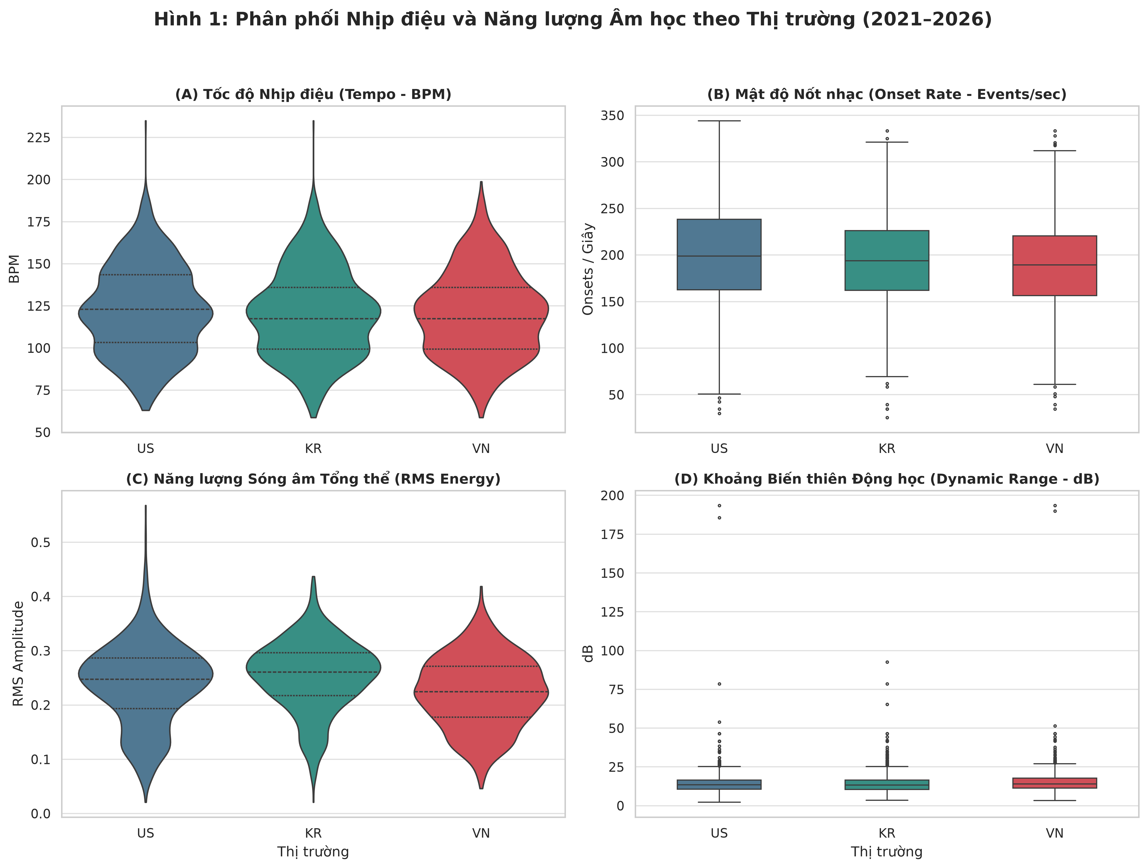
Figure 1: Distribution of Rhythm and Acoustic Energy across Markets (Violin & Boxplots, 300 DPI)
Empirical Observations & Statistical Tests:
1. Tempo Invariance (Panel A): A distinct bimodal distribution is observed across all three countries, peaking at 90–105 BPM and 120–130 BPM. A Kruskal-Wallis H-test reveals NO statistically significant difference in tempo across markets (H = 2.87, p = 0.238 > 0.05; Mean: US 122.3, KR 120.6, VN 120.4 BPM; Medians: US 123.0, KR 117.5, VN 117.5 BPM).
2. Kinetic Note Density (Panel B): The United States exhibits the highest Onset Rate (median = 198.8, mean = 199.1 onsets/sec), followed by South Korea (median = 193.7, mean = 192.5) and Vietnam (median = 189.4, mean = 188.2), with extreme statistical significance (H = 22.35, p = 1.40 × 10⁻⁵ < 0.001).
3. RMS Energy & Dynamic Range (Panels C & D): Signal power exhibits massive divergence (H = 103.88, p = 2.77 × 10⁻²³ < 0.001): KR is highest (mean = 0.254, median = 0.261), followed by US (mean = 0.238, median = 0.248) and VN (mean = 0.224, median = 0.225). Conversely, Vietnam leads in Dynamic Range (mean = 15.51 dB vs US: 14.53 dB and KR: 14.48 dB; H = 18.12, p = 1.16 × 10⁻⁴ < 0.001).
Acoustic Interpretation & Engineering Implications:
The tempo invariance is grounded in biological motor entrainment: pop music globally targets a synchronized sweet spot for human heart rate and somatic movement. Conversely, onset rate and RMS divergence reflect stark production techniques: US and K-Pop feature dense 16th-note drum subdivisions and aggressive dynamic mastering compression (optimizing for high perceptual loudness on mobile earphones). Vietnamese tracks preserve acoustic headroom and vocal space with sparser arrangements and greater dynamic range. For predictive modeling, Onset Rate and RMS Energy represent premier candidates for market-level feature importance.

2.2. Spectral Brightness and Temporal Stability (Figure 2)
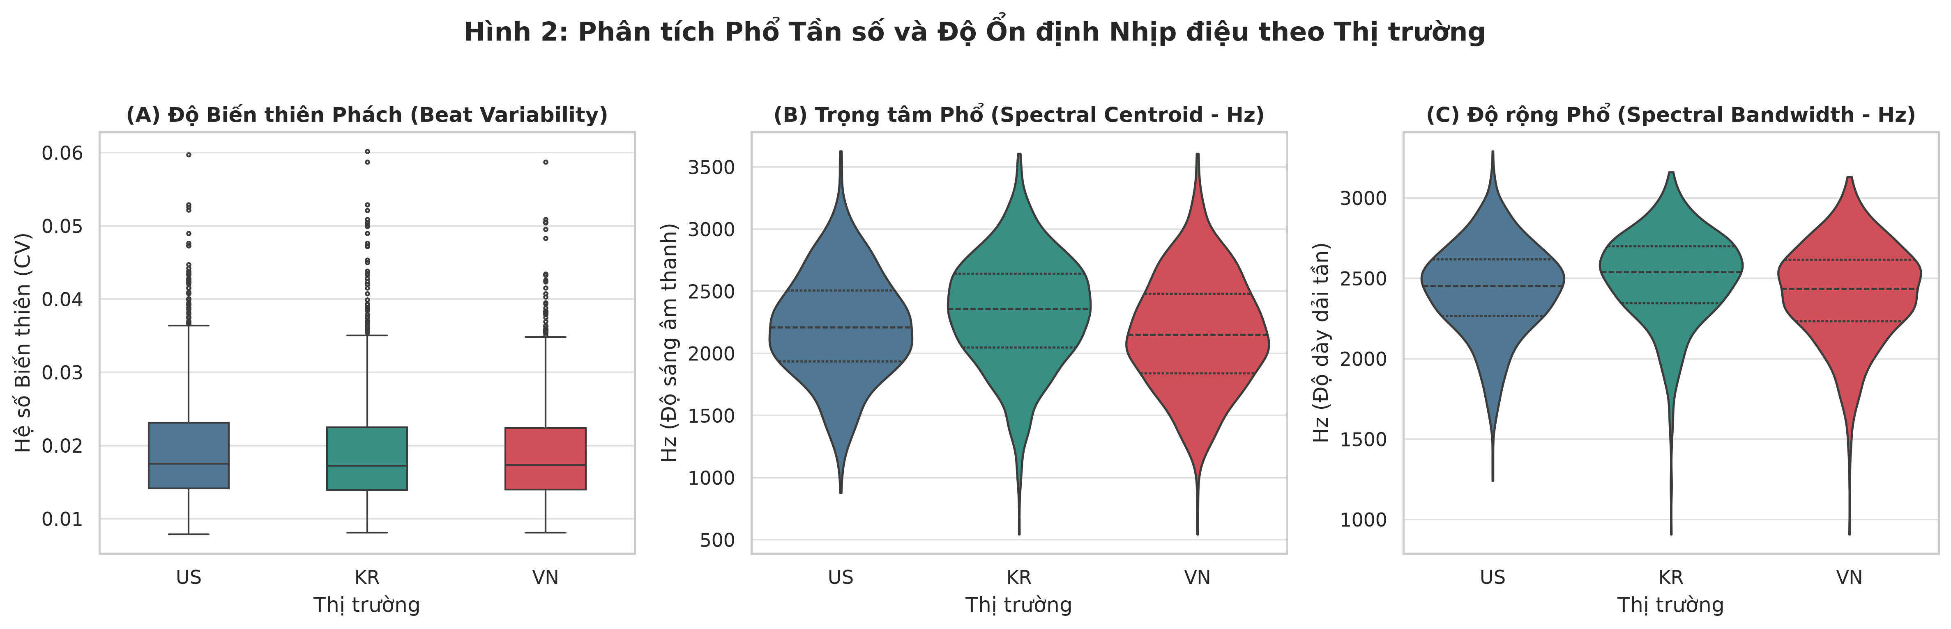
Figure 2: Spectral Characteristics and Beat Interval Stability by Market (300 DPI)
Empirical Observations & Statistical Tests:
1. Extreme Beat Regularity (Panel A): The coefficient of variation for beat intervals (CV) is compressed uniformly near zero across all three markets (KR median = 0.0172, VN = 0.0173, US = 0.0175; H = 1.41, p = 0.495 > 0.05).
2. Spectral Centroid Brightness (Panel B): South Korea displays the brightest spectral center of mass (median = 2,359.6 Hz, mean = 2,335.3 Hz), significantly outranking the US (median = 2,211.1 Hz, mean = 2,214.9 Hz) and Vietnam (median = 2,150.3 Hz, mean = 2,166.0 Hz) (H = 80.28, p = 3.70 × 10⁻¹⁸ < 0.001).
3. Spectral Bandwidth Fullness (Panel C): South Korea similarly exhibits the widest spectral spread (mean = 2,507.4 Hz), followed by the US (2,430.3 Hz) and Vietnam (2,409.7 Hz) (H = 68.73, p < 0.001).
Acoustic Interpretation & Engineering Implications:
The near-zero beat variability (< 0.02) provides quantitative proof that modern charting tracks are universally produced on Digital Audio Workstations (DAWs) snapped to quantized metronomic grids. Human timing micro-drifts (rubato) are virtually eliminated from commercial pop. The significantly higher spectral centroid and bandwidth in K-Pop indicate intentional high-frequency excitation: heavy synthesis layers, bright vocal formant boosts, and boosted high-shelf EQ (8–12 kHz). Vietnamese tracks maintain a warmer, lower midrange acoustic envelope centered on lyrical intelligibility.

2.3. Tonal Center, Modality, and Harmonic Velocity (Figure 3)
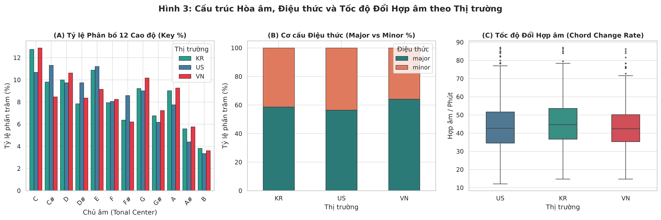
Figure 3: Key Distribution, Mode Ratios, and Chord Change Rates across Markets (300 DPI)
Empirical Observations & Statistical Tests:
1. Universal Key Preference (Panel A): Pitch classes C, C#, D, and E consistently dominate all markets (~10–13% each), while B and A# are least frequent (<4%). A Chi-Square Test of Independence yields χ² = 20.82 (df = 22, p = 0.532 > 0.05), confirming that musical key choice is statistically independent of market region.
2. Major Modality Preference (Panel B): Vietnam displays the highest proportion of Major keys at 64.1%, significantly higher than South Korea (58.6%) and the United States (56.4%) (Chi-Square χ² = 11.70, df = 2, p = 0.0029 < 0.01).
3. Chord Transition Velocity (Panel C): South Korea displays a significantly faster harmonic rhythm (mean = 44.8 chords/min, median = 43.6) compared to the US (mean = 43.8, median = 43.4) and Vietnam (mean = 42.1, median = 41.5) (H = 19.50, p = 5.83 × 10⁻⁵ < 0.001).
Acoustic Interpretation & Engineering Implications:
Key selection is governed by instrument ergonomics (natural key centers of piano keyboards, guitar fretboards, and DAW MIDI defaults), rather than regional culture. Vietnam's significant preference for Major modality reflects commercial listener affinity for bright, uplifting, accessible melodic themes. K-Pop's accelerated chord change rate aligns with its compositional identity: frequent two-beat substitutions and passing chords designed to maintain auditory excitement.

2.4. Structural Recurrence & Repetition Determinism (Figure 4)
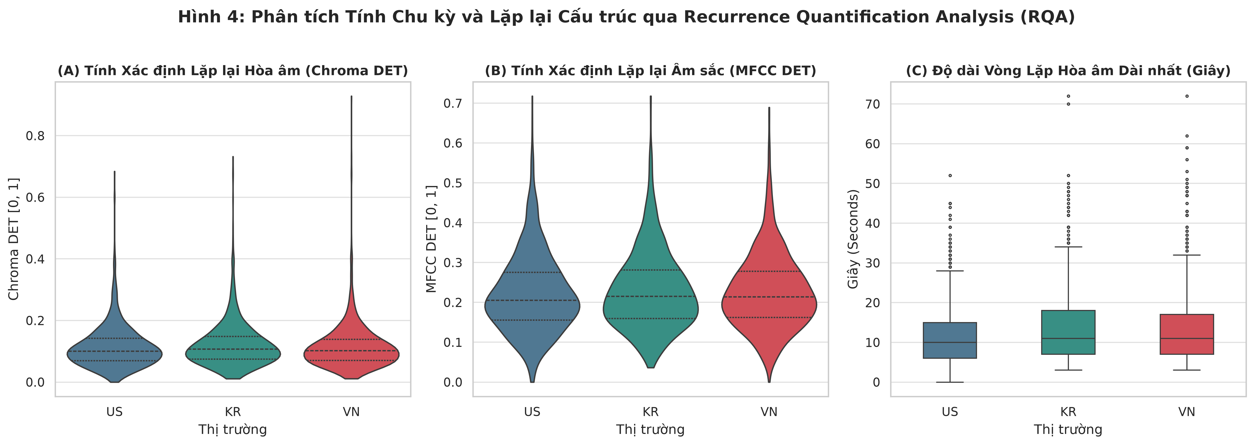
Figure 4: Recurrence Quantification Analysis (RQA) of Harmonic and Timbral Loops (300 DPI)
Empirical Observations & Statistical Tests:
1. Harmonic Repetition (Panel A): Chroma DET displays a uniform, tapered distribution centered at 0.08–0.15 across all three markets.
2. Timbral Repetition Uniformity (Panel B): MFCC Recurrence Determinism hovers consistently around 0.22–0.23 across markets (KR mean = 0.230, VN = 0.227, US = 0.223, medians ~0.21; H = 2.95, p = 0.229 > 0.05), showing no statistically significant cross-market divergence.
3. Universal 8-Bar Hook Duration (Panel C): The distribution of the longest recurring pattern duration clusters at a median of 10.0 to 11.0 seconds across all regions (KR: 11.0s, VN: 11.0s, US: 10.0s; Means: VN 14.16s, KR 13.82s, US 12.09s; H = 22.61, p = 1.23 × 10⁻⁵ < 0.001) with extreme right-skewness.
Acoustic Interpretation & Engineering Implications:
The cross-market stability of MFCC determinism highlights a universal production philosophy: modern commercial pop across all continents relies on standardized loop beds and sample repetition. The 10–11 second median hook length precisely matches an 8-measure musical phrase at 120 BPM, bounded by the limits of human working memory for melodic recall.

2.5. Holistic Market Fingerprints: Polar Radar Synthesis (Figure 5)
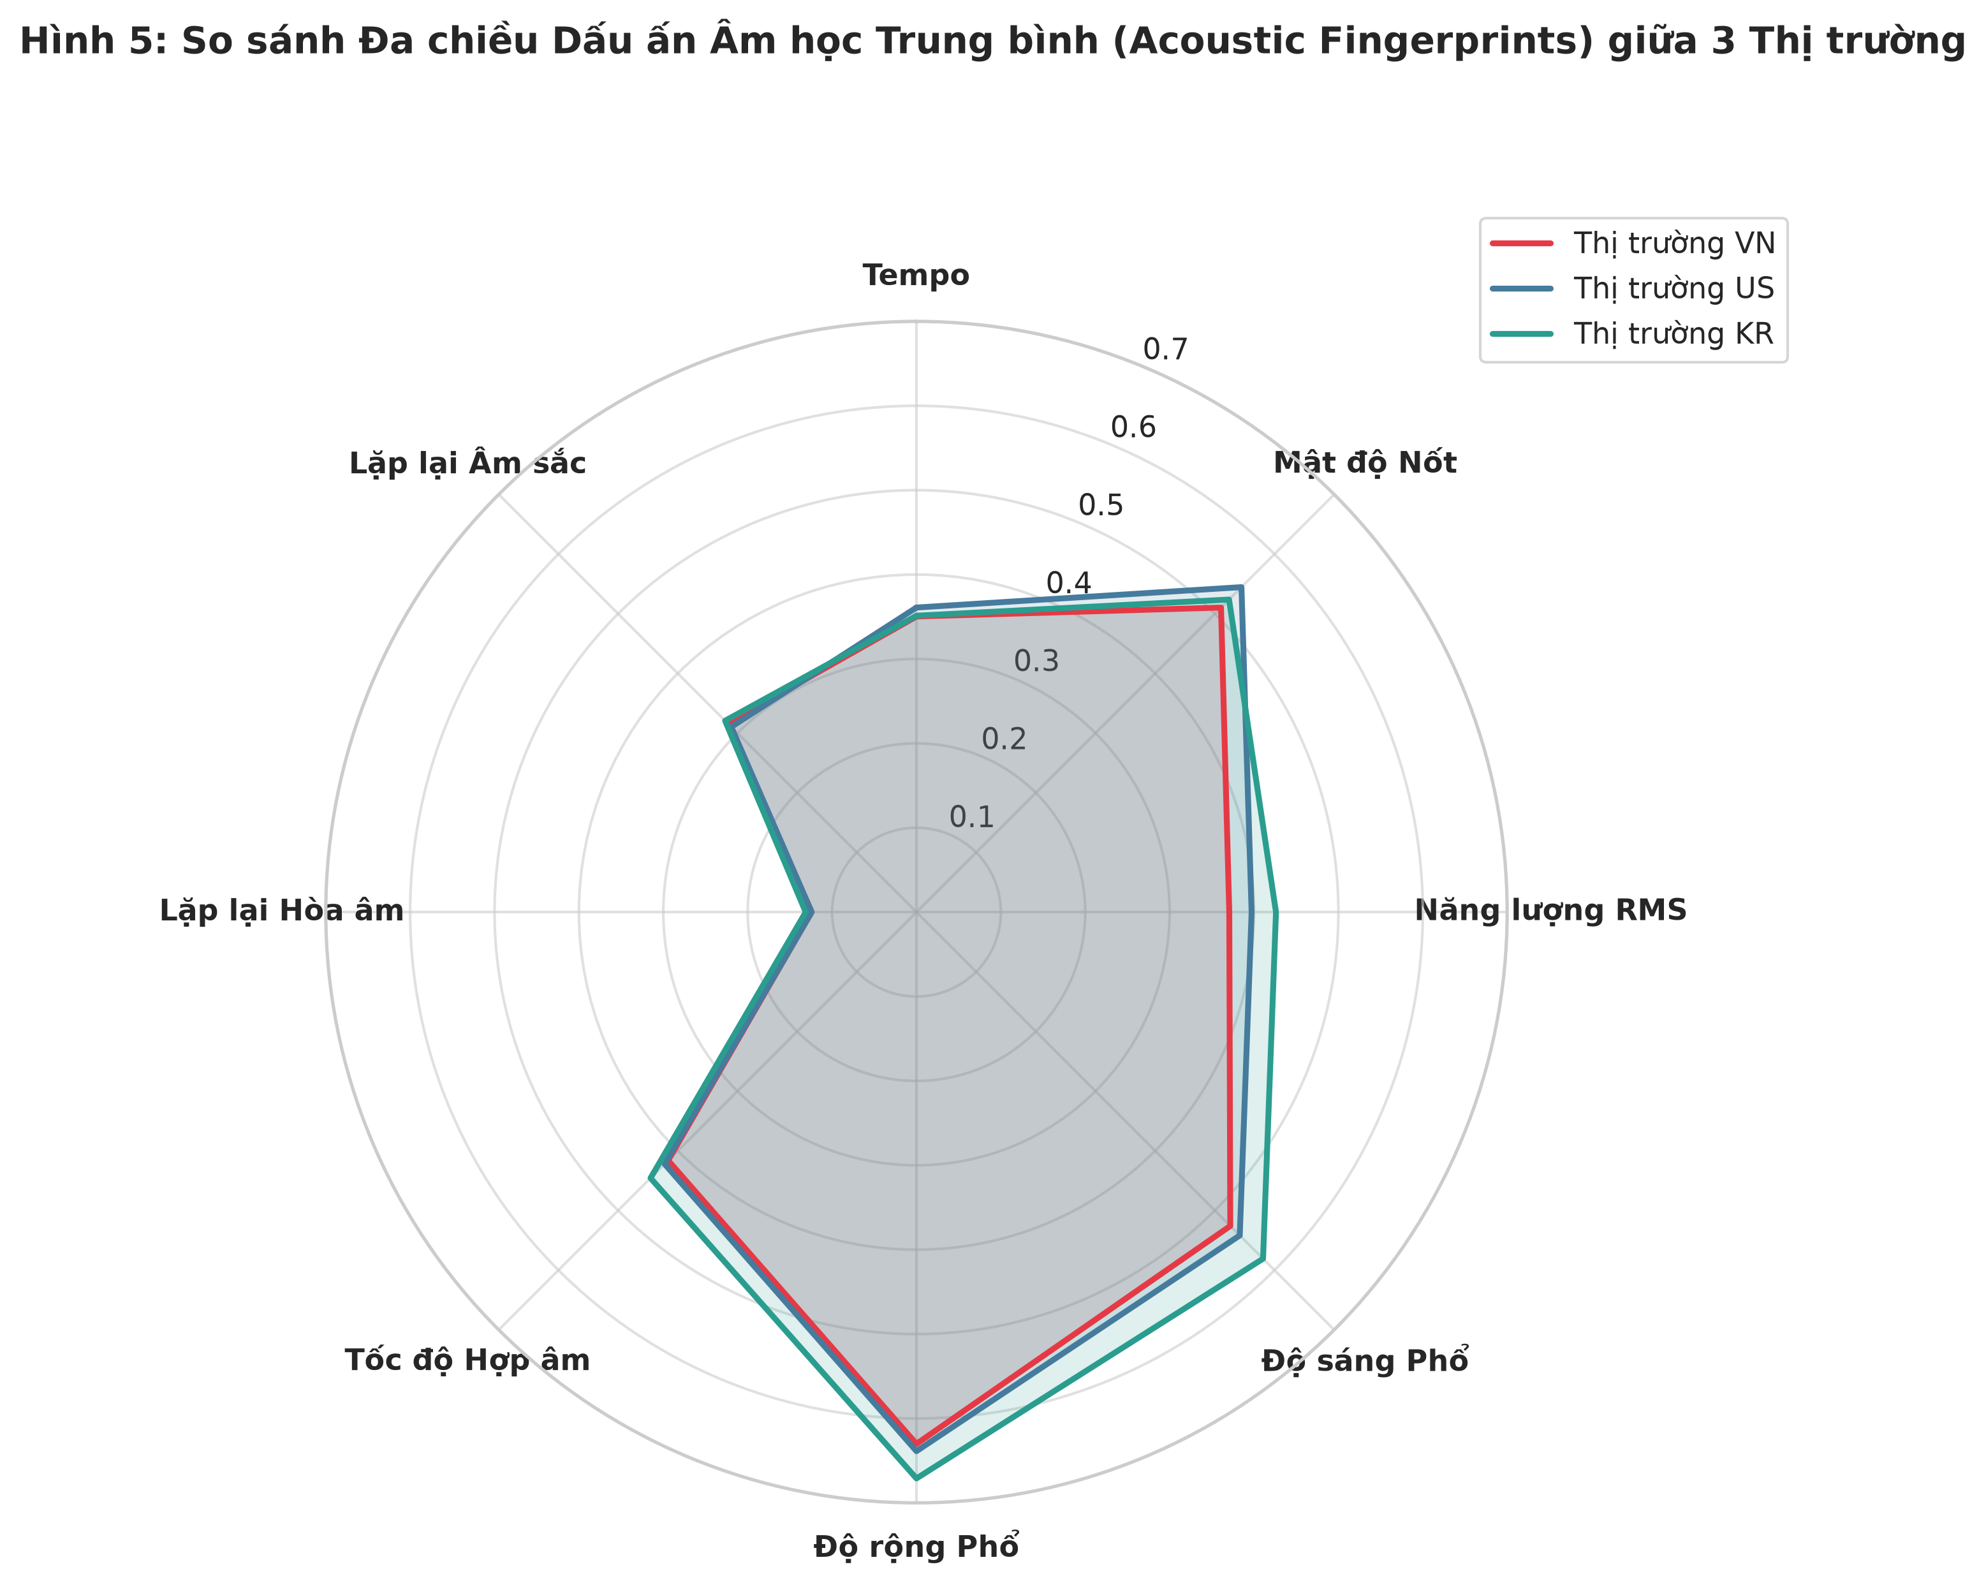
Figure 5: Normalized Multidimensional Acoustic Fingerprints (Polar Radar Chart, 300 DPI)
Holistic Profiling Synthesis:
By normalizing all continuous metrics onto a uniform [0, 1] scale, Figure 5 encapsulates the overarching acoustic signatures:
• South Korea (Teal Polygon): Defined by Maximum Kinetic Intensity. Leads on 6 of 8 axes: RMS Energy (0.426), Spectral Centroid (0.581), Spectral Bandwidth (0.671), Chord Change Rate (0.446), Chroma DET (0.131), and MFCC DET (0.321).
• United States (Blue Polygon): Defined by Rhythmic Drive & Vocal Speed. Leads on 2 axes: Onset Rate (0.545) and Tempo BPM (0.361).
• Vietnam (Red Polygon): Defined by Dynamic Headroom & Melodic Space. Dominates Dynamic Range (15.51 dB), preserving acoustic space for emotionally expressive vocal phrasing.

3. Concrete Handover Recommendations for Member 4 (Modeling)
• Multicollinearity Elimination: loudness_proxy and rms_energy exhibit Pearson r > 0.95. Member 4 must drop loudness_proxy and retain rms_energy as the uncorrupted physical signal metric. Similarly, keep beat_interval_variability and drop tempo_stability.
• Logarithmic Transformations: RQA durational features (chroma_longest_pattern_duration and mfcc_longest_pattern_duration) exhibit heavy right skewness (kurtosis > 5.0). Member 4 must apply log1p transformations before fitting regularized linear models (Ridge/Lasso).
• Categorical Encoding Strategy: Encode audio_mode as binary (Major = 1, Minor = 0). For audio_key, standard One-Hot Encoding is recommended, or optionally mapping onto Circle-of-Fifths 2D Cartesian coordinates (cos(2πk/12), sin(2πk/12)) to preserve harmonic proximity.
• Algorithm Suitability: Due to non-linear saturation plateaus identified in energy and repetition, non-linear tree ensembles (LightGBM Regressor, XGBoost, Random Forest) will yield superior R² and RMSE over OLS regression.

