## Quota allocation policies in U.S. federal fisheries management and implications for climate resilience

Christopher M. Free1,2*, Zoë J. Kitchel3, Matthew Seeley4, Allison Shields4

1 Marine Science Institute, University of California, Santa Barbara, Santa Barbara, CA, 93106, USA

2 Bren School of Environmental Science and Management, University of California, Santa Barbara, Santa Barbara, CA, 93106, USA

3 Vantuna Research Group, Occidental College, Los Angeles, CA, 90041, USA

4 Environmental Defense Fund

**\* Corresponding author:** 2400 Bren Hall, Bren School of Environmental Science and Management, University of California, Santa Barbara, Santa Barbara, CA, 93106, USA; [cfree14@gmail.com](mailto:cfree14@gmail.com)

### Abstract

Quota allocation, which divides fishing catch or effort between regions, sectors, subsectors, individuals, and/or seasons, is one of the most important and contentious processes in fisheries management. Quota allocation policies often aim to advance fairness and equity goals by preserving levels of historical participation and access. However, this reliance on historical patterns makes allocation policies vulnerable to climate change, which is shifting the accessibility of marine resources among historical and new participants. Despite this, there is little guidance on best practices for adapting allocation policies to climate change. In the United States, regional flexibility to design locally relevant allocation policies has innovated a diversity of approaches that can be studied for their climate vulnerability and/or adaptivity. Here, we conduct a systematic review of allocation policies used in U.S. federal fisheries (491 stocks, 42 management plans, 8 regions) and brief review of allocation policies in international fisheries, which we use to identify best practices for climate-adaptive quota allocation. We find that allocation policies are used to manage 49% of federally managed stocks. Although most policies are based on historical catch, many include features that promote climate adaptiveness, including the ability to transfer quota between states, sectors, or individuals; adjustment of allocations based on current resource distribution or abundance; set aside of quota to support research and experimentation; and gradual phase in of policy changes. Ultimately, we provide eight globally transferable recommendations for improving the ability for allocation policies to advance their fairness and equity goals under climate change.

**Keywords:** adaptive management, catch allocations, catch shares, climate change, equity, fairness

**Short title:** Quota allocation and climate resilience

### Table of Contents

1. Introduction

2. Methods

2.1 Systematic review of U.S. allocation policies

2.2 Brief review of international allocation policies

2.3 Identifying best practices for climate-adaptive allocation policies

3. Allocation policies in U.S. fisheries

3.1. Overview

3.2. Spatial allocations

3.3. Sector allocations

3.4. Subsector allocations

3.5. Catch share allocations

3.6. Seasonal allocations

4. Allocation policies in international fisheries

4.1. Europe

4.2. Australia

4.3. New Zealand

4.4. Pacific Island skipjack tuna

5. Best practices for climate-adaptive allocation policies

5.1 Define clear and measurable management objectives

5.2 Define and collect data required to assess and adjust allocation policies

5.3 Facilitate quota transfers between regions, sectors, and individuals

5.4 Balance historical and contemporary resource access in setting allocations

5.5 Ensure opportunities for new entrants

5.6 Allocate quota for research and experimentation

5.7 Reduce impacts of changes to allocation policies on stakeholders

5.8 Conduct regular reviews of allocation policies

6. Conclusions

Acknowledgements

Data availability statement

Conflict of interests statement

References

Tables and Figures

### 1. Introduction

Climate change is shifting the abundance, distribution, and phenology of harvested marine resources, challenging the ability for managers to maintain conservation and socioeconomic goals set for global fisheries [(IPCC, 2019)](https://www.zotero.org/google-docs/?7ZLMgb). To achieve conservation goals, managers must establish catch or effort controls that maintain sustainability as stocks experience climate-driven shifts in their productivity and distribution [(Gaines et al., 2018)](https://www.zotero.org/google-docs/?jxMPcE). To meet socioeconomic goals, managers must further ensure that access to shifting resources remains fair and equitable despite changing oceanographic conditions [(Tokunaga et al., 2023)](https://www.zotero.org/google-docs/?wgAx8N). This can be achieved through a combination of management policies ranging from permitting, which governs who can access resources, to quota allocation, which governs how much catch or effort is available to those with access [(Ojea et al., 2017)](https://www.zotero.org/google-docs/?zOVq6Q).

Quota allocation is one of the most important and contentious processes in fisheries management as it dictates how access is shared among fishery participants. While the establishment of catch limits is a largely objective and scientific process [(Punt, 2010)](https://www.zotero.org/google-docs/?fyT3Nr), decisions about how to distribute the resulting quota is more subjective and depends on complex socioeconomic considerations [(Morrison & Scott, 2014)](https://www.zotero.org/google-docs/?PSeZ5f). Quota allocations are often made between jurisdictions (e.g., international, regional, state), sectors (e.g., commercial, recreational, tribal, research), subsectors (e.g., gillnets, longlines), individuals (e.g., catch shares), and seasons. Allocations are generally based on relative levels of historical catch or effort as they frequently aim to maintain proportional access for people historically dependent on fishery resources [(Cox, 2009; FLSF, 2010; Lynham, 2014)](https://www.zotero.org/google-docs/?uu5QQS). However, climate change is causing rapid departures from historical conditions, which can lead to unfair, inequitable, and inefficient resource use when access is based solely on historical dynamics [(Palacios-Abrantes et al., 2020, 2023; Pinsky et al., 2018; Vogel et al., 2024)](https://www.zotero.org/google-docs/?YXHll1). As a result, quota allocation policies must adapt to advance their fairness and equity objectives with changing ocean conditions.

The challenge posed by climate change is most direct for spatial allocation policies as climate change will rearrange the distribution of stocks. Spatial allocations, which allocate quota across different management areas (e.g., countries, regions, states), generally aim to ensure that harvest is proportional to either the biological availability of the resource or the historical dependence of fishing communities on the resource. However, climate-driven shifts in the distribution of marine species imply that historical benchmarks used to set spatial allocations will not reflect future distributions [(Palacios-Abrantes et al., 2020, 2023; Pinsky et al., 2018)](https://www.zotero.org/google-docs/?K7u3lE). This presents several conflicts, inequities, and inefficiencies. For example, if allocations are not updated to reflect shifted distributions, some fishing communities may be unable to capitalize on increases in local availability, which would be especially challenging if other species in their portfolio are negatively impacted by climate change [(Cline et al., 2017)](https://www.zotero.org/google-docs/?NOJluz). Worse still, fisheries may be at increased risk of closure if they are unable to avoid a newly abundant resource for which they have little allocation. Furthermore, vessels from a region maintaining its allocation based on historical distributions may need to travel farther to fulfill their quota [(Young et al., 2019)](https://www.zotero.org/google-docs/?WNJNb9), increasing costs, safety concerns, and carbon emissions [(Papaioannou et al., 2021; Scherrer et al., 2024)](https://www.zotero.org/google-docs/?iiJYxB). Thus, frameworks for adapting spatial allocation policies to shifting species distributions resulting from climate change are urgently needed.

The allocation of quota between and within fishing sectors has less direct though still important connections to climate change. Allocations among sectors guarantee access for diverse fishery participants and, like spatial allocations, are often allocated in proportion to historical dependence [(Edwards, 1990)](https://www.zotero.org/google-docs/?k2dXtw). However, climate change is pushing resources deeper [(Pinsky et al., 2013)](https://www.zotero.org/google-docs/?Z1Ulke), which could challenge the ability for nearshore recreational fisheries and/or small-scale commercial vessels to attain their historical quotas [(Papaioannou et al., 2021)](https://www.zotero.org/google-docs/?BrPyJ3). Allocations among gears within a sector similarly protect diverse access, but can also be used to limit effort by gears with larger bycatch or habitat impacts [(Jenkins & Garrison, 2013)](https://www.zotero.org/google-docs/?nzit9I). However, because climate change is altering bycatch patterns [(Free, Anderson, et al., 2023)](https://www.zotero.org/google-docs/?74BnBP), allocations based solely on historical landings could exacerbate bycatch issues. Finally, allocations between individuals or groups (e.g., fishing cooperatives or communities), often termed “catch shares,” can improve safety-at-sea by slowing the race to fish [(Birkenbach et al., 2017)](https://www.zotero.org/google-docs/?AvjsQW) and sustainability by better aligning conservation and economic incentives (e.g., shares only hold value if a stock is healthy and the quota is large) [(Costello et al., 2008)](https://www.zotero.org/google-docs/?jbY919). However, these policies are also largely based on historical catch patterns [(Lynham, 2014)](https://www.zotero.org/google-docs/?Qyf9fG), which makes them vulnerable to climate change [(Tokunaga et al., 2023)](https://www.zotero.org/google-docs/?rS5zvY). Equity issues can arise as distribution shifts further the distance between the share owners and the resource [(D. N. Edwards & Pinkerton, 2019)](https://www.zotero.org/google-docs/?7qIXIc). Furthermore, catch shares often lead to less diverse fishing portfolios [(Holland et al., 2017)](https://www.zotero.org/google-docs/?wRFnQm), reducing resilience to climate change.

The laws governing U.S. federal fisheries management mandate that allocation policies be fair, equitable, and transparent, but gives regional managers immense flexibility in how they achieve these goals. The Magnuson-Stevens Fishery Conservation and Management Act, the primary legislation governing U.S. federal fisheries, provides ten National Standards to define management requirements, of which National Standard 4 specifies that quota allocations must be *“(1) fair and equitable to all such fishermen; (2) reasonably calculated to promote conservation; and (3) carried out in such manner that no particular individual, corporation, or other entity acquires an excessive share of such privileges”* [(US-DOC, 2007)](https://www.zotero.org/google-docs/?fdC1Gr). To date, both official guidance and adopted practices have generally aimed to be fair and equitable by maintaining historical access, though with additional considerations for new entrants, bycatch, economic efficiency, and other factors [(Plummer et al., 2012)](https://www.zotero.org/google-docs/?m6toJi). These additional considerations give the eight regional Fishery Management Councils (FMCs) (**Figure 1**) flexibility to design allocation policies tailored to their specific socioeconomic and ecological contexts. These approaches may have different abilities to maintain fairness and equity under climate change.

In 2011, the U.S. National Marine Fisheries Service (NMFS) launched an effort to provide more detailed guidance on allocation, but these recommendations do not explicitly consider climate change impacts on U.S. fisheries [(Lapointe, 2012)](https://www.zotero.org/google-docs/?zOP86q). This process began with a review of the allocation policies used in U.S. federal fisheries management [(Morrison & Scott, 2014; Plummer et al., 2012)](https://www.zotero.org/google-docs/?RGBREf), providing the context for subsequent guidance on criteria for triggering the review of allocation policies [(Morrison, 2016a)](https://www.zotero.org/google-docs/?4zn9pf) and factors to consider when conducting such reviews [(Morrison, 2016b, 2017c)](https://www.zotero.org/google-docs/?OHaQNz). This guidance, which was cemented as national policy between 2016 and 2017 [(Morrison, 2017b, 2017a)](https://www.zotero.org/google-docs/?AzAwDV), calls for an adaptive process for evaluating whether allocations are meeting management objectives and for adjusting allocations when objectives are not being met. These policies suggest that the review of an allocation policy could be triggered based on a tracked performance indicator, stakeholder input, or at regular time intervals. They also suggest that the ability to transfer quota between states, sectors, or individuals offers in-season adaptability. While both suggestions provide some inherent climate resilience, the connection to climate change is not explicit, and more guidance on strategies for climate-adaptive allocation policies is needed [(US GAO, 2022)](https://www.zotero.org/google-docs/?AZ776n).

In this paper, we synthesize the diverse allocation policies used to manage U.S. federal fisheries, evaluate the adaptivity of these policies to climate change, and provide recommendations for increasing the climate-adaptiveness of quota allocation. We begin by cataloging the allocation policies of 491 stocks managed by the 42 fisheries management plans developed by the 8 FMCs into a standardized database. This provides a platform for understanding the myriad of allocation approaches taken across the U.S. and for understanding how approaches differ by region. We then evaluate the adaptiveness of these policies to climate change and offer recommendations for increasing the ability of these policies to maintain fairness and equity under climate change. We draw these recommendations from best practices identified from both U.S. and international fisheries management. These recommendations provide a roadmap for any federal, state, or international fishery seeking to maintain the fairness and equity of their allocation policies under climate change.

### 2. Methods

#### 2.1 Systematic review of U.S. allocation policies

We inventoried the quota allocation policies currently implemented in U.S. federal fisheries management by reviewing all 42 Fishery Management Plans (FMPs; including 5 “Fishery Ecosystem Plans” or FEPs) and their associated amendments for descriptions of their allocation policies (**Table S1**). We prepared a summary of each allocation policy to provide a clear and concise description of these often complex policies. Each summary describes the types of allocation policies used, the recipients of quota, the amount of quota allocated to each recipient, and the basis for the allocation amounts. When possible, we summarized the history of changes made to the allocation policy and the motivation for these changes. These historical adjustments provide critical insights into considerations and pathways for adapting allocation policies to climate change. The summaries are provided in **Appendix A**.

We used the summaries to develop a database describing the allocation policies used to manage 491 federally managed marine fish and invertebrate stocks with a common set of characteristics (**Figure 1; Table S1**). The database summarizes: (1) basic information on each stock (i.e., FMC, FMP, species group); (2) the allocation policy types used to manage the stock; and (3) traits of each of the implemented allocation policy types. We classified allocation policy types into five categories: spatial, sector-based (among sectors), subsector-based (within a sector), catch shares, or seasonal (**Figures 2 & 3**). Spatial policies allocate quota among countries, states, or other management areas. Sector-based policies allocate quota among commercial, recreational, tribal, and research sectors. Subsector-based policies allocate quota to groups (e.g., gear types, vessel size tiers) within a sector. Seasonal policies allocate quota across different seasons. We use “catch shares” as a general term for policies that allocate quota among individual fishermen, groups of fishermen, cooperatives, fishing communities, or other entities, which includes individual fishing quotas (IFQs), territorial use rights for fisheries (TURFs), and limited access privilege programs (LAPPs). We recorded the basis for each allocation type, i.e., whether the allocation amount was derived based on historical catch or effort, recent catch or effort, recent resource distributions, or a combination of approaches. We also recorded the number and identity of entities receiving allocations. The structure of the database is illustrated in **Table S2** and the full database is provided in **Supp. Data 1**.

We confirmed the accuracy of our summaries and database by comparing them to information synthesized in other relevant but less comprehensive reports [(FLSF, 2010; Morrison & Scott, 2014; Plummer et al., 2012; Tokunaga et al., 2023)](https://www.zotero.org/google-docs/?h8kDbU) (**Figure S1 & S2**) and by asking FMC staff with expert knowledge of allocation policies to review the summaries. We received reviews from FMC staff for 35 of 42 FMPs (83%).

#### 2.2 Brief review of international allocation policies

To broaden our search for climate-adaptive quota allocation policies, we supplemented our systematic review of U.S. allocation policies with a brief review of allocation policies in international fisheries. We focused this review on international fisheries whose quota allocation policies have been well summarized in a few key sources (i.e., where an exhaustive review was not required to generate a comprehensive understanding of each entity’s allocation policies). The selected vignettes and their key references are: Europe [(Carpenter & Williams, 2021; Scholaert, 2023; Seas At Risk, 2024)](https://www.zotero.org/google-docs/?ERYezp), Australia [(Knuckey et al., 2019; Mazur et al., 2020; McShane et al., 2021)](https://www.zotero.org/google-docs/?Ntcx9h), New Zealand [(Lock & Leslie, 2007)](https://www.zotero.org/google-docs/?Wjxczp), and the Parties to the Nauru Agreement for Pacific skipjack tuna (*Katsuwonus pelamis*, Scombridae) [(Aqorau et al., 2018)](https://www.zotero.org/google-docs/?8VRcab). The successes and failures of these allocation policies are highly instructive to the U.S. and any other country that allocates quota in the context of climate change.

#### 2.3 Identifying best practices for climate-adaptive allocation policies

We used our systematic review of U.S. allocation policies and brief review of international policies to identify best practices for climate-adaptive allocation. We identify these practices as policies that either (1) directly consider climate change in the allocation of quota or (2) support the adaptive management of allocation policies, which indirectly but effectively bolsters management responsiveness to climate change. Adaptive management views management strategies as experiments that can be iteratively studied and adjusted in response to outcomes [(Walters, 1986)](https://www.zotero.org/google-docs/?Uc92Dn). By periodically reviewing and updating management to ensure that objectives are continually met [(Bahri et al., 2021; Walters, 1986)](https://www.zotero.org/google-docs/?E82Y8U), adaptive management provides inherent climate resilience by ensuring that management is responsive to changing conditions [(Bahri et al., 2021)](https://www.zotero.org/google-docs/?OJZEG2). Adaptive management is often implemented through a cyclic process that can be divided into the following stages: (1) planning, (2) doing, (3) evaluating and learning, and (4) adjusting [(Jones, 2005)](https://www.zotero.org/google-docs/?3eJeO6). We organized the identified best practices for climate-adaptive allocation within this cyclic adaptive management framework.

### 3. Allocation policies in U.S. fisheries

#### 3.1. Overview

A large portion (59.3%; 242 of 491 stocks) of federally managed stocks are managed using some form of quota allocation policy (**Figure 3**). Catch shares are most common, followed by sector, subsector-based, spatial, and seasonal allocation policies. Allocation policies are especially commonly used by the U.S. East Coast FMCs (i.e., the Mid-Atlantic, South Atlantic, and New England, in order of decreasing frequency).

#### 3.2. Spatial allocations

Spatial allocation policies are used in the management of 12% (n=59 stocks) of federally managed stocks (**Figure 3**). All regions except for the South Atlantic, Gulf of Mexico, and Caribbean employ country-based spatial allocations of transnational stocks **(Figure 4A)**. The lack of country-based allocations in the South Atlantic is likely due to its distance from an international border (**Figure 1**). The lack of country-based allocations in the Gulf of Mexico, which neighbors Mexico, and in the Caribbean, which neighbors many island nations, is likely due to (1) insufficient data to quantify the transnational distribution of resources and (2) the regional prevalence of reef fish, which exhibit higher site fidelity and more granular population structure than other fish [(Coleman et al., 1999)](https://www.zotero.org/google-docs/?3d566J). In the Pacific, country-based allocations for coastal pelagic species are based on fixed percentages (**Figure 4B**), despite awareness that these stocks experience dynamic shifts in distribution in response to oceanographic conditions [(Pozo Buil et al., 2021)](https://www.zotero.org/google-docs/?mhfUsI). In New England, country-based allocations for Eastern Georges Bank haddock (*Melanogrammus aeglefinus*, Gadidae), Atlantic cod (*Gadus morhua*, Gadidae), and yellowtail flounder (*Pleuronectes ferruginea*, Pleuronectidae) are jointly managed by the U.S. and Canada through the Transboundary Management Guidance Committee (TMGC). The TMGC determines annual allocations for each stock by combining both historical landings and current resource distribution according to fisheries independent trawl surveys [(Andrushchenko et al., 2022)](https://www.zotero.org/google-docs/?0D5g6l). This approach is climate-adaptive because it incorporates information on recent distribution shifts. By retaining the influence of historical landings, it also balances current distributions with historical dependence. This policy was first implemented in 2003 weighing historical landings at 40% and current distribution at 60% and was annually adjusted in 5% increments until reaching the target 90% current distribution to 10% historical landings weighting in 2010 [(Andrushchenko et al., 2022)](https://www.zotero.org/google-docs/?QdbhfL). Such gradual changes, termed “phase ins,” allow time for fleets to adapt to changes in their allocation, a good practice for reducing socioeconomic impacts when changing fisheries policies [(S. Cox et al., 2019)](https://www.zotero.org/google-docs/?qpjhJz).

The Mid-Atlantic and Gulf of Mexico are the only regions to allocate quota among constituent states **(Figure 4A)**. The North Pacific lacks state-based allocations because Alaska is the region’s only state. The lack of state-based spatial allocations in the Pacific is likely because Pacific groundfish stocks are often assumed to have state-based stock structure and thus have state-specific catch limits [(PFMC, 2023b)](https://www.zotero.org/google-docs/?2LJmkz). Although the Western Pacific and Caribbean regions have many island territories (**Figure 1**), they do not use territorial allocations because, like the Pacific, catch limits are calculated at the island-territory level. Although state-based allocations for Mid-Atlantic bluefish (*Pomatomus saltatrix*, Pomatomidae) are fixed percentages (**Figure 4C**), they are transferable between states, increasing their adaptiveness to climate-driven distribution shifts. In contrast, the state-based allocations for Mid-Atlantic black sea bass (*Centropristis striata*, Serranidae) and summer flounder (*Paralichthys dentatus*, Paralichthyidae) are dynamically updated, weighing both historical landings and current abundance or distribution. Specifically, when summer flounder quota is below 9.55 million pounds, quota is allocated based on default percentages (**Figure 4C**); when it is above this threshold, the excess quota is allocated in equal shares (except Maine, New Hampshire, and Delaware, which split 1% of the additional quota). Black sea bass allocations are even more spatially dynamic: 75% of the quota is allocated using historical landings-based default percentages and the remaining 25% is regionally allocated based on regional biomass distributions estimated by the most recent stock assessment (**Figure 4C**).

Area allocations are the only spatial allocation used in the South Atlantic and Atlantic HMS and are also widely used in the North Pacific and New England (**Figure 4A**). Area allocations for Gulf of Alaska groundfish are regularly updated based on scientific surveys and are therefore inherently responsive to climate impacts.

#### 3.3. Sector allocations

Sector allocations are used in the management of 18.5% (n=91 stocks) of federally managed stocks (**Figure 3**). The approach to allocating catch between commercial, recreational, tribal, and research sectors differs widely by region. In the South Atlantic, Gulf of Mexico, and Mid-Atlantic, which have the largest recreational fisheries of the eight regions [(NMFS, 2022)](https://www.zotero.org/google-docs/?PxSodl) (**Figure 1**), allocations between commercial and recreational sectors are implemented as a fixed percentage of the total allowable catch, generally based on historical reference periods (**Figure 5AB**). The percentage and reference periods vary by region and stock. In a nationally unique example, the management of Mid-Atlantic bluefish allows for in-season quota transfers between the commercial and recreational sectors. In the Caribbean, there are no explicit quota allocations between commercial and recreational sectors, but the use of a constant catch harvest control rule that sets catch limits for each sector [(Free, Mangin, et al., 2023)](https://www.zotero.org/google-docs/?RYquHI) represents an implicit allocation policy, as the allocation remains fixed based on historical precedent (**Figure 5C**). In the remaining regions with smaller recreational fisheries, allocations to the recreational sector are largely done through “set asides,” which remove projections of the expected recreational catch from the total allowable catch and allocate the remainder to the commercial fishery. The only exceptions are for Gulf of Maine Atlantic cod and haddock in New England, which are allocated using fixed percentages (**Figure 5A**), and for Pacific salmon (*Oncorhynchus* spp., Salmonidae), which is allocated using policies that increase the percent allocation to recreational fisheries at low population sizes to ensure reasonable recreational fishing opportunities (**Figure 5D**). Allocations to tribal fisheries and research are also assigned through set asides. Allocations for research are common for the scientific surveys (e.g., bottom trawl surveys) that support stock assessments as well as for programs that support cooperative research (e.g., “exempted fishing permits” or the “research set asides” programs).

#### 3.4. Subsector allocations

Subsector allocations are used in the management of 16.5% (n=81 stocks) of federally managed stocks (**Figure 3**). They are especially common in the Pacific, New England, and North Pacific regions, which support varied fleets targeting diverse groundfish species (**Figures 3 & 6**). They are not used in the Western Pacific or Caribbean, potentially due to insufficient fleet-specific catch data. Subsector allocations are primarily used to divide catch within the commercial fishing sector (**Figure 6A**). Gulf of Mexico red snapper (*Lutjanus campechanus*, Lutjanidae), which allocates recreational catch between the for-hire (42.3%) and private fleets (57.7%), is the only stock managed using recreational subsector allocations. Within the commercial sector, subsector allocations are divided between fleets that differ in their: gear type (e.g., longline, gillnet, trap; 45 stocks), catch share participation (25 stocks), end use of catch (e.g., bait vs. food; 6 stocks), target species (e.g., herring vs. non-herring; 2 stocks), and vessel tier (e.g., specialists vs. generalists; 2 stocks) (**Figure 6A**). Atlantic mackerel (*Scomber scombrus*, Scombridae) and golden tilefish (*Lopholatilus chamaeleonticeps*, Malacanthidae) in the Mid-Atlantic are the only stocks for which quota is allocated among vessels exhibiting different “tiers” of participation in the fishery. The Northeast Skate Complex FMP, which allocates catch among vessels targeting skates for bait or for human consumption (“wing” fishery), is the only FMP to allocate based on end use. The Northeast Multispecies FMP is the only FMP to allocate catch among commercial fleets that do or do not participate in a catch share program.

#### 3.5. Catch share allocations

Catch shares are used in the management of 22.8% (n=112 stocks) of federally managed stocks (**Figure 3**). There are currently 19 catch share programs for federally managed species. The first program (Mid-Atlantic: Surf Clam and Ocean Quahog) was implemented in 1990 and the most recent (North Pacific: Pacific Cod Trawl Cooperative Program) in 2024 (**Table S3; Figure 7**). Catch shares are most common in the North Pacific. Currently, neither the Caribbean nor the Western Pacific implement any catch share programs. Initial allocations are typically distributed to active participants in the fishery at the time of program implementation based on best years of landings during a historical reference period (**Figure 7**). However, alternative allocation procedures exist. For example, the Atlantic Sea Scallops IFQ bases allocations on historical landings and vessel size. Within the voluntary Weathervane Scallop Cooperative, allocations are negotiated by participants on a yearly basis. For some highly self-regulated Alaskan catch share programs, allocations are also negotiated internally. In some programs, participants transfer individual allowance (e.g., quota, catch history) to cooperatives or sectors (e.g., “potential sector contribution” for New England Multispecies) on either a mandatory or voluntary basis. Some programs, including the Bering Sea and Aleutian Islands Non-Pollock (Amendment 80) Cooperative Program and the U.S. Atlantic Bluefin Tuna Longline Individual Bluefin Quota Program, were implemented to manage bycatch of non-target species in a fishery.

U.S. catch share programs share many characteristics. Currently, most programs allow transfers of both quota shares (permanent sale) and annual allocations (temporary lease) among entities. However, quota share caps (holdings cap) and annual allocation caps (use caps) are commonly implemented to limit consolidation [(Brinson & Thunberg, 2016)](https://www.zotero.org/google-docs/?zHShmt). Transfers can act as a mechanism for entering a fishery, yet new entrants are uncommon due to high quota costs, especially for early career fishermen [(Holland et al., 2017)](https://www.zotero.org/google-docs/?NfR65t). To combat this, programs such as the Gulf of Alaska’s Halibut and Sablefish IFQ’s Community Quota Entities rely on non-profits to buy quota and lease it to community members; however, these programs tend to be underutilized [(Soliman, 2015)](https://www.zotero.org/google-docs/?hxySYa). Although uncommon, adaptive catch share programs aim to facilitate new entrants, reduce the prevalence of absentee quota owners, and ensure that allocation is representative of current species distributions and fishery activity [(Stephen et al., 2019)](https://www.zotero.org/google-docs/?vjsE30). For example, the West Coast Groundfish Trawl Catch Share Program sets aside 10% of quota to address issues arising in the catch share program, but this reserve has consistently been passed-through to IFQ participants because the Pacific FMC has not yet identified ways to effectively utilize the set-aside quota [(NOAA, 2014)](https://www.zotero.org/google-docs/?9ygkOE). Adaptive catch share programs can also allow management to reclaim and redistribute quota, presenting a mechanism for adaptively revising allocation policies to advance fairness and equity goals under climate change.

#### 3.6. Seasonal allocations

Seasonal quota allocations are only used to manage 7.1% (n=35 stocks) of federally managed stocks (**Figure 8**). Seasonal allocations are most common on the U.S. East Coast (**Figure 8**). On the West Coast, they are only used for Pacific sardine (*Sardinops sagax*, Alosidae) and select species managed by the Bering Sea-Aleutian Island and Gulf of Alaska Groundfish FMPs (percents unknown). Existing seasonal allocations are divided among quarters (e.g., New England silver and red hake), trimesters (e.g., Mid-Atlantic longfin inshore squid), or seasons (e.g., South Atlantic king mackerel) (**Figure 8**). In general, seasonal allocations are used to avoid catch limit overages and to curb the race to fish. A notable exception is the seasonal allocation of Atlantic herring (*Clupea harengus*, Clupeidae), which is used to ensure that the majority of catch comes when the demand for bait for the American lobster (*Homarus americanus*, Nephropidae) fishery is highest and the herring fishery is therefore most profitable. The Atlantic herring allocation policy is also noteworthy because of its flexibility, which makes it climate-adaptive. The policy is determined annually and can be allocated across bi-monthly, trimester, or seasonal periods based on recommendations from constituent states. Similarly, updates to seasonal allocations of New England groundfish are considered biennially based on the most recent 5 years of catch patterns.

### 4. Allocation policies in international fisheries

#### 4.1. Europe

The Common Fisheries Policy (CFP), which governs fisheries management in the European Union (EU), allocates EU Member States a fixed percentage of the annual total allowable catch (TAC) of more than 200 stocks based on each state’s historical (1973-1978) catch [(Carpenter & Williams, 2021)](https://www.zotero.org/google-docs/?4irJfo). This policy aims to provide “relative stability” for each Member State. Although the CFP provides guidance on how Member States should further distribute their allocated quota among subnational fleets, it awards States ultimate authority over these distributions. Specifically, Article 16 of the CFP states that “*each Member State shall decide how the fishing opportunities that are allocated to it…may be allocated to vessels flying its flag*” and Article 17 suggests that allocations use *“transparent and objective criteria including those of an environmental, social and economic nature, [which could include] the impact of fishing on the environment, the history of compliance, the contribution to the local economy, and historic catch levels”* [(Carpenter & Williams, 2021)](https://www.zotero.org/google-docs/?J42qTf). However, to date, nearly all subnational allocations have been based on historical catches and have rarely considered other social, economic, or environmental criteria [(Carpenter & Williams, 2021; Scholaert, 2023; Seas At Risk, 2024)](https://www.zotero.org/google-docs/?OdLw15). The most common reason for allocations to deviate from historical catches has been to support small-scale fishing opportunities or low impact fishing gears, which often go hand in hand [(Seas At Risk, 2024)](https://www.zotero.org/google-docs/?Rb1c1B). For example, the Swedish scampi (*Nephrops norvegicus*, Nephropidae) fishery incentivizes the use of lower impact creel traps over higher impact bottom trawls, by allocating more quota to small-scale creel fishers than would be awarded based on historical catch proportions. In some cases, allocations have been used to encourage new entrants. For example, Ireland’s coastal multispecies fishery and Malta’s bluefin tuna (*Thunnus thynnus*, Scombridae) fishery reserve quota for fishermen without previous participation and catch records. Finally, Greece’s bluefin tuna fishery allocates quota for vulnerable populations, including fishermen with island residency, disabled children, small vessels, or small crews. These examples, though exceptions to the rule, illustrate the broad array of ecological, economic, and social objectives that quota allocation can be used to support.

#### 4.2. Australia

Australian allocation policies vary widely across subnational jurisdictions. In 2010, the Australian Fisheries Managers Forum identified allocation as one the most important policy issues to address [(AFMF, 2010)](https://www.zotero.org/google-docs/?qeXyAv). In response, a working group was formed to synthesize existing allocation policies and provide recommendations for reform [(FRDC, 2012)](https://www.zotero.org/google-docs/?ydkHnI). The working group report found that only two of the country’s seven coastal jurisdictions (Western Australia and South Australia) had clear policies for guiding allocation decisions [(Neville, 2012)](https://www.zotero.org/google-docs/?u0TW9a). In 2016, another government report concluded that *“the basis for allocation is often opaque, uncertain, and/or of questionable efficiency”* and that *“stated policy objectives include multiple and sometimes competing goals that often provide limited guidance on how judgements should be made”* [(Productivity Commission, 2016)](https://www.zotero.org/google-docs/?IS3btB). Since then, Queensland, New South Wales, and Northern Territory have written allocation policies but have yet to implement them. Victoria and Tasmania have yet to write an allocation policy [(Knuckey et al., 2019)](https://www.zotero.org/google-docs/?xS12x6). In Western Australia and South Australia, allocations are made between commercial, recreational, and Indigenous sectors, and have been primarily based on historical catch, despite recognition of the importance of other social, cultural, and economic values within the allocation policies [(Smyth et al., 2018)](https://www.zotero.org/google-docs/?Zf2Yly). A lack of data on Indigenous catch has led to a default allocation of 1% to Indigenous fishermen for most fisheries with sector allocations. However, the South Australia management plan for Goolwa pipi (*Latona deltoides,* Donacidae), a small saltwater clam, allows for trading between sectors, and the Indigenous allocation has reached as high as 25% of the catch. A 2021 review of Australian allocation policies found no examples of subsector allocations, which the review described as being difficult to implement due to their controversial political nature [(McShane et al., 2021)](https://www.zotero.org/google-docs/?OCZFpq). In several jurisdictions, panels of independent experts and fishing industry representatives are convened to review and adjust allocation policies [(Mazur et al., 2020)](https://www.zotero.org/google-docs/?TU5kG2). These reviews can be triggered when based on stakeholder feedback, if a sector exceeds its allocation, or when the management plan is reviewed or changed substantially. If the panel determines adjustments are necessary based on information on historical catch, current management, and/or species biology, the panel makes recommendations to the minister of the relevant department, who makes the ultimate decision. This process is similar to NOAA guidelines for U.S. allocation policy reviews [(Morrison, 2016a, 2017b)](https://www.zotero.org/google-docs/?noh3PF), except for its use of an independent panel to make unbiased judgements.

#### 4.3. New Zealand

The majority of New Zealand’s harvested marine species are managed through the Quota Management System (QMS), the national program under which catch limits are set and allocated between commercial, recreational, and customary fishery sectors [(Lock & Leslie, 2007)](https://www.zotero.org/google-docs/?i9vUxN). Customary fisheries, which are managed by *tangata whenua* (people of the land with authority in a particular *rohe moana* [fishing area]) for non-commercial food gathering, were secured by the Treaty of Waitangi (Fisheries Claims) Settlement Act 1992. The allocation between sectors varies by species [(Fisheries of New Zealand, 2024a)](https://www.zotero.org/google-docs/?3FS72K) but is generally dominated by the commercial sector (**Figure S3**). Within the commercial sector, quota is allocated among commercial fishermen that individually own Annual Catch Entitlements (ACEs) in the QMS catch share system. ACEs may be sold or leased, but there are species-specific maximum holding limits to curtail aggregation, diversify ownership, and promote pathways for entering the fishery. There are also minimum holdings limits [(Fisheries of New Zealand, 2024b)](https://www.zotero.org/google-docs/?WjAcAT), which are presumably used to reduce complexity, increase attainment, and/or encourage stewardship. Initial allocations were made based on each vessel owner’s catch history (i.e., owner’s choice of catch from the 1981/82, 82/83, or 83/84 seasons) and negotiations through a complex appeal process. When first introduced in 1986, these allocations were made as a fixed tonnage based on the Government’s misguided belief that catch limits would only increase with improved management [(Lock & Leslie, 2007)](https://www.zotero.org/google-docs/?ItRMWH). However, in 1990, the near collapse of the orange roughy (*Hoplostethus atlanticus*, Trachichthyidae) fishery led the Government to convert shares to a fixed proportion, based on quota owners holdings at the time of the transition. In the interim years, the Government bought back surplus quota when the sum of quota exceeded the catch limit, which was predictably expensive and inefficient. The Māori, the indigenous people of New Zealand, were excluded from the initial commercial quota allocation process. The 1996 Fisheries Act determined that the Māori would be allocated 20% of the commercial quota for all new species added to the QMS and the remainder would be allocated to fishing permit holders based on their catch history. In 2022, the Māori were reported to own 33% of commercial quota (47% by value) and 100% of the customary quota [(Hudson, 2022)](https://www.zotero.org/google-docs/?9OGYdn).

#### 4.4. Pacific Island skipjack tuna

The Parties to the Nauru Agreement (PNA), which governs the management of skipjack tuna in nine Pacific Island countries, has been heralded as one of the best climate-adaptive spatial allocation systems [(Aqorau et al., 2018)](https://www.zotero.org/google-docs/?W7pX9F). The PNA’s “vessel day scheme” (VDS) was explicitly developed to cooperatively manage this highly migratory species as it shifts across the waters of PNA members due to changing oceanographic conditions. The VDS is a “cap and trade” system that sets the total annual purse-seine fishing effort at ~45,000 days and allocates days to member countries based on the area of their Exclusive Economic Zones and the preceding 7-8 years of catch. Importantly, the VDS also provides a pathway for PNA members to trade quota in response to the El Niño Southern Oscillation (ENSO). During the La Niña phase of ENSO, the catch is concentrated in the west, whereas during the El Niño phase, the catch is concentrated in the east [(Lehodey et al., 1997)](https://www.zotero.org/google-docs/?h4x4Js). With trading, the VDS allows countries to purchase fishing days when tuna are located in their region and sell fishing days when tuna are located elsewhere. In this way, the VDS allows member countries to profit regardless of where skipjack tuna are caught that year. This system is expected to provide community resilience as skipjack tuna shift east due to directional climate change [(Bell et al., 2013)](https://www.zotero.org/google-docs/?KfK4gG). The expectation is that eastern PNA countries will gradually receive greater allocations as their catch history increases relative to western PNA countries, and western countries will be compensated for these directional losses through the annual leasing of their remaining allocation [(Aqorau et al., 2018)](https://www.zotero.org/google-docs/?J6eAp6).

### 5. Best practices for climate-adaptive allocation policies

Based on our systematic review of U.S. allocation policies and brief review of international policies, we identified eight best practices for implementing or enhancing the adaptive management of quota allocation policies to advance their fairness and equity goals under climate change (**Figure 9**). These best practices are to: (1) define clear and measurable management objectives; (2) define and collect data required to assess and adjust allocation policies; (3) facilitate quota transfers between regions, sectors, and individuals; (4) balance historical and contemporary resource access in setting allocations; (5) ensure opportunities for new entrants; (6) allocate quota for research and experimentation; (7) reduce impacts of changes to allocation policies on stakeholders; and (8) conduct regular reviews of allocation policies. We detail these recommendations below.

#### 5.1 Define clear and measurable management objectives

The adaptive management of quota allocation policies depends on the definition of clear and measurable management objectives [(Plummer et al., 2012)](https://www.zotero.org/google-docs/?iD9epm). Without these, managers will be unable to track whether objectives are being met or determine if adjustments are necessary, which is problematic as climate change accelerates the need for policy modifications. We recommend that each FMP/FEP or other relevant policy document (e.g., catch share policy) define allocation objectives, discuss tradeoffs between competing objectives [(Mardle et al., 2000)](https://www.zotero.org/google-docs/?fRHQHr), and identify data sources that can be used to monitor progress towards the objectives (see *section 5.2* for more details). Adaptive management of allocation policies provides inherent climate resilience by ensuring that policies are regularly revisited to ensure that they are achieving their objectives as oceanographic and socioeconomic conditions change. There may also be opportunities to explicitly incorporate climate change into allocation policy objectives. For example, allocation could be used as a tool for mitigating the negative impacts of climate change by allocating climate-vulnerable communities [(Colburn et al., 2016)](https://www.zotero.org/google-docs/?9XLhJ3) more quota than their historical share (**Figure S4C**). While allocations have historically sought to maintain “horizontal equity”, where allocations are proportional to historical access (**Figure S4B**), federal policy leaves the door open for alternative definitions of equity [(Morrison, 2016b)](https://www.zotero.org/google-docs/?30ZW58). For example, managers could set goals for “vertical equity” (**Figure S4C**) and use allocation as a tool for compensating communities disadvantaged by historical allocations, climate change, or other management actions [(Kourantidou et al., 2021)](https://www.zotero.org/google-docs/?FjcjKN).

#### 5.2 Define and collect data required to assess and adjust allocation policies

The adaptive management process hinges on the definition and evaluation of indicators for tracking management performance and for determining when adjustments to management strategies or objectives are needed [(Walters, 1986)](https://www.zotero.org/google-docs/?MPKGbJ). This requires resources to be directed to data collection and analysis. The following list of potential indicators is not comprehensive but illustrates some of the data types that could be useful for tracking performance. First, catch reporting and monitoring should be specific enough to evaluate attainment (i.e., the percent of the allocation caught annually) among the entities allocated catch. If rigorous catch monitoring is established and a specific entity (e.g., state, sector, subsector) is consistently under its quota, then reallocation of that quota to another entity, especially one consistently meeting its quota, may be justified. Second, reliable estimates of recreational catch, which are notoriously difficult to quantify and require well-designed and well-supported surveys to generate, are necessary to ensure fair access for this sector [(Ryan et al., 2016)](https://www.zotero.org/google-docs/?fngPA8). Third, reliable estimates of discards are necessary to determine whether current allocations are using the resource efficiently and minimizing waste and ecosystem impacts. Fourth, demographic information on fishery participants throughout the supply chain (e.g., owners, captains, crew, processors, dealers), especially on vulnerable groups, is necessary for evaluating the fairness and equity of allocation policies [(NAS, 2024)](https://www.zotero.org/google-docs/?DkkTmi). Fifth, knowledge of species distributions, which may require coordination across jurisdictions, will involve collection, curation, and analysis of fisheries-independent survey data [(Maureaud et al., 2021)](https://www.zotero.org/google-docs/?BzdG6D). Sixth, regional Climate Vulnerability Assessments [(NOAA Fisheries, 2024)](https://www.zotero.org/google-docs/?dtt71B) should be revisited to ensure the inclusion of all federally managed species to better support the consideration of climate vulnerability in allocation decisions. Finally, to effectively consider habitat impacts of a gear, protected species bycatch, or other factors in making allocations, data must be collected to inform these judgements. Ultimately, the data collected should be aligned with management objectives; a management objective may prove ineffective if it is not measurable or is not actively measured.

#### 5.3 Facilitate quota transfers between regions, sectors, and individuals

The ability for quota owners to transfer access rights – either temporarily through leasing or permanently through sale – provides flexibility for fishermen to adapt to climate change and other shocks [(Tokunaga et al., 2023)](https://www.zotero.org/google-docs/?yBsAze). The temporary transfer of quota through leasing provides in-season flexibility and the ability for fishermen to rapidly respond to changes in ways that are more self-governed. The permanent transfer of quota provides a mechanism for fishermen who are losing access to resources within their fishing grounds to be compensated and provides capital necessary for adapting to this loss. While the ability to transfer quota between individuals is a feature of most catch share programs, the ability to transfer quota between states, sectors, and subsectors is less common, presenting a key opportunity to enhance climate resilience. For example, limited ability to transfer or lease quota between the at-sea and inshore Bering Sea pollock (*Gadus chalcogrammus*, Gadidae) subsectors have limited the fishery’s ability to respond to changes in species distributions, bycatch management, and market dynamics [(Criddle & Strong, 2013)](https://www.zotero.org/google-docs/?t4sSrC). These programs could be modeled after Mid-Atlantic bluefish, which allows for in-season transfers between the commercial and recreational sectors and between states, and Mid-Atlantic black sea bass and summer flounder, which also allows for transfers between states. In catch share programs, a key risk in allowing transfers is the consolidation of quota among a few entities, some of which may no longer actively fish or even reside in the community; however, this adverse outcome can be curbed through the use of allocation caps that limit the percent of quota that can be possessed or used by an individual entity [(Brinson & Thunberg, 2016)](https://www.zotero.org/google-docs/?0idAfu), as required by National Standard 4. The transferability of quota also serves to: (1) increase economic efficiency, by ensuring that quota aggregates among those with easiest access to the resource; (2) promote conservation, by ensuring that fishing effort occurs in proportion to biomass, thereby avoiding the local depletion that could occur if quota remained tied to areas with declining abundance [(Pinsky & Fogarty, 2012)](https://www.zotero.org/google-docs/?fQOrKn); and (3) provide a mechanism for fishermen losing access to be directly compensated and for fishermen gaining access to capitalize on emerging resources, which could compensate for climate-driven losses in other fisheries in their portfolio [(Cline et al., 2017)](https://www.zotero.org/google-docs/?hE1seh). Finally, the ability to transfer quota is aligned with resilience principles that encourage self-governance and flexibility [(Mason et al., 2022)](https://www.zotero.org/google-docs/?VSN1dp). Subsequently, the FAO recommends the establishment of tradable fishing rights among nations as a tool to either respond to or (ideally) anticipate distributional shifts [(Bahri et al., 2021)](https://www.zotero.org/google-docs/?phERhX).

#### 5.4 Balance historical and contemporary resource access in setting allocations

The adaptation of allocation policies to climate-driven changes in resource distribution will require weighing both historical and contemporary resource access **(Figure S5**). The tendency for current allocation policies to interpret equity as the maintenance of historical access is unlikely to meet fisheries objectives as stocks shift in availability. A failure to adjust allocations in response to these shifts could undermine (1) fairness and equity, by preventing those with growing local fisheries from benefiting from these gains, (2) efficiency, by requiring vessels to travel further to access the resource, increasing costs, safety concerns, and carbon emissions [(Papaioannou et al., 2021; Scherrer et al., 2024)](https://www.zotero.org/google-docs/?5CpIwu); and (3) conservation, by promoting local depletion if quota holders continue to fish in areas at the trailing edge of a shifting distribution [(Pinsky & Fogarty, 2012)](https://www.zotero.org/google-docs/?LqCJwN). However, fully adjusting allocation policies in response to contemporary or projected changes in resource distributions would introduce inequities by reducing access for stakeholders with historical dependence on the resource [(Palacios-Abrantes et al., 2023)](https://www.zotero.org/google-docs/?MbCxMl). Thus, adjusting allocations by weighing both historical and contemporary access may present a useful compromise, especially when quota is transferable (see *section 5.3*). This can be achieved by calculating allocation percentages by weighing historical landings with recent landings (e.g., sector allocations in the majority of South Atlantic snapper-grouper stocks) or with current biomass distribution as estimated from either a survey (e.g., area allocations in the Gulf of Alaska pollock fishery) or an assessment model (e.g., state allocations in the Mid-Atlantic black sea bass commercial fishery). Among these approaches, we recommend weighing current conditions based on the distribution of the resource, as the distribution of the catch lags behind resource shifts and is inherently limited by existing allocation policies and management regulations [(Pinsky & Fogarty, 2012)](https://www.zotero.org/google-docs/?uGVe7Q). Additionally, we recommend mapping current distributions using fisheries-independent surveys given the high temporal and spatial resolution of these surveys compared to stock assessments, which are updated less regularly (e.g., every 2-10 years) and represent coarse spatial structure. The weight assigned to historical and contemporary access is a policy decision that should be explicitly linked to policy objectives, but we generally recommend that static stocks favor historical access and shifting stocks favor contemporary access. In the Mid-Atlantic, scientists and managers are exploring the viability of an automated “dynamic allocation” procedure that uses both current distributions and historical catch to update allocations for shifting stocks without requiring renegotiations and time intensive FMP amendments [(Vogel et al., 2024)](https://www.zotero.org/google-docs/?pv16k3). If successful, this may provide a template for updating allocations in other fisheries.

#### 5.5 Ensure opportunities for new entrants

Any policy that allocates natural resources among harvesters should consider new entrants seeking access to the resource [(Cox, 2009)](https://www.zotero.org/google-docs/?hc6krS). The initial capital required to obtain commercial fishing permits, quota, gear, and/or vessels limits new participants [(Cullenberg et al., 2017)](https://www.zotero.org/google-docs/?JlN91p). These barriers are particularly steep in fisheries with catch shares or other limited entry programs, and have contributed to the ‘graying of the fleet,’ or the increased average age of commercial fishermen [(Cramer et al., 2018)](https://www.zotero.org/google-docs/?xGh8RE). Climate change is likely to exacerbate new entrant challenges as climate-driven range shifts will make fisheries available to new regions, sectors, and individuals [(Pinsky et al., 2018)](https://www.zotero.org/google-docs/?oS5aBz). A pathway for providing access to these new participants is critical for increasing economic efficiency, perceptions of fairness, and the stability of allocation decisions [(Cox, 2009)](https://www.zotero.org/google-docs/?D8vDPF). Access for new entrants could be catalyzed through set asides reserved for new entrants or through quota and/or permit banks that ease access for new participants. For example, through the Adaptive Management Program (AMP; Amendment 20 of the Pacific Groundfish FMP), the Pacific FMC sets aside quota from the groundfish catch share program in a “public trust pool” that can be used to support conservation, new entrants, community stability, or to compensate for unintended consequences of the catch share program. Unfortunately, the program has yet to be used (i.e., the quota has just been passed to quota holders in proportion to their shares), limiting insights into the benefits and pitfalls of new entrant set asides [(Nayani & Warlick, 2018)](https://www.zotero.org/google-docs/?HOV4Lh). The leasing of quota or permits to new participants through fisheries trusts (banks), potentially at rates lower than from a traditional owner, can help new entrants gain experience and capital before buying quota or permits themselves [(Kauer et al., 2024)](https://www.zotero.org/google-docs/?CBUG8k). For example, in 2010, the Maine Department of Marine Resources purchased eleven federal Northeast Multispecies permits, which it leases to fishermen through the Maine Groundfish Permit Bank [(Maine DMR, 2022)](https://www.zotero.org/google-docs/?hqjimN). Other examples include the Alaska Community Quota Entities, which lease groundfish and crab quota to catch share members [(NPFMC, 2016)](https://www.zotero.org/google-docs/?QEAL8X) and the Monterey Bay Fisheries Trust, which leases groundfish quota at reduced rates to local fishermen [(Kauer et al., 2024)](https://www.zotero.org/google-docs/?B6pP12). Finally, quota transfers (see *section 5.3*) are useful to fishermen seeking to expand participation in an emerging fishery, which can enhance climate resilience if other fisheries in their portfolios are experiencing climate-driven declines [(Cline et al., 2017)](https://www.zotero.org/google-docs/?0V6wHP).

#### 5.6 Allocate quota for research and experimentation

The allocation of quota towards programs that support research and experimentation could incentivize adaptive innovation in response to climate change. This could include the reservation of quota for existing programs such as “research set asides” or for “exempted fishing permits”. Research set asides, which have only been used by the New England and Mid-Atlantic FMCs, represent a portion of quota that is set aside for vessels engaged in scientific research. The set-aside quota is awarded through a competitive grant process and the sale of the associated catch funds the research and compensates the vessels supporting the research [(NOAA, 2024)](https://www.zotero.org/google-docs/?0GOTq2). These programs have been especially successful for high value stocks such as Atlantic scallops (*Placopecten magellanicus*, Pectinidae) and monkfish (*Lophius americanus*, Lophiidae) in New England (Vogel et al. 2024), where they have supported innovative research on climate change and population dynamics, survey methods, and bycatch avoidance [(NOAA, 2024)](https://www.zotero.org/google-docs/?IZTm8p). The program in the Mid-Atlantic lasted from 2002-2014 and funded 41 projects totalling $16 million in value [(MAFMC, 2024)](https://www.zotero.org/google-docs/?FyFHjq) on issues ranging from black sea bass trap design to evaluations of summer flounder size and bag limits [(MAFMC, 2021b)](https://www.zotero.org/google-docs/?Wzzyte). However, the program was discontinued due to concerns of misuse (e.g., misreporting of landings) and concerns that the quality of the science did not justify the costs [(Seagraves, 2014)](https://www.zotero.org/google-docs/?MXjLKR). While some projects, such as the trawl survey conducted by the Northeast Area Monitoring and Assessment Program, generated data used in management, many other projects failed scientific review post-completion, raising concerns about proposal vetting and project oversight [(MAFMC, 2024)](https://www.zotero.org/google-docs/?bCB4li). Thus, expansion of the research set aside program would require reforms that address these issues. Exempted fishing permits are a national program supported by all the FMCs [(NMFS, 1996)](https://www.zotero.org/google-docs/?ce4y7t). These permits allow fishermen who conduct cooperative research with scientists to fish in ways that may not otherwise be permitted. The dedicated allocation of quota to these programs could incentivize research into adaptive actions that promote climate resilience [(Bonito et al., 2022)](https://www.zotero.org/google-docs/?HLLaY1). For example, research could reveal methods for targeting emerging fisheries, avoiding bycatch, generating better abundance indices, marketing new products, or improving gear efficiency [(Free, Anderson, et al., 2023)](https://www.zotero.org/google-docs/?b8198F).

#### 5.7 Reduce impacts of changes to allocation policies on stakeholders

The adjustment of quota allocation policies in response to climate change and other socioecological factors will inevitably result in a set of “winners” who gain quota and “losers” whose quota is taken away. Several actions can be taken to minimize the socioeconomic impacts to individuals and communities losing access to quota when allocation policies change, directly supporting National Standard 8’s goal to *“minimize adverse economic impacts on [fishing] communities”* [(US-DOC, 2007)](https://www.zotero.org/google-docs/?uVCdBP). First, the gradual “phase in” or “phase out” of changes to allocation policies provides time to adapt. For example, the Mid-Atlantic FMC used a 7-year phase-in period to reallocate commercial bluefish quota among fourteen East Coast states [(MAFMC, 2021a)](https://www.zotero.org/google-docs/?9tCouD). Second, the preservation of some minimal amount of quota through a “*de minimis*” allocation guarantees at least some level of access for historical participants when allocations are dynamically updated based on the current abundance or distribution of resources. *De minimis* allocations have been used by the Mid-Atlantic FMC to preserve commercial access to bluefish by states when distributions change [(MAFMC, 2021a)](https://www.zotero.org/google-docs/?ZLEIVy) and by the Pacific FMC to preserve recreational access to South of Cape Falcon Coho salmon (*Oncorhynchus kisutch*, Salmonidae) when biomass fluctuates [(PFMC, 2021)](https://www.zotero.org/google-docs/?TtNNkT). Such policies could preserve access if the adjustment of spatial quota allocations in response to survey-based (e.g., New England TMGC-managed stocks) or model-based (e.g., Mid-Atlantic black sea bass) estimates of spatial distribution became more common. Finally, the redistribution of allocation through the sale of quota rather than through policy adjustments allows those losing quota to be directly compensated, providing capital necessary for adaptation [(Mason et al., 2022)](https://www.zotero.org/google-docs/?gySZwE).

#### 5.8 Conduct regular reviews of allocation policies

Adaptive management requires periodic policy reviews determine whether objectives are being met or if adjustments are needed [(Walters, 1986)](https://www.zotero.org/google-docs/?2BDSpj). Thus, managers must develop a clear procedure for deciding when to review allocation policies and whether and how to adjust them. Many NOAA policy documents provide useful guidance on scheduling and conducting allocation policy reviews [(Morrison, 2016b, 2017b, 2017c)](https://www.zotero.org/google-docs/?Edz6LK), but implementation of this guidance has lagged [(US GAO, 2020)](https://www.zotero.org/google-docs/?8mh0IN). These guidelines suggest that reviews could be scheduled at regular intervals, prompted by stakeholder feedback, or triggered by a tracked performance indicator. Managers could blend approaches to balance their advantages and disadvantages. For example, allocation reviews require time and resources that compete with other FMC responsibilities [(PFMC, 2023a)](https://www.zotero.org/google-docs/?cMXHdN), so regular reviews should not be too frequent. Instead, regularly scheduled reviews could operate as a failsafe in case a review is not triggered by either stakeholder input or a performance indicator within a set timeframe. The ability for stakeholder feedback to prompt allocation reviews strengthens inclusive, participatory, and transparent governance, which is central to climate-resilient fisheries management [(Mason et al., 2022)](https://www.zotero.org/google-docs/?vp2KJJ); however, to avoid taking on allocation reviews too frequently, clear criteria for stakeholder-prompted reviews must be established. Furthermore, some stakeholder groups may have better representation and access to managing bodies than others, underscoring the value of regular or indicator-triggered reviews to ensure fairness and equity for underrepresented groups. Triggering reviews based on a tracked performance indicator is a compelling approach because it forces managers to define clear and measurable management objectives. The indicator could be economic (e.g., cost-benefit, economic impact, or economic efficiency analyses; [Edwards, 1990; Plummer et al., 2012](https://www.zotero.org/google-docs/?oRGL7H)), social (e.g., metrics of resilience, vulnerability, or well-being; [Jepson & Colburn, 2013](https://www.zotero.org/google-docs/?MNRx0j)), ecological (e.g., changes in stock status, increases in discards, changes in species distribution), or a combination, noting that National Standard 5 prevents allocation decisions from being made based on economics alone [(US-DOC, 2007)](https://www.zotero.org/google-docs/?H8DCDk).

### 6. Conclusions

Quota allocations are a highly versatile fisheries management tool. They can be used to promote fairness and equity, improve economic efficiency, prevent local depletion, avoid catch limit overages, reduce bycatch, and curb the race to fish. However, without adaptive management, climate change threatens the ability for these important policies to achieve their intended objectives by altering the abundance, distribution, and phenology of both target and non-target species. First and foremost, the success of adaptive management depends on clearly defined management objectives so that the performance of management strategies can be regularly evaluated and updated when needed. Given the “fairness and equity” objectives common to most national and international allocation policies, a much needed first step for operationalizing adaptive quota allocation is clearly defining these important but often murky concepts. In the absence of clear definitions, most quota allocation policies have envisioned “fairness and equity” as the maintenance of historical access to fishing opportunities. However, the continuation of such an objective under directional climate change is ill-advised if not impossible. This opens the door for envisioning new fairness and equity objectives that could focus on incorporating historically excluded participants, creating opportunities for new entrants, or offsetting negative impacts from climate change, offshore wind development, or other factors inhibiting fisheries, all while protecting opportunities for historical participants and providing time for them to adapt as stocks shift beneath them. Through an analysis of “bright spots” of climate-adaptive allocation policies, we provide a roadmap toward helping allocation policies to achieve their fairness and equity goals in a rapidly changing ocean.

### Acknowledgements

This research was funded by the Walton Family Foundation. We are grateful to the following FMC staff for reviewing our allocation summaries: ASMFC: James Boyle; MAFMC: Julia Beaty, Jessica Coaklet, Kiley Dancy, Jason Didden, Hannah Hart, José Montañez; SAFMC: John Hadley, Allie Iberle, Mike Schmidtke, Christina Wiegand; GFMC: Assane Diagne, Carrie Simmons; NEFMC: Andrew Applegate, Rachel Feeney, Robin Frede, Jonathon Peros; PFMC: Katrina Bernaus, Robin Ehlke, Angela Forristall, Jessi Waller; NPFMC: Sara Cleaver, Abby Jahn, Sarah Marrinan; CFMC: Graciela Garcia-Moliner. We are also grateful to the following industry stakeholders for their insightful feedback on our recommended best practices: Matt Alward (North Pacific), Rick Bellavance (New England), Susan Boggs (Gulf of Mexico), Dan Farnham (Mid-Atlantic), Hannah Heimbuch (North Pacific), Maddie Lightsey (North Pacific), and Wes Townsend (Mid-Atlantic).

### Data availability statement

All the data used in the paper are available in the supplemental materials or on GitHub here: <https://github.com/zoekitchel/cc_allocation>

### Conflict of interests statement

CMF serves on the Scientific and Statistical Committee of the Pacific Fisheries Management Council. The other authors have no conflicts of interest to declare.

### References

[AFMF. (2010). *National Statement of Intent on Fisheries and Aquaculture*. Australian Fisheries Management Forum. https://www.daf.qld.gov.au/__data/assets/pdf_file/0006/1875552/australian-fisheries-management-forum-statement.pdf](https://www.zotero.org/google-docs/?QTcmR9)

[Andrushchenko, I. A., Brooks, E. N., & Way-Nee, E. (2022). *Allocation Shares for Canada and the USA of the Transboundary Resources of Atlantic Cod, Haddock, and Yellowtail Flounder on Georges Bank Through Fishing Year 2023*. https://repository.library.noaa.gov/view/noaa/46450](https://www.zotero.org/google-docs/?QTcmR9)

[Aqorau, T., Bell, J., & Kittinger, J. N. (2018). Good governance for migratory species. *Science*, *361*(6408), 1208–1209. https://doi.org/10.1126/science.aav2051](https://www.zotero.org/google-docs/?QTcmR9)

[Bahri, T., Vasconcellos, M., Welch, D. J., Johnson, J., Perry, R. I., Ma, X., & Sharma, R. (2021). *Adaptive management of fisheries in response to climate change* (FAO Fisheries and Aquaculture Technical Paper 667). United Nations Food and Agricultural Organization (FAO). https://doi.org/10.4060/cb3095en](https://www.zotero.org/google-docs/?QTcmR9)

[Bell, J. D., Ganachaud, A., Gehrke, P. C., Griffiths, S. P., Hobday, A. J., Hoegh-Guldberg, O., Johnson, J. E., Le Borgne, R., Lehodey, P., Lough, J. M., Matear, R. J., Pickering, T. D., Pratchett, M. S., Gupta, A. S., Senina, I., & Waycott, M. (2013). Mixed responses of tropical Pacific fisheries and aquaculture to climate change. *Nature Climate Change*, *3*(6), Article 6. https://doi.org/10.1038/nclimate1838](https://www.zotero.org/google-docs/?QTcmR9)

[Birkenbach, A. M., Kaczan, D. J., & Smith, M. D. (2017). Catch shares slow the race to fish. *Nature*, *544*(7649), Article 7649. https://doi.org/10.1038/nature21728](https://www.zotero.org/google-docs/?QTcmR9)

[Bonito, L., Bellquist, L., Jackson, A. M., Kauer, K., Gleason, M. G., Wilson, J., & Sandin, S. (2022). U.S. exempted fishing permits: Role, value, and lessons learned for adaptive fisheries management. *Marine Policy*, *138*, 104992. https://doi.org/10.1016/j.marpol.2022.104992](https://www.zotero.org/google-docs/?QTcmR9)

[Brinson, A., & Thunberg, E. (2016). Performance of federally managed catch share fisheries in the United States. *Fisheries Research*, *179*, 213–223. https://doi.org/10.1016/j.fishres.2016.03.008](https://www.zotero.org/google-docs/?QTcmR9)

[Carpenter, G., & Williams, C. (2021). *Who gets to fish in the European Union? A 2021 update of how EU member states allocate fishing opportunities*. New Economics Foundation.](https://www.zotero.org/google-docs/?QTcmR9)

[Cline, T. J., Schindler, D. E., & Hilborn, R. (2017). Fisheries portfolio diversification and turnover buffer Alaskan fishing communities from abrupt resource and market changes. *Nature Communications*, *8*, 14042. https://doi.org/10.1038/ncomms14042](https://www.zotero.org/google-docs/?QTcmR9)

[Colburn, L. L., Jepson, M., Weng, C., Seara, T., Weiss, J., & Hare, J. A. (2016). Indicators of climate change and social vulnerability in fishing dependent communities along the Eastern and Gulf Coasts of the United States. *Marine Policy*, *74*, 323–333. https://doi.org/10.1016/j.marpol.2016.04.030](https://www.zotero.org/google-docs/?QTcmR9)

[Coleman, F., Koenig, C., Eklund, A. M., & Grimes, C. (1999). Management and conservation of temperate reef fishes in the grouper-snapper complex of the southeastern United States. *Am. Fish. Soc. Symp.*, *23*, 233–242.](https://www.zotero.org/google-docs/?QTcmR9)

[Costello, C., Gaines, S. D., & Lynham, J. (2008). Can Catch Shares Prevent Fisheries Collapse? *Science*, *321*(5896), 1678–1681. https://doi.org/10.1126/science.1159478](https://www.zotero.org/google-docs/?QTcmR9)

[Cox, A. (2009). *Quota Allocation in International Fisheries* (OECD Food, Agriculture and Fisheries Papers 22; OECD Food, Agriculture and Fisheries Papers, Vol. 22). OECD Publishing. https://doi.org/10.1787/218520326143](https://www.zotero.org/google-docs/?QTcmR9)

[Cox, S., Holt, K., & Johnson, S. (2019). *Evaluating the robustness of management procedures for the Sablefish (Anoplopoma fimbria) fishery in British Columbia, Canada for 2017-18* (Can. Sci. Advis. Sec. Res. Doc. 2019/032).](https://www.zotero.org/google-docs/?QTcmR9)

[Cramer, L. A., Flathers, C., Caracciolo, D., Russell, S. M., & Conway, F. (2018). Graying of the fleet: Perceived impacts on coastal resilience and local policy. *Marine Policy*, *96*, 27–35. https://doi.org/10.1016/j.marpol.2018.07.012](https://www.zotero.org/google-docs/?QTcmR9)

[Criddle, K. R., & Strong, J. (2013). Dysfunction by design: Consequences of limitations on transferability of catch shares in the Alaska pollock fishery. *Marine Policy*, *40*, 91–99. https://doi.org/10.1016/j.marpol.2013.01.006](https://www.zotero.org/google-docs/?QTcmR9)

[Cullenberg, P., Donkersloot, R., Carothers, C., Coleman, J., & Ringer, D. (2017). *Turning the tide: How can Alaska address the “graying of the fleet” and loss of rural fisheries access?* (A Review of Programs and Policies to Address Access Challenges in Alaska Fisheries). https://repository.library.noaa.gov/view/noaa/40752](https://www.zotero.org/google-docs/?QTcmR9)

[Edwards, D. N., & Pinkerton, E. (2019). Rise of the investor class in the British Columbia Pacific halibut fishery. *Marine Policy*, *109*, 103676. https://doi.org/10.1016/j.marpol.2019.103676](https://www.zotero.org/google-docs/?QTcmR9)

[Edwards, S. F. (1990). *An economics guide to allocation of fish stocks between commercial and recreational fisheries* (NOAA Technical Report NMFS 94). https://repository.library.noaa.gov/view/noaa/5953](https://www.zotero.org/google-docs/?QTcmR9)

[Fisheries of New Zealand. (2024a). *Fisheries Infosite: Species Catch*. https://fs.fish.govt.nz/Page.aspx?pk=6&tk=97](https://www.zotero.org/google-docs/?QTcmR9)

[Fisheries of New Zealand. (2024b, May 27). *Commercial fishing annual catch entitlement (ACE)*. Ministry for Primary Industries; Ministry for Primary Industries. https://www.mpi.govt.nz/fishing-aquaculture/commercial-fishing/operating-as-a-commercial-fisher/commercial-fishing-annual-catch-entitlement/](https://www.zotero.org/google-docs/?QTcmR9)

[FLSF. (2010). *Allocation across the regional fishery management councils*. Fisheries Leadership & Sustainability Forum. https://nicholasinstitute.duke.edu/sites/default/files/publications/11420_FLSF_RegionalAllocationReport2010-paper.pdf](https://www.zotero.org/google-docs/?QTcmR9)

[FRDC. (2012). *Principles and Guidelines in Support of Fisheries Inter-Sectoral Access and Allocation Decisions*. Fisheries Research and Development Corporation. https://www.frdc.com.au/sites/default/files/products/2013-028%20-%20Resource%20access%20and%20allocation%20July%202012.pdf](https://www.zotero.org/google-docs/?QTcmR9)

[Free, C. M., Anderson, S. C., Hellmers, E. A., Muhling, B. A., Navarro, M. O., Richerson, K., Rogers, L. A., Satterthwaite, W. H., Thompson, A. R., Burt, J. M., Gaines, S. D., Marshall, K. N., White, J. W., & Bellquist, L. F. (2023). Impact of the 2014–2016 marine heatwave on US and Canada West Coast fisheries: Surprises and lessons from key case studies. *Fish and Fisheries*, *24:*, 652–674. https://doi.org/10.1111/faf.12753](https://www.zotero.org/google-docs/?QTcmR9)

[Free, C. M., Mangin, T., Wiedenmann, J., Smith, C., McVeigh, H., & Gaines, S. D. (2023). Harvest control rules used in US federal fisheries management and implications for climate resilience. *Fish and Fisheries*, *24*(2), 248–262. https://doi.org/10.1111/faf.12724](https://www.zotero.org/google-docs/?QTcmR9)

[Gaines, S. D., Costello, C., Owashi, B., Mangin, T., Bone, J., Molinos, J. G., Burden, M., Dennis, H., Halpern, B. S., Kappel, C. V., Kleisner, K. M., & Ovando, D. (2018). Improved fisheries management could offset many negative effects of climate change. *Science Advances*, *4*(8), eaao1378. https://doi.org/10.1126/sciadv.aao1378](https://www.zotero.org/google-docs/?QTcmR9)

[Holland, D. S., Speir, C., Agar, J., Crosson, S., DePiper, G., Kasperski, S., Kitts, A. W., & Perruso, L. (2017). Impact of catch shares on diversification of fishers’ income and risk. *Proceedings of the National Academy of Sciences*, *114*(35), 9302–9307. https://doi.org/10.1073/pnas.1702382114](https://www.zotero.org/google-docs/?QTcmR9)

[Hudson, M. (2022, July 6). *Māori hold a third of NZ’s fishing interests, but as the ocean warms and fish migrate, these rights don’t move with them*. The Conversation. http://theconversation.com/maori-hold-a-third-of-nzs-fishing-interests-but-as-the-ocean-warms-and-fish-migrate-these-rights-dont-move-with-them-186284](https://www.zotero.org/google-docs/?QTcmR9)

[IPCC. (2019). *IPCC Special Report on the Ocean and Cryosphere in a Changing Climate*. https://www.ipcc.ch/site/assets/uploads/sites/3/2022/03/SROCC_FullReport_FINAL.pdf](https://www.zotero.org/google-docs/?QTcmR9)

[Jenkins, L. D., & Garrison, K. (2013). Fishing gear substitution to reduce bycatch and habitat impacts: An example of social–ecological research to inform policy. *Marine Policy*, *38*, 293–303. https://doi.org/10.1016/j.marpol.2012.06.005](https://www.zotero.org/google-docs/?QTcmR9)

[Jepson, M., & Colburn, L. L. (2013). *Development of Social Indicators of Fishing Community Vulnerability and Resilience in the U.S. Southeast and Northeast Regions* (NOAA Technical Memorandum NMFS-F/SPO-129). U.S. Dept. of Commerce.](https://www.zotero.org/google-docs/?QTcmR9)

[Jones, G. (2005). Is the management plan achieving its objectives? In G. Worboys, M. Lockwood, & T. De Lacy (Eds.), *Protected Area Management: Principles and Practice* (pp. 555–567). Oxford University Press. https://tethys.pnnl.gov/publications/management-plan-achieving-its-objectives](https://www.zotero.org/google-docs/?QTcmR9)

[Kauer, K., Bellquist, L., Humberstone, J., Saccomanno, V., Oberhoff, D., Flumerfelt, S., & Gleason, M. (2024). Advancing fisheries sustainability and access through community fisheries trusts. *Marine Policy*, *165*, 106210. https://doi.org/10.1016/j.marpol.2024.106210](https://www.zotero.org/google-docs/?QTcmR9)

[Knuckey, I., Sen, S., & McShane, P. (2019). *Review of fishery resource access and allocation arrangements across Australian jurisdictions* (FRDC Project 2017/122). Fishwell Consulting.](https://www.zotero.org/google-docs/?QTcmR9)

[Kourantidou, M., Hoagland, P., Dale, A., & Bailey, M. (2021). Equitable Allocations in Northern Fisheries: Bridging the Divide for Labrador Inuit. *Frontiers in Marine Science*, *8*. https://doi.org/10.3389/fmars.2021.590213](https://www.zotero.org/google-docs/?QTcmR9)

[Lapointe, G. (2012). *Marine Fishery Allocation Issues: Findings, discussion, and options*. George Lapointe Consulting LLC.](https://www.zotero.org/google-docs/?QTcmR9)

[Lehodey, P., Bertignac, M., Hampton, J., Lewis, A., & Picaut, J. (1997). El Niño Southern Oscillation and tuna in the western Pacific. *Nature*, *389*(6652), 715–718. https://doi.org/10.1038/39575](https://www.zotero.org/google-docs/?QTcmR9)

[Lock, K., & Leslie, S. (2007). 3. Allocation, Trade and Holding of Quota. In *New Zealand’s Quota Management System: A History of the First 20 Years*. Motu Economic and Public Policy Research. https://fs.fish.govt.nz/NR/rdonlyres/C720A226-A8A9-46BE-87F3-3EABB8D7E248/0/qms_chapter_03_allocation_trade_holding.pdf](https://www.zotero.org/google-docs/?QTcmR9)

[Lynham, J. (2014). How have catch shares been allocated? *Marine Policy*, *44*, 42–48. https://doi.org/10.1016/j.marpol.2013.08.007](https://www.zotero.org/google-docs/?QTcmR9)

[MAFMC. (2021a). *Bluefish Allocation And Rebuilding Amendment: Amendment 7 To The Bluefish Fishery Management Plan*. https://static1.squarespace.com/static/511cdc7fe4b00307a2628ac6/t/613104477cc5457c839fe04c/1630602830744/Bluefish+Amendment+7+EA.pdf](https://www.zotero.org/google-docs/?QTcmR9)

[MAFMC. (2021b). *Comprehensive Mid-Atlantic Research Set-Aside Timeline*. https://static1.squarespace.com/static/511cdc7fe4b00307a2628ac6/t/60ba892443dd500cdcf2a39a/1622838915591/4_Comprehensive+Mid-Atlantic+RSA+Timeline.pdf](https://www.zotero.org/google-docs/?QTcmR9)

[MAFMC. (2024). *Research Set-Aside Program*. Mid-Atlantic Fishery Management Council. https://www.mafmc.org/research-set-aside](https://www.zotero.org/google-docs/?QTcmR9)

[Maine DMR. (2022). *Maine Groundfish Permit Bank*. Department of Marine Resources. https://www.maine.gov/dmr/fisheries/commercial/fisheries-by-species/groundfish-multispecies/maine-groundfish-permit-bank](https://www.zotero.org/google-docs/?QTcmR9)

[Mardle, S., Pascoe, S., Tamiz, M., & Jones, D. (2000). Resource allocation in the North Sea demersal fisheries: A goal programming approach. *Annals of Operations Research*, *94*, 321–342.](https://www.zotero.org/google-docs/?QTcmR9)

[Mason, J. G., Eurich, J. G., Lau, J. D., Battista, W., Free, C. M., Mills, K. E., Tokunaga, K., Zhao, L. Z., Dickey-Collas, M., Valle, M., Pecl, G. T., Cinner, J. E., McClanahan, T. R., Allison, E. H., Friedman, W. R., Silva, C., Yáñez, E., Barbieri, M. Á., & Kleisner, K. M. (2022). Attributes of climate resilience in fisheries: From theory to practice. *Fish and Fisheries*, *n/a*(n/a). https://doi.org/10.1111/faf.12630](https://www.zotero.org/google-docs/?QTcmR9)

[Maureaud, A. A., Frelat, R., Pécuchet, L., Shackell, N., Mérigot, B., Pinsky, M. L., Amador, K., Anderson, S. C., Arkhipkin, A., Auber, A., Barri, I., Bell, R. J., Belmaker, J., Beukhof, E., Camara, M. L., Guevara-Carrasco, R., Choi, J., Christensen, H. T., Conner, J., … T. Thorson, J. (2021). Are we ready to track climate-driven shifts in marine species across international boundaries? - A global survey of scientific bottom trawl data. *Global Change Biology*, *27*(2), 220–236. https://doi.org/10.1111/gcb.15404](https://www.zotero.org/google-docs/?QTcmR9)

[Mazur, K., Bath, A., Savage, J., & Curtotti R, R. (2020). *Allocating fish stocks between commercial and recreational fishers—Examples from Australia and overseas*. https://doi.org/10.25814/5EC4BD22339DA](https://www.zotero.org/google-docs/?QTcmR9)

[McShane, P., Knuckey, I., & Sen, S. (2021). Access and allocation in fisheries: The Australian experience. *Marine Policy*, *132*, 104702. https://doi.org/10.1016/j.marpol.2021.104702](https://www.zotero.org/google-docs/?QTcmR9)

[Morrison, W. (2016a). *Criteria for Initiating Fisheries Allocation Reviews Council Coordinating Committee Allocation Workgroup Guidance Document* (National Marine Fisheries Service Procedure 01-119–01). National Marine Fisheries Service.](https://www.zotero.org/google-docs/?QTcmR9)

[Morrison, W. (2016b). *Recommended Practices and Factors to Consider When Reviewing and Making Allocation Decisions* (National Marine Fisheries Service Procedure 01-119–02). National Marine Fisheries Service.](https://www.zotero.org/google-docs/?QTcmR9)

[Morrison, W. (2017a). *Catch Share Policy* (National Marine Fisheries Service Policy 01–121). National Marine Fisheries Service.](https://www.zotero.org/google-docs/?QTcmR9)

[Morrison, W. (2017b). *Fisheries Allocation Review Policy* (National Marine Fisheries Service Policy 01–119). National Marine Fisheries Service.](https://www.zotero.org/google-docs/?QTcmR9)

[Morrison, W. (2017c). *Guidance for Conducting Review of Catch Share Programs* (National Marine Fisheries Service Procedure 01-121–01). National Marine Fisheries Service.](https://www.zotero.org/google-docs/?QTcmR9)

[Morrison, W. E., & Scott, T. L. (2014). *Review of Laws, Guidance, Technical Memorandums and Case Studies Related to Fisheries Allocation* (NOAA Technical Memorandum NMFS-F/SPO-148). National Marine Fisheries Service.](https://www.zotero.org/google-docs/?QTcmR9)

[NAS. (2024). *Assessing Equity in the Distribution of Fisheries Management Benefits: Data and Information Availability*. National Academies Press. https://doi.org/10.17226/27313](https://www.zotero.org/google-docs/?QTcmR9)

[Nayani, S., & Warlick, A. (2018). Implementation Challenges for Quota Set-Asides: Policy Analysis to Inform Fisheries Management Decision-Making. *Coastal Management*, *46*(6), 638–655. https://doi.org/10.1080/08920753.2018.1522493](https://www.zotero.org/google-docs/?QTcmR9)

[Neville, P. (2012). *Principles and Guidelines in Support of Fisheries Inter-Sectoral Access and Allocation Decisions* [FRDC: Fisheries Resource Access and Allocation Project].](https://www.zotero.org/google-docs/?QTcmR9)

[NMFS. (1996). *50 CFR § 600.745—Scientific research activity, exempted fishing, and exempted educational activity*. https://www.govinfo.gov/content/pkg/CFR-2018-title50-vol12/pdf/CFR-2018-title50-vol12-sec600-745.pdf](https://www.zotero.org/google-docs/?QTcmR9)

[NMFS. (2022). *Fisheries Economics of the United States, 2022* (NOAA Technical Memorandum NMFS-F/SPO-248A; p. 28). National Marine Fisheries Service.](https://www.zotero.org/google-docs/?QTcmR9)

[NOAA. (2014). *Environmental Assessment for Continuation of Adaptive Management Program Quota Pounds Pass-Through*.](https://www.zotero.org/google-docs/?QTcmR9)

[NOAA. (2024, May 2). *Research Set-Aside Programs*. NOAA Fisheries. https://www.fisheries.noaa.gov/new-england-mid-atlantic/funding-financial-services/research-set-aside-programs](https://www.zotero.org/google-docs/?QTcmR9)

[NOAA Fisheries. (2024, May 14). *Climate Vulnerability Assessment Tool* (National). https://www.fisheries.noaa.gov/data-tools/climate-vulnerability-assessment-tool](https://www.zotero.org/google-docs/?QTcmR9)

[NPFMC. (2016). *Twenty-Year Review of the Pacific Halibut and Sablefish Individual Fishing Quota Management Program*. North Pacific Fishery Management Council. https://www.npfmc.org/wp-content/PDFdocuments/halibut/IFQProgramReview_417.pdf](https://www.zotero.org/google-docs/?QTcmR9)

[Ojea, E., Pearlman, I., Gaines, S. D., & Lester, S. E. (2017). Fisheries regulatory regimes and resilience to climate change. *Ambio*, *46*(4), 399–412. https://doi.org/10.1007/s13280-016-0850-1](https://www.zotero.org/google-docs/?QTcmR9)

[Palacios-Abrantes, J., Crosson, S., Dumas, C., Fujita, R., Levine, A., Longo, C., & Jensen, O. P. (2023). Quantifying fish range shifts across poorly defined management boundaries. *PLOS ONE*, *18*(1), e0279025. https://doi.org/10.1371/journal.pone.0279025](https://www.zotero.org/google-docs/?QTcmR9)

[Palacios-Abrantes, J., Sumaila, U. R., & Cheung, W. (2020). Challenges to transboundary fisheries management in North America under climate change. *Ecology and Society*, *25*(4). https://doi.org/10.5751/ES-11743-250441](https://www.zotero.org/google-docs/?QTcmR9)

[Papaioannou, E. A., Selden, R. L., Olson, J., McCay, B. J., Pinsky, M. L., & St. Martin, K. (2021). Not All Those Who Wander Are Lost – Responses of Fishers’ Communities to Shifts in the Distribution and Abundance of Fish. *Frontiers in Marine Science*, *8*. https://doi.org/10.3389/fmars.2021.669094](https://www.zotero.org/google-docs/?QTcmR9)

[PFMC. (2021, September). *Pacific Coast Salmon Fishery Management Plan*. Pacific Fishery Management Council. https://www.pcouncil.org/documents/2016/03/salmon-fmp-through-amendment-20.pdf/](https://www.zotero.org/google-docs/?QTcmR9)

[PFMC. (2023a). *Implementing council efficiencies in line with the grant application process staff white paper* (Agenda Item C.2 Attachment 1). Pacific Fishery Management Council. https://www.pcouncil.org/documents/2023/06/c-2-attachment-1-implementing-council-efficiencies-in-line-with-the-grant-application-process.pdf/](https://www.zotero.org/google-docs/?QTcmR9)

[PFMC. (2023b). *Pacific Coast Groundfish Fishery Management Plan*. Pacific Fishery Management Council.](https://www.zotero.org/google-docs/?QTcmR9)

[Pinsky, M. L., & Fogarty, M. (2012). Lagged social-ecological responses to climate and range shifts in fisheries. *Climatic Change*, *115*(3), 883–891. https://doi.org/10.1007/s10584-012-0599-x](https://www.zotero.org/google-docs/?QTcmR9)

[Pinsky, M. L., Reygondeau, G., Caddell, R., Palacios-Abrantes, J., Spijkers, J., & Cheung, W. W. L. (2018). Preparing ocean governance for species on the move. *Science*, *360*(6394), 1189–1191.](https://www.zotero.org/google-docs/?QTcmR9)

[Pinsky, M. L., Worm, B., Fogarty, M. J., Sarmiento, J. L., & Levin, S. A. (2013). Marine taxa track local climate velocities. *Science*, *341*(6151), 1239–1242. https://doi.org/10.1126/science.1239352](https://www.zotero.org/google-docs/?QTcmR9)

[Plummer, M., Morrison, W., & Steiner, E. (2012). *Allocation of Fishery Harvests under the Magnuson-Stevens Fishery Conservation and Management Act: Principles and Practice* (NOAA Technical Memorandum NMFS-NWFSC-115.). Northwest Fisheries Science Center.](https://www.zotero.org/google-docs/?QTcmR9)

[Pozo Buil, M., Jacox, M. G., Fiechter, J., Alexander, M. A., Bograd, S. J., Curchitser, E. N., Edwards, C. A., Rykaczewski, R. R., & Stock, C. A. (2021). A Dynamically Downscaled Ensemble of Future Projections for the California Current System. *Frontiers in Marine Science*, *8*. https://doi.org/10.3389/fmars.2021.612874](https://www.zotero.org/google-docs/?QTcmR9)

[Productivity Commission. (2016). *Marine Fisheries and Aquaculture, Final Report* (Productivity Commission Inquiry Report 81). Commonwealth of Australia. https://www.pc.gov.au/inquiries/completed/fisheries-aquaculture/report/fisheries-aquaculture.pdf](https://www.zotero.org/google-docs/?QTcmR9)

[Punt, A. E. (2010). Harvest Control Rules and Fisheries Management. In R. Q. Grafton, R. Hilborn, D. Squires, M. Tait, & M. J. Williams (Eds.), *Handbook of Marine Fisheries Conservation and Management* (p. 13). Oxford University Pres.](https://www.zotero.org/google-docs/?QTcmR9)

[Ryan, K. L., Trinnie, F. I., Jones, R., Hart, A. M., & Wise, B. S. (2016). Recreational fisheries data requirements for monitoring catch shares. *Fisheries Management and Ecology*, *23*(3–4), 218–233. https://doi.org/10.1111/fme.12151](https://www.zotero.org/google-docs/?QTcmR9)

[Scherrer, K. J. N., Langbehn, T. J., Ljungström, G., Enberg, K., Hornborg, S., Dingsør, G., & Jørgensen, C. (2024). Spatial restrictions inadvertently doubled the carbon footprint of Norway’s mackerel fishing fleet. *Marine Policy*, *161*, 106014. https://doi.org/10.1016/j.marpol.2024.106014](https://www.zotero.org/google-docs/?QTcmR9)

[Scholaert, F. (2023). *Common fisheries policy: State of play*. European Parliament.](https://www.zotero.org/google-docs/?QTcmR9)

[Seagraves, R. (2014). *RSA Program Issue* [Memorandum]. Mid-Atlantic Fishery Management Council.](https://www.zotero.org/google-docs/?QTcmR9)

[Seas At Risk. (2024). *Allocating fishing opportunities with environmental, social, and economic criteria in mind: Examples from the EU Member States*. Seas At Risk. https://seas-at-risk.org/wp-content/uploads/2024/02/2024_Fisheries_Allocation-report_final-w-charts-and-changes.pdf](https://www.zotero.org/google-docs/?QTcmR9)

[Smyth, L., Egan, H., & Rod Kennett. (2018). *Livelihood values of Indigenous customary fishing: Final report to the Fisheries Research and Development Corporation* (FRDC Project No 2015/205).](https://www.zotero.org/google-docs/?QTcmR9)

[Soliman, A. (2015). Alaska’s Community Quota Entities Program for Halibut and Sablefish: Between Governability Challenges and Opportunities. In S. Jentoft & R. Chuenpagdee (Eds.), *Interactive Governance for Small-Scale Fisheries: Global Reflections* (pp. 299–318). Springer International Publishing. https://doi.org/10.1007/978-3-319-17034-3_16](https://www.zotero.org/google-docs/?QTcmR9)

[Stephen, J. A., Brouwer, M., Errigo, M., Wiegand, C., Hadley, J., Cheuvront, B., Travis, M., Jepson, M., Stephen, J., Gray-Dileone, A., LaVine, B., Grimes, S., Mitchell, K. P., Hughes, B., DeVictor, R., Crosson, S., & Gloeckner, D. (2019). *Review of the Wreckfish Individual Transferable Quota Program of the South Atlantic Fishery Management Council*. South Atlantic Fishery Management Council.](https://www.zotero.org/google-docs/?QTcmR9)

[Tokunaga, K., Kerr, L. A., & Pershing, A. J. (2023). Implications of fisheries allocation policy on anticipated climate change impacts. *Marine Policy*, *148*, 105402. https://doi.org/10.1016/j.marpol.2022.105402](https://www.zotero.org/google-docs/?QTcmR9)

[US GAO. (2020). *Mixed-Use Fisheries: South Atlantic and Gulf of Mexico Councils Would Benefit from Documented Processes for Allocation Reviews* (Report to Congressional Committees GAO-20-216). United States Government Accountability Office. https://www.gao.gov/assets/gao-22-105132.pdf](https://www.zotero.org/google-docs/?QTcmR9)

[US GAO. (2022). *Opportunities Exist to Enhance Climate Resilience* (Report to Congressional Committees GAO-22-105132). United States Government Accountability Office. https://www.gao.gov/assets/gao-22-105132.pdf](https://www.zotero.org/google-docs/?QTcmR9)

[US-DOC. (2007). *Magnuson-Stevens Fishery Conservation and Management Act* (94–265). U.S. Dept. of Commerce. https://media.fisheries.noaa.gov/dam-migration/msa-amended-2007.pdf](https://www.zotero.org/google-docs/?QTcmR9)

[Vogel, J. M., Levine, A., Longo, C., Fujita, R., Alves, C. L., Carroll, G., Craig, J. K., Dancy, K., Errend, M., Essington, T. E., Farchadi, N., Glaser, S., Golden, A. S., Jensen, O. P., LeFlore, M., Mason, J. G., Mills, K. E., Palacios-Abrantes, J., Rogers, A., … Wabnitz, C. C. C. (2024). Fisheries in flux: Bridging science and policy for climate-resilient management of US fisheries under distributional change. *Marine Policy*, *170*, 106385. https://doi.org/10.1016/j.marpol.2024.106385](https://www.zotero.org/google-docs/?QTcmR9)

[Walters, C. J. (1986). *Adaptive Management of Renewable Resources*. Macmillan Publishers Ltd. https://iiasa.dev.local/](https://www.zotero.org/google-docs/?QTcmR9)

[Young, T., Fuller, E. C., Provost, M. M., Coleman, K. E., St. Martin, K., McCay, B. J., & Pinsky, M. L. (2019). Adaptation strategies of coastal fishing communities as species shift poleward. *ICES Journal of Marine Science*, *76*(1), 93–103. https://doi.org/10.1093/icesjms/fsy140](https://www.zotero.org/google-docs/?QTcmR9)

### Tables and Figures

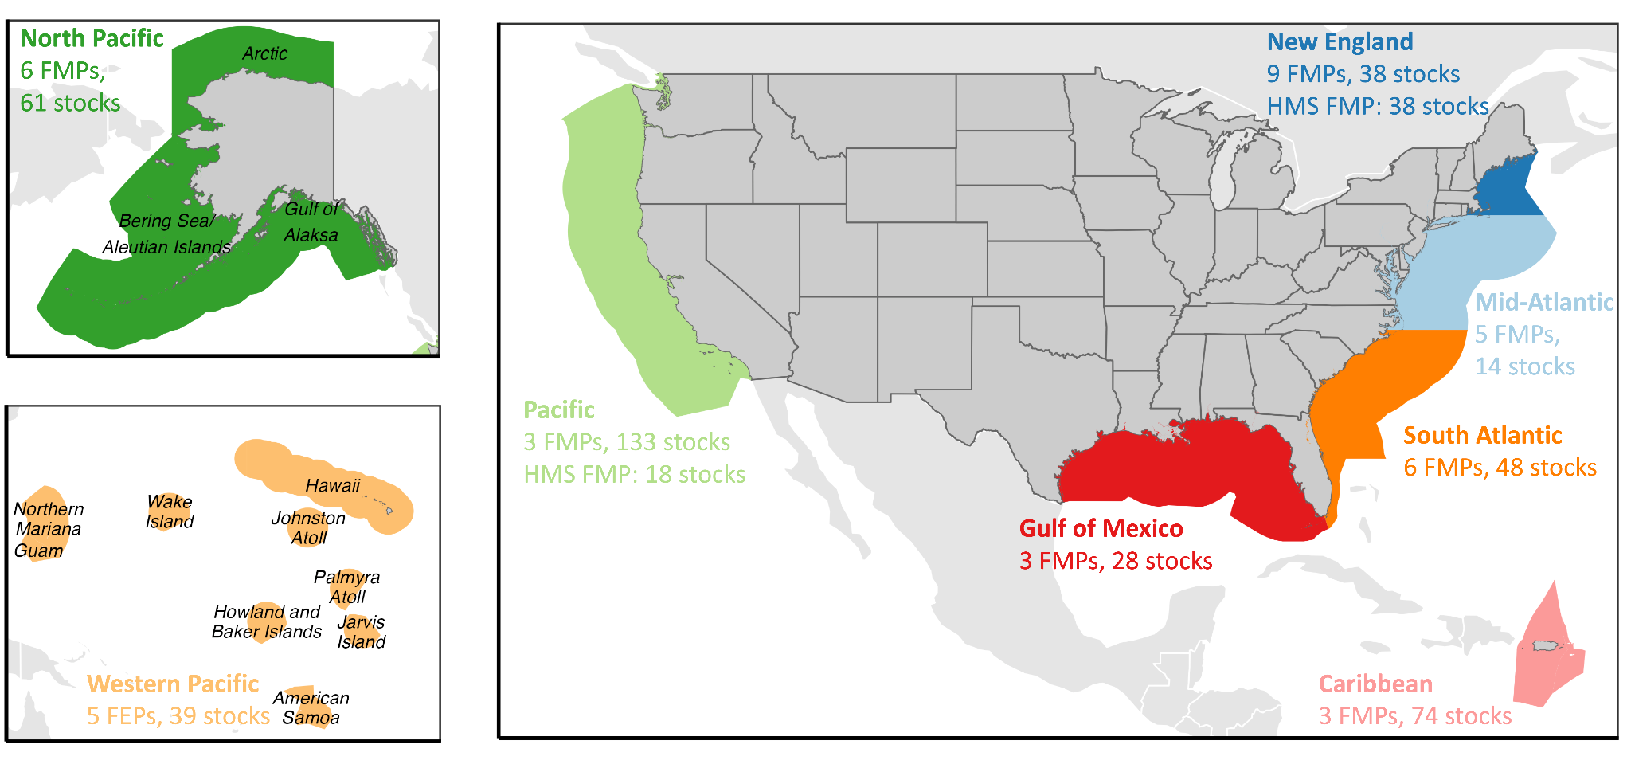

**Figure 1.** The jurisdiction of the eight U.S. Fishery Management Councils (FMCs), the number of Fishery Management Plans (FMPs) or Fishery Ecosystem Plans (FEPs) developed by each FMC, and the number of stocks managed by each FMC through these FMPs. The Atlantic and Pacific Highly Migratory Species (HMS) FMPs are developed by NOAA but are listed with the Pacific and New England FMCs.

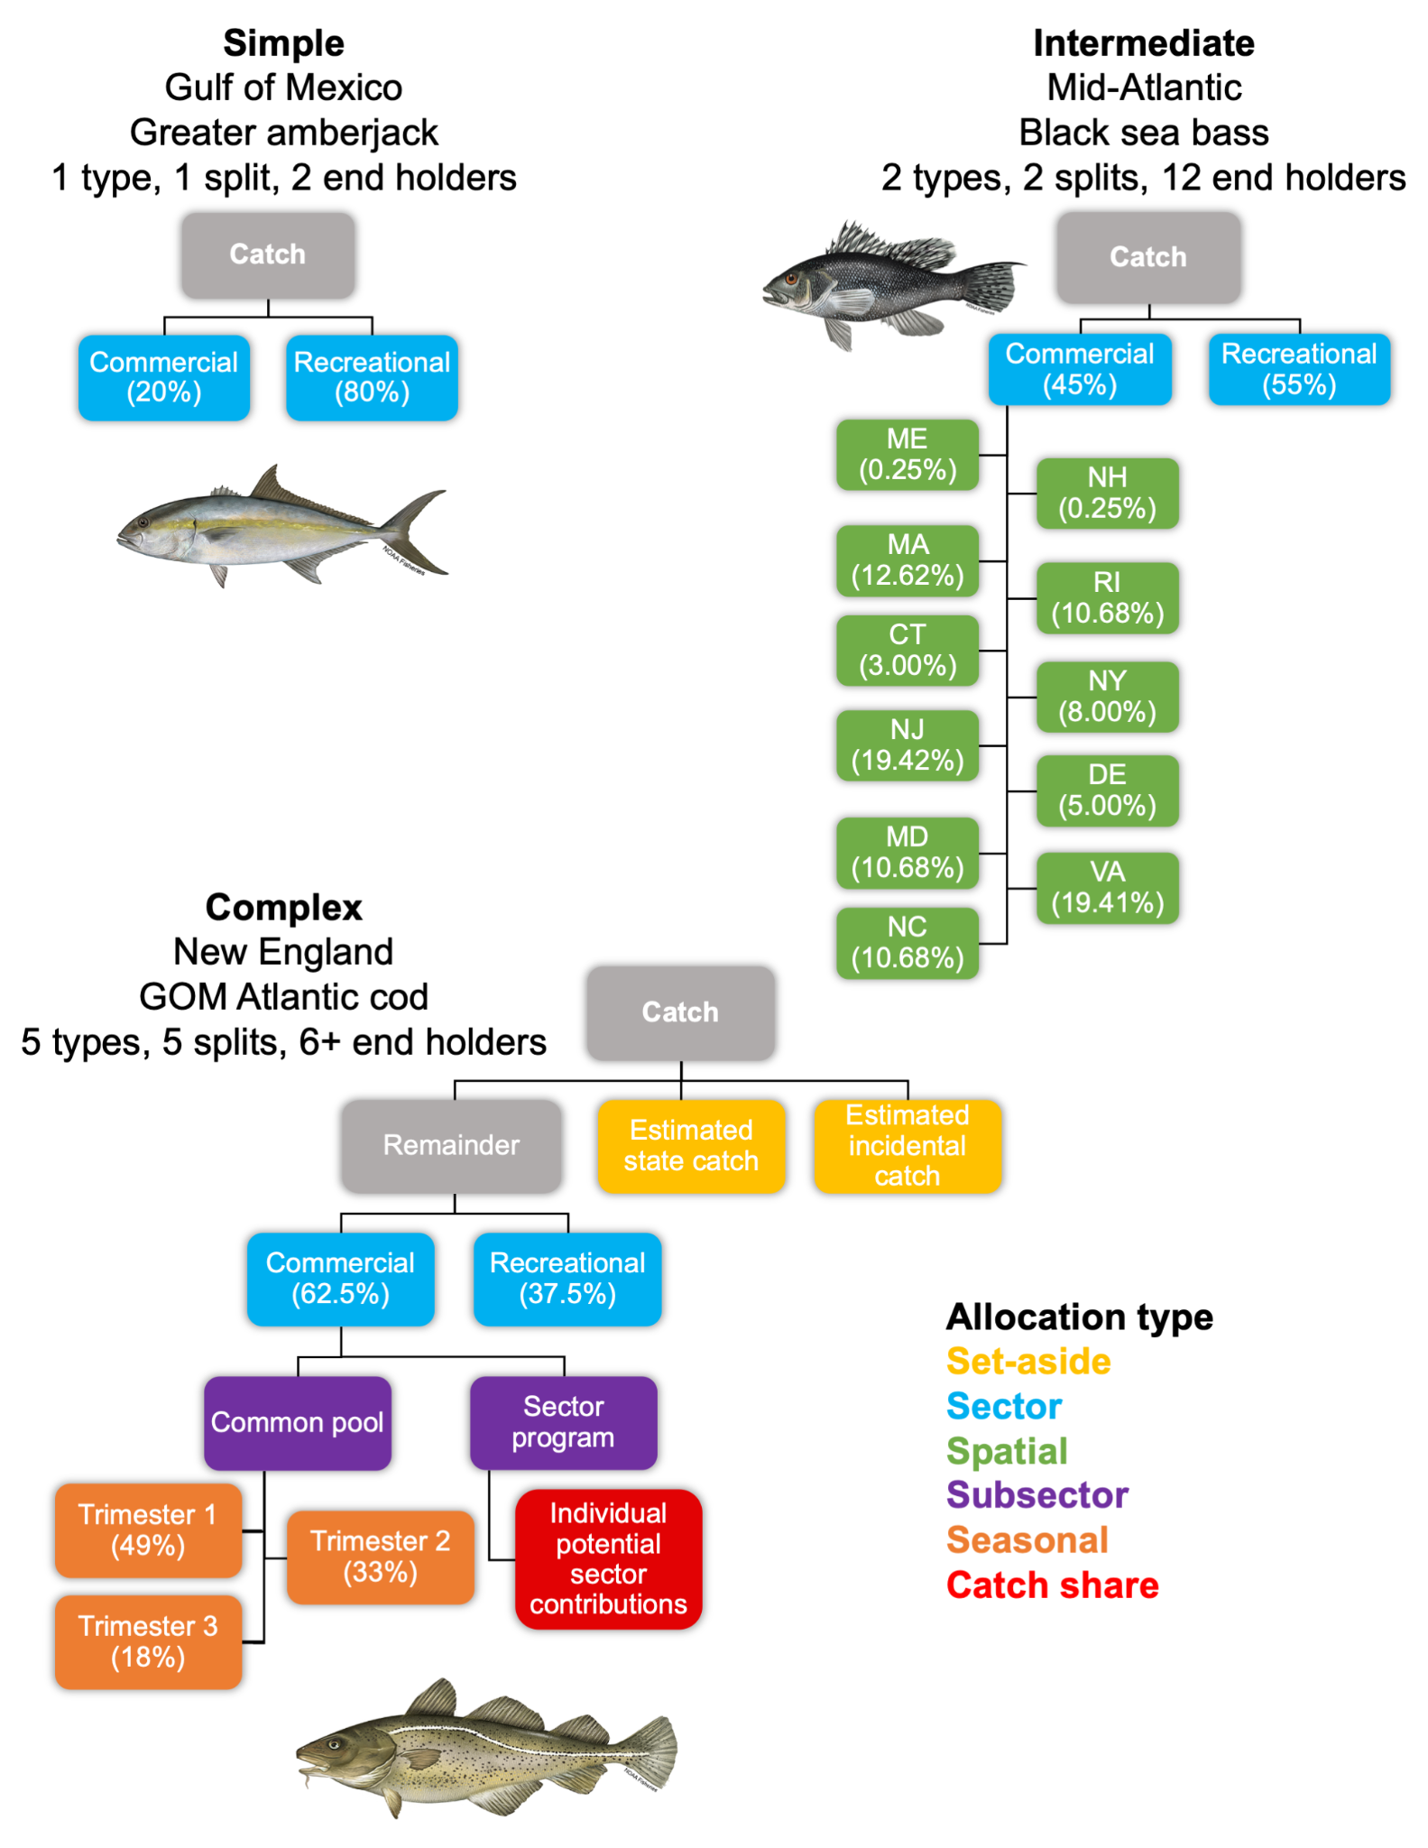

**Figure 2.** Flowcharts illustrating examples of quota allocation policies of low, medium, and high complexity. The illustrated “set asides” are forms of subsector allocations.

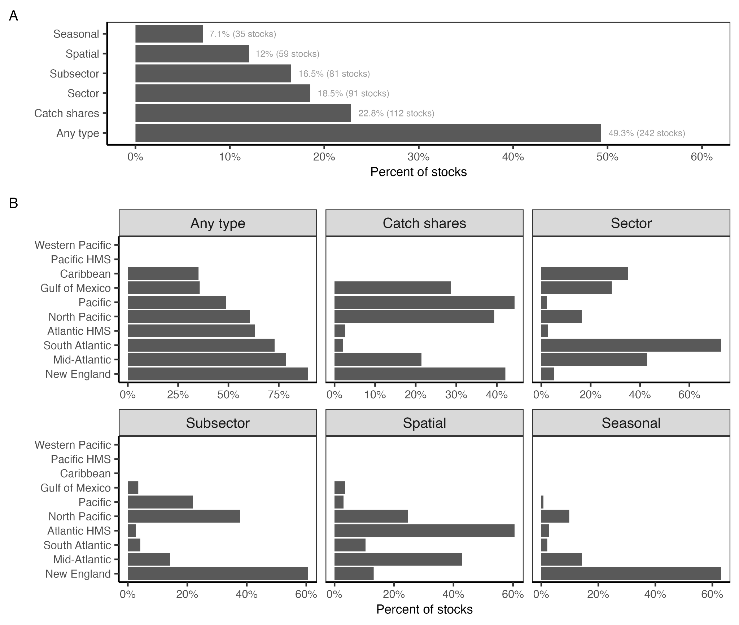

**Figure 3.** The percent of federally managed fish and invertebrate stocks managed using quota allocation policies **(A)** nationwide and **(B)** by Fishery Management Council.

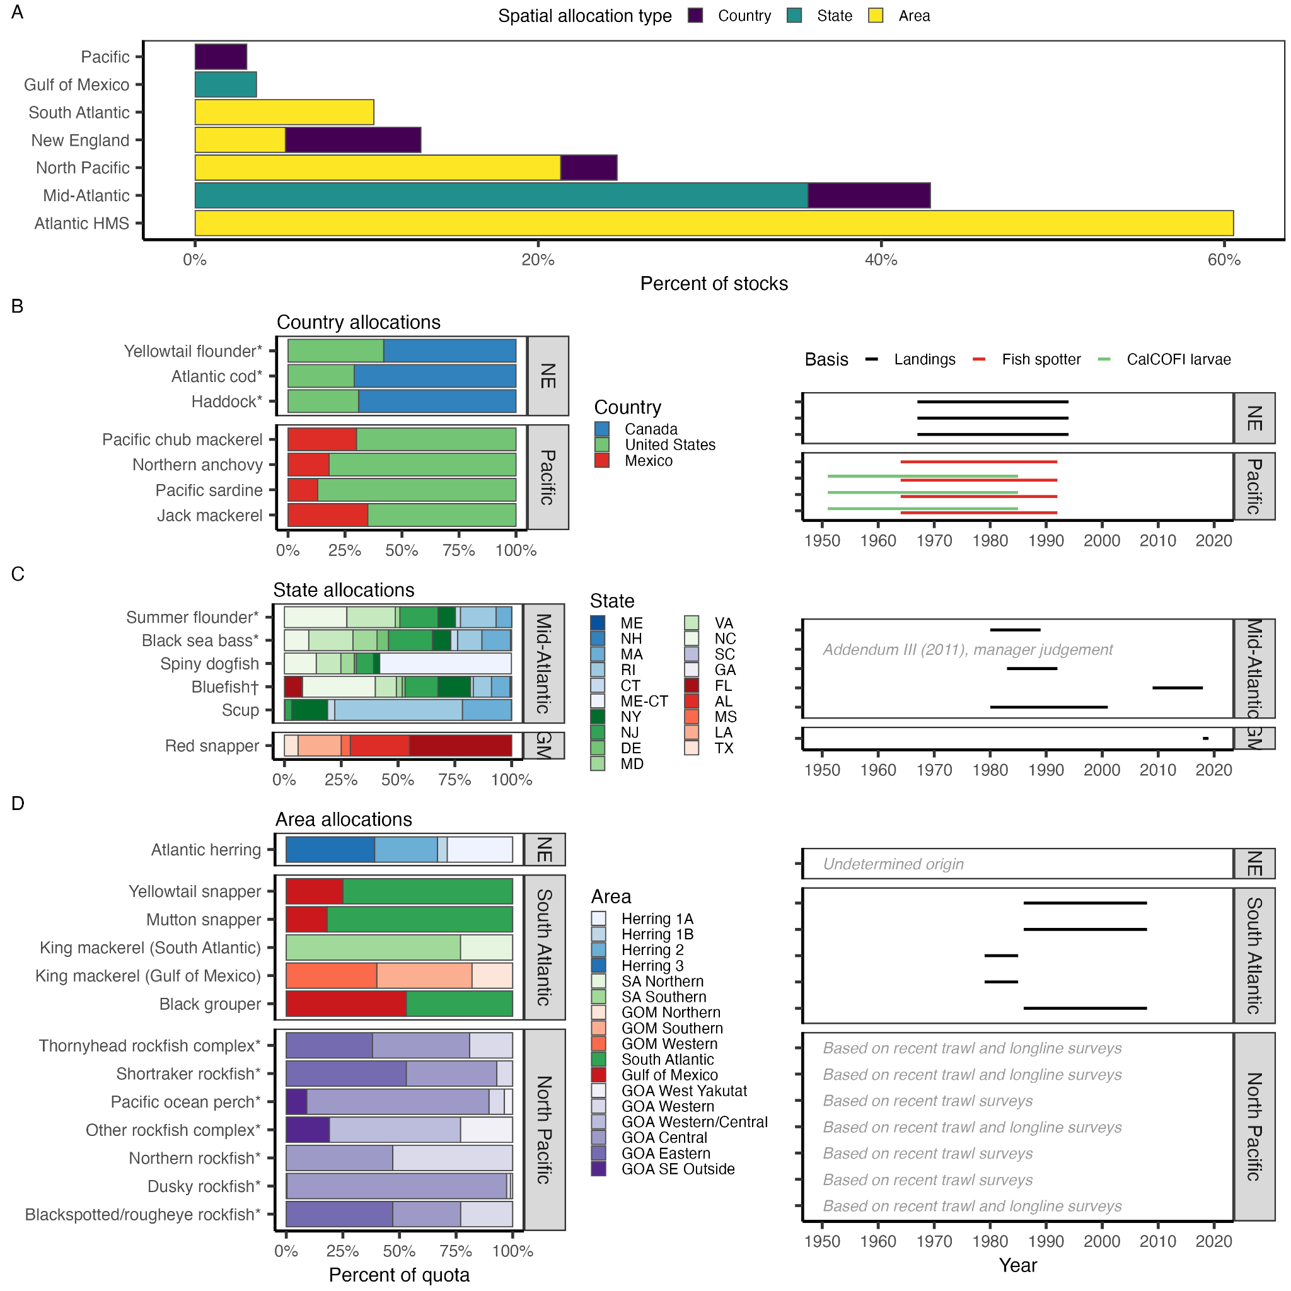

**Figure 4.** The **(A)** percent of stocks managed with spatial allocation policies by Fishery Management Council (FMC) and spatial allocation type and the percent allocations for stocks managed with **(B)** country-, **(C)** state-, and **(D)** area-based spatial allocation policies. The righthand panels show the historical reference periods used to set the spatial allocation. Recent or default percentages are shown for stocks, marked by an asterisk (*), whose allocations update based on distribution or abundance. Stocks whose allocations are transferable are marked by a dagger (†). In **(C)**, color groups indicate the FMC representing each state: New England (blues), Mid-Atlantic (greens), South Atlantic (purples), and Gulf of Mexico (reds). In **(D)**, color groups indicate the area scheme: herring zones (blues), South Atlantic (greens) and Gulf of Mexico (reds) king mackerel zones (greens), and Gulf of Alaska zones (purples).

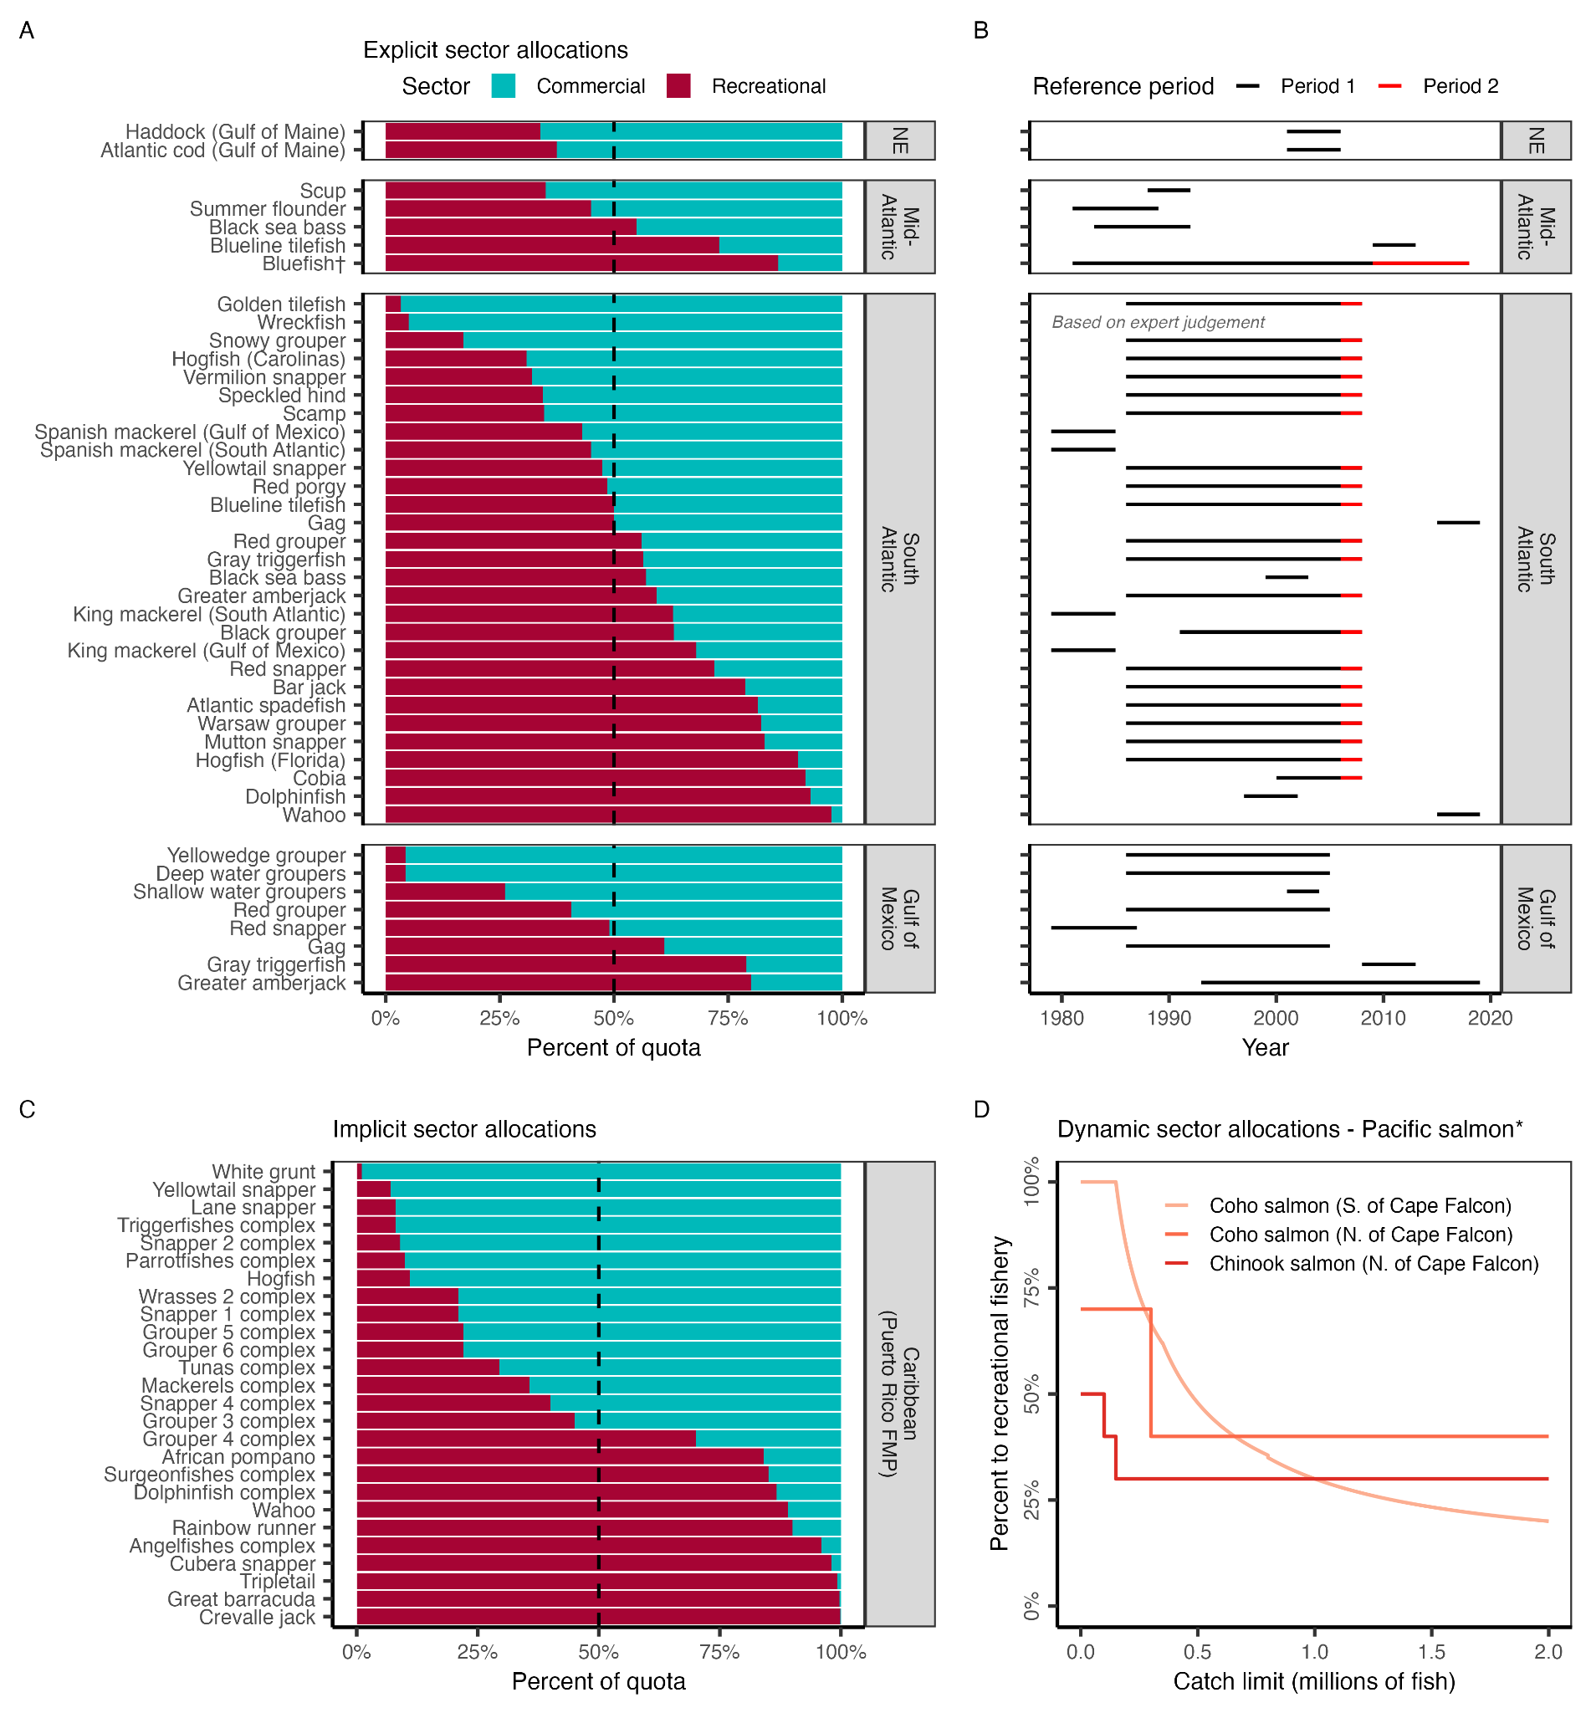

**Figure 5.** Sector-based allocation policies by Fishery Management Council (FMC). Panel **A** shows the percent of quota allocated to commercial and recreational fisheries by FMC and stock. Stocks are sorted in order of increasing allocations to recreational fisheries. The vertical dashed line indicates a 50:50 split. Panel **B** shows the reference period used to derive the allocation policy. A few policies weigh a recent time period (red) in addition to the full reference time period (black). Panel **C** illustrates the implicit allocation policies resulting from setting fixed catch limits based on historical catch time series for stocks managed by the CFMC Puerto Rico FMP. Panel **D** shows the dynamic sector allocation policies used to vary allocations based on stock size of select PFMC Pacific stocks. Only Mid-Atlantic bluefish are managed using transferable sector quota (†) and only Pacific salmon are managed using dynamic sector quota (*).

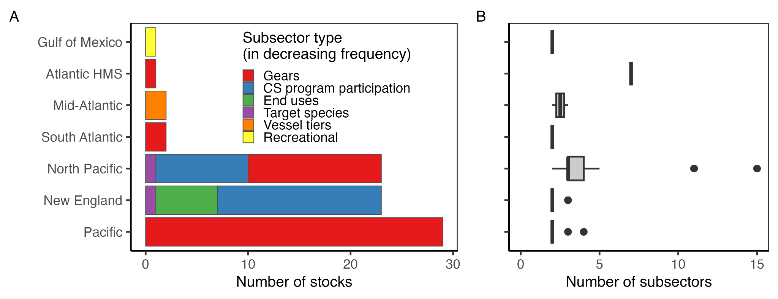

**Figure 6.** The **(A)** number of stocks managed using subsector allocations by Fishery Management Council (FMC) and subsector type and **(B)** number of subsectors included within each subsector allocation policy. In **(A)**, all but the “Recreational” subsector type are commercial subsectors. In the boxplots, the solid line indicates the median, the box indicates the interquartile range (IQR; 25th to 75th percentiles), the whiskers indicate 1.5 times the IQR, and points indicate outliers.

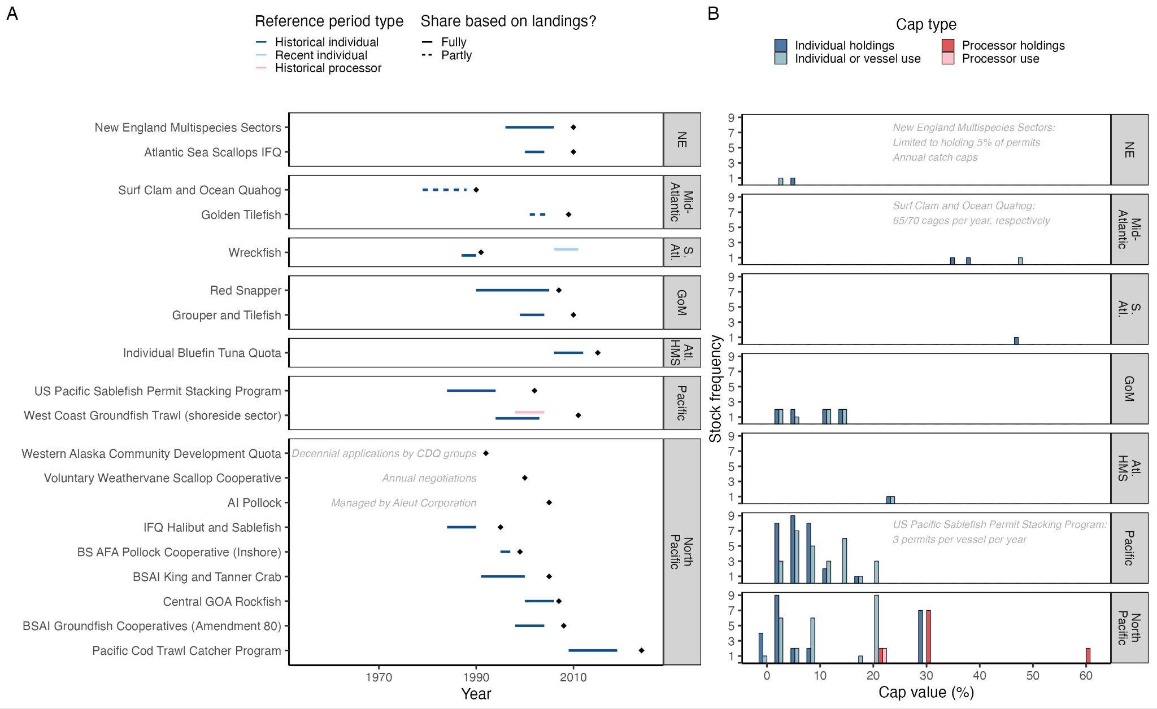

**Figure 7.** The **(A)** reference period and year of implementation (diamond) for catch share allocations by Fishery Management Council (FMC) and program and **(B)** frequency of stock-level holding and use caps by FMC. In **(A),** reference periods are colored by type (historical vs. recent, individual vs. processor). Programs with reference periods are sorted by implementation year. In 2012, inactive wreckfish quota was redistributed using a recent reference period (light blue). Dashed lines highlight programs in which shares are partly rather than fully based on landings (i.e., Golden Tilefish also depends on tier; Surf Clam and Quahog also depend on vessel size). Gray text explains protocols for programs that do not use landings to determine shares. Reference period can vary by species (New England Multispecies) and permit (Pacific Cod Trawl Catcher Program); only the most common reference period is illustrated. In **(B)**, cap value frequencies are colored by cap type (holding vs. use, individual vs. processor). Protocols for programs with non-percent-based caps are described in gray text. Crew, catcher/processor, and cooperative caps are rare and therefore excluded. The Weathervane Scallop Cooperative, Western Alaska Community Development Quota, and AI Pollock programs do not employ caps. Bars are offset by 3 when necessary for visualization.

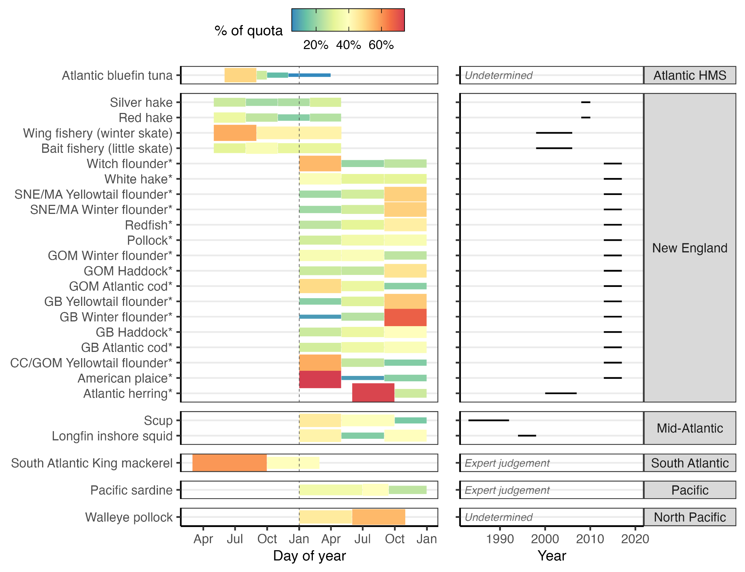

**Figure 8.** Seasonal allocations and the historical reference period used to set them by Fishery Management Council and stock. Blocks indicate the temporal extent of each season. Only New England groundfish and Atlantic herring use dynamically updated seasonal allocations (*).

***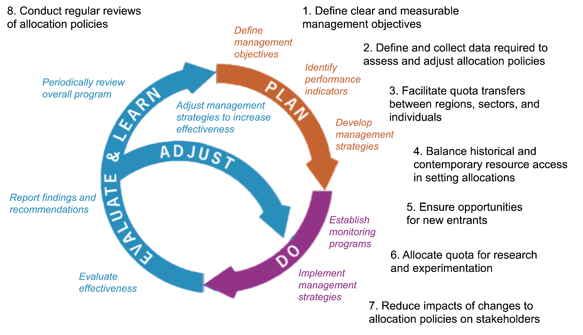*Figure 9.** Eight best practices (black text) for enhancing the adaptive management of quota allocation policies. The figure is adapted from Jones et al. (2005).