May 29, 2025

Dear Dr. Godwin:

We are grateful for the opportunity to submit our revised manuscript, “Quota allocation policies in U.S. federal fisheries management and implications for climate resilience”, for consideration as an Article in *Fish and Fisheries*.

We carefully reviewed the comments from you and the reviewers and appreciate this thoughtful feedback. We address each comment individually below with the original comment shown in black text and the response shown in indented blue text. This feedback and the associated revisions have greatly improved the manuscript.

Briefly, we made the following notable changes to the manuscript text:

1. Reduced the word count to 11,999
2. Cleaned the supplement and database for publication
3. Highlighted the international review and international implications in the abstract
4. Updated the figures and results text in response to a few new council staff reviews
5. Added markers to the figures to indicate allocation policies that are adaptive

Finally, our University Library will be ending its program to cover Open Access publishing fees on June 1st (3 days from now). If our paper is accepted before then, we will be excited to leverage this program to ensure that our paper is freely accessible to all readers.

Thank you for your consideration and please let us know if you have any questions.

On behalf of all authors,

Sincerely,

Christopher Free

## 

## Editor

Thank you very much for your submission—it was a great read and I believe the quality of the manuscript is reflected in the positive comments of the reviewers. Please see the reviewers’ feedback below and revise and respond accordingly. I agree with Reviewer 1’s request of adding a sentence to the abstract with international context, given the journal’s audience and scope.

We are grateful for your close review of our manuscript, for this kind acknowledgement, and for your thoughtful and constructive feedback. We agree with all of your comments and suggestions and detail how we addressed them in the indented blue text below.

We added the following underlined text to the abstract to highlight (1) our brief review of allocation in international fisheries and (2) the implications of our work to international fisheries:

**Methods sentence:** Here, we conduct a systematic review of allocation policies used in U.S. federal fisheries (491 stocks, 42 management plans, 8 regions) and brief review of allocation policies in international fisheries, which we use to identify best practices for climate-adaptive quota allocation.”

**Concluding sentence:** “Ultimately, we provide eight globally transferable recommendations for improving the ability for allocation policies to advance their fairness and equity goals under climate change.”

The only issue from the journal’s perspective is the word count, which currently exceeds the 10,000 limit. I’ve discussed this with the other Editors, exceeding the word limit in this case would be fine in this case, given the depth and breadth of the paper. If you can find a way to bring it down to 12,000 words (e.g., by putting something in the supplementary material), that would be enough in this case.

We appreciate the generous exception made for our article. The paper was originally 13,980 words from the introduction through the figure legends. We cut 1,981 words bringing the paper down to 11,999 words. We achieved this by moving two figures to the supplement, cutting a few redundant references, and editing the manuscript for brevity.

## 

## Reviewer 1

This paper synthesizes the allocation policies used to manage US federal fisheries alongside international fisheries in Europe, Australia, New Zealand, and the Parties to the Nauru Agreement. It identifies best practices for increasing the climate-adaptiveness of quota allocation policies and provides eight concrete recommendations for maintaining equity and fairness under climate change.

This is an excellent and timely review of US federal fisheries quota allocation policies and offers a comprehensive and informative overview of five key allocation schemes—sector, subsector, spatial, seasonal, and catch shares. While the review includes detailed examples of allocation policies, the writing is very clear and easy to read. The figures are powerful to show the patterns across regions. I particularly love the conceptual diagrams that illustrate the best practices for climate-adaptive quota allocation and provide thoughtful pathways to enhance equity. I believe these insights are highly relevant to ongoing policy discussions and hold great contribution value to future management practices under climate uncertainties.

We are grateful for your close review of our manuscript, for this kind acknowledgement, and for your thoughtful and constructive feedback. We agree with all of your comments and suggestions and detail how we addressed them in the indented blue text below.

Some minor comments and suggestions I have:

1. The abstract is concise and well-written, but I find the international reviews were not included, which I believe is a valuable strength of the paper. Several best practices and recommendations are also tied to these international cases. I suggest briefly mentioning them in the abstract, which would broaden the appeal and impact of the work, particularly for international audiences.

We added the following underlined text to the abstract to highlight (1) our brief review of allocation in international fisheries and (2) the implications of our work to international fisheries:

**Methods sentence:** Here, we conduct a systematic review of allocation policies used in U.S. federal fisheries (491 stocks, 42 management plans, 8 regions) and brief review of allocation policies in international fisheries, which we use to identify best practices for climate-adaptive quota allocation.”

**Concluding sentence:** “Ultimately, we provide eight globally transferable recommendations for improving the ability for allocation policies to advance their fairness and equity goals under climate change.”

2. In several places, the manuscript states that this study evaluates the vulnerability of these policies to climate change. This phrase may be misleading, as it does reflect what this study did, which is to provide best practices of climate-ready quota allocation policies through data and information synthesis. I suggest rephrasing or removing these statements to better reflect the scope of the study.

This is a very helpful suggestion as our methods really do center on identifying and generalizing adaptive policies. We updated this in several places:

**Abstract:** “Here, we conduct a systematic review of allocation policies used in U.S. federal fisheries (491 stocks, 42 management plans, 8 regions) and brief review of allocation policies in international fisheries, which we use to identify best practices for climate-adaptive quota allocation.”

**Last paragraph of intro:** “In this paper, we synthesize the diverse allocation policies used to manage U.S. federal fisheries, evaluate the ~~vulnerability or~~ adaptivity of these policies to climate change, and provide recommendations for increasing the climate-adaptiveness of quota allocation. We begin by cataloging the allocation policies of 491 stocks managed by the 42 fisheries management plans developed by the 8 FMCs into a standardized database. This provides a platform for understanding the myriad of allocation approaches taken across the U.S. and for understanding how approaches differ by region. We then evaluate the ~~vulnerability or~~ adaptiveness of these policies to climate change and offer recommendations for increasing the ability for these policies to maintain equity and fairness under climate change.

3. Line 211: In addition to the climate change considerations and management responsiveness, ensuring equity and fairness is also an important aspect of best practices. This was brought up in the introduction and discussion and is central to the paper’s framework—so I suggest this should be emphasized as well when you talk about the identification of best practices.

This is a very valuable point and we added the following underlined text to clarify that we also looked for best practices that ensure equity and fairness under climate change in the “2.3 Identifying best practices for climate-adaptive allocation policies” section:

“Based on our systematic review of U.S. allocation policies and brief review of international policies, we identified eight best practices for implementing or enhancing the adaptive management of quota allocation policies to advance their fairness and equity goals under climate change (**Figure 9**).”

4. Line 277 and Figure 4C: The figure is informative, but the spatial dynamics mentioned in the text do not seem to be represented. It appears to only show default percentage allocations—if that’s the case, please clarify.

Thank you for spotting this inconsistency. We aligned the text and figure by marking which stocks employ dynamic spatial allocations and by clarifying in the caption that default percentages are shown for stocks with dynamic allocation procedures. Specifically, we added the following caption text:

“The righthand panels show the historical reference periods used to set the spatial allocation. Recent or default percentages are shown for stocks, marked by an asterisk (*), whose allocations update based on distribution or abundance. Stocks whose allocations are transferable are marked by a dagger (†).”

The updated figure is provided below for reference:

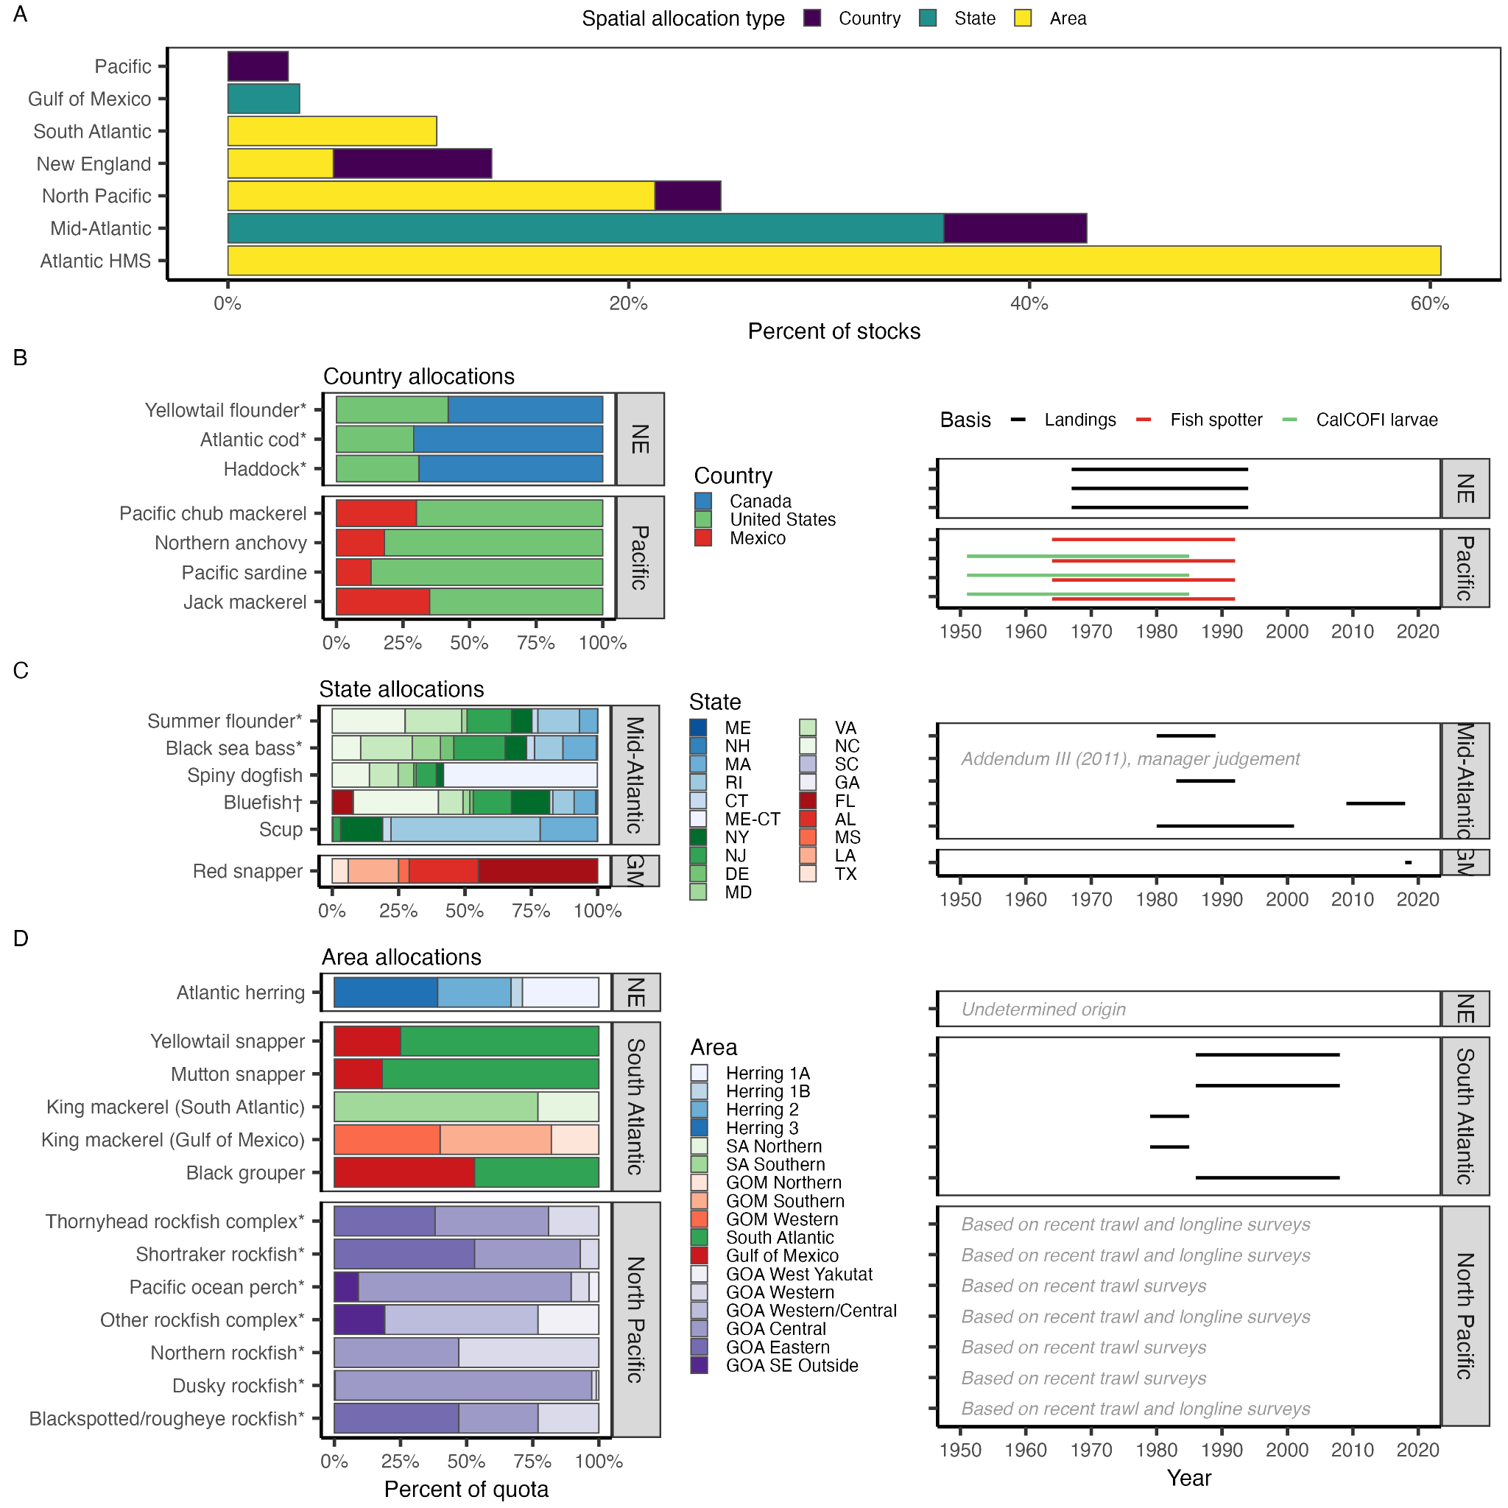

5. Figure 4: The panels on the right lack captions explaining the lines. I assume they show reference periods used to determine quotas, but this should be clarified.

Thank you for spotting this omission. We added the following text to the caption to explain that the lines are indeed the reference periods used to determine allocations:

“The righthand panels show the historical reference periods used to set the spatial allocation.”

6. Figure 5 and Figure 7 are very useful. To further enhance their impact, it would be nice to quantify how many federally managed stocks currently use adaptive allocation policies. For instance, how many have updated quotas based on recent reference periods? Which categories (sector, spatial, seasonal, etc.) have been the most adaptive and which lack such flexibility? Even approximate numbers or percentages would provide valuable context.

This is a very helpful and thought-provoking comment.

In Figures 4, 5, and 8, we added an asterisk (*) to mark stocks managed using dynamic allocations (i.e., percentages vary based on distribution or abundance) and we added a dagger (†) to mark stocks managed using a transfer system. We added text to explain these indicators in the caption. This helps to convey how rare these dynamic actions are.

**Figure 4 (spatial allocations): “**Recent or default percentages are shown for stocks, marked by an asterisk (*), whose allocations update based on distribution or abundance. Stocks whose allocations are transferable are marked by a dagger (†).”

**Figure 5 (sector allocations):** “Only Mid-Atlantic bluefish are managed using transferable sector quota (†) and only Pacific salmon are managed using dynamic sector quota (*).”

**Figure 8 (seasonal allocations):** “Only New England groundfish and Atlantic herring use dynamically updated seasonal allocations (*).”

We note that nearly all catch share programs include some amount of transferability and that this is noted in the results: “Currently, most programs allow transfers of both quota shares (permanent sale) and annual allocations (temporary lease) among entities.”

## 

## Reviewer 2

The authors synthesize the diverse fisheries allocation policies used to manage U.S. federal

fisheries (and select international fisheries) and evaluate the vulnerability of these policies

to climate change. Quota allocation is one of the most important and contentious

processes in fisheries management as it dictates how access is shared among fishery

participants. While the establishment of catch limits is a largely objective and scientific

process, decisions about how to distribute the resulting quota are more subjective. U.S.

federal fisheries laws give regional fishery management councils flexibility in the

implementation of allocation policies, resulting in a diversity of policies with various pros

and cons. The authors find that allocation policies are used to manage 46% of U.S.

federally managed stocks. Although most policies are based on historical catch, many

include features that promote climate adaptiveness. The authors outline eight

recommendations for improving allocation policies under climate change.

The article provides an excellent review and summary of fisheries allocation policies in the

U.S., with additional illustrative examples drawn from international fisheries. The article is

well-organized and clearly written.

The standardized database developed by the authors of the fisheries allocation policies of

491 stocks managed by the 42 fisheries management plans developed by the 8 U.S.

fisheries management councils reflects a large amount of work and should be very useful

to other researchers working on fisheries allocation policies.

The authors made very good efforts to validate the contents of the database by comparing

the database with other less comprehensive databases and by obtaining reviews by

relevant federal management council staff.

In the reviewer’s opinion, this article is an excellent example of extremely valuable “review

article” research that summarizes and organizes information in an accessible and useful

manner. Such review articles are often “unsung,” but they are very valuable work, as they

greatly improve the efficiency of the research process by reducing the need for other

researchers to undertake very time-consuming, redundant efforts. The reviewer believes

that this article would be widely read and would support a tremendous amount of follow-

on research. The article would serve as a solid foundation and reference for future articles

that attempt to identify and propose solutions for the complex problem of fisheries

allocation under climate change. The article would also be extremely useful for university

teaching and agency training purposes.

We are grateful for your close review of our manuscript, for this kind acknowledgement, and for your thoughtful and constructive feedback. We agree with all of your comments and suggestions and detail how we addressed them in the indented blue text below.

**Minor Issues**

Line 330 – The sentence that begins “Within the commercial sector, …” appears to refer to

all fisheries, rather than to the Gulf of Alaska Pacific cod fisheries mentioned in the

preceding sentence. This needs to be made a bit clearer.

This text actually did refer to all fisheries and not to the Gulf of Alaska Pacific cod fishery. However, to reduce confusion and to help reduce word count, we removed the minor result relating to the GOA Pacific cod fishery from the text. This eases the segue from subsector allocations in the recreational sector to subsector allocations in the commercial sector. These sentences now read as follows:

“Gulf of Mexico red snapper (*Lutjanus campechanus*, Lutjanidae), which allocates recreational catch between the for-hire (42.3%) and private fleets (57.7%), is the only stock managed using subsector allocations within the recreational sector. ~~Commercial quota for Gulf of Alaska Pacific cod (~~*~~Gadus macrocephalus~~*~~, Gadidae) is divided between fifteen subsectors, the maximum number of divisions of any subsector-based allocation policy (~~**~~Figure 6B~~**~~).~~ Within the commercial sector, subsector allocations are divided between fleets that differ in their: gear type (e.g., longline, gillnet, trap; 45 stocks), catch share program participation (25 stocks), end use of catch (e.g., bait or food; 6 stocks), target species (e.g., herring, non-herring; 2 stocks), and vessel tier (e.g., specialists vs. generalists; 2 stocks) (**Figure 6A**).”

In the caption of Figure 4, very briefly describe what the gray-colored boxes to the right of

(B), (C) and (D) show; I believe it’s reference period.

Thank you for spotting this omission. We added the following text to the caption to explain that the lines are indeed the reference periods used to determine allocations:

“The righthand panels show the historical reference periods used to set the spatial allocation.”

Figures 10 and 11 seem unnecessary. Maybe incorporate some of the caption of Figure 10

regarding definitions of equity into the body of the text.

We moved Figures 10 and 11 to the supplement to help reduce our word count.

Page 117 (of 144) – Some highlighted notes indicate that some additional work needs to be

done for the BSAI groundfish fishery.

Thank you for spotting this incomplete summary. We completed the summary and we also heavily reformatted the supplemental summaries to make them more consistent and readable, namely by formatting the references and table/figure numbers.