### Supplemental Tables and Figures

**Table S1.** Fishery Management Plans (FMPs) and Fishery Ecosystem Plans (FEPs) used to manage U.S. federal fish and invertebrate stocks.†

|  |  |  |  |
| --- | --- | --- | --- |
| **FMP/FEP** | **Year** | **# of species** | **# of stocks** |
| *New England (10 FMPs)* |  |  |  |
| Atlantic Sea Scallop | 1982 | 1 | 1 |
| Deep-Sea Red Crab | 2002 | 1 | 1 |
| Northeast Multispecies | 1986 | 13 | 20 |
| Small-Mesh Multispecies (Whiting) | 2000 | 3 | 5 |
| Northeast Skate Complex | 2003 | 7 | 7 |
| Atlantic Herring | 1999 | 1 | 1 |
| Atlantic Salmon | 1988 | 1 | 1 |
| Monkfish *(with MAFMC)* | 1999 | 1 | 1 |
| Spiny Dogfish *(with MAFMC)* | 1999 | 1 | 1 |
| Atlantic HMS *(with all East Coast RFMCs)* | 2006 |  |  |
| *Mid-Atlantic (5 FMPs)* |  |  |  |
| Atlantic Surfclam & Ocean Quahog | 1977 | 2 | 2 |
| Bluefish | 1990 | 1 | 1 |
| Mackerel, Squid, Butterfish | 1978 | 5 | 5 |
| Summer Flounder, Scup, Black Sea Bass | 1988 | 3 | 3 |
| Tilefish | 2001 | 2 | 2 |
| *South Atlantic (6 FMPs)* |  |  |  |
| Dolphin & Wahoo | 2004 | 4 | 4 |
| Golden Crab | 1996 | 1 | 1 |
| Shrimp | 1993 | 4 | 4 |
| Snapper-Grouper | 1983 | 55 | 55 |
| Coastal Migratory Pelagics *(with GFMC)* | 1983 | 3 | 3 |
| GOM & SA Spiny Lobster *(with GFMC)* | 1982 | 1 | 1 |
| *Gulf of Mexico (3 FMPs)* |  |  |  |
| Red Drum | 1986 | 1 | 1 |
| GOM Reef Fish | 1984 | 31 | 31 |
| GOM Shrimp | 1981 | 4 | 4 |
| *Caribbean (3 FMPs)* |  |  |  |
| Puerto Rico | 2022 | 65, plus cucumbers/urchins/corals | 37 |
| St. Thomas & St. John | 2022 | 45, plus cucumbers/urchins/corals | 26 |
| St. Croix | 2022 | 49, plus cucumbers/urchins/corals | 26 |
| *Pacific (4 FMPs)* |  |  |  |
| Coastal Pelagic Species | 2000 | 5 | 5 |
| Pacific Groundfish | 1982 | 86 | 100+ |
| Pacific Salmon | 2016 | 3 | 67 |
| Pacific HMS | 2003 | 11 | 11 |
| *North Pacific (6 FMPs)* |  |  |  |
| BSAI King & Tanner Crabs | 1989 | 5 | 10 |
| Arctic Fish | 2009 | 3 | 3 |
| BSAI Groundfish | 1982 | 17, plus 3 complexes | 23 |
| GOA Groundfish | 1978 | 19, plus 5 complexes | 28 |
| AK Salmon | 1979 | 5 | many |
| AK Scallop | 1995 | 1 | 1 |
| *Western Pacific (5 FEPs)* |  |  |  |
| American Samoa Archipelago | 2009 |  | 1 |
| Hawaii Archipelago | 2009 |  | 15 |
| Guam (Mariana Archipelago) | 2009 |  | 2 |
| Pacific Pelagic Fisheries | 2009 |  | 16 |
| Pacific Remote Island Areas | 2009 |  | 5 |

*† We did not evaluate the seven habitat-oriented FMPs because they do not manage marine fish or invertebrate fisheries: (1) New England: Habitat FMP; (2) South Atlantic: Coral and Sargassum FMPs; (3) Gulf of Mexico: Aquaculture, Coral, and Essential Fish Habitat FMPs; and (4) Pacific: Fishery Ecosystem Plan.*

**Table S2.** Structure of the quota allocation policy database.

|  |  |  |
| --- | --- | --- |
| **Description** | **Column name** | **Example** |
| Council | council | NEFMC |
| Management plan | fmp | Northeast Multispecies |
| Stock name | stock | Granger fish - Georges Bank |
| Common name | comm_name | Granger fish |
| Scientific name | sci_name | *Petrificus totalus* |
| Catch prohibited (yes/no)? | prohibited_yn | No |
| Allocation rule (yes/no)? | allocation_yn | Yes |
| Geographic rule (yes/no)? | spatial_yn | Yes |
| Country rule (yes/no)? | country_yn | Yes |
| List of countries | country_list | US, Canada |
| Number of countries | county_n | 2 |
| Country reference years | country_yrs | 1985-1990, 1995-2001 |
| State rule (yes/no)? | state_yn | Yes |
| List of states | state_list | ME, NH, RI |
| Number of states | state_n | 3 |
| State reference years | state_yrs | 1985-1990 |
| Area (yes/no)? | area_yn | Yes |
| List of areas | area_list | Georges Bank, Gulf of Maine |
| Number of areas | area_n | 2 |
| Area reference years | area_yrs | 1985-1990, 1995-2001 |
| Sector rule (yes/no)? | sector_yn | Yes |
| Sector rule type (explicit/implicit) | sector_type | Explicit |
| List of sectors receiving set asides | sector_setaside_list | Research, incidental |
| List of sectors | sector_list | Recreational, commercial |
| Number of sectors | sector_n | 2 |
| Sector reference years | sector_yrs | 1985-1990 |
| Basis (catch/effort) | sector_basis | Catch |
| Subsector rule (yes/no)? | subsector_yn | Yes |
| List of recreational subsectors | subsector_list_rec | For-hire, private |
| List of commercial subsectors | subsector_list_comm | Longline, gillnet, trap |
| Number of subsectors | subsector_n | 5 |
| Subsector reference years | subsector_yrs | 1985-1990, 1995-2001 |
| Seasonal rule (yes/no)? | season_yn | Yes |
| List of seasons | season_list | Jan - May, Jun - Dec |
| Number of seasons | season_n | 2 |
| Season reference years | season_yrs | 1985-1990 |
| Indiv/group rule (yes/no)? | shares_yn | Yes |
| Year program first implemented | shares_start_year | 1998 |
| Basis (hist., equal, auction) | shares_basis | Historical catch |
| Reference years | shares_yrs | 1985-1990 |
| Owner | shares_owner | Vessel |
| Share cap | share_cap | Person (4%), Vessel (8%) |
| Shares transferable (yes/no)? | shares_transfer_yn | Yes |
| Program name | share_program | Granger Fish ITQ |

**Table S3.** Catch share programs by Fishery Management Council (FMC).

|  |  |
| --- | --- |
| **Program** | **Year** |
| *Atlantic HMS* |  |
| Individual Bluefin Tuna Quota | 2015 |
| *New England* |  |
| Atlantic Sea Scallops IFQ | 2010 |
| New England Multispecies Sectors | 2010 |
| *Mid-Atlantic* |  |
| Surf Clam and Ocean Quahog | 1990 |
| Golden Tilefish | 2009 |
| *South Atlantic* |  |
| Wreckfish | 1991 |
| *Gulf of Mexico* |  |
| Red Snapper | 2007 |
| Grouper and Tilefish | 2010 |
| *Pacific* |  |
| Pacific Sablefish Permit Stacking | 2001 |
| West Coast Groundfish Trawl Rationalization | 2011 |
| *North Pacific* |  |
| Western Alaska Community Development Quota Program | 1992 |
| Individual Fishing Quota Halibut and Sablefish | 1995 |
| Bering Sea AFA Pollock Cooperative | 1999 |
| Weathervane Scallop Cooperative* | 2000 |
| Bering Sea and Aleutian Islands King and Tanner Crab | 2005 |
| Aleutian Islands Pollock | 2005 |
| Bering Sea and Aleutian Islands Groundfish (Non-Pollock) Cooperatives - Amendment 80 | 2008 |
| Central Gulf of Alaska Rockfish | 2011 |
| Pacific Cod Trawl Cooperative Program | 2024 |

† The Weathervane Scallop Cooperative is a voluntary program and is not listed on the NOAA Catch Share website (<https://www.fisheries.noaa.gov/national/sustainable-fisheries/catch-shares>). Our inclusion of this program and the recently added Pacific Cod Trawl Cooperative Program is why we arrive at 19 rather than 17 catch share programs.

### 

### 

**Figure S1.** Sector-based allocation policies documented by Morrison and Scott (2014). Panel **A** shows the percent of quota allocated to commercial and recreational fisheries by Fishery Management Council and stock. Stocks are sorted in order of increasing allocations to recreational fisheries. The vertical dashed line indicates a 50:50 split. Panel **B** shows the reference period used to derive the allocation policy (lines) and the year in which the allocation policy went into effect (points). A few policies weigh the recent time period in addition to the selected reference time period.

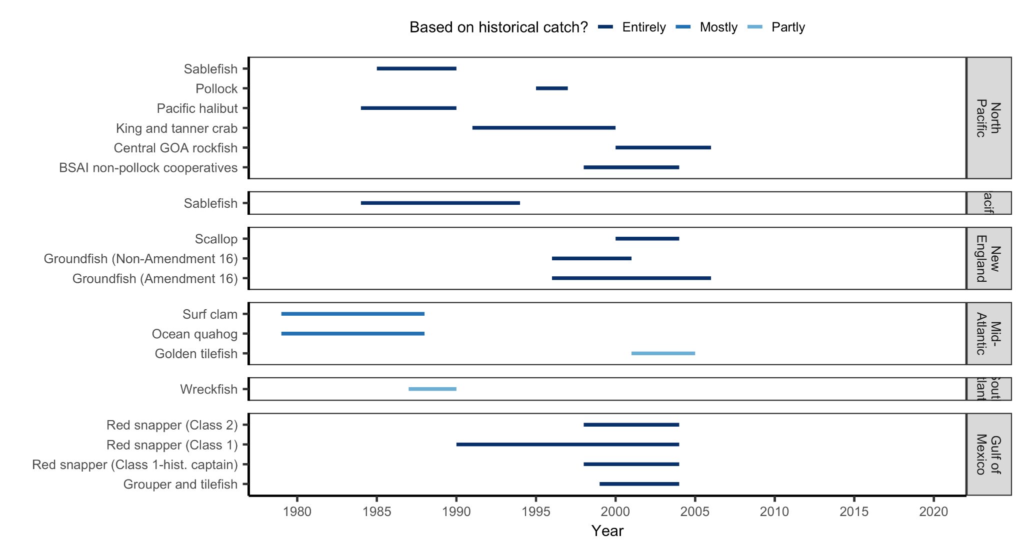**Figure S2.** Basis for catch share allocations documented by Morrison and Scott (2014).

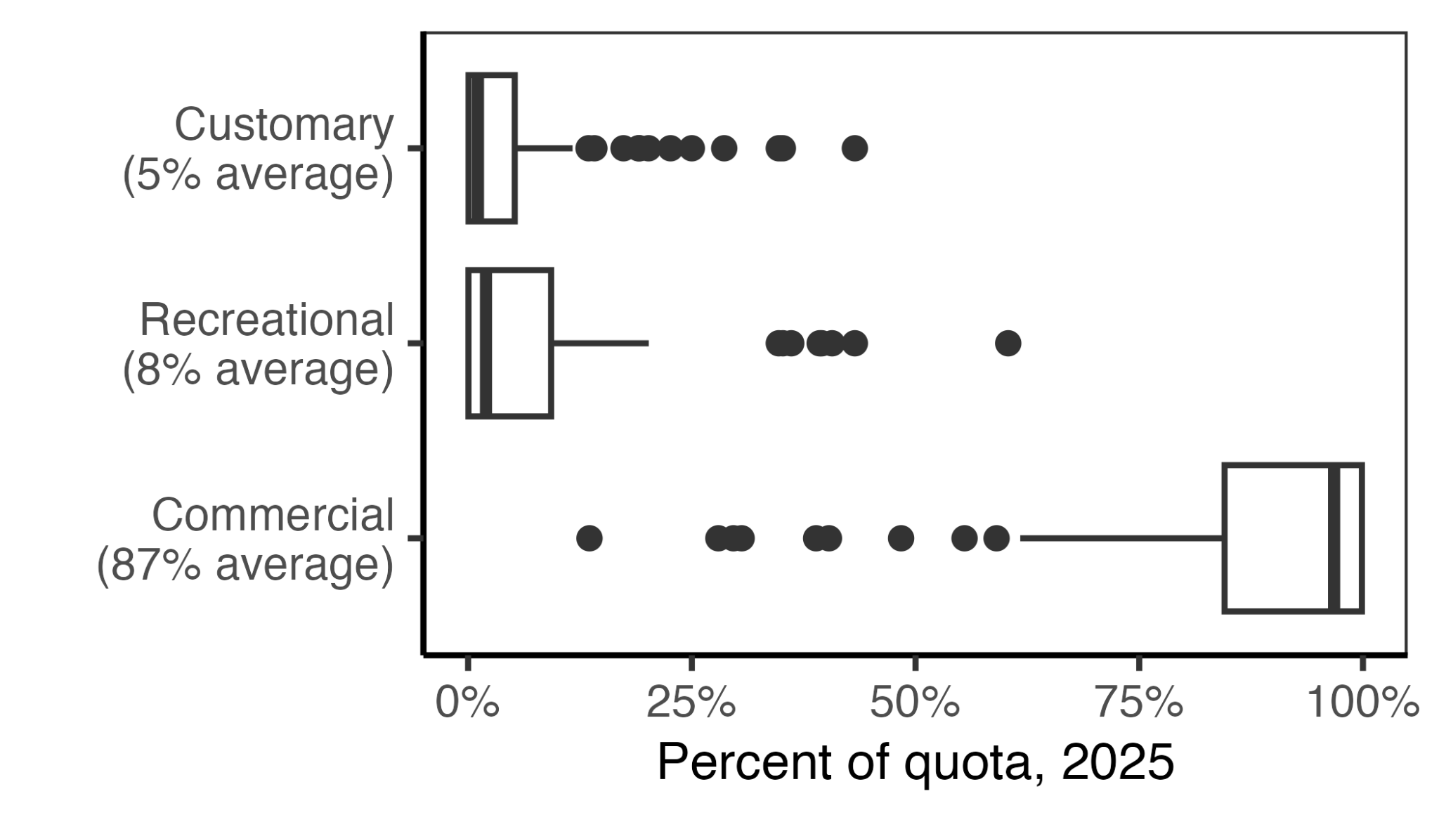

**Figure S3.** Quota allocation percentages among sectors for the 98 species managed within New Zealand’s Quota Management System in 2025 [(Fisheries of New Zealand, 2024a)](https://www.zotero.org/google-docs/?NNXLkC). In the boxplots, the solid line indicates the median, the box indicates the interquartile range (IQR; 25th to 75th percentiles), the whiskers indicate 1.5 times the IQR, and points indicate outliers.

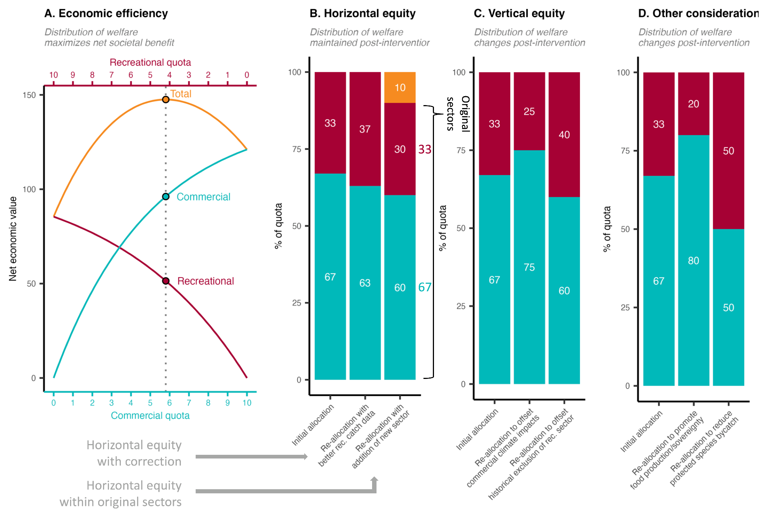

**Figure S4.** An illustration of alternative conceptualizations of equity in quota allocation policies. Panel **A** illustrates an allocation policy that seeks to optimize economic efficiency by maximizing the net economic benefits of commercial and recreational fisheries. The optimal policy is marked by the vertical dotted line. Panel **B** illustrates a suite of allocation policies that seek to maintain “horizontal equity” whereby the distribution of welfare remains proportional to historical levels. Column 1 shows the initial allocation based on historical catch. Column 2 illustrates a scenario in which the policy is updated with improved estimates of historical recreational catches. Although it results in a different distribution of welfare relative to the initial policy, it is motivated by the same goals (but uses better data) and is therefore still an example of horizontal equity. Column 3 illustrates a scenario in which a historically omitted subsistence sector (orange) is given access. The losses in allocation to the original sectors are proportional; thus, horizontal equity is maintained. Panel **C** illustrates a suite of allocation policies that seek to achieve “vertical equity” whereby the distribution of welfare changes after an intervention in a way considered more fair. This could be to compensate communities disadvantaged by historical allocations (column 2) or by the impacts of contemporary or future climate change (column 3). Panel **D** illustrates how managers could adjust allocation policies to achieve other fisheries objectives, such as promoting food production and sovereignty by prioritizing commercial fishing (column 2) or reducing bycatch of protected species by prioritizing more selective recreational fisheries (column 3). Although these adjustments change the distribution of welfare, they are not motivated by fairness and equity between sectors (though they do relate to broader societal concepts of fairness) and therefore do not qualify as vertical equity. We illustrate these concepts using sector allocations as an example, but all these concepts apply to any allocation between harvesting entities (states, subsectors, individuals, etc).

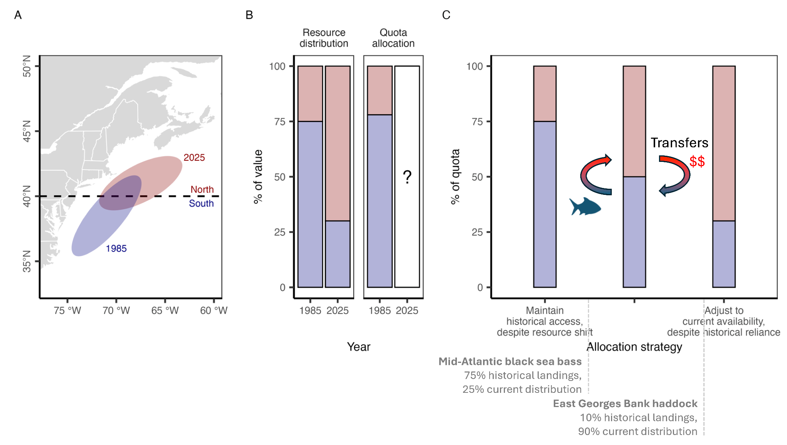

**Figure S5.** A conceptual schematic illustrating the spectrum of allocation options available to managers as stocks shift distributions and their availability to fisheries under climate change. Panel **A** illustrates the shift in distribution of hypothetical stock from 1985 to 2025 relative to a hypothetical management boundary. Panel **B** illustrates the proportional distribution of the resource between the two management zones in 1985 and 2025. The allocation of quota between the zones roughly matches the 1985 distribution because it was established based on 1980-1985 catch distribution. Managers must now decide whether and how to adjust the quota allocation given the climate-driven shift in distribution. Panel **C** illustrates the spectrum of options available to managers. On one end of the spectrum, managers could maintain historical access despite the resource shift. This protects historical access for southern zone fishermen but introduces inefficiencies, risks local depletion, and is unfair to northern zone fishermen. On the other end of the spectrum, managers could fully adjust to current resource distribution. This is efficient and aligned with conservation goals but does not protect historical dependence and is therefore unfair to southern fishermen. As a result, managers may wish to find a middle ground between these two extremes. Examples of allocation policies that fall in middleground are highlighted. Furthermore, allowing transfers between zones provides a mechanism for northern fishermen to gain access and for southern fishermen to be compensated for lost access.