**Lotka Volterra**

***The two populations in this model are described by the following equations:***



***H (herbivore), P (predator), b (prey birth rate), a (predator attack rate), e (conversion efficiency of prey to predators), s (predator death rate)***

***1. The conceptual model***

Located in Directory Lotka Volterra, file LotkaVolterraConceptualModel1.png

***2. Dynamics with initial conditions and parameters of b=.5, a=.02, e=.1, s=.2, Ho=25, Po=5***

Located in directory Lotka Volterra, sub-directory Lotka-Volterra-Plots, file LV.png

***3. Additional simulations changing different parameters at each time:***

Located in directory Lotka Volterra, sub-directory Lotka-Volterra-Plots

Vary Initial Conditions= varying the initial number of prey and predators alters the graphs and its primary shape, to keep the other simulations under the same conditions, the initial conditions provided in part 2 were used instead.

Vary A= .01, .04, .005, .08

Vary B= .1, .3, 1, 2

Vary S= .1, .4, .05, .8

Vary E= .2, .4, .05, .025

Each variable is located in its own folder.

All of the conditions varied held the other variables constant at the initial condition parameters from step 2. The graphs were formed separately then combined into one. The combined graph is easily labeled LV-(variable, a/b/s/e).png.

***The Role of Each Parameter:***

*B (prey birth rate)*

The slope of the herbivore population is affected by changes in the prey birth rate. A larger b value simply means that the increase in prey when it is already beginning to rise will increase faster as opposed to a smaller b value. This is observed in the figure below.

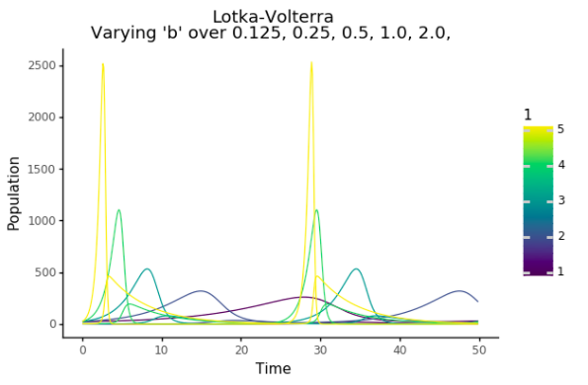

The figure shows that the value b was varied from .125 to 2 and at 2 we see the yellow peaks being the highest and the steepest. At .125 the prey population increases very slowly.

*A (predator attack rate)*

This variable is an indication of the predator’s ability to kill. The higher the rate the better the predator. A higher rate will cause a quicker decrease in prey population and quicker increase in predator population. With a low A the prey population obtains very high numbers and with a high A they remain low. We observe with an A of .005 in the figure below that prey populations reach very high numbers. Also with an A of .08 the predator and prey populations are very stable.

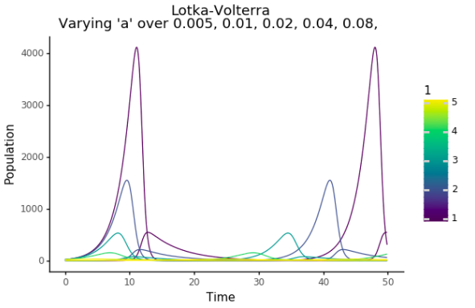

*E(conversion efficiency of prey to predators)*

The variable E shows how the predators eating translates into their birthrate. The higher the E the faster predators are born in response to prey being eaten. The lower the E the slower the predator population will rise. This can be observed from the figure below.

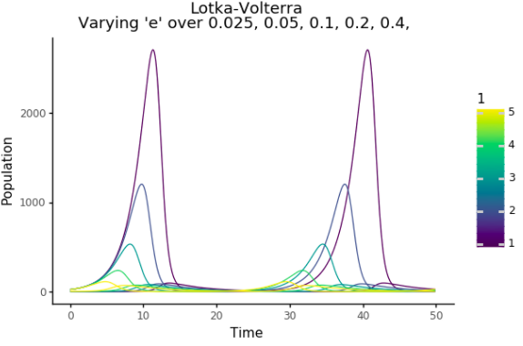

The figure shows that a E value of .025 the predator population is at its lowest while the prey population is at its highest. With few predators and their inability to eat, the prey population in turn can grow at a faster rate. At an E of .4 the prey populations are at their highest and peaks in prey population correlate to valleys in predator population.

S (predator death rate)

S determines the exponential rate that predators will die. It determines how quickly the predator population will decrease after it has reached its maxima. This is shown in the figure below.

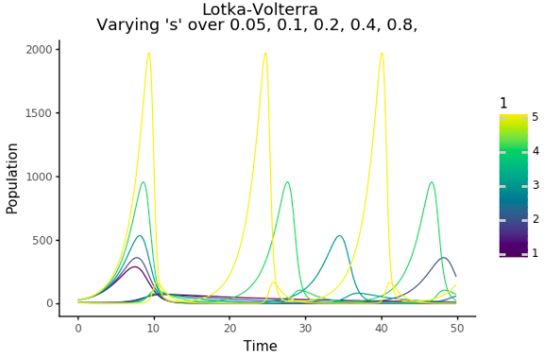

The figure shows that at a high S value of .8 allows for a larger prey population and also a sharper decrease in predator population. A low value of S at .05 shows a more gentle decrease in predator population.

***Role of Predators:***

Predators will eat in response to the prey available. Increase in prey would lead to an increase in feeding. The associated rise in predator population will cause the prey population to be depleted after which the predator population will decrease as well. The prey population is then allowed to regenerate. Therefore there is a cyclical behavior to the system. The predators are assumed to have a fixed life span and therefore decrease at an exponential rate regardless of food availability.

***Parameter Values and Predator-Prey Cycle Length:***

Increasing the parameter values either leads to faster generation of a populations species of faster decrease of a population species. Increasing parameter values makes the simulation go quicker through its cyclical behavior, there will a shorter cycle time. This is illustrated in the plots above. The slower cycles are the purple lines and the faster cycles correspond to the yellow lines.

**Rosenzweig MacArthur**

***The two populations in this model are described by the following equations:***





***H (herbivore), P (predator), b (prey birth rate), a (carrying capacity), e (conversion efficiency of prey to predators), s (predator death rate), w (attack rate), d (prey camouflage ability)***

***1. The conceptual model***

Located in Directory Rosenzweig MacArthur, file Rosenzweig MacArthur ConceptualModel1.png

***2. Dynamics with initial conditions and parameters of b=.8, a=.001, e=.07, s=.2, Ho=500, Po=120, d=400, w=5***

Located in directory Rosenzweig MacArthur, sub-directory Rosenzweig-MacArthur -Plots, file RM.png

***3. Additional simulations changing different parameters at each time:***

Located in directory Rosenzweig MacArthur, sub-directory Rosenzweig-MacArthur -Plots

Vary a= .001, .002, .004, .005, .00025

Vary b= ..2, .4, .8, .1.6

Vary d= 100, 200, 400, 500, 800

Vary e= .05, .06, .07, .08, .09

Vary s= .05, .1, .2, .3, .4

Vary w= 3, 4, 5, 6, 7

Each variable is located in its own folder.

All of the conditions varied held the other variables constant at the initial condition parameters from step 2. The graphs were formed separately then combined into one. The combined graph is easily labeled RM-(variable).png

***Difference from Lotka-Volterra:***

The Lotka-Volterra model gives a cyclical dynamics whereas the R-M model has a more stable dynamics with saturation levels.

***Role of Each Parameter:***

*B (prey birth rate)*

The "b" parameter represents an interaction between the prey and predators. This is shown in the figure below. When reduced to 0.2, the top line (prey population) falls more precipitously to start before sharply - more so compared to the default model where b = 0.8. The second decline in the prey population is slower compared to the default, as is the rebounding population of the predators. At higher b values (e.g. 3.2), the prey population increases, then decreases somewhat as the predator population increases. The values remain constant thereafter.

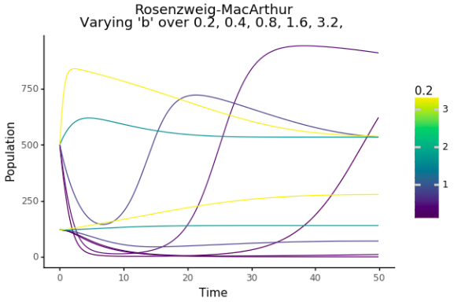

*D (prey camouflage ability)*

The "d" parameter has the least visible effect on the model, but it does seem to affect whether or not the prey population dips initially before increasing. This dip can be seen in the figure below.

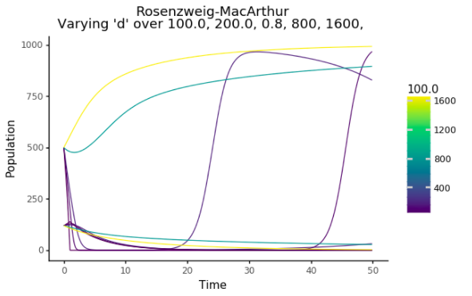

The biological understanding of this could simply mean that the prey is bad at hiding. At low D of 100 we see the prey population goes way down because they are easily eaten by the predators. At high D we see the prey population is more stable.

*E (conversion efficiency of prey to predators)*

The "e" parameter represents another distinction interaction between the two species. At low e values, the prey population stabilizes at increasingly higher numbers. Higher e values cause the prey and predator values to fluctuate - the frequency doesn't change in so much as the slopes of the spikes in the prey and predator populations. This can be seen in the figure below.

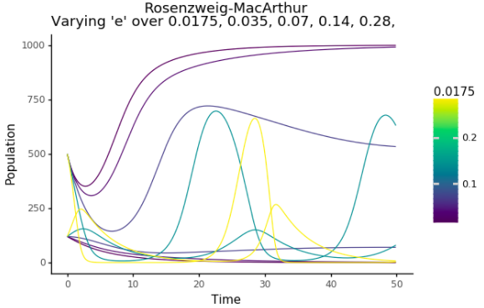

At high E values of .28 there is a more volatile dynamics because the predator population reaches unsustainable levels and therefore the solutions become more cyclical like the L-V model. At low E values of .0175 you see a more stable dynamics with the prey population tending to saturation levels.

S (predator death rate)

The "s" parameter represents some other interaction between the killed and the killers. At low s values, the model behaves like a high e value model; at high s values, the model behaves like a low e value. This seems to imply that the e and s interactions may be inverse operations or the opposite of each other. This is seen in the figure below.

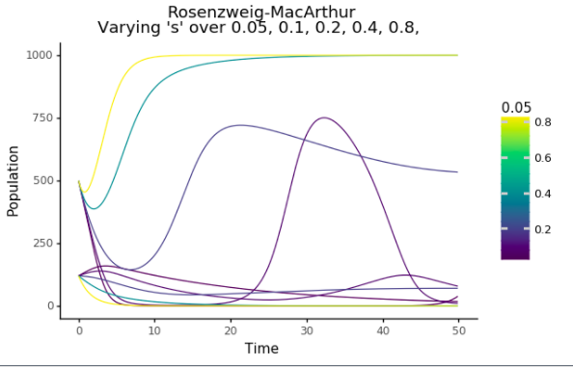

At a high S value of .8 the predators die faster and the predator populations are more responsive to diminishing prey availability and this gives more stable dynamics tending toward equilibrium. Whereas at low S values the predator remains and depletes the prey.

*W (attack rate)*

The "w" parameter also controls the stability of the model. Increasing it generally produces cycles of growth and collapse for both populations, whereas decreasing it cause the model to flatline. This is shown in the figure below.

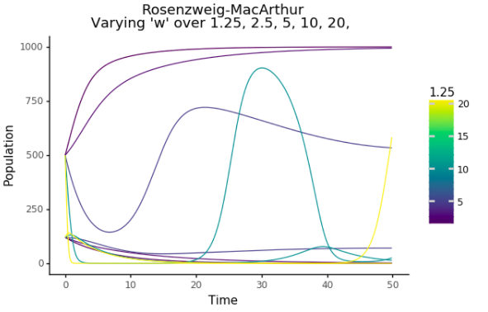

At low values around 1.25 you see that the prey population easily tends towards saturation levels whereas at high levels of w around 20 the dynamics become cyclical because the predators deplete the prey population before it rebounds.

*A (carrying capacity)*

The "alpha" parameter represents carrying capacity. Modifying this parameter has a marked effect on the model output - a higher alpha value represents a lower carrying capacity, whereas a lower alpha value represents a higher carrying capacity (as stated in the rubric). The effects of modifying this parameter is described in the "Paradox of Enrichment" section below. The figure can be seen below.

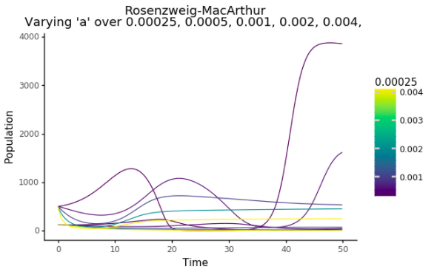

With a low A value and therefore high saturation levels of prey population we see that the dynamics become unstable. With high A the saturation levels are at stable levels and we see that the prey populations tend towards those saturation levels. This A parameter is the main difference between the 2 models because it limits the prey population and therefore controls the predator response. At the right levels this ensures that the dynamics becomes stable and so the R-M model is not bound to being cyclical like the L-V model.

***Parameter Values and Predator abundance:***

The values of the parameters have the following effects on predator-prey cycle length:

Increase b: Time to stabilize is relatively minimized - quicker equilibrium.

Decrease b: Time to stabilize is prolonged - slower equilibrium.

Increase a: Less instability in populations, i.e. fewer cycles, equilibrium, constant prey/predator populations.

Decrease a: More instability in populations, i.e. increases frequency of cycles, prey/predator populations

Increase e: More instability in populations, i.e. generally increases frequency of cycles.

Decrease e: Less instability in populations, i.e. fewer cycles, equilibirum, constant prey/predator populations.

Increase s: Less instability in populations, i.e. fewer cycles, equilibirum, constant prey/predator populations.

Decrease s: More instability in populations, i.e. generally increases frequency of cycles.

Increase w: More instability in populations, i.e. generally increases frequency of cycles.

Decrease w: Less instability in populations, i.e. fewer cycles, equilibirum, constant prey/predator populations.

Increase d: Little effect on the model (see figure entitled "d200")

Decrease d: Little effect on the model (see figure entitled "d800")

**Paradox of Enrichment**

***Simulated dynamics with capacity varying from 800 to 2000***

Located in Directory Paradox of Enrichment, file PE800.png and PE2000.png

The code is the same as used in the Rosenzweig MacArthur code. The carrying capacity, variable a (alpha) was changed from .00125 to .0005 which gave capacities from 800 to 2000.

***Increase in Carrying Capacity:***

Lowering the alpha value, or increasing carrying capacity, interestingly causes destabilization of the ecosystem. More food available means that there is a boom in the prey population, followed by a boom in predator population, which is then followed by a crash in the prey population, which then causes a crash in the predator population.

***Paradox of Enrichment:***

The paradox of enrichment occurs because increasing the carrying capacity of the prey species causes an unsustainable and sharp increase in the predator population, which has more food than before. The rate of predator reproduction will quickly outstrip the rate at which the prey can replenish their numbers; the prey numbers are culled quickly and cause the predators to starve - paradoxically, an initial increase in food can destabilize the ecosystem and cause periods of starvation. The figures can be seen below.

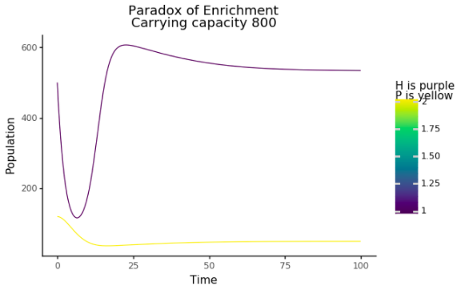

This figure shows that with low carrying capacity the predator and prey population tends towards a stable equilibrium.

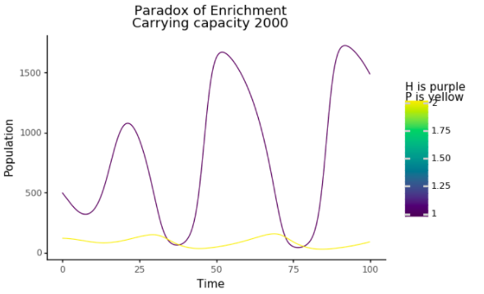

In this figure the high saturation levels allow the prey population to shoot up at high levels which leads to the predator population to explode. This causes the predators to deplete the prey population and start a cyclical behavior.