Mammal Activity Summary

2024-07-22

# Catch All Markdown for Mammal Community and Activity Summary Figures and Stats

### Behind the Scenes

#### Pull and Clean Data

#### Fix Messed Up Dates in Dataset

#### We should add in some metadata for sorting and analysis purposes

### Ok! Now we can organize and play with the nice clean data (I hope). A summary:

(all numbers have been rounded UP to the nearest integer, except percentages)

| Camera Location (N to S) | Number of Active Trap Nights | Total Triggers | Seconds of Mammal Activity | Number of Human Sightings | Number of Unique Mammal Species | Percent of Triggers Containing Mammals |
| --- | --- | --- | --- | --- | --- | --- |
| Boathouse Cam | 113 | 5428 | 704 | 68 | 4 | 12.97% |
| Ladrones Cam | 55 | 46 | 27 | 1 | 3 | 58.70% |
| Saucito Cam | 135 | 156 | 99 | 7 | 3 | 63.46% |
| Water Canyon Cam | 55 | 149 | 59 | 19 | 3 | 39.60% |
| Not Water Canyon Cam | 135 | 54 | 24 | 6 | 3 | 44.44% |
| Morida Cam | 80 | 361 | 35 | 2 | 3 | 9.70% |
| RIZ Cam | 108 | 770 | 54 | 132 | 4 | 7.01% |
| RIZ Cam Backup | 138 | 576 | 15 | 9 | 3 | 2.60% |
| RIZ Cam S Canyon | 38 | 29 | 19 | 4 | 3 | 65.52% |
| Sudden Canyon Cam | 155 | 4338 | 49 | 11 | 4 | 1.13% |
| Old Fencepost Cam | 101 | 11056 | 88 | 8 | 4 | 0.80% |
| Jolluru Cam | 38 | 30 | 32 | 3 | 1 | 106.67% |
| Short Canyon Cam | 15 | 24 | 11 | 0 | 2 | 45.83% |
| Jalama Cam | 152 | 3891 | 83 | 3061 | 3 | 2.13% |
| Jalama 2 Cam | 113 | 105 | 28 | 17 | 3 | 26.67% |
| Cojalama Cam | 72 | 534 | 5 | 29 | 2 | 0.94% |
| Cojo Gate Cam | 106 | 684 | 30 | 113 | 5 | 4.39% |
| Cojo Canyon Cam | 109 | 567 | 39 | 419 | 3 | 6.88% |
| Seawall Cam | 127 | 348 | 14 | 69 | 3 | 4.02% |
| Black Canyon Cam | 178 | 5393 | 359 | 88 | 6 | 6.66% |
| North Beach Fort Cam | 182 | 5157 | 910 | 388 | 5 | 17.65% |
| North Vista Spring Cam | 167 | 6534 | 185 | 59 | 5 | 2.83% |
| North Beach Canyon Cam | 74 | 197 | 33 | 28 | 1 | 16.75% |
| Boneyard Cam | 24 | 58 | 38 | 0 | 4 | 65.52% |
| Cove Cam | 218 | 3615 | 172 | 16 | 2 | 4.76% |
| Govies Cliff Cam | 153 | 3374 | 47 | 0 | 3 | 1.39% |
| Big Cojo Cam | 245 | 6534 | 568 | 129 | 7 | 8.69% |
| Percos Boat Cam | 124 | 15037 | 435 | 783 | 6 | 2.89% |
| Percos Driftwood Cam | 183 | 1127 | 37 | 34 | 6 | 3.28% |
| Wood Canyon Cam | 162 | 7887 | 668 | 0 | 5 | 8.47% |
| Percos Beach Cam | 209 | 1279 | 124 | 54 | 7 | 9.70% |
| Percos Log Cam | 185 | 17249 | 318 | 63 | 6 | 1.84% |
| Percos Post Cam | 205 | 14067 | 98 | 42 | 3 | 0.70% |
| Damsite Creek Cam | 191 | 2000 | 829 | 15 | 7 | 41.45% |

### We can also visualize effort, or how many average nights the cameras were active per month across the year of sampling

In December 2022 only one camera was running (or rather, they were all running but most got washed away or the data was unusable because of storms) 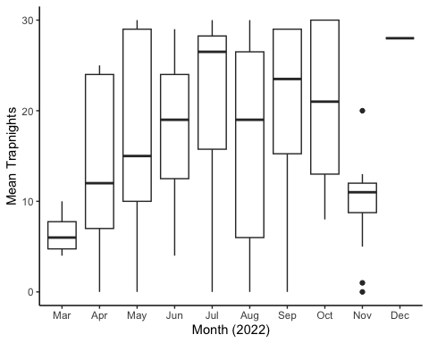

### Is there a seasonal effect on human activity? Probably!

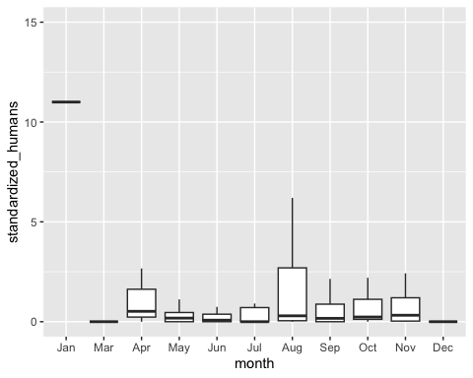

### Finally, let’s get an idea of mammal beach activity/detection, standardized by effort, across the entire year

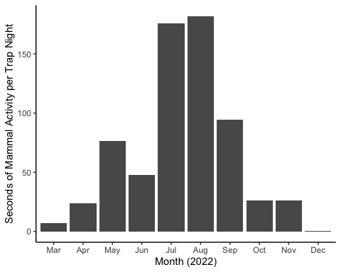

## Let’s visualize rough community composition a couple different ways:

### First, activity by species across the study standardized by effort (trap nights)

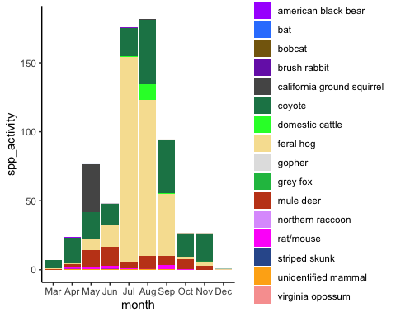 Robin: you might see a coyote every day, but you’ll also see a pig a day and there’s 12 of them

### Then, standardized activity by species but represented as a percentage of the total community

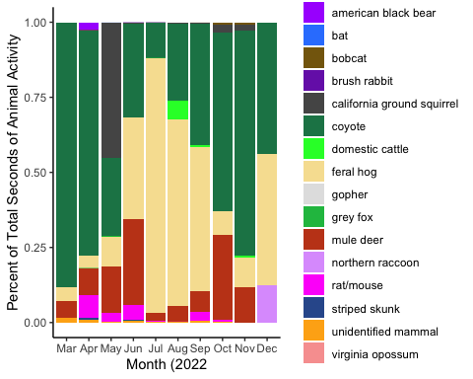

## Now we are ready to use vegan to calculate a bunch of community ecology metrics - the below taken from An Bui’s vegan workshop.

### vegan analysis with site metadata from: <https://docs.google.com/spreadsheets/d/1F1pI3ORnCh-Zq6jd1Y11ThUozsBy3iryT9zxW7QCeVY/edit?usp=sharing>

### How speciose are my communities?

* one caveat: we lumped all rats & mice into one “species” because they’re super hard to tell apart with cam trap footage 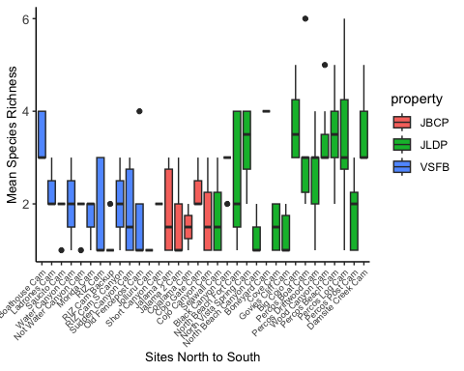

### How diverse are my communities?

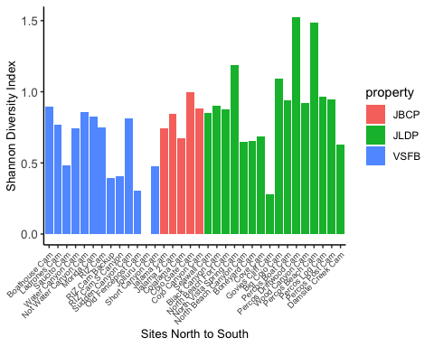

### Is there a correlation between diversity index and human activity?

caveat: we have a crazy outlier of human activity at Jalama - over 3000 “human seconds” where most are in the hundreds including one plot with raw human activity and one with log transformed

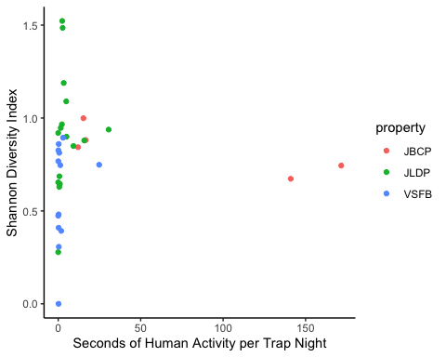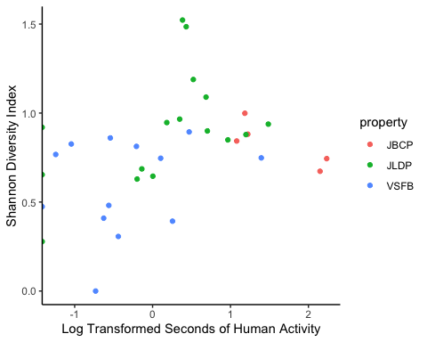

### How different are my communities in species composition?

#### perMANOVA

Permutational analysis of variance: are the centroids of my communities different?

## Permutation test for adonis under reduced model  
## Terms added sequentially (first to last)  
## Permutation: free  
## Number of permutations: 999  
##   
## adonis2(formula = count_matrix_expanded ~ sitename, data = vegan_metadata)  
## Df SumOfSqs R2 F Pr(>F)   
## sitename 33 20.916 0.40607 2.797 0.001 ***  
## Residual 135 30.593 0.59393   
## Total 168 51.509 1.00000   
## ---  
## Signif. codes: 0 '***' 0.001 '**' 0.01 '*' 0.05 '.' 0.1 ' ' 1

Looks like they are.