Code screenshots
Coding task 1:
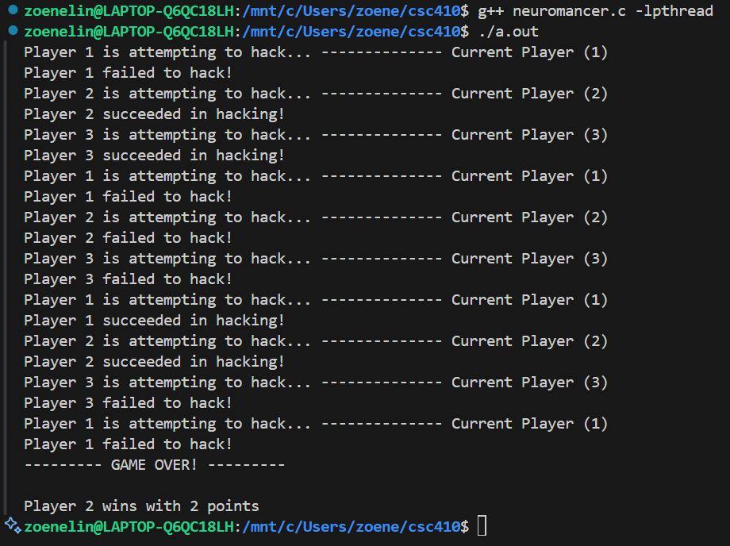
Coding task 2:
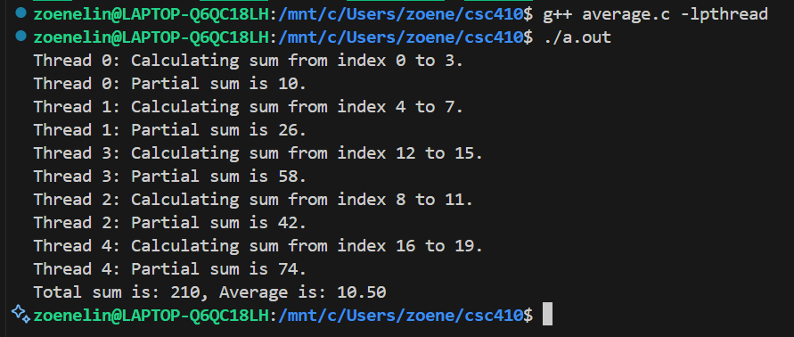
Task 3:
My solution did not require the use of synchronization primitives. The reason being each thread worked out its own sum (for array sum) or own rows (matrix multiplication). With the array sum the results were then stored in an array that was shared by the threads. Because of this there were no conflicts that needed use of synchronization primitives.

Task 4:
This synchronization technique would NOT work, as it would lead to problems like racing conditions. This occurs when more than one thread accesses the (lock == 0) at the same time before the lock is set to 1. When this happens we receive undefined behavior or incorrect results.

