Coding Task 1 Screenshot:
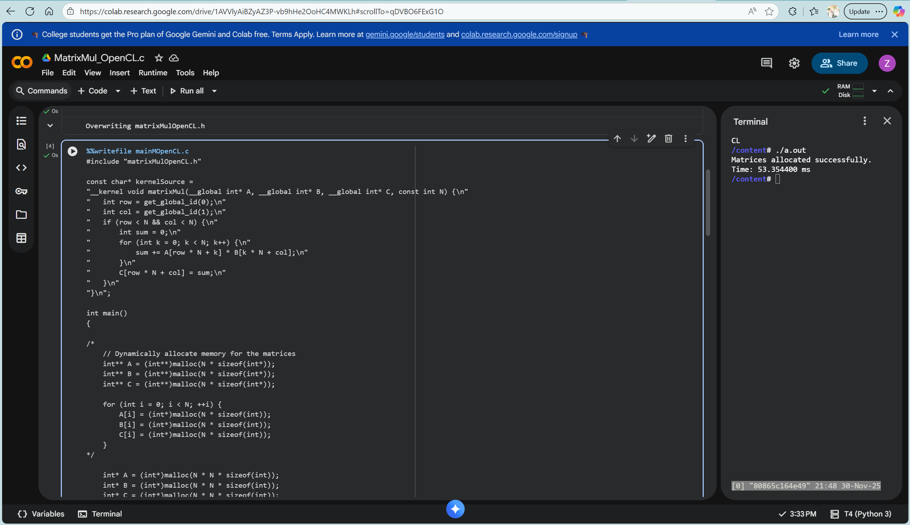
Task 2:
 | Sequential | OpenCL
Time | 4.482 s | 53.35400 ms

D2L Discussion Task 3:
Discuss your observations from coding task 1 and task 2 in detail. How does OpenCL compare with the previous tools like Pthreads, OpenMP, and MPI.
The speedup is noteworthy with a huge improvement. The use of GPU to execute in parallel shows the best speedup when compared to Pthreads, OpenMP, and MPI. I will say the learning curve is more steep (at least for me) and more programming then when compared to OpenMP for example.

