Code Screenshots
Coding task 1: 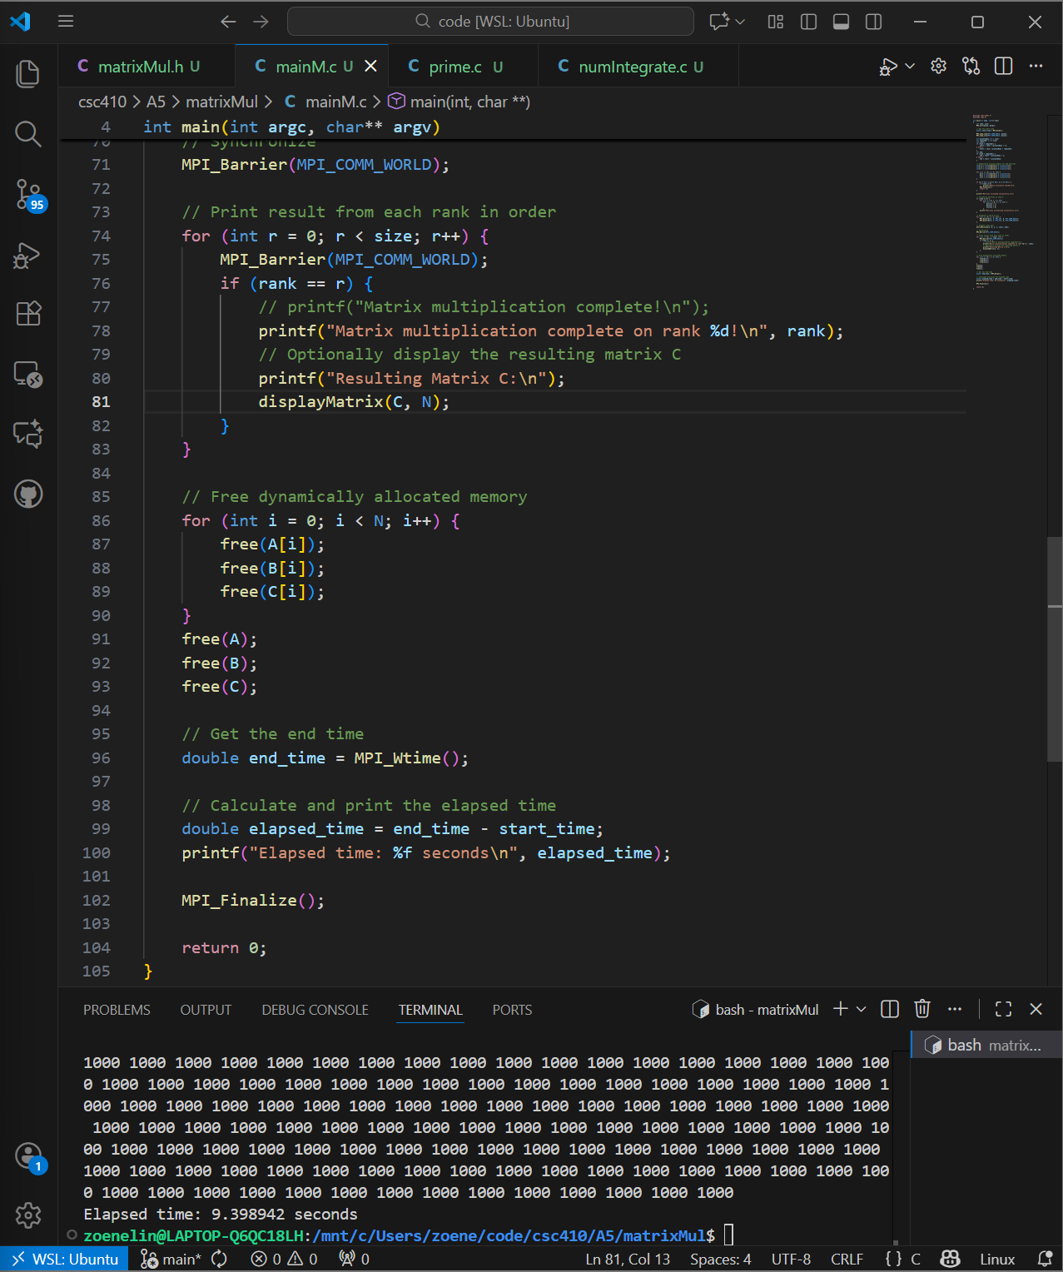

Coding task 2:
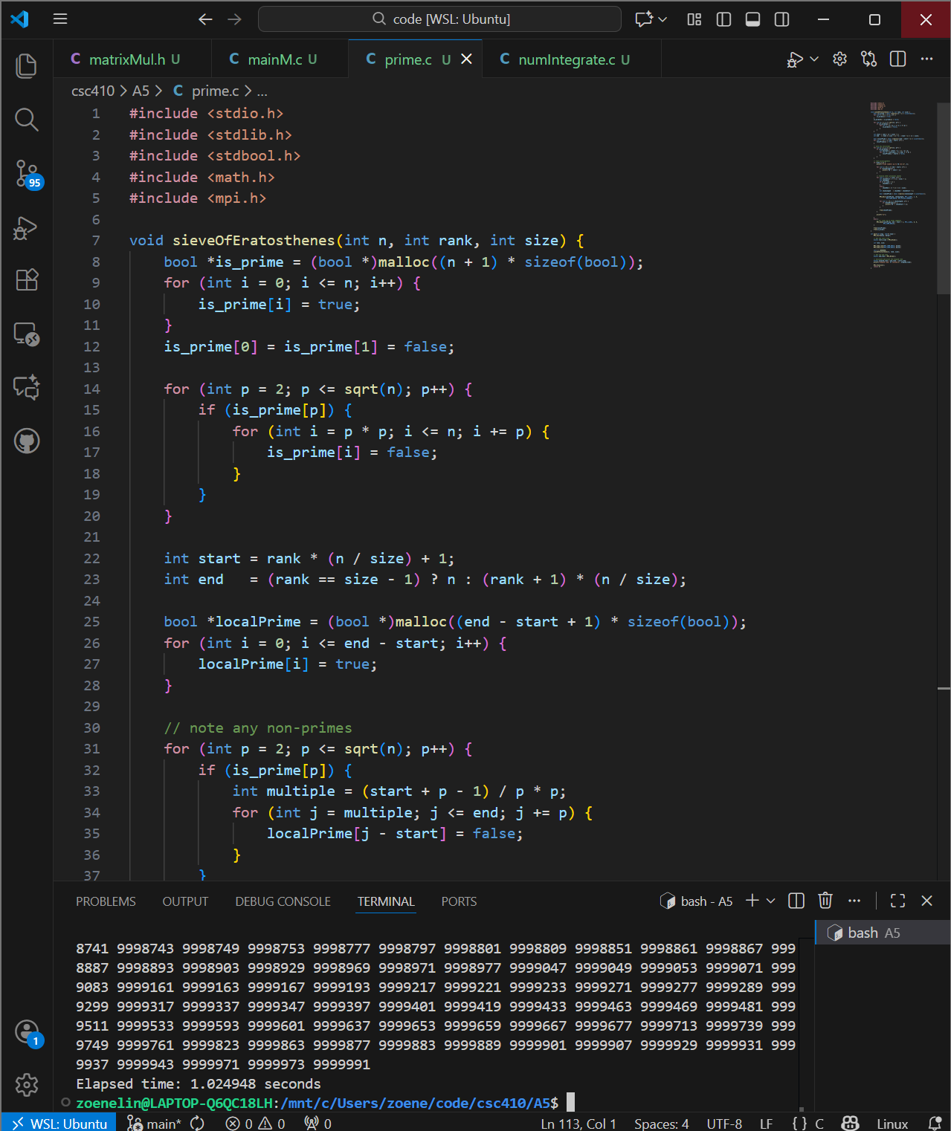

Coding task 3:
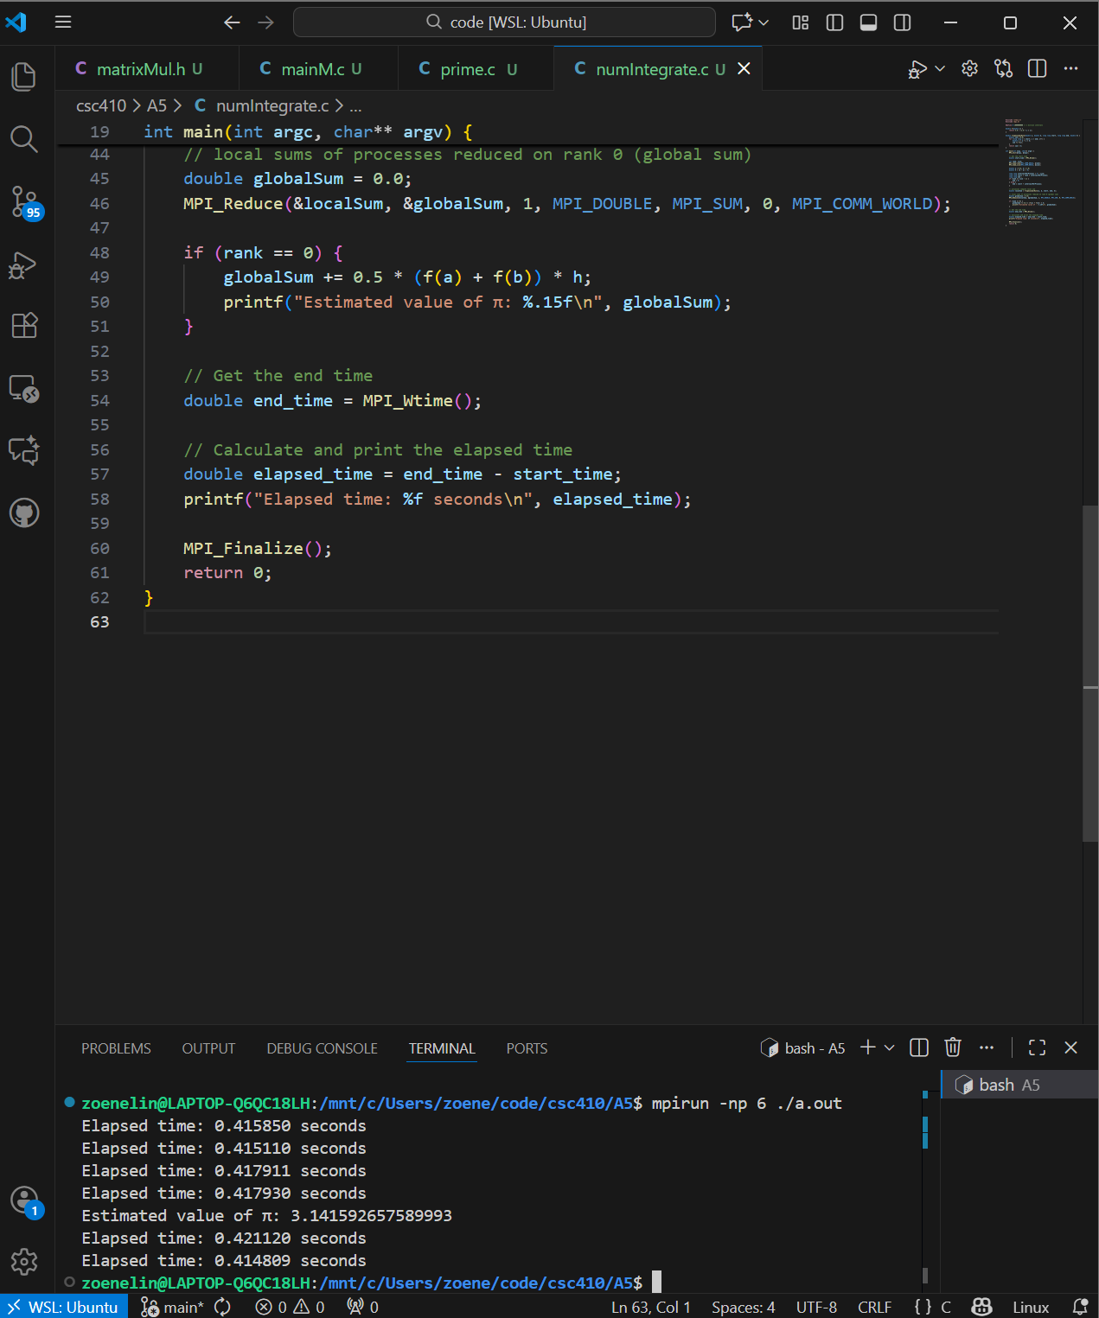

Task 4
Matrix Multiplication (for matrix size 1,000)
 | Sequential | 1 process | 2 process | 4 process | 6 process
Time | 5.906s | 5.711276s | 6.800569s | 9.398942s | 11.543605s
Sieve of Eratosthenes (for n 10,000,000)
 | Sequential | 1 process | 2 process | 4 process | 6 process
Time | 1.116s | 1.098957s | 0.991489s | 0.971830s | 1.024948s
Trapezoidal Rule Integration (for interval size 1,000,000,000)
 | sequential | 1 process | 2 process | 4 process | 6 process
Time | 2.575s | 2.543162s | 1.266517s  1.273678s | 1.273678s  0.635061s  0.636227s  0.639260s | 0.412839s  0.410474s  0.410517s  0.415760s  0.415736s  0.416690s

[D2L Discussion Post] Task 5
As the number of processes increased using MPI for matrix multiplication, the time it took to increased as well (performing worse with each process added). I assume this is caused from the high communication costs. With the Sieve of Eratosthenes, minimal progressed was noticed after benchmarking times (assuming I coded this correctly – I assume I did). The time was best with 4 processes for me, and after using 6 processes time slightly increased. Trapezoidal Rule Integration had the best speedup with times improving from 1-6 processes. Trapezoidal if my memory recalls, has had great speedup up with Pthreads, OpenMP, and MPI.

