Screenshots
Coding task 1:
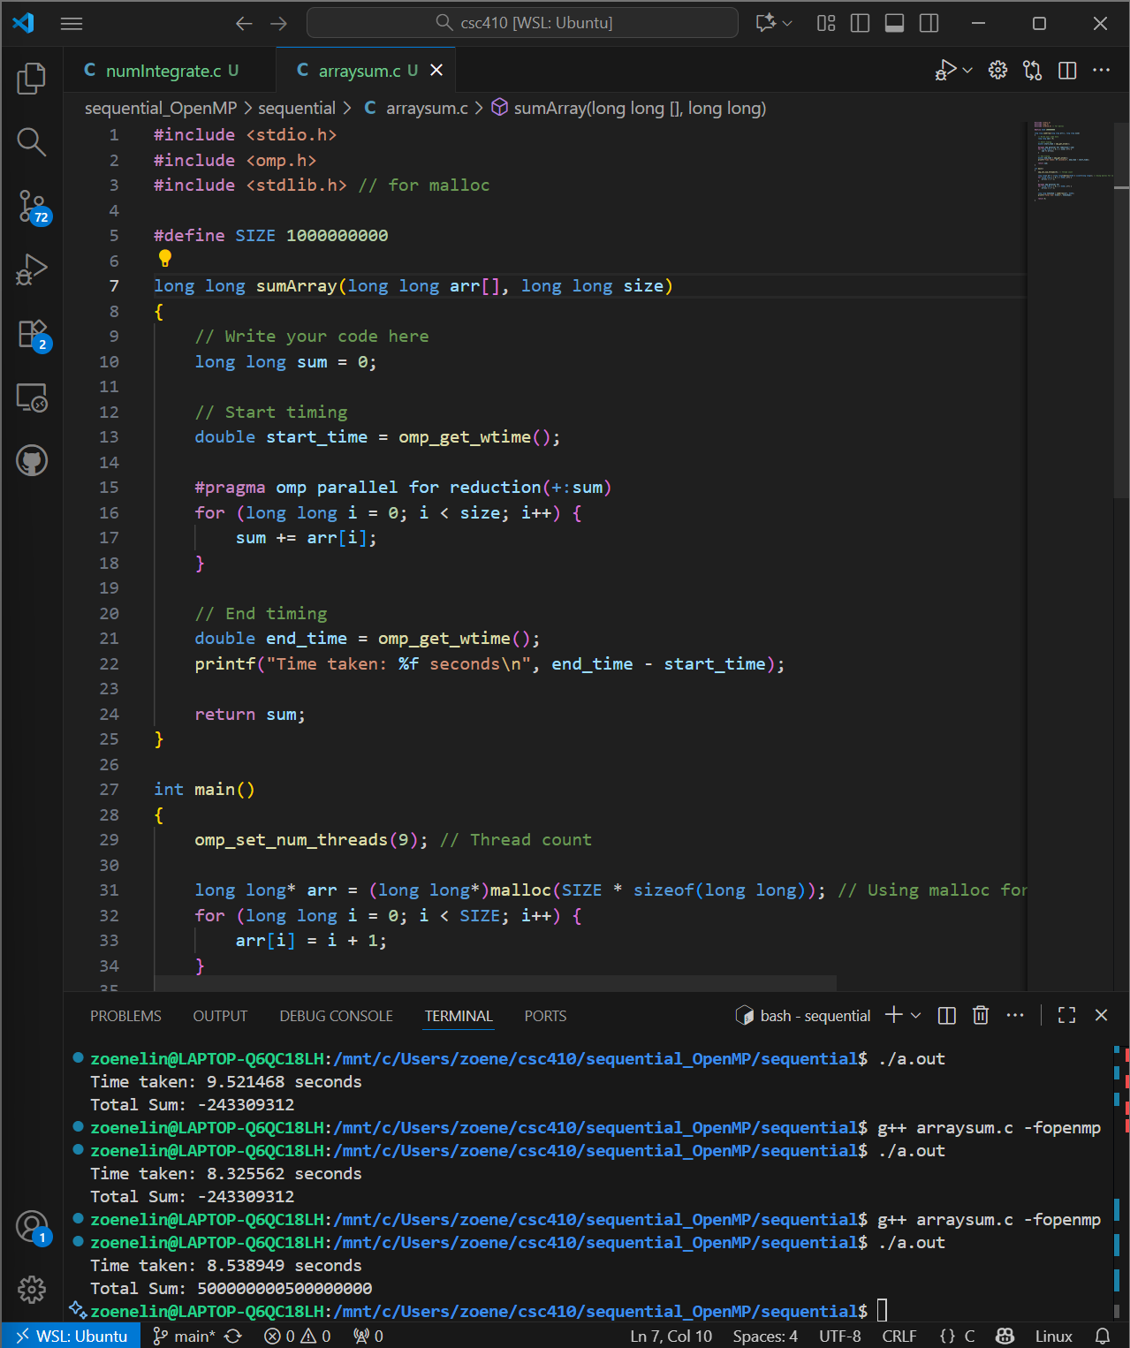
Coding task 2:
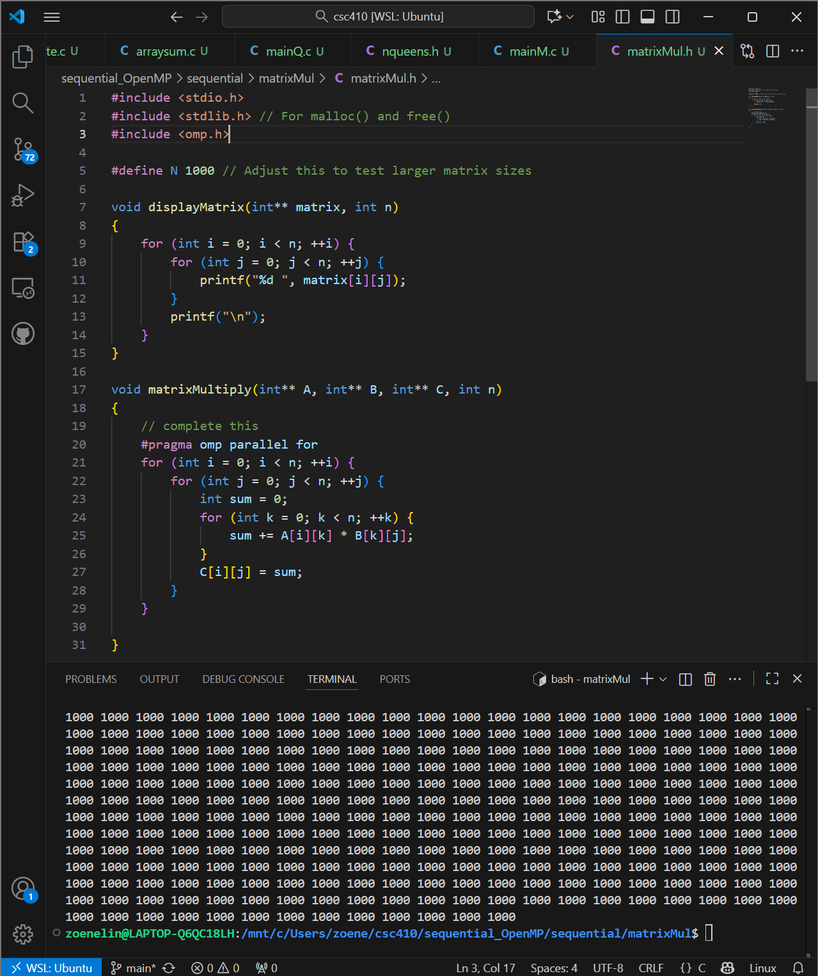
Coding task 3:
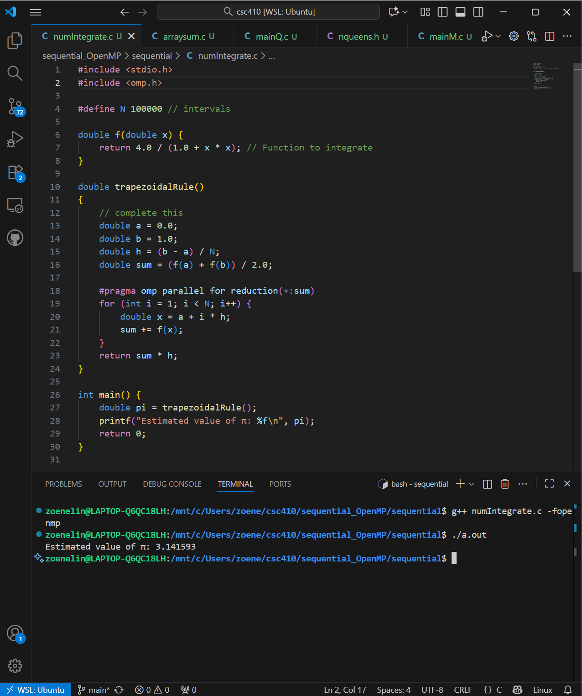
Coding task 4:
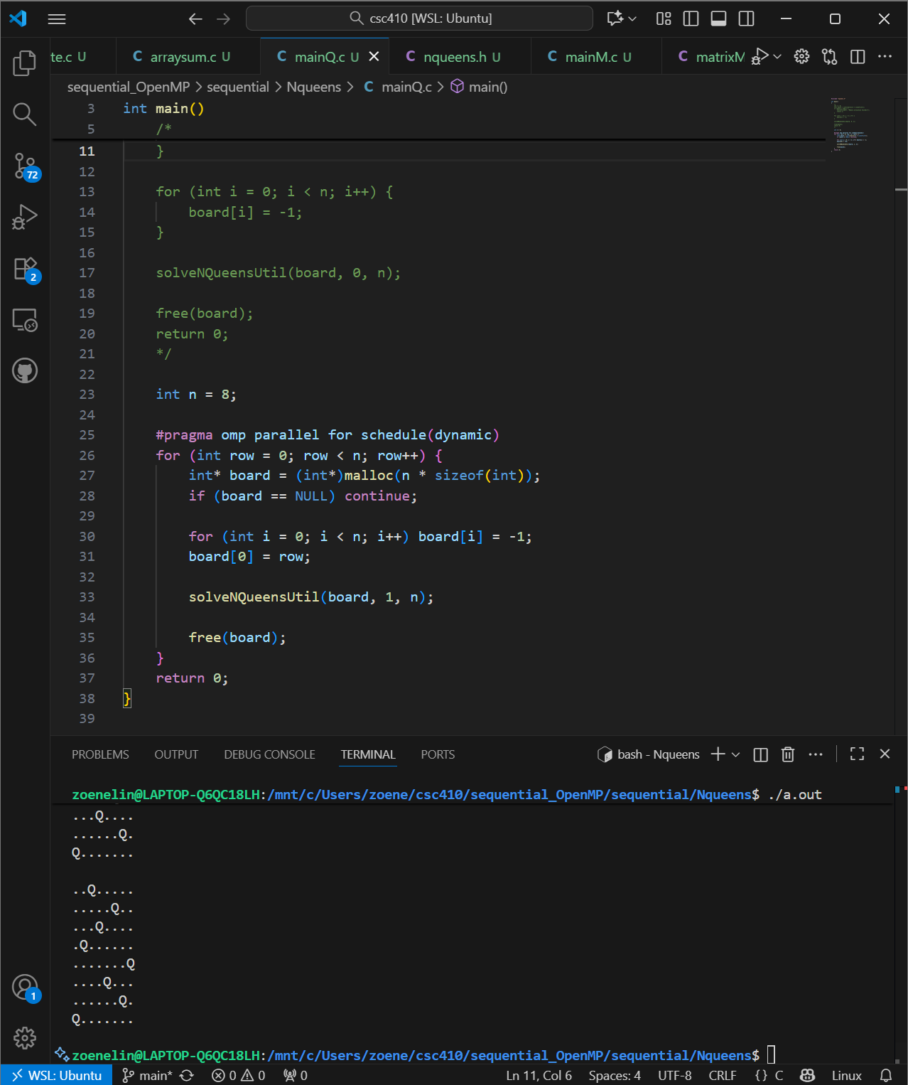
Task 5:
Benchmark the time it took for your sequential, Pthread, and OpenMP versions for tasks 1, 2, 3, and 4 using the table below:
NOTE: please use time ./a.out or Clock (MONOTONIC, ..) for timing.
For OpenMP use omp_get_wtime() as follows:
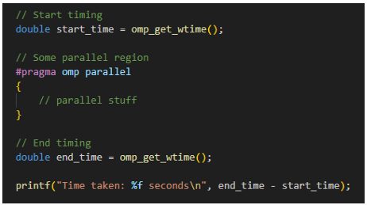

Array Sum (for N 1,000,000,000)
 | Sequential | 1 Thread | 2 Threads | 5 Threads | 7 Threads | 9 Threads
Time | 6.794s
Pthread |  | 1m0.650s | 37.187s | 18.529s | 15.066s | 11.657s
OpenMP |  | 45.910160s | 32.135853s | 11.343171s | 7.272228s | 5.764278s
Matrix Multiplication (for matrix size 1,000)
 | Sequential | 1 Thread | 2 Threads | 5 Threads | 7 Threads | 9 Threads
Time | 4.203s
Pthread |  | 4.571s | 2.178s | 0.857s | 0.738s | 0.666s
OpenMP |  | 2.792148s | 1.292858s | 0.507700s | 0.507585s | 0.465389s
Trapezoidal Rule Integration (for interval size 1,000,000,000)
 | Sequential | 1 Thread | 2 Threads | 5 Threads | 7 Threads | 9 Threads
Time | 2.524s
Pthread |  | 2.626s | 1.308s | 0.539s | 0.485s | 0.419s
OpenMP |  | 0.281839s | 0.279590s | 0.287078s | 0.306649s | 0.291401s
N Queens (for N = 15)
 | Sequential | 1 Thread | 2 Threads | 5 Threads | 7 Threads | 9 Threads
Time | 0.009s
Pthread |  | 52.808s | 28.369s | 11.640s | 9.724s | 8.364s
OpenMP |  | 53.036038s | 28.006453s | 11.020455s | 9.774582s | 7.959648s

[D2L Discussion post] Task 6:
The differences you observed between Pthreads and OpenMP in terms of control, complexity, and performance timing.
With Pthreads offers more control since you do much of the work like thread creation, dividing the workload, managing shared memory, and handling of synchronization. All of which also involves more overhead, the biggest drawback when looking at how Pthreads performed versus OpenMP. OpenMP has less overhead, easier to read and manage since it’s more abstract and does lots of the work for you behind the scenes. You can make the choices of dynamic scheduling, or static scheduling and easily with less code (just two words schedule and in parentheses either static, dynamic, or guided) can make that happen, with the work happening again behind the scene.
Experiment with static, dynamic, and guided scheduling and report on the impact on performance.
With static scheduling, its impact on performance is best when the threads get an even amount of work. When the workload is unbalanced, a better option would be to either use dynamic or guided scheduling as both are more suited for handling uneven workloads. For dynamic scheduling, when it comes to unbalanced workloads, no threads will sit idle for long if at all when receiving work from a queue. Lastly, guided scheduling is a mix of the two (static and dynamic, that is). When experimenting with the impact these scheduling options would have on the performance of my 4 different programs here is what I found.
Array Sum | 2 Threads | 5 Threads | 7 Threads
Static | 35.665677s | 15.832181s | 11.776389s
Dynamic | 76.235964s | 76.093069s | 77.444651s
Guided | 36.069209s | 16.587262s | 9.835265s
Matrix Multiplication | 2 Threads | 5 Threads | 7 Threads
Static | 2.561391s | 1.118495s | 0.991613s
Dynamic | 2.748301s | 1.189814s | 0.934129s
Guided | 2.557809s | 1.12319s | 1.063147s
Trapezoidal Rule Integration | 2 Threads | 5 Threads | 7 Threads
Static | 0.302305s | 0.305909s | 0.299113s
Dynamic | 27.652602s | 28.878339s | 28.705951s
Guided | 0.268402s | 0.278881s | 0.291217s
N Queens | 2 Threads | 5 Threads | 7 Threads
Static | 45.162206s | 20.097604s | 15.761322s
Dynamic | 46.169511s | 18.006984s | 16.098847s
Guided | 45.468737s | 19.378230s | 15.680672s

