sys_new

Overview
This is the schema for the Tester Order System (TOS) which resides in mecca_oms (Host:db005wp.mecca.com.au) in the dbo schema.
The table of mecca_oms.dbo schema have been imported into Glinda’s sys_oms schema.
Problem Statement:
Working in Supply Chain I want to understand the tester orders.

Status
GID-3069 - Enable Staff Sales Table in Glinda Done

DFD
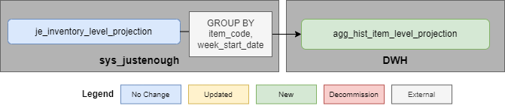

ERD
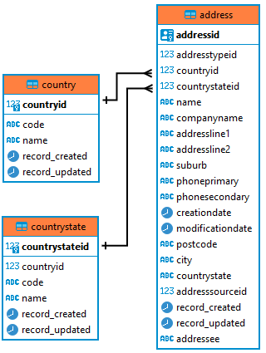

Import Method
- Schedule: Sunday 10PM
- DAG: import_sys_new.py
Table Name | Rows | Import Method
orderitemadjustmentreasons | 50 | Full load
orderitems | 100 | Incremental load

sys_new.orderitemadjustmentreasons

Description
Order adjustment reasons for orderitems.
Line 2.

Granularity
- order_item_adjustment_reason_id

Table Structure
Column Name | Data Type | Nullable | Description | Source/Column
order_item_adjustment_reason_id | int4 | NOT NULL |  | dbo.orderitemadjustmentreasons/  orderitemadjustmentreasonid
reason | text | NOT NULL |  | dbo.orderitemadjustmentreasons
record_created | timestamptz | NOT NULL
record_updated | timestamptz | NOT NULL
record_deleted | timestamptz | NULL

sys_new.orderitems

Description
Tester order items.

Granularity
- order_item_id

Foreign Keys
- order_item_adjustment_reason_id

Indexes
- order_id
- item_code
- record_updated

Table Structure
Column Name | Data Type | Nullable | Description | Source/Column
order_item_id | uuid | NOT NULL |  | dbo.orderitems/orderitemid
order_id | uuid | NOT NULL |  | dbo.orderitems/  orderid
item_code | text | NOT NULL |  | dbo.orderitems/  itemcode
description | text | NULL |  | dbo.orderitems
quantity | int4 | NOT NULL |  | dbo.orderitems
unit_price | numeric | NOT NULL |  | dbo.orderitems/  unitprice
adjusted_quantity | int4 | NULL |  | dbo.orderitems/  adjustedquantity
order_item_adjustment_reason_id | int4 | NULL |  | dbo.orderitems/  orderitemadjustmentreasonid
record_created | timestamptz | NOT NULL
record_updated | timestamptz | NOT NULL

SQL
SELECT * FROM dwh.fct_sale

Stakeholders
- Hello Goodbye (hello.goodbye@mecca.com.au)

Created by
- Zoe Seeger (zoe.seeger@mecca.com.au)

