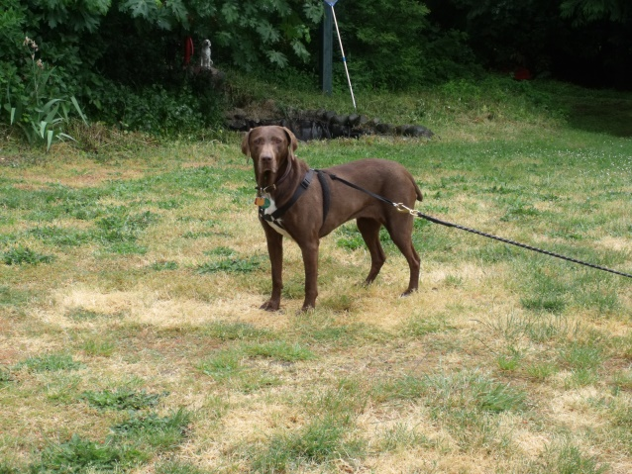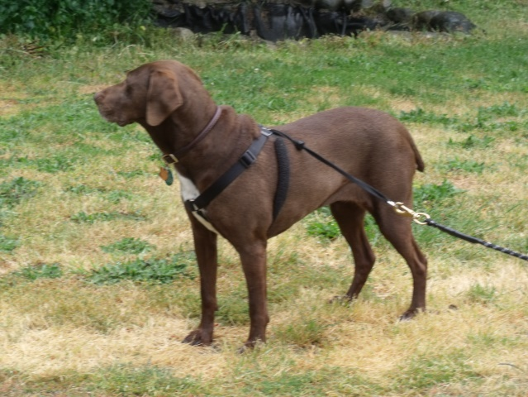

Trella – Adopted ??

Congratulations Trella!

Trella is doing very well and is happy with her new family. To them, she is a unique gift. She has no bottom, front teeth, just stumps. However, it does not make difference to Trella when she eats.

She is doing very well at being on a long rope. And can occasionally become excited for hunting, but is getting a lot better at it.

She loves her bed, being under a blanket, and soft toys. She will constantly talk up a storm when she wants to play with her toy (or two) that are already in her mouth.

We can’t wait for more updates of Trella!