**Tugas3 Pemograman 6**

**Nama : Febriansyah Makarim**

**Kelas : Reg.Malam**

**Nim : 19020014**

|  |  |  |
| --- | --- | --- |
|  | Link youtube : <https://youtu.be/1dY9mZpZl7Y> | https://youtu.be/1dY9mZpZl7Y |
|  | **Link Github** | **: https://github.com/zoetank1999/Tugas-Pemprog3-Febri/** |

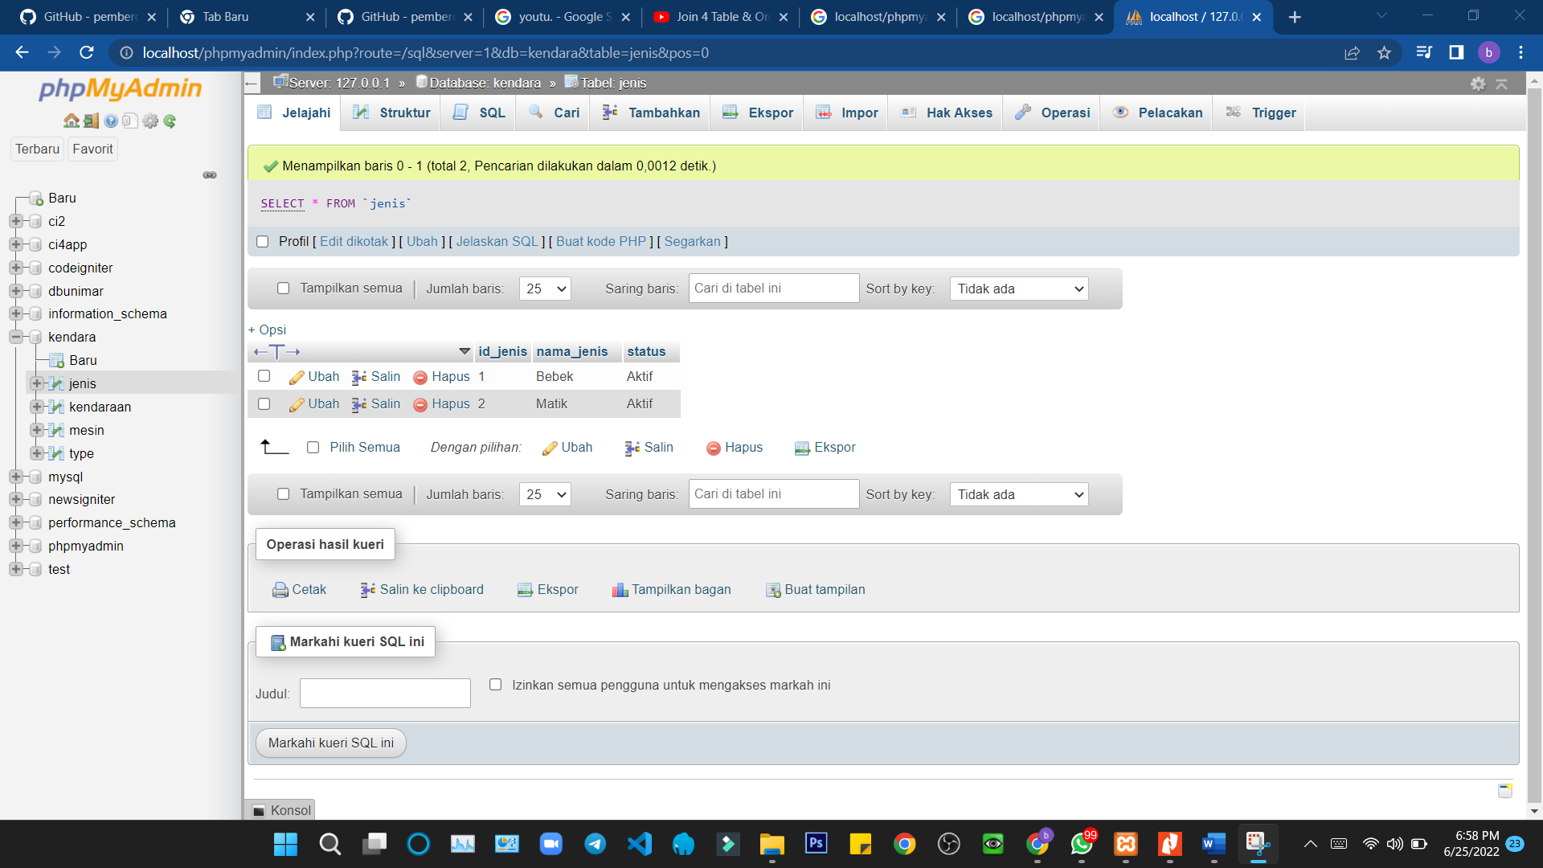

**SELECT c.nama_kendaraan, b.nama_type, a.nama_jenis, d.nama_mesin**

**FROM jenis a JOIN type b**

**ON a.id_jenis=b.jenis_id JOIN kendaraan c**

**ON b.kendaraan_id=c.id_kendaraan JOIN mesin d**

**ON b.mesin_id=d.id_mesin**

**ORDER BY c.nama_kendaraan DESC;**