Vamo
System Architecture — Engineering Build Document
Cross-platform mobile · Supabase core · solo or shared, any trip · heavy services extracted at the location, video and replay waves
Version 0.2 · June 2026 · Status: build reference

1. Purpose & scope
This document is the engineering reference for building Vamo: a phased product shipped as six separately-releasable apps that converge into one. Vamo works for any trip — a commute, a weekend, a holiday — used solo or with friends, private by default. It defines the target stack, the shared platform core, the data model, each module's services, the privacy/sharing model, the journey-merge and interactive replay endgame, and the scaling triggers that say when to graduate off managed infrastructure.
Guiding constraint: ship cheap, cash early, scale only what proves out. Every choice optimises for time-to-first-release and low fixed cost, then names the moment it should be replaced. Solo-first removes the cold-start dependency on groups. Nothing requires AI; where AI helps (e.g. auto-highlighting clips) it is optional.

2. The six apps
Each app is independently shippable and monetisable; all six share one core and one data model so merging them into the unified suite is assembly, not rewrite. Every app works solo (a trip can have a single member) and gets richer when shared.
App | Module | What it does | Build weight
SplitTrip | Split | Trip framing + bill splitting; solo trip capture; branded snapshot share | Light
EventList | Events | Group events, RSVP, guest list, shared checklists | Light
TripBoard | Itinerary | Collaborative day-by-day itinerary and shared lists | Light
TripMap | Map | Opt-in location, place pins; merged ghost-trail map (rung 1) | Heavy
TripReel | Memories | Media on pins, action-cam sync, auto recap video (rung 2) | Heaviest
Vamo suite | All | Unified app + interactive branching journey replay (rung 3) | Integration

3. Architecture at a glance
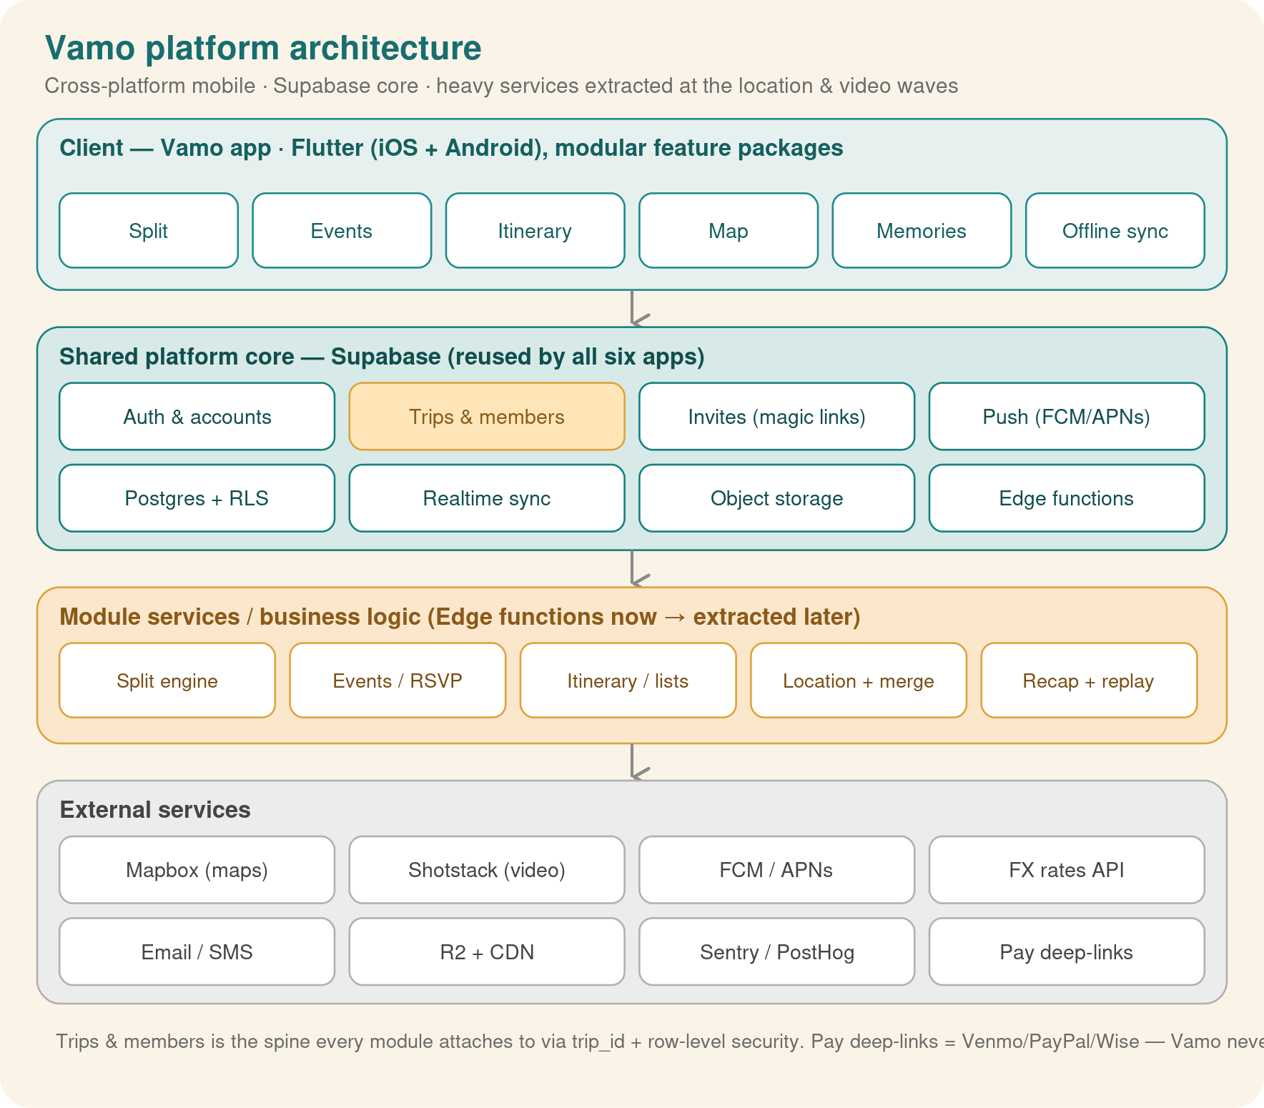
Four layers. A single Flutter client carries all five feature modules as packages. They sit on one Supabase platform core whose spine is the Trips & members entity — every module attaches rows to a trip and inherits that trip's membership, visibility and permissions (Row-Level Security). Module logic starts as Edge Functions and is extracted into dedicated services only when load demands it. The Location and Memories modules evolve into the journey-merge and interactive replay endgame. External services sit behind thin adapters so any one can be swapped.

4. Client architecture

4.1 Framework: Flutter
Flutter is the recommended client: ~46% cross-platform share in 2026, Impeller 120fps, AOT startup — all of which matter for an animation-heavy, brand-led product whose payoff is an interactive replay. One Dart codebase ships iOS and Android. React Native (New Architecture) is a viable fallback if hiring dominates, with no change server-side.

4.2 Repository & packaging
A monorepo with a shared core package and one feature package per module. app_core holds the design system (teal & sand), auth, trip context, networking, offline cache, push, and the sharing/visibility layer. Early waves compile single-feature app shells (e.g. standalone SplitTrip); the suite shell composes all five. Because features share app_core and the data model, no module is rewritten when the suite is assembled.

4.3 Offline-first
Travel happens with poor connectivity, so the client is offline-first: a local store (Drift/SQLite) is the UI source of truth, with a sync queue reconciling against Supabase. Writes are optimistic, last-write-wins per field, with realtime reconciling concurrent edits to shared objects.

5. Backend: recommendation & rationale
Recommended: Supabase as a lean backend-as-a-service for waves 1–3, extracting dedicated services only at the location, video and replay waves. Postgres is the deciding factor: bill-splitting, balances, memberships and journey data are relational, and Row-Level Security expresses per-trip access (and private-by-default visibility) directly in the database. Supabase also bundles auth, storage, realtime and Edge Functions, so the early waves need no servers of your own.
Criterion | Supabase (recommended) | Firebase | Custom now
Data model | Relational Postgres; natural for trips, balances, journeys | NoSQL; awkward for relational queries | Anything, but you build it all
Authorization | RLS in the DB; one model for access + privacy | Security rules; separate model | Hand-rolled
Realtime / Storage / Auth / Functions | Included and integrated | Included | Assemble & operate yourself
Time to first release | Days | Days | Weeks to months

6. Shared platform core
Everything every module reuses lives here, in Supabase.
- Identity & accounts — Supabase Auth (email, Apple/Google OAuth, phone via SMS). One account spans all apps.
- Trips & members (the spine) — a trip has dates, a destination, and a member list with roles. A trip can have ONE member (solo). Every module row carries trip_id.
- Sharing & visibility — every trip and asset has a visibility setting; private by default. Public/branded sharing is an explicit, revocable opt-in. Enforced by RLS.
- Invites & join-a-trip — magic links add the opener to a trip — including mid-trip, so friends can join a journey already underway.
- Realtime, storage, push — Postgres change streams; S3-compatible media buckets behind signed URLs; FCM/APNs notifications.
- Branded social export — a share service that renders snapshots/recaps with the Vamo watermark and a join link, for one-tap posting to WhatsApp/Instagram/TikTok.

7. Solo mode, privacy & sharing
Three product rules with direct architectural consequences:
- Solo is a first-class case. A trip with a single member must work end-to-end: plan, capture, recap, export. No data model assumes more than one member; group features simply light up when others join.
- Private by default. Nothing is visible outside the trip's members unless explicitly shared. Visibility is a column on trips and assets, enforced by RLS, with signed URLs for media. Location data is opt-in, batched, and retention-limited.
- Branded share is the growth surface. The only thing that leaves the private boundary is a deliberate, watermarked export the user chooses to post. That turns every voluntary share into reach — the engine the growth model depends on.

8. Data model
One Postgres database. Core tables hold the spine; modules add tables referencing trip_id. RLS restricts every row to members of its trip and respects visibility.

8.1 Core
Table | Key columns | Purpose
users | id, display_name, phone/email | Account identity
trips | id, name, destination, dates, owner_id, visibility | The spine (solo or group)
trip_members | trip_id, user_id, role, status | Membership + roles
invites | id, trip_id, token, expires_at | Magic-link / join-a-trip

8.2 Module tables
Module | Tables | Notes
Split | expenses, expense_shares, settlements, currencies | Balances derived; solo trips skip shares
Events / Itinerary | events, rsvps, checklist_items, itinerary_items, lists | Collaborative; realtime
Map / Journey | location_pings, places, place_tags, journey_tracks, segments, branch_points | Per-member traces merged by timestamp
Memories / Replay | media_assets, actioncam_assets, media_links, recaps, replays | Media time-synced to the route

9. Module services
Module logic begins as Edge Functions and is extracted when a wave's load demands it.

9.1 Split engine
Records expenses, computes balances, and a minimal settle-up via deterministic debt simplification (net positions, then greedily match largest creditor to largest debtor). Multi-currency via a daily FX API. Critically, Vamo never moves money: settle-up marks debts settled and deep-links to Venmo/PayPal/Wise — no money-transmission licensing, no PCI scope.

9.2 Events, RSVP, itinerary, lists
CRUD over the core tables plus realtime co-editing and offline reconciliation. No dedicated service needed; these are what turn an occasional user into a daily-active one during a trip.

9.3 Location pipeline + journey merge (heavier)
Opt-in, per-member, batched location pings (not a constant stream, to protect battery), ingested through an Edge Function (later a dedicated service) and rendered with the Mapbox Flutter SDK (free up to 25k mobile MAU). The merge step crosses every member's trace by timestamp into one journey: where the group was together, and where individuals split off — the basis of the ghost-trail map and, later, the replay.

9.4 Recap render + action-cam (heaviest)
Media (photos, clips, and GoPro/action-cam files) is time-synced and placed on the route. Recap videos start on Shotstack (managed FFmpeg, ~$0.20–0.30/min rendered) so the wave ships with zero video infrastructure; migrate to self-hosted FFmpeg workers when per-minute cost dominates. A render-jobs table tracks status; output lands in object storage behind a CDN.

10. Journey merge & interactive replay (the endgame)
The differentiating feature, and the heaviest. It is built as a three-rung ladder, cheapest first, so it never blocks the business:

Rung 1 — merged ghost-trail map + timeline (ships with TripMap, wave 3)
Every member's path on one map, scrubable by time: see who was where and where the group diverged. Mostly the location data you already have; cheap and already delightful and shareable.

Rung 2 — media on the route (ships with TripReel, wave 4)
Pin photos and short clips, including action-cam footage, at their GPS + timestamp position. Adds storage/bandwidth cost and the action-cam upload + time-sync problem.

Rung 3 — interactive branching replay (the suite, wave 5)
Replay the trip online and choose whose path to follow at branch points — e.g. after a shared segment, “go left to Positano with George & Marta, or right back to the hotel.” Technically a small game engine over a map: a branch graph derived from where traces split/rejoin, a synchronized media+map player, and a web runtime. The expensive part, and the premium centerpiece. Private by default; the branded public replay is an explicit, highly-shareable opt-in.
Engineering risks to plan for: multi-source GPS time-sync (clock skew, gaps, accuracy), action-cam ingestion (large files, sync), interactive player complexity, and storage/bandwidth cost. The ladder de-risks all of them by delivering value at each rung.

11. Security & privacy
- RLS everywhere — policies restrict rows to trip members and honour each row's visibility; storage shares the same policies.
- Private by default — trips, journeys and media are visible only to members; public/branded sharing is explicit and revocable.
- Location opt-in — off by default, per trip, batched, retention-limited, never sold or placed in URLs.
- No money movement — balances only; settlement is external. No PCI, no money-transmitter exposure.

12. Web strategy
Mobile-first does not mean mobile-only. Vamo ships web surfaces in step with the features that need them, against the same Supabase backend: every web client obeys the same RLS policies and hits the same API, so the backend needs no changes to support the web. Three distinct surfaces, each with its own technology and trigger:
Surface | What it is | Technology | Arrives
Share & preview pages (public) | View-before-install trip preview behind invite links; branded snapshot/recap share pages that unfurl on socials and load instantly with no install | Next.js (SSR for instant load, link unfurls, SEO), Vercel free tier | Wave 2–3, with the first shareable surfaces
PC dashboard (authenticated) | The comfortable big-screen home for travel history and complexity: Tally stats, Atlas journey archive, the Orbit globe, trip planning | Flutter Web — same codebase and packages as the app, compiled for browser | Waves 3–5, as Tally/Atlas/Orbit ship
Interactive replay runtime (public, opt-in shares) | The branching “choose whose path” journey replay, playable in any browser from a shared link | Interactive web runtime (already named in the scaling triggers) | Wave 5
The split is deliberate. Public pages need SSR and crawlability, which Flutter Web is poor at — so they go to Next.js. The logged-in dashboard reuses the existing Dart packages (settle-up engine, models, Supabase client) at near-zero marginal cost — so it stays Flutter Web. The viral loop depends on the public tier: an invite or replay link that demands an install before showing anything would kill conversion at its most valuable moment.

13. Scaling triggers
Wave | What you add | Trigger
1–2 (Split, Events, Itinerary) | Nothing beyond Supabase | —
3 (Map + ghost-trail) | Dedicated location-ingestion + merge service | High-volume location writes / Edge timeouts
4 (Reel + action-cam) | Self-hosted FFmpeg workers; object storage + CDN | Shotstack per-minute cost exceeds a worker fleet
5 (Branching replay) | Replay graph builder + media-sync compute + interactive web runtime | Replay usage and media volume grow

14. Tech stack summary
Layer | Choice | Why
Client | Flutter (Dart) | One codebase, 120fps, animation-rich brand
Backend | Supabase (Postgres + RLS) | Relational fit, access + privacy in one model
Custom logic | Edge Functions (Deno/TS) | Settle-up, FX, merge, render orchestration
Maps | Mapbox SDK | MAU pricing; ghost-trail + replay basemap
Video | Shotstack → FFmpeg workers | Zero infra now, owned later
Replay | Branch graph + web player | Interactive multi-path runtime (wave 5)
Media/CDN | Cloudflare R2 + CDN | Cheap storage and egress for clips/action-cam
Observability | Sentry + PostHog | Crashes + growth-loop funnels

15. Environments, CI/CD, testing
- Environments — local, staging, production Supabase projects; schema as migrations in the repo.
- CI/CD — analyze + tests on every PR; fastlane to TestFlight/Play internal tracks.
- Testing — unit tests on the settle-up engine, FX math and the journey-merge/branch logic (deterministic, high-value); widget tests on core flows; one end-to-end happy path per module before release.

