Vamo
Business Plan
Every trip, solo or together — plan it, split it, live it, relive it.
Bootstrap-lean · realistic base case · v0.3 · June 2026
Figures are driven by the accompanying editable financial model (Vamo_Financial_Model.xlsx). Assumptions are sourced to 2026 benchmarks and stated conservatively. Base case unless noted.

Part A — Executive summary

What Vamo is
Vamo is a mobile app for any trip — a daily commute, a weekend away, or a big holiday — used solo or with friends. On your own, you plan the trip, the app captures the places and route, and at the end you get a recap story or video. Shared with others, it also splits the costs, coordinates the group, and lets everyone add to the memory. Everything is private by default; you choose if and what to post publicly, and public shares carry the Vamo brand. It ships as standalone apps that converge into one suite.
The wedge: trip-framed bill splitting. People already pay to split travel costs, and every shared bill pulls in 3–6 friends for free. Because the app also works solo — plan, capture, recap — a new user gets value on day one without assembling a group first. That removes the cold-start problem and widens the funnel to commuters and solo travellers.
The moat: not any single feature — every one has an incumbent — but owning the complete loop, plus a multi-perspective journey replay no incumbent offers. Splitwise splits bills, Wanderlog plans, Polarsteps and Relive make memories; none stitch the whole journey, solo or shared, under one account.

Market
Vamo targets any trip, not just vacations, solo or in a group. The directly-monetisable wedge — bill-splitting apps — is roughly $708M in 2026, growing ~7% a year to ~$1.3B by 2035, with Splitwise at ~35M users and Tricount at ~11.7M monthly actives. The any-trip + solo framing widens the addressable base well beyond holiday bill-splitters.

Headline economics (base case)
Metric | Figure | Read
Wedge breakeven | ≈ month 11 | Solo funnel + tiered pricing
Peak cash need (pre-capital) | ≈ $4.5k | Lowest balance ~$6.3k once the €10K is counted
Funding | €10K founder injection | Funds all three scenarios — even the downside
Year-3 EBITDA / net revenue | ≈ $91k / $183k | Exit run-rate ≈ $279k/yr net
Net LTV vs paid CAC | $41 vs $125 | Growth must be viral/organic, not paid
The plan, in one line: the founder builds it unpaid and AI-accelerated, funded by a €10K injection. That fully covers the build: the cash dip bottoms at ~$6.3k still in the bank, the wedge turns profitable around month 11, and the company is cumulatively cash-positive during year 2. No outside capital is required — a raise is optional, only to accelerate.
Honest framing: making the app work solo, on any trip, de-risks the whole thing — it removes the dependence on a group to start, so every scenario lifts and even the pessimistic case survives on €10K and breaks even. Tiered pricing (a premium Pioneer tier) raises revenue without raising the cost floor much. Outcomes remain power-law: with the loops running hot, the same model reaches a ~$3.4M/yr run-rate in the upside case. The bet is buying that cheaply, because the downside is a small funded app, not a large loss.

Part B — Operating plan

1. Problem & opportunity
Travel — any travel, from a commute to a holiday — is coordinated and remembered across a mess of tools: chat for planning, a spreadsheet or Splitwise for money, a separate app for the itinerary, camera rolls scattered across phones, and nothing that ties the memory together. Each tool solves one slice, none talks to the others, and none work for a person travelling alone. The opportunity is a single product organised around the trip and its members — usable solo or shared — that carries you from “shall we go?” to “remember when?”.

2. Product, audience & the six apps
Vamo is built as six separately-shippable apps on one shared platform and data model (see the Architecture and Roadmap documents):
- SplitTrip — trip framing + bill splitting (the wedge), plus solo trip capture.
- EventList — group events, RSVP, guest list, checklists.
- TripBoard — collaborative itinerary and shared lists.
- TripMap — opt-in location, pins, and the merged ghost-trail map.
- TripReel — photos/videos + action-cam on the route, auto recap video.
- Vamo suite — all five unified, plus the interactive branching journey replay.
Add-on experiences (named, tiered): Tally (travel stats) + Vamo Wrapped, Atlas (journey history), and Orbit (a 3D globe of your journeys across time) with Constellations (explore friends' shared journeys). These power the premium tiers.
Who it is for: solo travellers and commuters who want to plan and remember; friend groups who share costs and memories; and people invited to join a trip already underway.

3. Market analysis
TAM — the any-trip coordination + memory space (split + planning + memories), solo and group. Bill-split alone is ~$708M and growing; with planning, memories and the solo/any-trip framing the addressable spend is several $B globally.
SAM — smartphone users who travel (broadly) in English-first markets and will pay a small subscription or per-trip fee. Wider than holiday-only bill-splitters because solo and commute use cases qualify.
SOM (3-year, base) — a few thousand paying users and roughly $0.15M annual run-rate — deliberately modest. The value is in proving the loops and retention, which unlock the larger surface and the upside.

4. Competition & positioning
Competitor | Owns | Gap Vamo exploits
Splitwise / Tricount | Bill splitting (35M / 11.7M users) | Group-only; no planning, memories or solo value
Wanderlog | Itinerary + some expense split | Vacation-only; weak memory loop; not solo-first
Partiful | Free event RSVP | Events only; no money, travel or memory layer
Polarsteps / Relive | Trip memories & route recaps | Post-hoc only; single-perspective; no planning or split
Positioning: the one app for any trip, solo or together. Defensibility is the whole loop, usable alone, plus the multi-perspective branching replay — and a brand built for the group moment.

5. Business model & pricing
Three tiers named for the crew, priced off real operating cost to hold ~70% gross margin. Free is the funnel; the paid tiers gate the features that actually cost money (render, storage, action-cam).
Tier | Price | Gets | Opex/user | Margin*
Vamigo (free) | $0 | Trips, split, solo capture, basic Tally, recent history | ~$0.05 | funnel
Voyager | ~$4/mo · $30/yr | Unlimited trips + Atlas, full Tally + Wrapped, recap video, ghost-trail, Orbit (your journeys) | ~$0.90 | ~74%
Pioneer | ~$11/mo | + action-cam, branching replay, Orbit + Constellations, unlimited render & storage | ~$3.10 | ~70%
* after the 15% store fee. A one-off Trip Pass unlocks Voyager features for a single trip (episodic users). The model blends these into an ARPU of ~$5.40 per paying user (base), driven by a ~20% Pioneer mix. Pioneer is priced at ~$11, not $5, precisely because action-cam storage and unlimited render would otherwise eat the margin — the pricing follows the opex.
- Private by default — trips are visible only to you or your group; public/branded sharing is an explicit, revocable opt-in.
- No money movement — Vamo tracks balances and deep-links to Venmo/PayPal/Wise; no money-transmission licensing, no PCI scope.
- Flexible, no-pressure billing — upgrade anytime; downgrade or cancel takes effect at the end of the current cycle, never mid-stream. No dark patterns, no forced upsell — the goal is that people stay on the tier they genuinely value, which keeps retention honest.

6. Go-to-market
Growth comes from the product, not paid ads. Paid CAC is ~$125 against a net LTV of ~$41 — paid installs lose money. Acquisition rests on three product loops: branded social shares (solo or group), join-a-trip, and the bill-split invite. Modelled as a viral coefficient of 0.14/active/month (base), plus ASO around ‘split trip costs’, ‘trip planner’ and ‘trip recap video’.
Seasonality & retention. Travel is episodic, so between-trip lapse is the central risk (see Risks). Solo and commute use cases raise baseline frequency; the annual plan, recap, and “plan the next one” nudges fight the gaps.

Viral growth strategy — engineering the loops
Because Vamo works solo there is no cold start — a single user produces a shareable recap on their first trip — and because it is better shared, every trip can pull in the group. The viral coefficient (0.10 Conservative — 0.20 Upside) is fed by three loops:
- Broadcast (main engine): the branded recap story/video is one-tap shareable to WhatsApp/Instagram/TikTok with the Vamo logo. Private by default, so the public share is a deliberate, delightful opt-in that advertises the app for free. Vamo Wrapped (annual Tally stats) and Orbit clips are extra shareable surfaces.
- Join-a-trip: friends hop into a live trip via one link; view-before-install (a web view, no account) lifts the join rate.
- Structural (when shared): you cannot split a bill alone, so splitting invites the group; owe-money SMS pulls in non-users.
- Amplifiers: two-sided referral and unlock-by-participation (the recap completes only once the crew adds photos); fire invites/shares at the three emotional peaks (start, settle-up, recap); seed dense crews (students, festival/ski/stag-hen groups).
Instrument the loops obsessively: viral coefficient, join-accept rate, and recap-share rate are the North-Star growth metrics. These tactics carry the coefficient from 0.10 toward 0.20 — the gap between the Conservative and Upside worlds.

7. Unit economics (base case)
Metric | Value | Note
Blended ARPU | $5.40 / mo | Voyager $4 + Pioneer $11 at ~20% mix
Net ARPU | $4.59 / mo | less 15% store fee
Avg paying lifetime | 12.5 months | 1 ÷ 8% monthly churn
Net LTV | ≈ $41 | after per-tier feature opex
Paid CAC | ≈ $125 | CPI ÷ conversion — unviable alone
Blended CAC | low (≈ $3) | growth is mostly organic/viral
The decisive insight: paid acquisition cannot pay back, so the model rests on the product loops and retention. Solo-first makes the loops reliable (no group needed to start), and branded social sharing is the cheapest channel there is.

8. Financial projections
Three scenarios from the same model. The spread is wide on purpose — consumer-social growth is power-law, and the model lets you toggle the drivers (conversion, churn, viral coefficient, organic funnel, tier mix) that decide the path.
Scenario | Y3 net revenue | Paying (m36) | MAU (m36) | Exit run-rate | Monthly breakeven
Conservative | ≈ $16k | ≈ 0.4k | ≈ 15k | ≈ $22k/yr | ≈ month 32
Base | ≈ $183k | ≈ 4.4k | ≈ 106k | ≈ $240k/yr | ≈ month 11
Upside | ≈ $1.9M | ≈ 52k | ≈ 900k | ≈ $3.4M/yr | ≈ month 5
Operator track in the numbers. From the Wave-3 gate, Base and Upside include B2B revenue from tour guides and operators running tours as Vamo trips (Base: 2 new operators/month from month 20 at ~$120/mo net; Upside: 5/month from month 16 at ~$180/mo) — billed on the web, so no store fee applies. Conservative deliberately assumes the gate kills the track: the downside case remains a pure consumer business and still survives on the €10K. All levers sit in the model’s Assumptions tab (operator rows), so the track can be dialed or zeroed without touching the consumer engine.
Base-case annual P&L (net revenue / total cost / EBITDA / cumulative cash):
Year | Net revenue | Total cost | EBITDA | Cumulative cash
Year 1 | $11.3k | $15.7k | ($4.4k) | ($4.4k)
Year 2 | $55.0k | $37.4k | $17.6k | $13.2k
Year 3 | $183.3k | $92.5k | $90.7k | $103.9k
Funding & runway. Base-case peak cash need (before capital) is only ~$4.5k. The founder's €10K injection covers it with room to spare — the lowest the bank balance ever reaches is ~$6.3k — and the company is cumulatively cash-positive during year 2. The wider solo funnel and tiered pricing mean even the pessimistic case is funded by the €10K and reaches monthly breakeven by ~month 32. No external raise is required.

9. Operating plan & team
Lean by design. The founder builds and ships every wave solo and unpaid, using a managed stack (Flutter + Supabase) plus an AI development stack — Claude Max, Cursor and Codex, ~$220/mo — to compress build time. There is no contractor in the model; that AI tooling is the deliberate substitute, bought because the scarcest resource is solo build time. Fixed costs are tooling and infrastructure (~$520/mo) plus per-tier feature opex (render/storage). The build follows the roadmap's five waves, each gated by a retention and unit-economics check before the next.
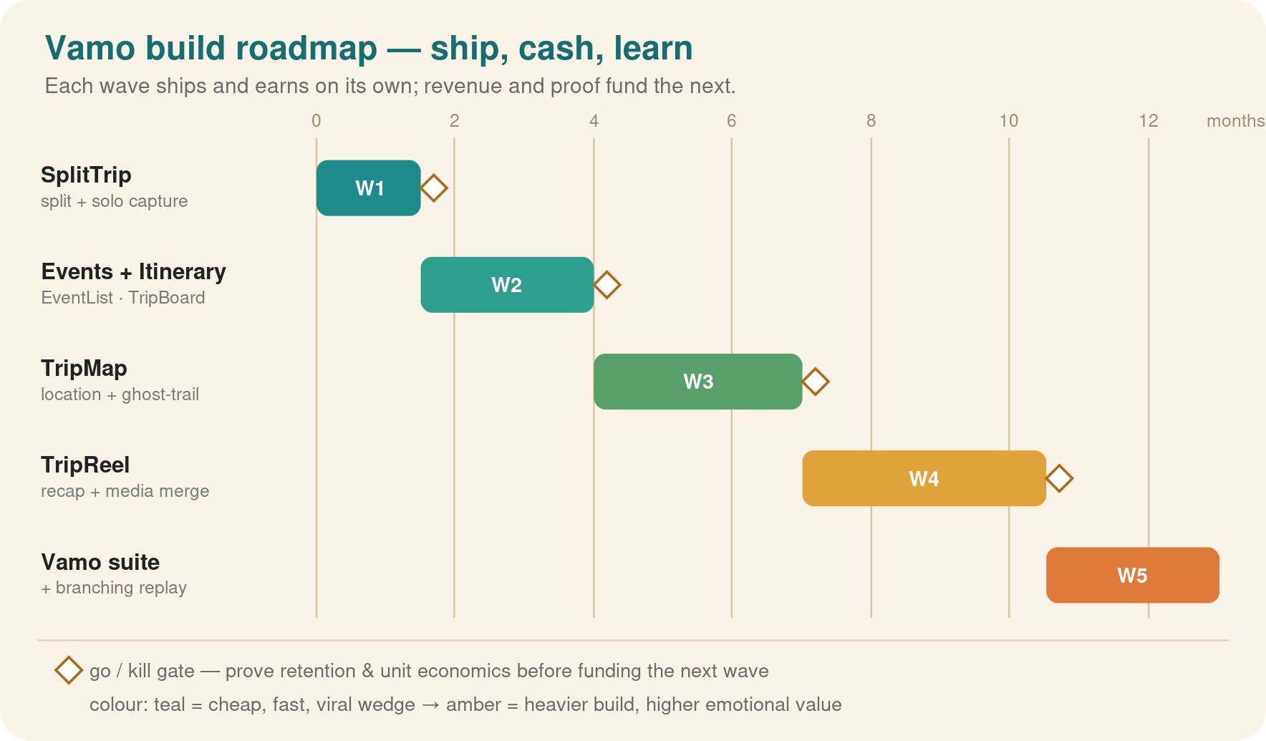

10. Milestones
- Wave 1 (mo 1–3) — built, June 2026: SplitTrip + solo capture + branded snapshot share; first paying users; invite/join/share loops measured.
- Wave 2 (mo ~2–6): Events + Itinerary; daily-active-during-trips rises.
- Wave 3 (mo ~6–12): TripMap + merged ghost-trail; Tally + Vamo Wrapped; location opt-in clears a comfort bar.
- Wave 4 (mo ~12–22): TripReel + action-cam + auto recap; Atlas; recap-share rate drives new-user pull.
- Wave 5–6 (mo ~22–32): Vamo suite + interactive branching replay + Orbit/Constellations; the premium centerpiece.

11. Risks & mitigations
Risk | Why it matters | Mitigation
Episodic churn | Travel is seasonal; users lapse between trips — the #1 threat | Solo + commute use cases raise frequency; annual plans, recap & next-trip hooks
Growth depends on loops | ARPU too low for paid acquisition | Solo-first removes cold start; branded shares + join-a-trip designed in from wave 1
Heavy-tier margin | Action-cam storage/render can eat margin | Pioneer priced ~$11 to opex; fair-use caps and overage on heavy storage
Crowded market | Splitwise/Wanderlog/Polarsteps each own a slice | Own the whole loop, solo or shared; branching replay no one else has
Privacy (location & sharing) | Trust and compliance | Private by default; opt-in, revocable, retention-limited; branded share is explicit
The honest bottom line: the wedge is cheap, fast and self-funding; the make-or-break variable is whether the loops and retention hold in an episodic category. Making the app work solo, on any trip, removes the cold start and lifts every scenario; tiered pricing raises revenue without much extra cost. Your €10K funds all three scenarios — the pessimistic one ends as a small, funded, break-even app; the base case is a ~$279k/yr business; and if the loops fire, the same €10K buys a shot at a ~$2.6M/yr run-rate. Capped downside, uncapped upside, on €10K.

