Vamo
Product Roadmap — Ship, Cash, Learn
Six apps, five waves. Solo or shared, any trip. Each wave ships and earns on its own; revenue and proof fund the next.
Version 0.2 · June 2026

Philosophy
You will not build the whole vision before releasing. Each wave is a standalone product that reaches the market, earns, and returns a real signal of demand. Bill-splitting funds you from week one and recruits users for free; making the app work solo (any trip, even a commute) removes the dependence on having a group and widens the funnel. The expensive, delightful endgame — location, action-cam, and the interactive branching replay — is earned only after the cheap waves prove people stick. You are never blocked; every wave ships and earns alone.

The roadmap
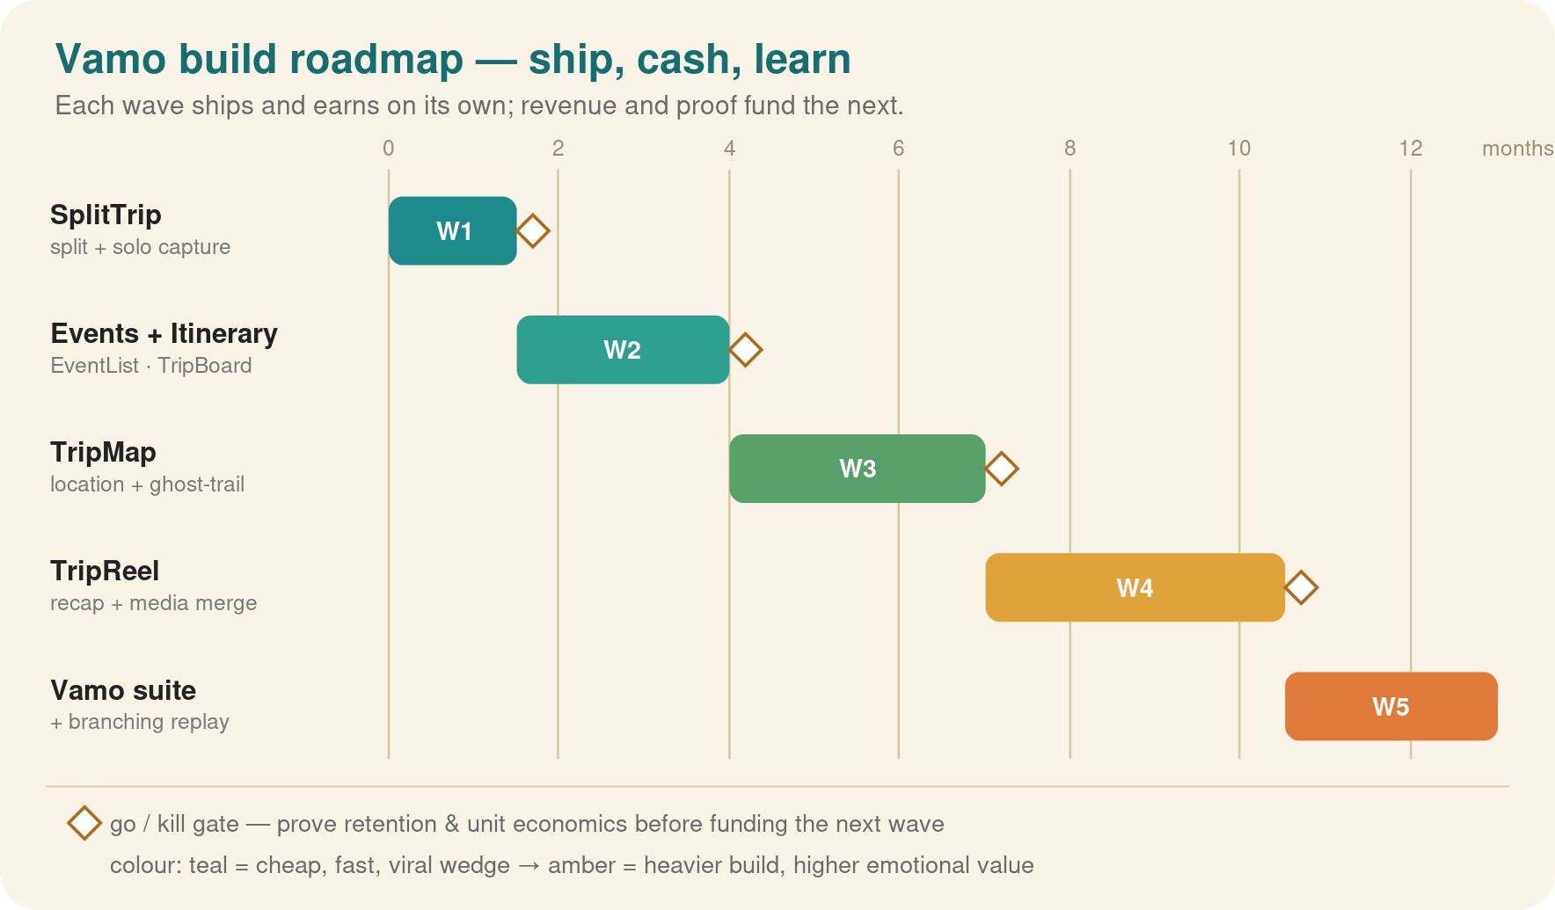
Waves are coloured cheap-teal to high-value-amber; a diamond between waves is a go/kill gate. The interactive replay is built as a ladder spread across waves 3–5 (ghost-trail → media-on-route → branching player), so its cost is staged and each rung delivers value on its own.

Wave 1 — SplitTrip (+ solo capture)
The wedge, now solo-friendly. Create any trip (solo or group), split bills if shared, capture the trip, and export a branded snapshot to share. Solo users get value day one with no group required; shared trips get the viral invite loop.
Field | Detail
In scope | Trips (solo or group), invites + join-a-trip, expenses/settle-up, multi-currency, solo capture, branded snapshot share, push
Out of scope | Live location, action-cam, recap video, branching replay
Monetisation | Free core; premium ($3–5/mo or per-trip) for receipt capture, multi-currency, unlimited trips
Go / kill gate | Trip-2 retention; invite/join coefficient; snapshot-share rate
Build estimate | 1–3 weeks

Wave 2 — EventList + TripBoard
Stickiness. Group events with RSVP and guest list, plus a collaborative itinerary and shared lists. Converts the app from “used twice at settle-up” to “open daily during the trip.”
Snapshot themes v1. the branded share card auto-themes from the destination via an AI resolver with a global per-destination cache (one generation per place on Earth, ever — see docs/AI_THEMING_SPEC.md); built-in keyword packs remain the offline fallback. Free for everyone as the day-1 taste. Premium tiers unlock the full pack library and photo backgrounds. The Vamo watermark is permanent on every tier: customization is sold, visibility never is.
Field | Detail
In scope | Events, RSVP, checklists, day-by-day itinerary, shared/packing lists, realtime co-edit
Out of scope | Location, media, replay
Monetisation | Premium expands: unlimited events, advanced lists
Go / kill gate | Daily-active during trips rises
Build estimate | 3–5 weeks

Wave 3 — TripMap (+ ghost-trail)
The moat begins. Opt-in, per-member location, place pins and tags, plus rung 1 of the replay: a merged ghost-trail map you can scrub through time to see where the group was together and where individuals split off. Tally also turns trips into stats (distance solo vs. together, who with, how often), with Vamo Wrapped as its shareable annual recap.
Immersion v1. riding on TripMap data, geo-anchored historical and cultural cards appear for places on the route (Rome → ancient-Rome experience, themed backgrounds per stop), tier-gated to Pioneer. The same geo-anchored content schema (location, language, source) is what the operator track later feeds.
Field | Detail
In scope | Opt-in location pings, map view, pins, tags, privacy controls, merged ghost-trail map + timeline, Tally stats + Vamo Wrapped
Out of scope | Action-cam, full recap video, branching player
Monetisation | Premium gains live trip map + ghost-trail replay
Go / kill gate | Opt-in rate clears a privacy bar; pins + ghost-trail engagement
Build estimate | 5–8 weeks

Wave 4 — TripReel (+ media merge)
The payoff and growth engine. Attach photos, clips and action-cam (GoPro) footage to the route (rung 2), and stitch an auto recap video at trip's end. Every branded recap shared is an advertisement — the cheapest, highest-intent channel you have.
Field | Detail
In scope | Media on pins/route, action-cam ingestion + time-sync, recap render (Shotstack), branded share, Atlas (journey history)
Out of scope | Self-hosted render until cost triggers it; branching player
Monetisation | Recap is the premium trigger everyone wants; per-recap or premium-gated
Go / kill gate | Recap share rate; new users pulled from shared recaps
Build estimate | 6–10 weeks

Wave 5 — Vamo suite (+ branching replay)
Convergence and the centerpiece. Unify all five modules under one account, and ship rung 3: the interactive branching replay — replay the trip online and choose whose path to follow at each fork. This is the moat no incumbent holds: the whole trip loop, plus a multi-perspective replay, in one product. Orbit (a 3D globe of all your journeys across time) and Constellations (explore friends shared journeys) ship here as the premium exploration layer.
Operator track (B2B option). from the Wave-3 gate onward, tour guides and operators can run tours as Vamo trips: an organizer-role member pre-loads geo-anchored multi-language audio and media and collects participant feedback. Built strictly as an extension, never a fork — same trips/membership/media schema with operator entitlements on top, plus a Next.js operator console from the web strategy. Consumer tiers stay shared; a single Operator tier sits above them. Go/no-go is a Wave-3-gate decision.
Field | Detail
In scope | Unified shell, single subscription, branch-graph builder, synchronized media+map web player, branded public replay, Orbit globe + Constellations
Out of scope | —
Monetisation | Single Vamo subscription; the replay is the headline upsell and share magnet
Go / kill gate | Cross-module usage; replay-share rate; blended retention/LTV beat the standalone apps
Build estimate | 8–12 weeks (replay is the heavy part)

Why this order
Bill-splitting first because it is cheapest, most viral, and monetises off a proven model. Solo capture rides in immediately so a lone user (or a commuter) has value and the branded-share growth loop is alive from day one. Events and itinerary turn occasional users into daily ones. Location, action-cam and the branching replay are expensive and privacy-loaded, so they are built last and as a staged ladder — each rung shippable — only once retention is proven. The suite can only be assembled once its parts exist, and assembling shared parts is cheap.

Gates & metrics summary
Wave | Primary go/kill metric | Rough build
1 SplitTrip (+solo) | Trip-2 retention; invite/join + snapshot-share rate | 1–3 wks
2 Events + Itinerary | Daily-active during trips | 3–5 wks
3 TripMap (+ghost-trail) | Location opt-in; ghost-trail engagement | 5–8 wks
4 TripReel (+media) | Recap share rate; new users per shared recap | 6–10 wks
5 Suite (+replay) | Replay-share rate; blended retention & LTV | 8–12 wks
Competitive note: Splitwise owns bill-split, Wanderlog bundles itinerary + split, and the memory endgame is contested (Polarsteps, Relive, a TripReel app). None offer solo-to-group coverage across the whole loop, and none do a multi-perspective branching replay — that gap, plus the brand, is the bet.

Extras — parked mechanics (decided at wave gates, not wave-committed)
Immersion unlock — pay or grow (Wave-4 gate). Generated HD destination themes unlock three ways: included with Pioneer; free when the trip reaches 5+ active vamigos; or a one-off Trip-Pass-style fee (~€1.99). The free path converts the paywall into an invite prompt aimed directly at the viral coefficient — the model’s decisive lever — and any “gaming” of the rule requires real joins, i.e. acquisition. Guards: framed as a theme unlock (the image is destination-cached, not commissioned art); positive copy (“your crew unlocked the Rome theme”), never hostage copy; count active joined members only; Pioneer keeps exclusive value beyond it (action-cam, replay, Orbit) so €1.99 tastes of Pioneer rather than replacing it. Instrument from day one: immersion_unlock_viewed → paid / invited-to-free / dismissed.
Popularity-gated imagery (cost rule for the above). Generate HD art lazily, only for destinations crossing a trip threshold — travel is power-law and the top ~5k places cover 90%+ of trips; the long tail keeps the colour-token theme. Open-weight image models via aggregators (~$0.015–0.03/image) are sufficient for stylised backgrounds and keep the cumulative three-year cost in the $150–250 range, inside the existing per-MAU infra line. Same global cache as theme tokens: one generation per place on Earth, ever.

