自动播放三个图片

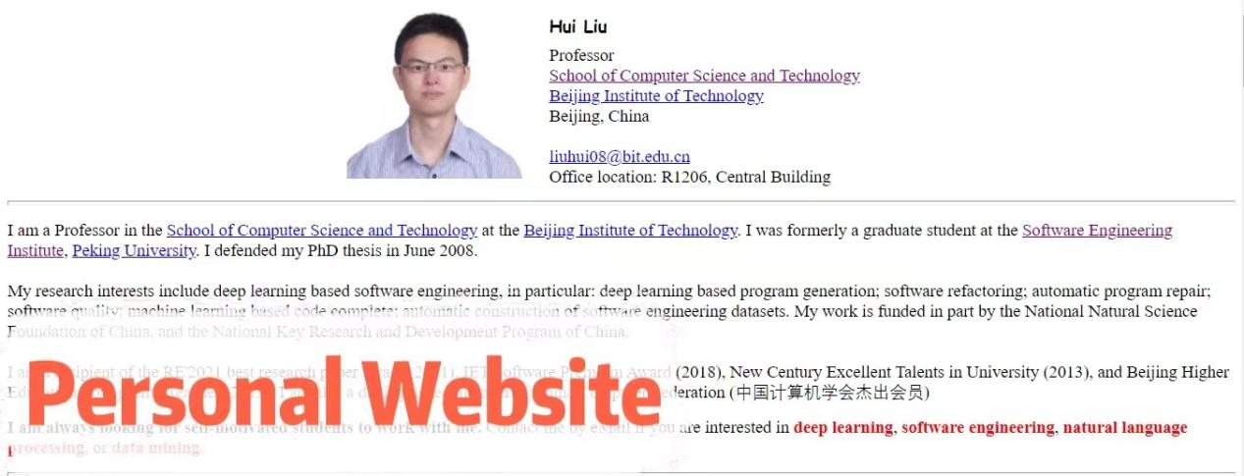

链接地址：<https://liuhuigmail.github.io/>

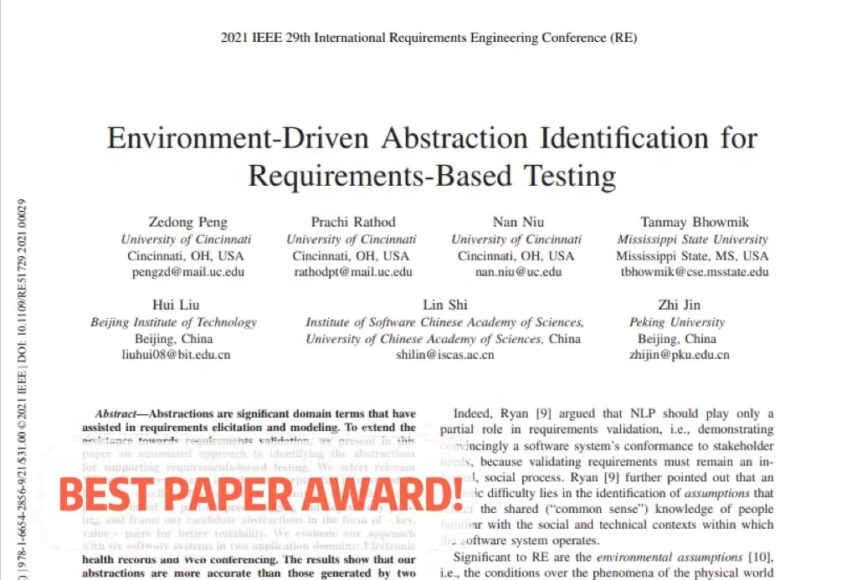

链接：这个里面的pdf





链接：<https://ieeexplore.ieee.org/document/9720157>

**Links内链接：**

Beijing Institute of Technology 对应 <https://www.bit.edu.cn/>

School of Science Technology 对应 <https://cs.bit.edu.cn/>

Personal Website 对应 <https://liuhuigmail.github.io/>

Beijing Institute of Technology Library 对应 <http://lib.bit.edu.cn/>

**主页自动滚动 五个论文标题**

1. **Hui Liu**\*, Mingzhu Shen, Jiaqi Zhu, Nan Niu, Ge Li and Lu Zhang, "[Deep Learning Based Program Generation from Requirements Text: Are We There Yet?](https://ieeexplore.ieee.org/document/9173704)" in IEEE Transactions on Software Engineering (*IEEE TSE*), vol. 48, no. 4, pp. 1268-1289, 1 April 2022, doi: 10.1109/TSE.2020.3018481
2. Lin Jiang, **Hui Liu\***, He Jiang, Lu Zhang and Hong Mei, "[Heuristic and Neural Network based Prediction of Project-Specific API Member Access](https://ieeexplore.ieee.org/document/9171589)," in IEEE Transactions on Software Engineering (*IEEE TSE*), vol. 48, no. 4, pp. 1249-1267, 1 April 2022, doi: 10.1109/TSE.2020.3017794
3. Li Leping, **Liu Hui**\*, Li Kejun, Jiang Yanjie and Sun, Rui. "[Generating Concise Patches for Newly Released Programming Assignments](https://ieeexplore.ieee.org/document/9720157)," in IEEE Transactions on Software Engineering, Online 2022, doi: 10.1109/TSE.2022.3153522.
4. Yinchen Tian, Yuxia Zhang*, Klaas-Jan Stol, Lin Jiang, **Hui Liu\***. What makes a Good Commit Message. 44th International Conference on Software Engineering (ICSE 2022), to appear.
5. Yuxia Zhang, **Hui Liu**, Xin Tan, Minghui Zhou, Zhi Jin, and Jiaxin Zhu. 2022. Turnover of Companies in OpenStack: Prevalence and Rationale. ACM Transactions on Software Engineering and Methodology (TOSEM), to appear