FP4 – Interface Evaluation and Medium-Fidelity Prototype

Heuristic Evaluation
Task 1 – Login and Manage Profile (Suiyang)
One issue was found in the login flow related to visibility of system status. When users entered incorrect login credentials, the error message was not visually prominent enough, making it easy to overlook. As a result, users might not clearly understand why the login attempt failed. To address this issue, the error message was redesigned to be more noticeable, with clearer placement and stronger visual emphasis. In addition, the profile editing interface was improved by grouping related information (e.g., Basic Info and Preferences), which helps reduce cognitive load and makes the overall interaction clearer and more structured.

Task 2 – Find and Join a Dining Event (Xinran)
One issue was found on the event detail page. The participant avatars looked clickable, but originally nothing happened when users clicked them. This could confuse users because they expected to see more participant information. To fix this problem, the avatars were updated to be clickable so users can view participant details.
Task 3 – Create a Dining Event (Zoey)
Two issues were found during the evaluation. First, on the Home screen, newly created event cards were not interactive, users could not tap them to view event details and had to navigate to the My Events tab instead. This violated Consistency and Standards, as users expected event cards to behave the same way regardless of which screen they appeared on. The cards were updated to be tappable and linked directly to the event detail page. Second, the "Vibe" field label and its options (Quiet / Casual / Deep) were unclear to users, who were unsure what the field represented and how to interpret the choices. This violated Match Between System and the Real World, as the terminology did not reflect familiar, everyday language. The field was renamed to "Dining Atmosphere" and the options were updated to Quiet Meal / Casual Hangout / Deep Conversation.
Task 4 - Communicate with others in the chatroom(Karena)
One issue was identified on the chatroom details page. When users toggle the “Mute Notifications” option on or off, there is no visible change in the chatroom interface. This may confuse users, as they expect the system to reflect their action in some way.This violates Visibility of System Status, because the system does not provide feedback to indicate whether notifications are muted or not. It also relates to User Control and Freedom, since users may feel uncertain whether their action has been successfully applied.

User Testing
Task 1 - Suiyang
One user testing session was conducted outside of the class with a new user. The user was asked to log in using the app. During testing, when the user entered incorrect login credentials, they did not immediately notice the error message and appeared unsure why the login attempt failed. This indicates that the system feedback was not sufficiently visible. Based on this feedback, the error message was redesigned to be more visually prominent. The profile page layout was also improved by grouping related fields, which made the form easier to scan and understand.

Task 2 – Xinran
One user testing session was conducted with Jackline Munene. The participant was asked to find and join a dining event. During the test, the participant searched for “sushi” and opened an event. On the event detail page, the user clicked the participant avatar expecting to see more information. However, nothing happened, which caused confusion. Based on this feedback, the design was updated so that participant avatars are clickable and display participant information. The search interaction was also improved by adding the keyboard when typing in the search bar.

Task 3 – Create a dining event (Zoey)
One user testing session was conducted for the Create Event task with Shaoyu Yan. During testing, two issues were identified. First, after successfully creating an event, users were unable to tap the newly created event card on the Home screen to view its details; they had to navigate to the My Events tab instead. Second, users found the "Vibe" field label unclear and struggled to interpret the options (Quiet / Casual / Deep). Based on this feedback, event cards on the Home screen were made tappable and linked to the event detail page. The "Vibe" field was also renamed to "Dining Atmosphere," with options updated to Quiet Meal / Casual Hangout / Deep Conversation for clarity.

Task 4 - Communicate with others in the chatroom(Karena)
One user testing session was conducted with Zhe Liu. During testing, one issue was identified. When the participant toggled the “Mute Notifications” option, there was no visible change in the chatroom interface, which made the participant unsure whether the action worked. Since mute notifications do not create visible changes in the interface, we did not further develop this feature. Instead, based on feedback, participants showed a stronger need to see important information during conversations. In addition, users rarely navigated to the chatroom details page and mostly focused on the main chat interface.Therefore, the design was updated by adding a pinned notice at the top of the chatroom so that important information is visible to all participants during the conversation.

Event Task | Screenshot of the relevant screen | Issue | Recommendations
Create an event | 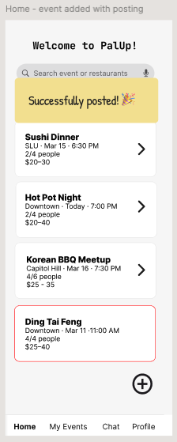 | After creating an event, users could not tap the event card on the Home tab to view event details; they had to navigate to the My Events tab instead. | Added interaction so tapping any event card on the Home tab navigates directly to the event detail page.
Create an event | 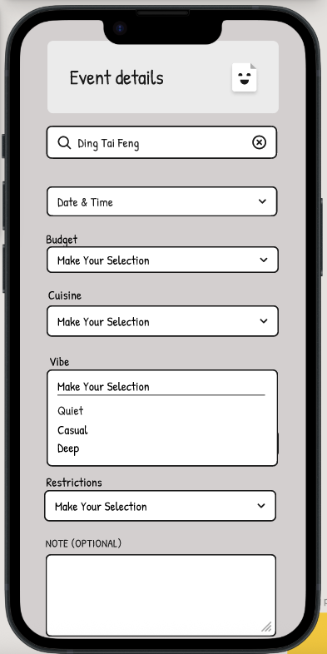 | Users were unclear about what "Vibe" meant as a field label, and found the options (Quiet / Casual / Deep) too abstract to interpret confidently. | Renamed the field to "Dining Atmosphere" and replaced options with more descriptive phrases: Quiet Meal / Casual Hangout / Deep Conversation.
Join an event | 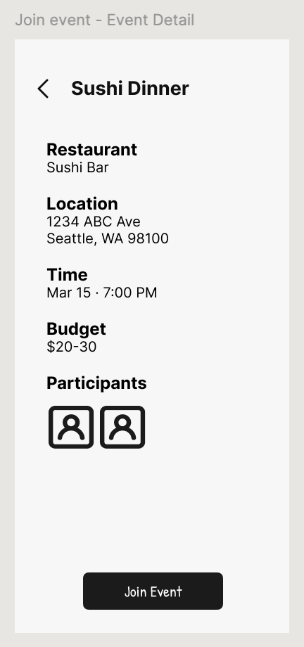 | Participant avatar originally had no interaction | Make avatar clickable to show participant information
Join an event | 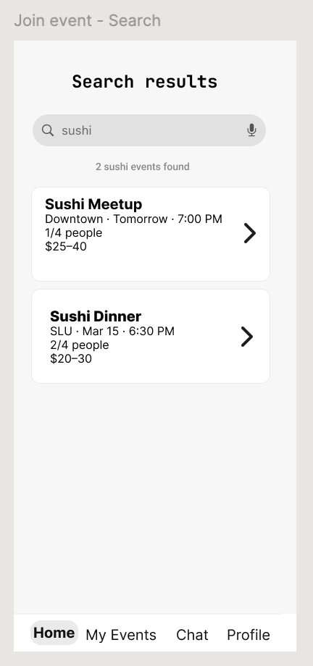 | Search interaction was unclear | Show keyboard when users type in search bar
Communicate with others in the chatroom | 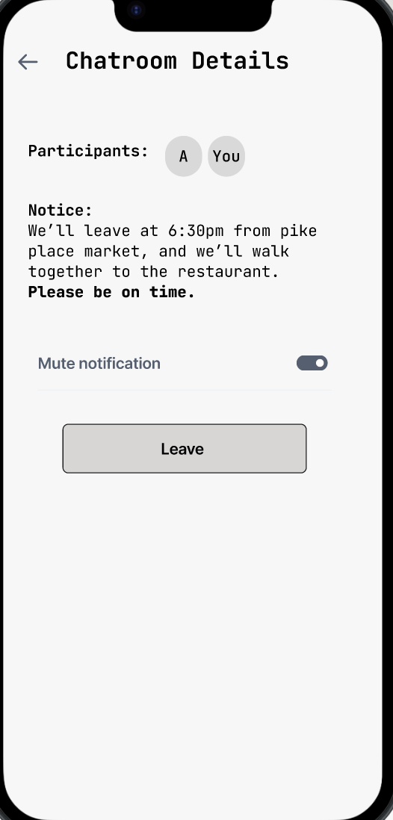 | Toggling “Mute Notifications” did not produce any visible change in the chatroom, making users unsure whether the action was applied. | Instead of focusing on mute notifications, a pinned notice was added at the top of the chatroom to ensure important information is visible to all participants during conversations.
Login | 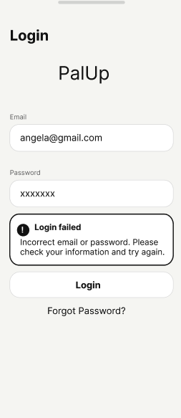 | Error message not clearly visible | Improve visibility using stronger contrast and clearer placement |

Updated Usage Scenarios
Task 1: Login and Manage Profile (Suiyang)
This task describes how users log in to the app and update their profile information.

To log in to the app:
- Open the app
- Enter email and password
- Tap “Log In”
- If login fails, view the error message

To manage profile information:
- Navigate to the Profile page
- Tap “Edit Profile”
- Update personal information (e.g., name, preferences)
- Tap “Save”
- View confirmation message (“Profile updated”)

Task 2 – Find and Join a Dining Event (Xinran)
This task describes how users find dining events and decide whether to join.
To find a dining event:

Open the PalUp app
- View recommended dining events on the Home page
- Use the search bar to look for specific events or restaurants
- Apply filters such as location, cuisine type, time, and budget
- Browse event cards to see basic information

To view event details:
- Tap on an event card
- View detailed information such as restaurant name, time, location, group size, and participant profiles

To join an event:
- Tap the “Join Event” button
- View the confirmation popup
- Tap “Confirm” to join the event
- View success message (“You have joined the event”)

After joining:
- Navigate to the “My Events” page
- View the joined event details
- Optionally tap “Leave” to exit the event

Task 3: Create a Dining Event (Zoey)
This task describes how a user creates and publishes a dining event on PalUp to find meal companions.
To create an event:
- Open the PalUp app and tap the "+" floating button on the bottom right of the Home screen.
- Search for a restaurant by name or apply filters to browse available options.
- Fill in the date, time, budget per person, cuisine type, dining atmosphere, food restrictions, and group size.
- Optionally tap "Add a note" to include any context for potential joiners.
To publish:
- Tap "Preview" to review how the listing appears to others; tap "Edit" to make changes.
- Tap "Post Event" to publish. A confirmation banner reads: "Your event has been posted!"
- The app redirects to the Home page.

Task 4: Communicate with others in the chatroom (Karena)
This task describes how a user communicates with other participants and stays informed about important event details in the chatroom.
To communicate in the chatroom:
- Open the PalUp app and navigate to the “Chat” tab.
- Tap a chat card to enter the chatroom.
- View messages from other participants in the conversation.
- Type a message in the input field at the bottom and tap “Send” to post it.

To view important event information:
- View the pinned notice displayed at the top of the chatroom, which shows key details such as meeting time and location.
- Tap the information (“i”) icon on the top right to access the chatroom details page for additional settings if needed.

Medium-Fidelity Prototype
Provide a public link.
https://www.figma.com/proto/GHEjNtXC88rwqjANMyj82r/PalUp?node-id=3-2&t=PHDMYLDzeeqvlV61-1&starting-point-node-id=152%3A643

UI Patterns
Login and Profile (Suiyang)
- Form — Users input email, password, and profile information.
- Error Message — The system displays feedback when login fails.
- Button — Users interact with “Log In” and “Save” buttons to complete actions.
- Confirmation Message — A “Profile updated” message confirms successful changes.
- Navigation — Users navigate between Login, Profile, and Edit Profile pages.
- Grouping — Related fields are organized into sections to reduce cognitive load.

Find and Join a Dining Event (Xinran)
- Search Bar — Users can quickly search for dining events or restaurants by typing keywords.
- Filter Controls — Users can narrow down results by location, cuisine type, time, and budget to find suitable events.
- Card Layout — Dining events are displayed as cards on the Home page, showing key information such as restaurant name, time, and group size.
- Information Display — The event detail page shows important information such as location, time, group size, and participant profiles.
- Button — Users tap the “Join Event” button to start joining an event.
- Confirmation Dialog — A confirmation popup appears to make sure the user really wants to join the event.
- Confirmation Feedback — After joining, the system shows a success message to confirm the action.
- Bottom Navigation Bar — Users can switch to the “My Events” page to view joined events.
- Action (Leave Event) — Users can leave an event by tapping the “Leave” button in My Events.
Create / Modify / Cancel Event: (Zoey)
- Bottom Navigation Bar — Users switch between Home, My Events, Chat, and Settings tabs via the bottom navigation bar.
- Floating Action Button — A floating "+" button on the bottom right of the Home screen triggers the Create Event flow.
- Card Layout — Created events are displayed as tappable cards on the Home screen, linking directly to the event detail page.
- Form — Users fill in event details (date, time, budget, cuisine type, dining atmosphere, food restrictions, group size) when creating or modifying an event.
- Preview & Confirm — Before publishing, users can preview how the event listing appears to others and return to edit if needed.
- Confirmation Feedback — A banner ("Your event has been posted!") appears upon successful event creation.
- Error Prevention / Confirmation Dialog — When canceling an event, users are prompted with a warning dialog ("Are you sure you want to cancel this event?") before the action is finalized.
Communicate with other participant in the chatroom (Karena)
- Bottom Navigation Bar — Users switch between Home, My Events, Chat, and Profile tabs via the bottom navigation bar.
- Chat Interface — Users communicate with other participants through a message-based chat interface, where messages are displayed as bubbles aligned left (others) and right (self).
- Input Field & Send Action — Users type messages in the input field at the bottom and tap the “Send” button to post messages.
- Pinned Notice — Important event information is displayed as a pinned notice at the top of the chatroom, ensuring visibility during conversation.
- Navigation (Details Access) — Users can tap the information (“i”) icon on the top right to access the chatroom details page.
- Toggle Switch — Users can enable or disable the pinned notice through a toggle on the details page. The notice is shown at the top of the chatroom when the toggle is on.

Contribution Statement
Suiyang
Designed Task 1: Login and Manage Profile, including login flow and profile interactions. Conducted heuristic evaluation and user testing, identified an issue related to error message visibility, and improved the design by enhancing feedback clarity. Contributed to documentation and refinement of the prototype.

Xinran
Designed Task 2: Find and Join a Dining Event. This includes the search results page, event detail page, and join event interaction. After user testing, the participant avatars were updated to be clickable and a keyboard interaction was added to improve the search experience.

Zoey:
Conducted user testing and heuristic evaluation for the Create/Modify/Cancel Event task, identifying two issues: non-interactive event cards on the Home screen and unclear "Vibe" field labeling. Updated the Figma prototype to make event cards tappable, renamed the field to "Dining Atmosphere" with revised options, and implemented the Cancel Event (confirmation dialog) and Modify Event flows. Also updated the Usage Scenario for Task 3 and documented the UI patterns for all Create/Modify/Cancel Event-related interactions.

Karena
Designed Task 4:Communicate in the Chatroom. This includes the chat interface, chatroom details page, and interaction for accessing event information. Conducted user testing and identified an issue where toggling mute notifications provided no visible feedback. Based on this, redesigned the feature by introducing a pinned notice at the top of the chatroom to improve visibility of important information. Updated the Figma prototype to reflect this change, including the toggle behavior (default on) and pinned notice display. Also updated the Usage Scenario for Task 4 and documented the corresponding UI patterns.

