Event Task | Screenshot of the relevant screen | Issue | Recommendations
Cancel and Edit Event - accessed from Event detail page | 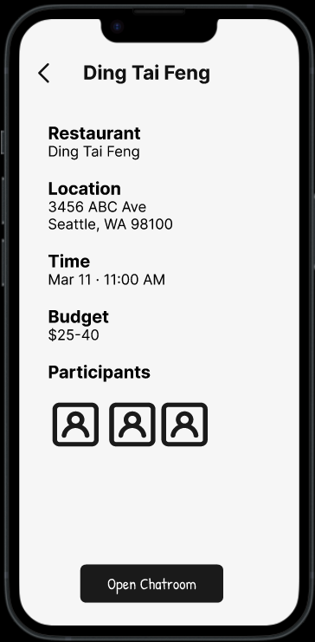 | Users who navigated to an event detail page directly from the Home screen had no way to cancel or edit the event from that page, they had to go to My Events to find those actions. This limits flexibility of use, as the same function requires different navigation paths depending on entry point. | Add Cancel and Edit buttons directly on the event detail page, so users can manage their event regardless of how they accessed it.
View Event details | 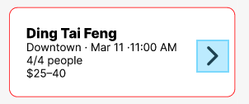 | The only tappable area to enter an event was a small ">" button on the right side of the card. The limited tap target reduces efficiency and conflicts with the proximity principle, the action trigger is visually separated from the content it relates to. | Retain the ">" indicator as a visual cue, but expand the entire event card as the tappable area, making navigation more intuitive and accessible.
Communicate with others in the chatroom - send a message | 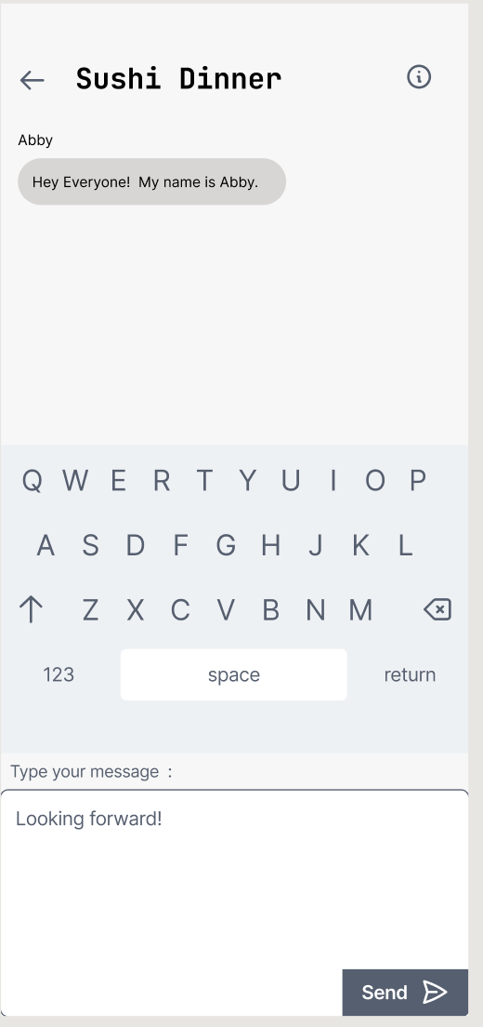 | The positioning of the keyboard and input field deviated from established mobile chat patterns. Specifically, the input field was located beneath the keyboard, creating an unnatural layout that hinders efficiency and risks confusing users during the messaging process. | The chatroom interface was updated to position the input field directly above the keyboard, adhering to established mobile messaging patterns. This adjustment enhances efficiency and aligns the layout with user expectations for standard chat interactions.
Newly established chatroom with no participants besides the creator (edge case scenario for the chat component interface)  . | 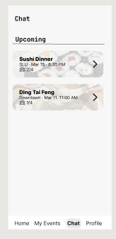 | The design did not consider the empty state of a newly created chatroom, where no participants or messages are present. This could make the interface feel incomplete or unclear to users. | Added an empty chatroom state (e.g., a newly created “Ding Tai Feng” chatroom with no messages) to better represent real user scenarios and improve the completeness of the interaction flow.
Login and Manage Profile | 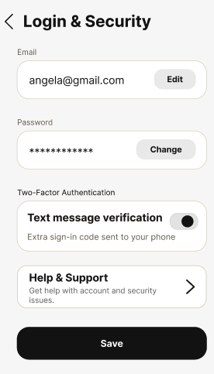 | The Login & Security screen did not include a clear entry point for help and support related to account/security tasks, making it harder for users to know where to go when something goes wrong. | Add a Help & Support button to provide assistance directly from Login & Security page

