Event Task | Screenshot of the relevant screen | Issue | Recommendations
Create Event – preferences screen | 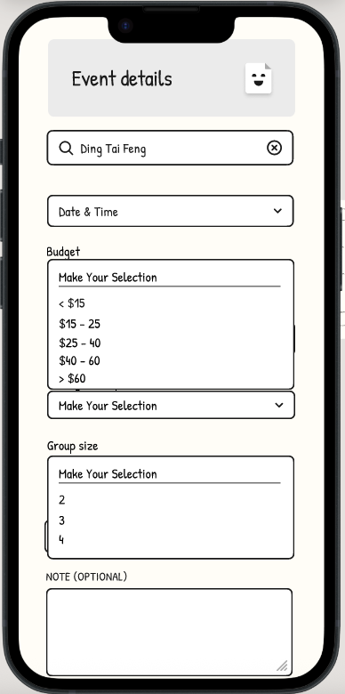 | The field labels "Budget" and "Group Size" were ambiguous. Users were unclear whether "Budget" referred to the total cost or per-person cost, and whether "Group Size" included the event creator. | Renamed "Budget" to "Budget/Person" to clarify the per-person cost expectation. Updated "Group Size" to include a hint such as "incl. yourself" to make clear that the creator is counted in the group.
Communicate with others in the chatroom - report a user | 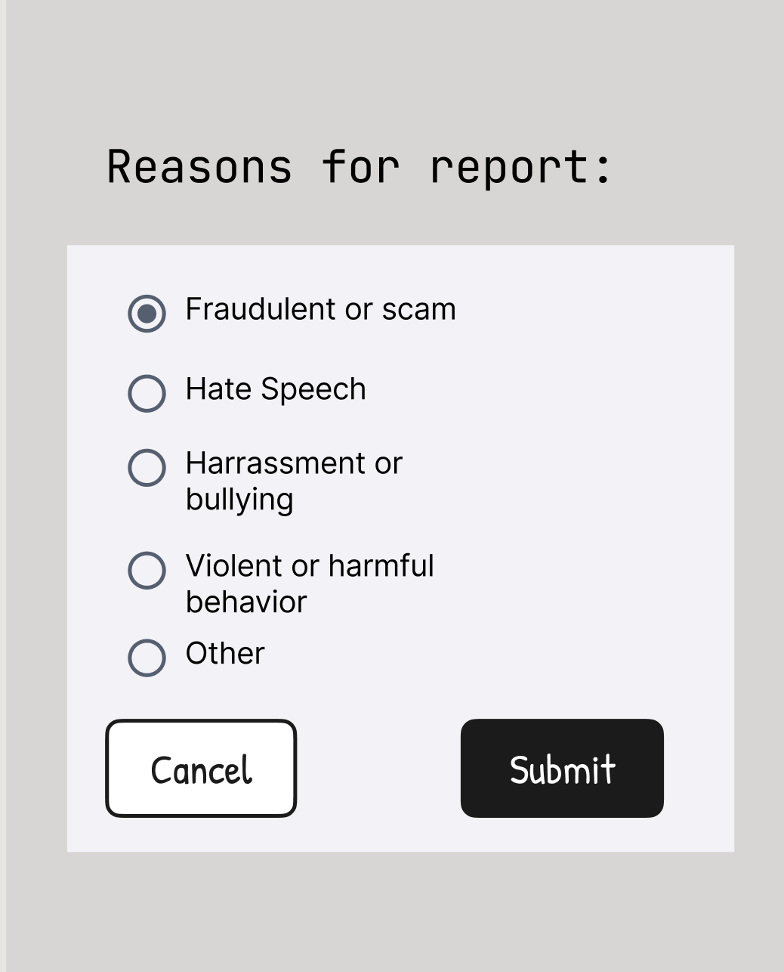 | The report interaction lacked flexibility, as users were unable to modify their selected reason once a choice was made. The interface immediately prompted for submission or cancellation, forcing users to exit and restart the process if an error occurred. This rigid workflow hindered efficiency by creating unnecessary navigation barriers during the reporting process. | The report interaction was updated to allow users to modify their selected reason within the same screen before submission. This adjustment enhances flexibility of use and improves efficiency by removing the need to restart the process if an error occurs.
Communicate with others in the chatroom - view a user by clicking their avatars in the chatroom | 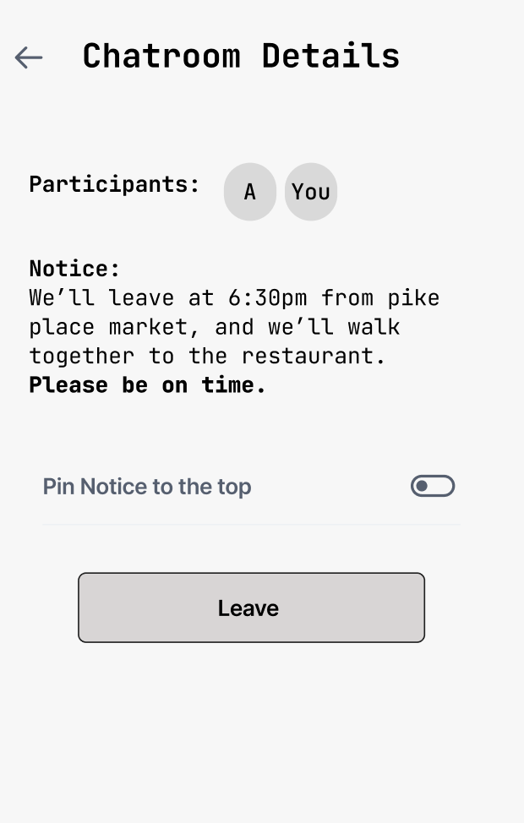 | Users could view other participants’ profiles by tapping on their avatars, but could not access their own profile by tapping on “You.” To view their own information, users had to leave the chatroom and navigate to the profile page, which creates an inconsistent and less efficient experience. | Updated the interaction so that tapping on “You” also opens the user’s own profile preview. This improves consistency and allows users to access profile information directly within the chatroom.
Login and Manage Profile | 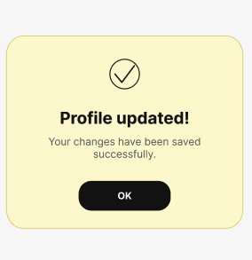 | Some screens still needed high-fidelity visual refinement. In particular, the confirmation screens and selected states needed to be more visually polished so users could clearly recognize completed actions and current selections. | The confirmation screens were redesigned with a clearer card layout, a subtle highlight background. This makes the end of each task easier to recognize, such as after resetting a password, saving profile changes, or selecting a subscription plan.
View Participants / View User Profile | 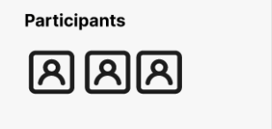 | Users could not easily view participant information. Previously, only part of the participant list was clickable. For example, if there were four users, sometimes only the first one could be clicked. Also, participant avatars were missing, which made the interface less clear. | Add avatars for all participants and make every participant in the list clickable, so users can view each person’s profile more easily.

