A4

Zoe Zhou

11/05/2020

#### TS1:

#### (i)

plot.ts(all$TS1, main = "Time Series 1")

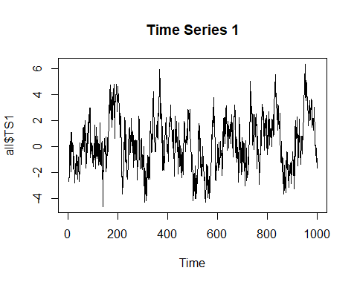

acf(all$TS1, main = "ACF plot for TS1")

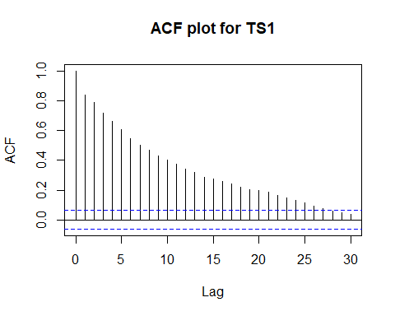

pacf(all$TS1, main = "PACF plot for TS1")

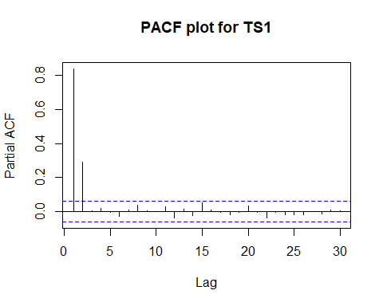

#### (ii)

$y_{t}=ρ_{1}y_{t−1}+ρ_{2}y_{t−2}+ϵ_{t}$

The most appropriate model will be a AR(2). From the series we can see strong clustering pattern which means we have positive autocorrelation in the series. The plot of ACF showed decay and PACF showed a cutoff at 2 lags.

#### (iii)

TS1.fit = arima(all$TS1, order = c(2, 0, 0))  
TS1.fit

##   
## Call:  
## arima(x = all$TS1, order = c(2, 0, 0))  
##   
## Coefficients:  
## ar1 ar2 intercept  
## 0.5958 0.2928 0.2106  
## s.e. 0.0302 0.0303 0.2821  
##   
## sigma^2 estimated as 1.008: log likelihood = -1423.72, aic = 2855.44

$y_{t}=0.5958y_{t−1}+0.2928y_{t−2}+ϵ_{t}$

#### (iv)

plot.ts(residuals(TS1.fit), main = "Residual Series for TS1")

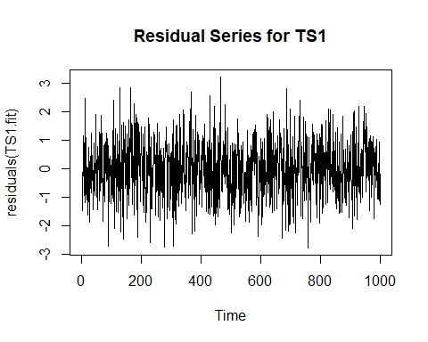

acf(residuals(TS1.fit))

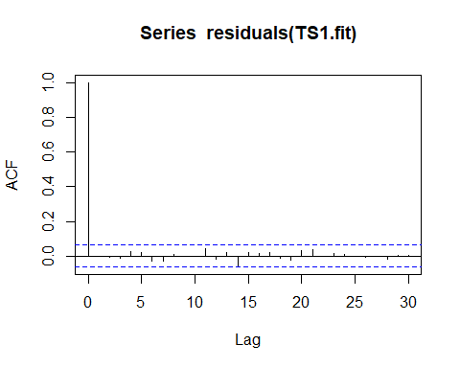

#### Comments:

The residual series seemed to follow a normal distribution with a mean around 0. The variance are reasonaly constant. The plot of ACF of the residuals showed no problems. All autocorrelation had been modelled.

#### (v)

Other models: ARMA(1, 1) AIC = 2863.19

AR(3) AIC = 2857.43, the 3rd AR term is not significant.

ARMA(1, 2) AIC = 2858.79

ARMA(2, 1) AIC = 2857.43, the 1st MA term is not significant

The AR(2) model had the smallest AIC (2855.44) and all terms are significant.

#### TS2:

#### (i)

plot.ts(all$TS2, main = "Time Series 2")

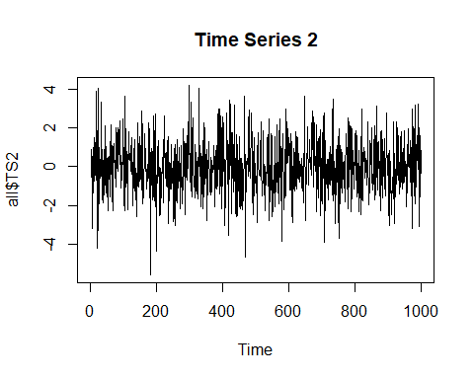

acf(all$TS2, main = "ACF plot for TS2")

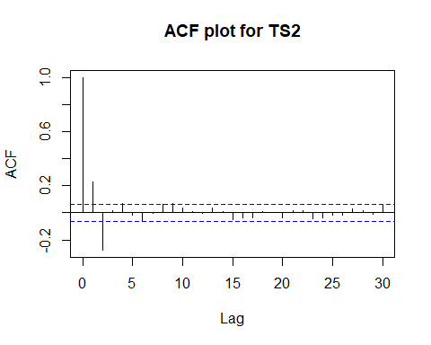

pacf(all$TS2, main = "PACF plot for TS2")

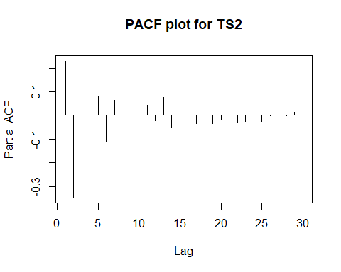

#### (ii)

$y_{t}=ρ_{1}y_{t−1}+ϵ_{t}+α_{1}ϵ_{t−1}$

The most appropriate model will be ARMA(1,1). From the series we can see strong clustering patterm which means we have autocorrelation in the series. The plot of ACF showed decay and PACF also showed decay or some persistence. Since we don’t know the order for the model we can start trying with ARMA(1,1).

#### (iii)

TS2.fit = arima(all$TS2, order = c(1, 0, 1))  
TS2.fit

##   
## Call:  
## arima(x = all$TS2, order = c(1, 0, 1))  
##   
## Coefficients:  
## ar1 ma1 intercept  
## -0.3504 0.8459 -0.0084  
## s.e. 0.0403 0.0219 0.0531  
##   
## sigma^2 estimated as 1.509: log likelihood = -1624.86, aic = 3257.73

$y_{t}=−0.3504y_{t−1}+ϵ_{t}+0.8459ϵ_{t−1}$

#### (iv)

plot.ts(residuals(TS2.fit), main = "Residual Series")

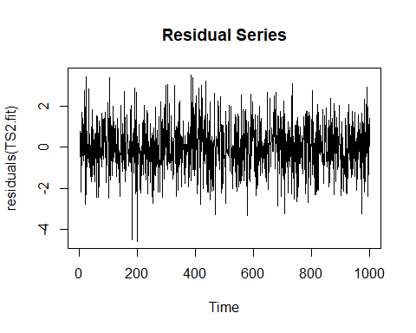

acf(residuals(TS2.fit))

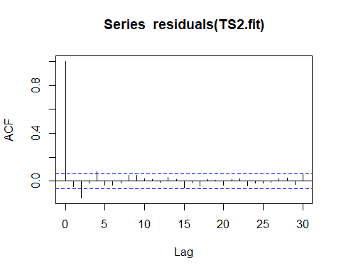

#### Comments:

The residual series seemed to follow a normal distribution with a mean around 0. The variance are reasonaly constant. The plot of ACF of the residuals showed we still have 2 significant lags at lag(2) and lag(4).

#### (v)

Better model:

# ARMA(2, 1)  
TS2.fit2 = arima(all$TS2, order = c(2, 0, 1))  
TS2.fit2

##   
## Call:  
## arima(x = all$TS2, order = c(2, 0, 1))  
##   
## Coefficients:  
## ar1 ar2 ma1 intercept  
## -0.2975 -0.1888 0.7471 -0.0088  
## s.e. 0.0490 0.0387 0.0427 0.0451  
##   
## sigma^2 estimated as 1.474: log likelihood = -1613.16, aic = 3236.32

ARMA(2, 1) AIC = 3236.32 $y_{t}=−0.2975y_{t−1}+−0.1888y_{t−1}+ϵ_{t}+0.7471ϵ_{t−1}$

The ARMA(2, 1) model has the smallest AIC (3236.32) and all terms are significant.

plot.ts(residuals(TS2.fit2), main="Residual Series")

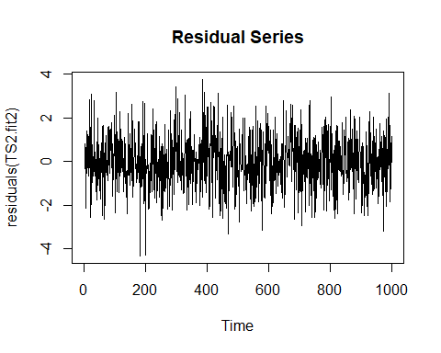

acf(residuals(TS2.fit2))

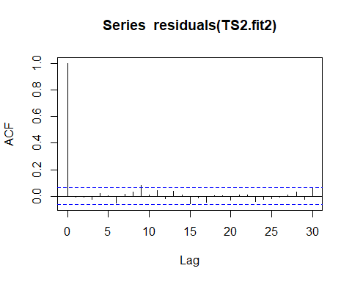 #### Comments: The residual series seemed to follow a normal distribution with a mean around 0. The variance are reasonaly constant. The plot of ACF of the residuals showed lag(9) is slightly significant but it is very weak and not of concern.

#### TS3:

#### (i)

plot.ts(all$TS3, main = "Time Series 3")

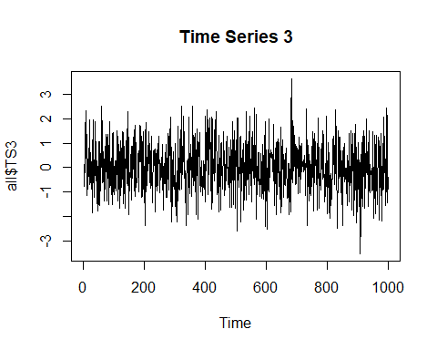

acf(all$TS3, main = "ACF plot for TS3")

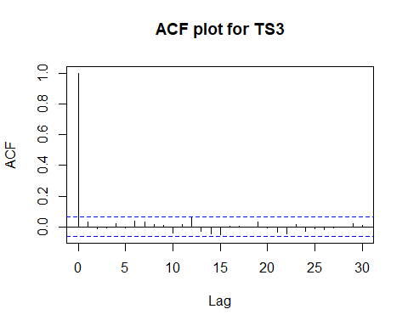

pacf(all$TS3, main = "PACF plot for TS3")

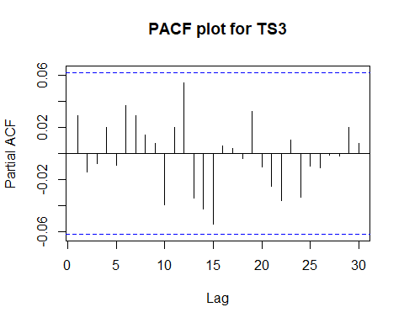

#### (ii)

$y_{t}=ϵ_{t}$

The most appropriate model will be a White noise. From the series we cannot really see much pattern happening. The variance seemed very constant and the series has an overall mean around 0. The plot of ACF showed no significant lags and the plot of PACF showed no significant lags as well. This series should be a white noise.

#### (iii)

TS3.fit = arima(all$TS3, order = c(0, 0, 0))  
TS3.fit

##   
## Call:  
## arima(x = all$TS3, order = c(0, 0, 0))  
##   
## Coefficients:  
## intercept  
## 0.0211  
## s.e. 0.0316  
##   
## sigma^2 estimated as 0.9961: log likelihood = -1417, aic = 2838

$y_{t}=ϵ_{t}$

#### (iv)

plot.ts(residuals(TS3.fit), main = "Residual Series")

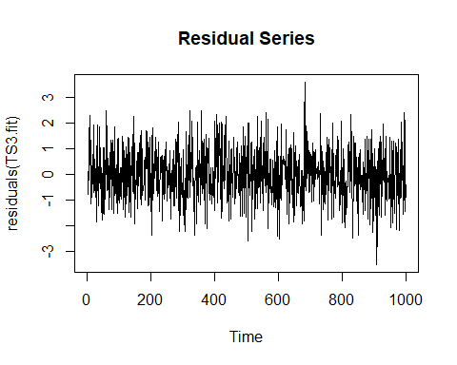

acf(residuals(TS3.fit))

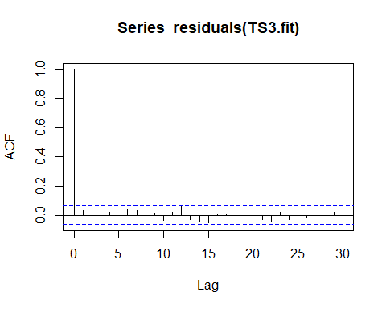

#### Comments:

The residual series seemed to follow a normal distribution with a mean around 0. The variance are reasonaly constant. The plot of ACF of the residuals showed no problems. All autocorrelation had been modelled.

#### (v)

Other models:

AR(1) AIC = 2839.17, the AR term is not significant MA(1) AIC = 2839.14, the MA term is not significant

The White Noise model has the smallest AIC (2838).

#### TS4:

#### (i)

plot.ts(all$TS4, main = "Time Series 4")

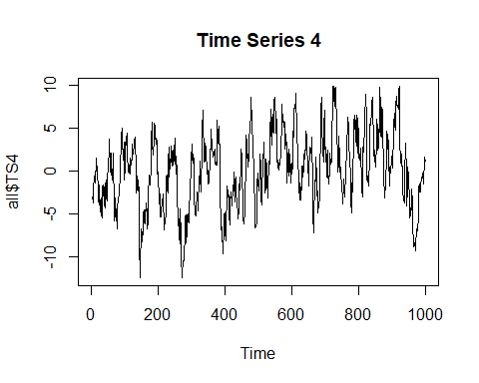

acf(all$TS4, main = "ACF plot for TS4")

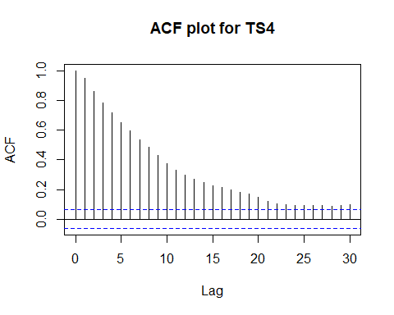

pacf(all$TS4, main = "PACF plot for TS4")

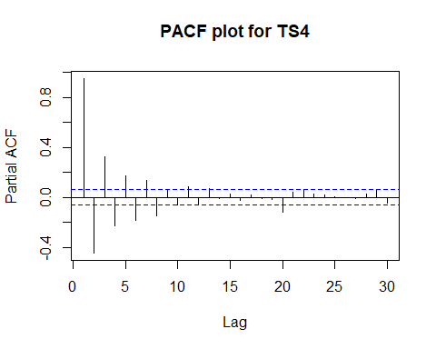

#### (ii)

$y_{t}=ρ_{1}y_{t−1}+ϵ_{t}+α_{1}ϵ_{t−1}$

The most appropriate model will be ARMA(1, 1). From the series we can see some clustering and osicilation The plot of ACF showed decay and PACF also showed decay or some persistence. Since we don’t know the order for the model we can start trying with ARMA(1,1).

#### (iii)

TS4.fit = arima(all$TS4, order = c(1, 0, 1))  
TS4.fit

##   
## Call:  
## arima(x = all$TS4, order = c(1, 0, 1))  
##   
## Coefficients:  
## ar1 ma1 intercept  
## 0.8974 0.9121 -0.0147  
## s.e. 0.0139 0.0128 0.5786  
##   
## sigma^2 estimated as 0.9828: log likelihood = -1412.55, aic = 2833.11

$y_{t}=0.8974y_{t−1}+ϵ_{t}+0.9121ϵ_{t−1}$

#### (iv)

plot.ts(residuals(TS4.fit), main = "Residual Series")

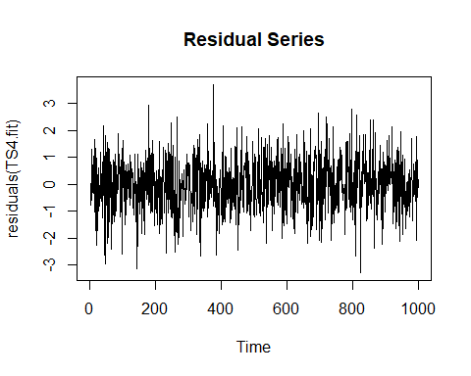

acf(residuals(TS4.fit))

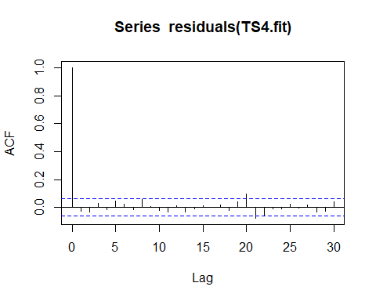

#### Comments:

The residual series seemed to follow a normal distribution with a mean around 0. The variance are reasonaly constant. The plot of ACF of the residuals showed at lag(20) and lag(21) they are slightly significant but it is not a big problem we can ignore.

#### (v)

Other models:

ARMA(2, 1) AIC = 2833.86, The 2nd AR term is not significant.

ARMA(1, 2) AIC = 2833.73, The 2nd MA term is not significant.

The ARMA(1, 1) model has the smallest AIC and all terms are significant.

#### TS5:

#### (i)

plot.ts(all$TS5, main = "Time Series 5")

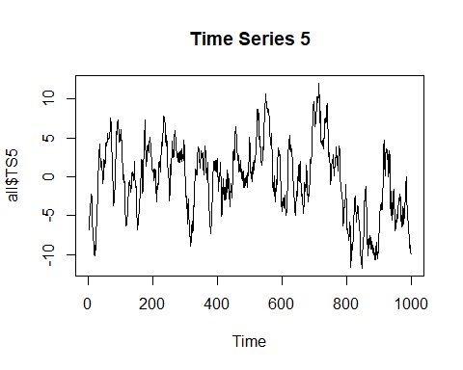

acf(all$TS5, main = "ACF plot for TS5")

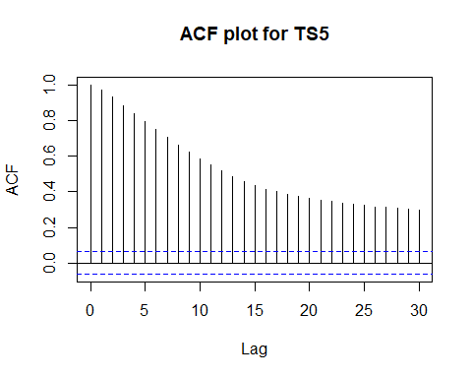

pacf(all$TS5, main = "PACF plot for TS5")

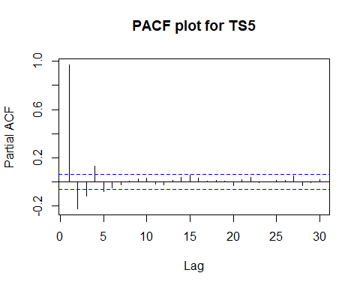

#### (ii)

$y_{t}=ρ_{1}y_{t−1}+ϵ_{t}+α_{1}ϵ_{t−1}$

The most appropriate model will be ARMA(1, 1). From the series we can see strong clustering and some osicilation. The plot of ACF showed decay and PACF also showed decay. Since we don’t know the order for the model we can start trying with ARMA(1,1).

#### (iii)

TS5.fit = arima(all$TS5, order = c(1, 0, 1))

## Warning in arima(all$TS5, order = c(1, 0, 1)): possible convergence  
## problem: optim gave code = 1

TS5.fit

##   
## Call:  
## arima(x = all$TS5, order = c(1, 0, 1))  
##   
## Coefficients:  
## ar1 ma1 intercept  
## 0.9674 0.1876 -0.6895  
## s.e. 0.0082 0.0260 1.1571  
##   
## sigma^2 estimated as 1.063: log likelihood = -1450.83, aic = 2909.67

$y_{t}=0.9674y_{t−1}+ϵ_{t}+0.1876ϵ_{t−1}$

#### (iv)

plot.ts(residuals(TS5.fit), main = "Residual Series")

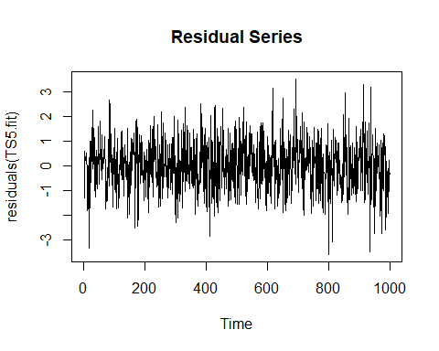

acf(residuals(TS5.fit))

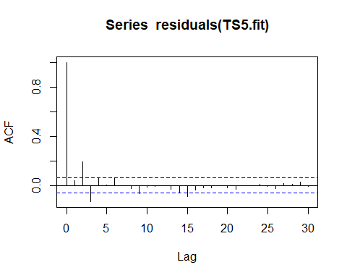

#### Comments:

The residual series seemed to follow a normal distribution with a mean around 0. The variance are reasonaly constant. But the plot of ACF of the residuals showed at lag(2) and lag(3) are significant.

#### (v)

Better model:

# ARMA(2, 2)  
TS5.fit2 = arima(all$TS5, order = c(2, 0, 2))  
TS5.fit2

##   
## Call:  
## arima(x = all$TS5, order = c(2, 0, 2))  
##   
## Coefficients:  
## ar1 ar2 ma1 ma2 intercept  
## 0.5840 0.3552 0.6361 0.3235 -0.5989  
## s.e. 0.1063 0.1040 0.1014 0.0325 0.9989  
##   
## sigma^2 estimated as 0.9954: log likelihood = -1418.31, aic = 2848.63

$y_{t}=0.5840y_{t−1}+0.3552y_{t−2}+ϵ_{t}+0.6361ϵ_{t−1}+0.3235ϵ_{t−2}$

ARMA(2, 2) AIC = 2848.63

plot.ts(residuals(TS5.fit2), main = "Residual Series")

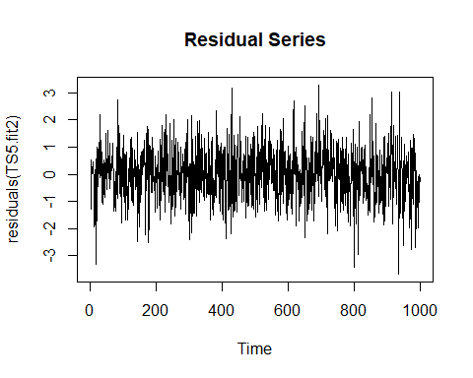

acf(residuals(TS5.fit2))

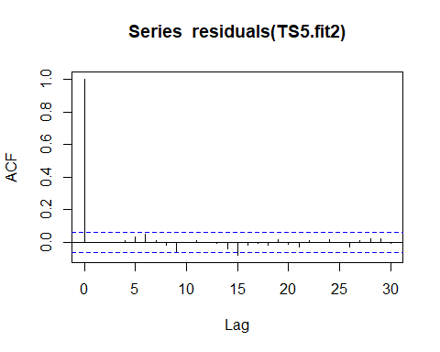

#### Comments:

The residual series seemed to follow a normal distribution with a mean around 0. The variance are reasonaly constant. The plot of ACF of the residuals showed at lag(15) is slightly significant, but it is very weak so we can ignore it.